Cover Page for International Decade for People of African Descent - #IPAD2015 – www.rtleads.com
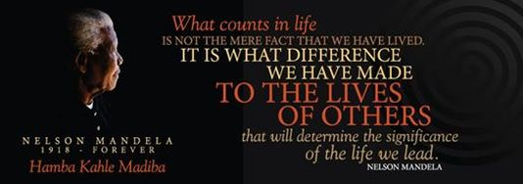

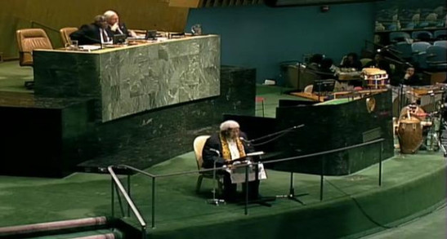
“Reiterating that all human beings are born free and equal in dignity and rights and have the potential to contribute constructively to the development and well-being of their societies, and that any doctrine of racial superiority is scientifically false, morally condemnable, socially unjust and dangerous and must be rejected, together with theories that attempt to determine the existence of separate human races,.”
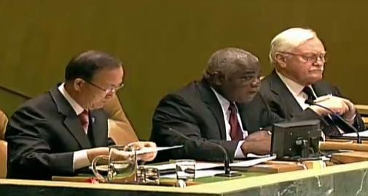
Proclaims the International Decade for People of African Descent, commencing on 1 January 2015 and ending on 31 December 2024, with the theme “People of African descent: recognition, justice and development”, to be officially launched immediately following the general debate of the sixty-ninth session of the General Assembly;
The aims and objectives of the New Forum for People of African Descent should be building/strengthening human rights institutions and creating platforms and initiatives that produce knowledge, ideas and strategies to advance a positive vision for the implementation of CERD, empowerment of stakeholders and creation of vibrant communities.
Thematic focus: “Building Human Rights Institutions and investing in the capacity of People of African descent: recognition, justice and development”,
What should the format and the agenda be? Assessing and building the capacity of Local, Regional and National Human Rights Institutions to implement the recommendations of CERD (CRC & CEDAW)
- Convene regional policy forums throughout the diaspora with workshops to assess the achievements and challenges for further improvements in the protection and promotion of human rights in four major areas: access to housing, social security, quality education and health services.
- Inform communities about how to access and partner with the three key mechanisms within the UN system, that the UN employs to defend and promote human rights: 1) Human Rights Treaties that further develop international human rights standards, including the protection of women's rights, the rights of the child, and the rights of those with disabilities; 2) Office of the High Commissioner for Human Rights (OHCHR), which works to promote and protect human rights in the field by monitoring and reporting on human rights violations and strengthening the capacity of national institutions to provide adequate human rights protection; and 3) the Human Rights Council, the only global intergovernmental body comprised of 47 member states that works to address human rights.
How do we ensure widespread participation in the Forum?
- Convene high impact, culturally rich & media-worthy educational events that demonstrate our shared interests, commitment to human rights, accountability and prosperity for all. Celebrate the diverse heritage of People of African Descent, commitment to human rights and global economic development through outreach to civil society organizations, neighborhood associations, consulates, local chambers of commerce, educational institutions and cultural organizations;
- Encourage widespread participation and stakeholder buy-in by featuring cultural products, goods and services from micro, small & medium sized enterprises; and
- Increase program impact by drawing in the youth and student organizations for social impact and for the sustainability of initiatives, leverage sms, social media, e-news letters, and satellite (pop-up) events throughout the year to inform and conduct trainings in themed neighborhoods
What should be its outcomes?
Strengthened Institutions and increased capacity of people of African descent to gain access to housing, social security, quality education and health services.

Partners: Nana B.F.A. Ofori-Atta, J.D. – President/ Managing Director of Real Time Leadership Solutions, Inc. www.rtleads.com/Editor of Real Time Africa – www.realtimeafricans.com;

