Appolinaire OUSSOU LIO, EJ practionner and GRABE-Benin NGO Chairman, BP: 13 Avrankou (République du Bénin) Tél:+229 97642295 E-mail: aoussoulio@gmail.com
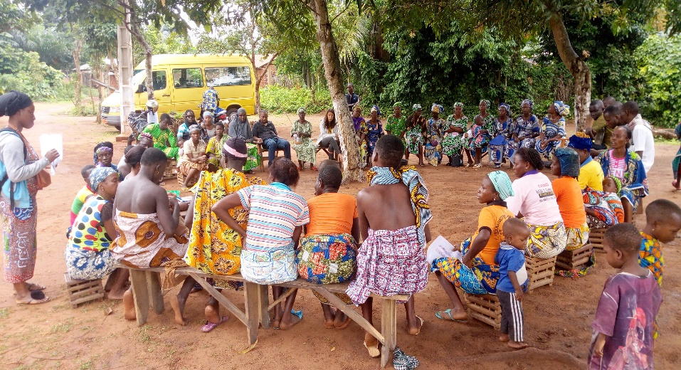
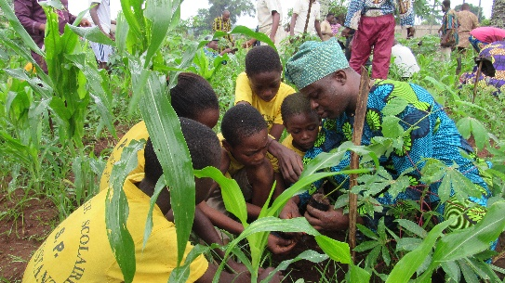
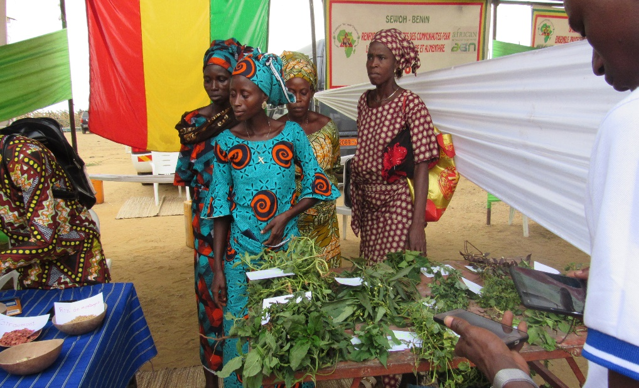
GRABE-BENIN ONG is a non-profit association born from the will of a group of citizens committed to the promotion of sustainable development with the objective of transmitting environmental awareness to populations and promoting well-being for all. It is committed to protecting the environment through the promotion of traditional knowledge and knowledge and has supported indigenous and local communities for the past twenty years in the protection of sacred natural sites. In addition, she has a long tradition of working with women keepers of traditional seed knowledge as well as farmers' organizations. To promote intergenerational dialogue, it is committed to creating a framework for exchange between young people and adults through environmental education through experience as well as the creation and animation of youth clubs. As part of her support for community actions for reforestation, the restoration of the critical ecosystem for mitigating the impact of climate change, she initiated and led several initiatives including:(01) the project for the preservation and sustainable management of natural resources and biodiversity: "I make my tree grow" having as direct beneficiaries 319 people including 87 women and 232 men and 9,179 people including 4,721 women and 4,458 men as indirect beneficiaries. It consisted in the establishment and training of 5 environmental classes, capacity building for sellers of traditional seeds, farmers and local sacred forest management committees on the importance of forests in safeguarding biodiversity and mitigating the effects of climate change and on traditional seed conservation techniques. 12,085 endogenous plants produced in this context were used for reforestation activities in forests, public arteries and the creation of green space.( 02) the "Tree of Life" project: whose objective is to strengthen agroecological practices and the well-being of the local community, thereby fighting poverty and reducing the effects of climate change. The results obtained for this project are: the development of a farm school through the installation of a demonstration site, the animation of training series on agroecology and climate change and the organization of visits community exchanges for sharing experiences between communities and stakeholder groups. All this has contributed to the promotion of agroecology, endogenous endangered plants with proven medicinal and food values, to the strengthening of environmental education, increase of the livelihoods of communities thanks to an agriculture centered on the environment and the establishment of similar forestry. The biodiversity of each of the intervention forests of these two projects was enhanced by planting seedlings, regular support for the organization of cultural ceremonies and the establishment of a garden of medicinal plants. Indigenous and local communities have been associated with a study on the development of endogenous knowledge and conservation of traditional seeds which led to the installation of seed banks, a study on national legal analysis and impact assessment laws, policies and institutional frameworks on indigenous peoples and on Indigenous and Community Heritage Areas and Territories (APACs). All this within the framework of the project for the sustainable development of sacred forests and the promotion of the APAC consortium in Benin under the financing of the Small Grants Program of the Global Environment Fund through the United Nations Development Program (UNDP).Today, this organization holds the lead in Benin in terms of support for traditional guardians of the Areas and Territories of Indigenous and Community Heritage (APAC) after the establishment of the national consortium APAC Benin for which it provides the permanent secretariat and represents the point Focal point of ICCA International consortium in Benin.

