Check against delivery
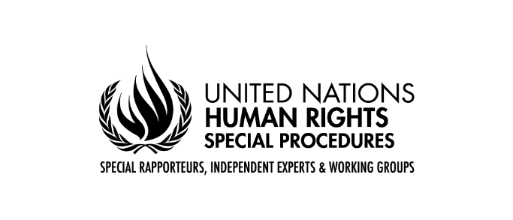

Oral Statement by Mr Surya Deva
Chairperson, Working Group on the issue of human rights and transnational corporations and other business enterprises
47th session of the Human Rights Council
Geneva, 7 July 2021

Madam Vice-President,
Excellencies,
Distinguished delegates,
I am honoured to present to the Human Rights Council the report of the Working Group on the issue of human rights and transnational corporations and other business enterprises on the ninth annual Forum on Business and Human Rights.
Organised under the guidance of the Working Group, the Forum is the world’s largest global gathering on business and human rights, bringing together participants from governments, UN bodies, businesses, institutional investors, human rights defenders, community groups and civil society organizations, national human rights institutions, trade unions, academia and the media.
In 2020, due to COVID-19 restrictions the Forum was held virtually from 16 to 18 November. Under the theme of “Preventing business-related human rights abuses: the key to a sustainable future for people and planet”, the Forum looked at what practical steps States and businesses should take to prevent and address human rights abuses in their activities and across value chains, in line with the UN Guiding Principles on Business and Human Rights. It considered how States, businesses and the investor community should respond to the COVID-19 pandemic in a manner that protects and respects human rights, and in turn can contribute to building back better. The Forum discussions also helped to inform the project of the Working Group to develop a vision and roadmap for action on business and human rights over the next decade: ‘Business and human rights: towards a decade of global implementation'.
I am pleased to report that over 4,000 participants registered from 140 countries and from a wide range of backgrounds and stakeholder groups. Participants took part in nearly 30 substantive sessions, including plenaries, thematic sessions and regional dialogues. A wide range of stakeholders shared their experiences on how to prevent and address human rights abuses, particularly during COVID-19 times, with a specific focus on the situation of individuals and groups at heightened risk of abuses such as migrant workers, children, women, indigenous peoples, human rights defenders, and workers in the informal economy.
Among the specific thematic issues, the Forum addressed the connection between the climate crisis and business and human rights, the key role of national human rights institutions and human rights defenders, and the alignment between the business and human rights agenda and the anti-corruption agenda. The Forum also provided a platform to explore ways to better prevent and address business-related human rights abuses in conflict-affected settings, the challenges and the way forward for companies in preventing and addressing xenophobia and racism, and efforts to improve access to effective and gender-responsive remedy for victims of business-related human rights abuses.
Not surprisingly, the Forum acknowledged the devastating human rights consequences caused by the pandemic that has amplified existing challenges posed by unprincipled business and State practices, in particular for people in precarious and marginalized positions. The Forum equally highlighted that the pandemic has shown that technology can play a vital role in managing public health, yet technological solutions also present challenges to human rights that need to be managed responsibly.
Discussions at the Forum also highlighted how the Guiding Principles are a key tool for preventing and remediating negative human rights impacts and for ensuring a sustainable recovery and building resilient societies.
Dear Ladies and Gentlemen,
As usual, the Forum provided a unique platform to exchange positive examples of legislation and policy developments that have proved effective in promoting responsible business conduct. Forum participants endorsed the implementation of a “smart mix” of voluntary and mandatory measures, in line with the Guiding Principles, and with the participation of rights-holders in developing these measures. The recent move by some countries and the European Union towards binding human rights due diligence laws, the negotiation of an international legally binding instrument on business and human rights, as well as the proliferation of initiatives to develop national action plans on business and human rights, are all positive initiatives addressed in different Forum sessions.
The ninth annual Forum had a strong focus on the responsibility and accountability of investors, development finance institutions and commercial banks. A dedicated session also focused on how international investment agreements could be aligned with international human rights obligations of States. The input received in this session informed a report currently being prepared by the Working Group to be presented to the General Assembly in October 2021.
The Forum also showcased ways in which national human rights institutions have been trying to facilitate access to remedy for business-related human rights abuses, as well as their role during the COVID-19 pandemic. The role of States and businesses in protecting human rights defenders, who continue to face threats, harassment and intimidation, was the focus of another session at the Forum. Discussions during these two sessions informed reports on national human rights institutions and human rights defenders that have been presented by the Working Group to this session of the Council.
Several sessions touched on the role of effective corporate accountability in preventing business-related human rights abuses, especially in cases with transnational dimensions. The Forum sessions underlined that, as more than 90 per cent of the targets of the Sustainable Development Goals are linked to international human rights standards, it is critical that businesses embed respect for human rights in their strategies and activities in order to create an inclusive and sustainable world.
Dear Delegates,
The Guiding Principles are a guidepost in times of crisis. Multiple crises, including the COVID-19 crisis, the climate crisis and the challenge of continued racism and inequality across the world, have shown the fragility of systems that do not put people and the planet at the centre. If the world is to be truly “future fit”, it needs to keep the focus on human rights going forward.
In conclusion, I note that the 10th annual Forum on Business and Human Rights will take place from 29 November to 1 December 2021. Due to ongoing COVID restrictions it will once again be held virtually. In light of the 10th anniversary of the Guiding Principles in 2021, the thematic focus of the Forum will be on an ambitious roadmap to promote their implementation over the next decade.
Thank you for your attention.

