 

Good practices in support systems

Supporting people with disabilities to take part in the community with everyone else

**Easy**

**Read**

# About this report



We are called the **Office of the United Nations High Commissioner for Human Rights.** Or **OHCHR** for short.



We are part of the **United Nations (UN)**.

The **United Nations** is a group of countries that work to make the world better and safer.

This report is about the good practices of support systems that people with disabilities might need so they can take part in their communities.

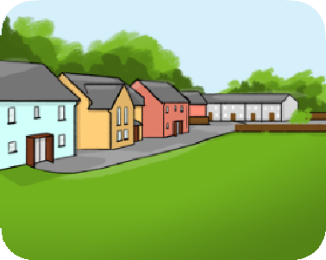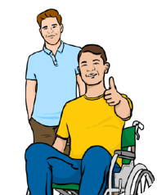

To write this report, we:

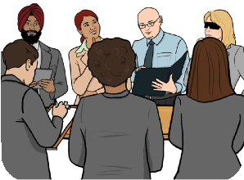

* Spoke to countries and organizations around the world.

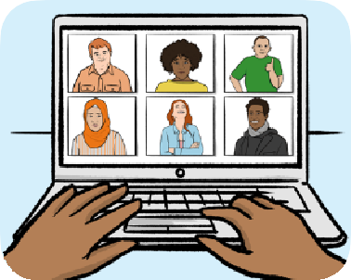

* Talked to people with disabilities online.

## 2

© European Easy-to-Read Logo: Inclusion Europe. More information at [www.inclusion-europe.eu/easy-to-read](http://www.inclusion-europe.eu/easy-to-read)

# Including people with disabilities

It is important that people with disabilities can get support and have control of their support.

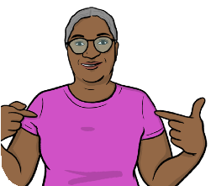

**Support** is extra help that people with disabilities might need to do things like:

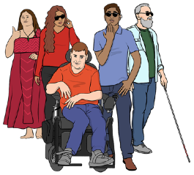

* Live in their own home.
* Make their own choices.
* Go to school, work or other places.
* Understand and share information.
* Have friends, relationships and children.

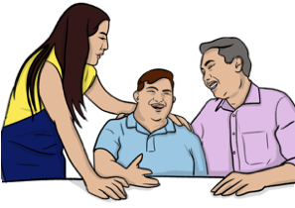

Many people get support from their family.

Support can make sure people with disabilities get their human rights and live independently.

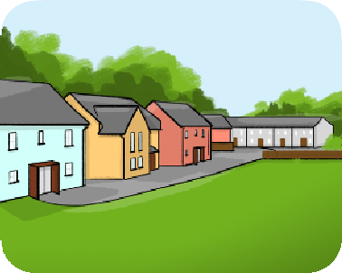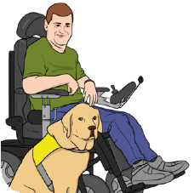

**Support systems** are the services and supports that countries provide to give people with disabilities the support that they need.

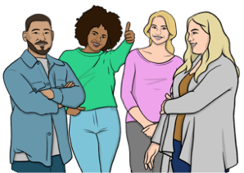

Support systems should think about all people, like children, women, men, older people, young people and people with disabilities.

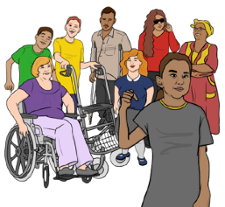

This report talks about good practices in support systems. This means the things that support systems are doing well.

Countries must change so that they:

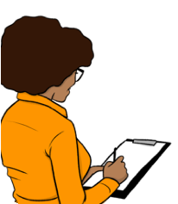

* Have good rules and listen to organizations of people with disabilities.

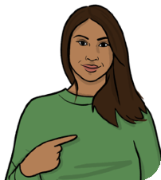

* Have ways of checking what support people with disabilities need.

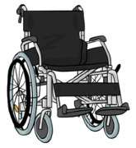

* Give people with disabilities the money to pay for the supports that they need.

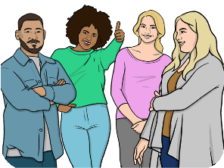

* Have workers with the right skills to support people.



* Have enough money to pay for different supports.

In 2023, parts of the UN talked about how to improve support for people with disabilities around the world.

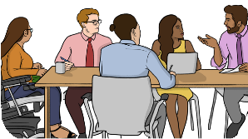

Organizations of people with disabilities talked about what support they need.

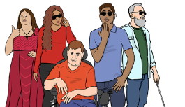

**We need…**

Some people said that, if countries only think about the people who give ‘care’, they might ignore the rights of people with disabilities.



**Care**

# Different supports that are working well



There is not a lot of information on supports that work well.



Many people with disabilities have extra costs they have to pay because of their disability.

Some countries give people with disabilities money to help with these extra costs. This is a good practice.

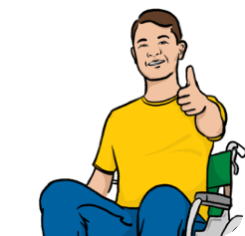

These are usually richer countries.

Some countries only give money to people with disabilities who cannot work. This is not a good practice.



**I cannot work**

Some countries give people money to help with extra costs, and do not need a doctor to say that they cannot work. This is a good practice.

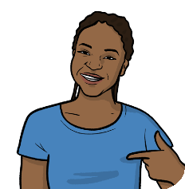

Many people with disabilities need things like wheelchairs, hearing aids and other equipment.



But not everyone can get these things.



Women often have less chance to get this equipment than men.

Organizations, including the WHO and UNICEF, are working to help more people get this equipment.



**More**

In some countries, people with disabilities can pay less for some services, like transport and health care.

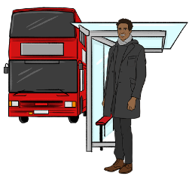

This helps them to use services.

But people should be able to get money to buy the extra things they need for their disability as well as help to use services.



**Caregivers** are people who give care and support. They sometimes have trouble with money and staying happy and healthy.

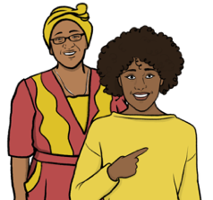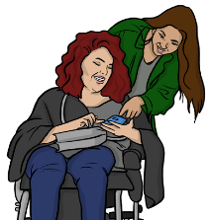

Many caregivers are family members, especially women and girls, who do a lot of work without being paid.

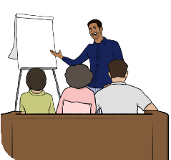

Some countries give money, advice and training to caregivers. This is good practice.

Local community groups, led by organizations of people with disabilities, can:

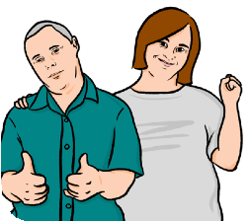

* Give information and advice to people with disabilities.

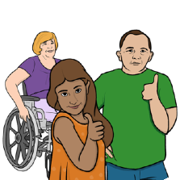

* Help people with disabilities to be included in their local community.

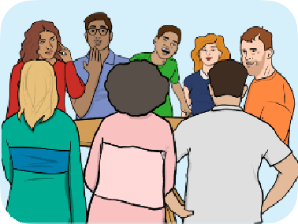

In many countries, people with disabilities take part in different groups to get the support and other services that they need.

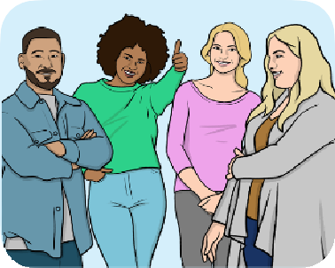**Support workers** are people whose job is to support people with disabilities.

Most of these workers are women, and some are people who have moved from a different country.

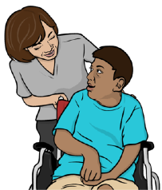

Support workers often have to work very hard, and do not get paid much money.

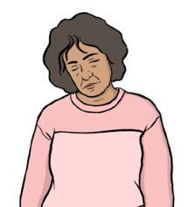

Some countries give people with disabilities money so they can choose and pay for their own support workers. This is good practice.

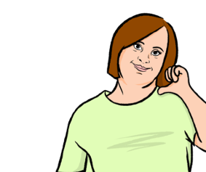

Some people with disabilities need support from sign language interpreters. They should get the chance to have this support in person.



Many countries make it cheaper for people with disabilities to use buses, trains and taxis.

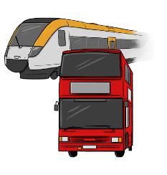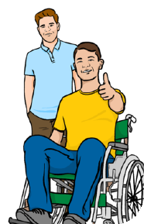

Some countries also make it cheaper for caregivers to get around.

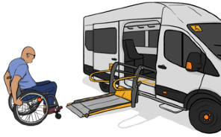

Some places have special bus or taxi services that help people with disabilities to and from their houses. These are good practices.

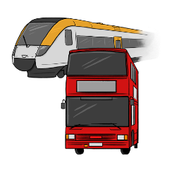

But all buses, trains and taxis should also be easy for people with disabilities to use.

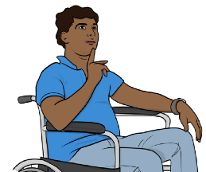

To take part in their community, people with disabilities must be able to choose what they do and where they live.

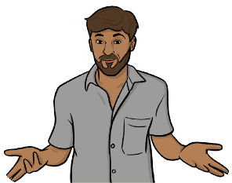

But many people with disabilities find it hard to get a good place to live.



Some countries help people with disabilities get good places to live. This is a good practice.

**Digital technology** is the internet, phones, computers, and other devices.



Digital technology can help people with disabilities to live independently.

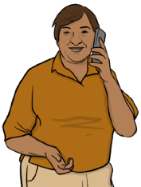

Some countries are making websites to show the support that people with disabilities and their families can get. This is a good practice.

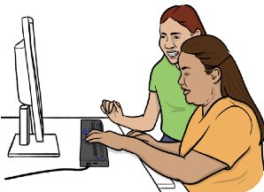

Companies also make new digital technology that helps people with disabilities, like computers that can understand what people say to them.



But these companies must follow rules and protect people’s rights.

# What else is important

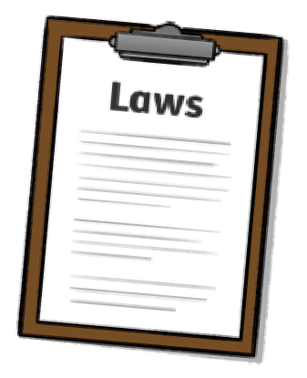

To have good care and support, countries need good laws and rules.

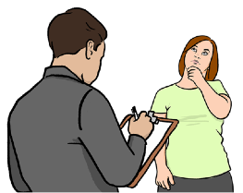

Some countries are finding out more about people with disabilities, and what they need.

It is important to make sure that countries can pay for good support systems.



Countries should work together to provide good care and support services.

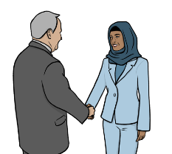

People need to learn more about disability. This will help countries to change for the better.



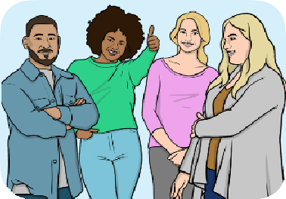Support workers must have the right skills and training to support people.

**What we think should happen**

Countries should:

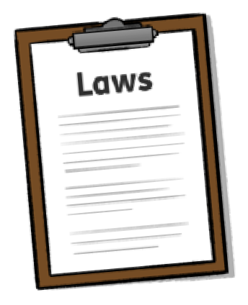

* Write rules and laws to make sure different organizations work together.
* Involve groups of people with disabilities when they write rules and laws.

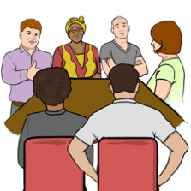

* 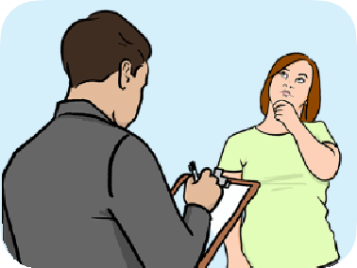Collect information to understand what supports people need.
* Spend money on care and support that protect people’s rights and treat them



fairly.



* Give people with disabilities money to pay for the extra things and equipment

they need to live well.

Countries should:



* Make sure that people with disabilities can get equipment like wheelchairs,

glasses or hearing aids.

* Give families and caregivers money, advice and training to make it easier for



them to support family members with disabilities.

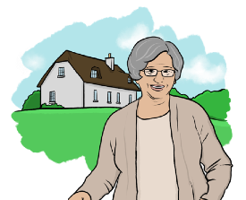

* Spend more on support services, especially for people with disabilities

who live a long way from cities.



* Give money to people with disabilities so that they can choose and control their

own care and support.

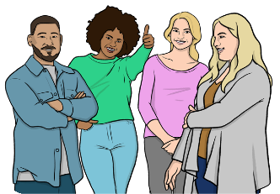

* Make it better to work as a paid support worker.

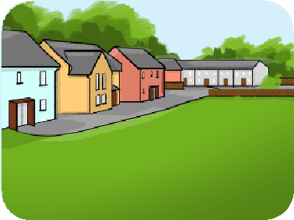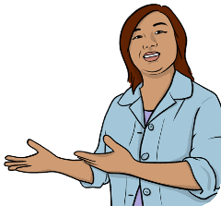

* Help communities that support people with disabilities to live well.

Countries should:

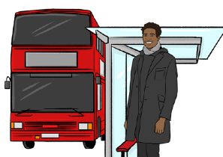

* Make sure that people with disabilities can easily get around their local area.

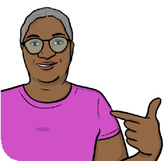

* Support people with disabilities to get their own places to live, that are easy for

them to live in and support them to take part in their communities.



* Use digital technology to help people with disabilities get the support they

need.



* Make sure that supports help people with disabilities to live independently.



* Collect information that people around the world can read, about the best ways

to support people with disabilities.

**Find out more**



You can look at our website here: [www.ohchr.org/en/disabilities/reports](http://www.ohchr.org/en/disabilities/reports)

## 16

This Easy Read booklet was produced by easy-read-online.co.uk

The booklet includes images licensed from Photosymbols & Shutterstock.