United Nations logo **United Nations Human Rights Council**

**Easy to read**

**How climate change is making it hard for many people to get the food they need**

Climate change is about the earth getting warmer and the problems that it is causing for people and the planet we live on.

# A picture containing logo Description automatically generatedAbout us

We are from the United Nations (UN).

The United Nations is a group of countries that work to make the world better and safer.

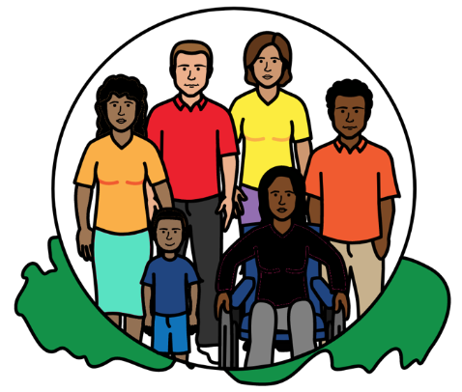

Our job is to make sure that

everyone in the world is treated fairly and gets their human rights.



Everyone has human rights.

For example, everyone has the right to food, water and a healthy world to live in.

That is what should happen in everyone’s lives.

# About this report

This report is about:

* Climate change and how it is causing big problems with food.
* Climate change problems because of the way food is grown and made.

* Some good work that countries and organizations are doing to solve this.
* What countries should do next.

Lots of countries and organizations gave us their ideas for this report.

**About climate change**

Climate change is about changes to the earth we live on.

The earth is getting warmer.

That is causing big problems for people, animals and plants.

For example, climate change is causing more big weather problems like floods, too much heat, bad storms and big fires.

**Food problems because of climate change**

Climate change is making it hard for many people to get the food they need.

And this might get worse in the future.

Many people are finding it harder to grow food because of big weather problems.

Like floods, big storms and not enough water.

For example, floods and too much heat can damage land and food that people grow.

That means there might be less food that people need. Like rice, wheat and corn.



Climate change can also make it harder to catch fish.

For example, climate change might change the sea and make it less safe for fish to live in.

More food has to be thrown away because of climate change.

For example, too much heat can damage food so it cannot be used.

That means climate change is leaving many people without enough food to eat.

It is also making many people poorer.

For example, many people cannot earn the money they need by growing food or catching fish anymore.

Climate change and food problems are often worse for some people in poorer parts of the world.

That includes:

* People who live in the countryside.
* People who grow food on the land. Or catch fish in the sea.

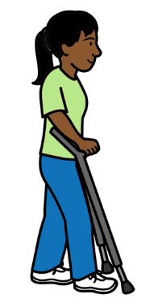

* People who have lived on their land for a very long time.
* People who do not have much money.
* Women, children and older people.
* **Icon

  Description automatically generated**People with disabilities.

Life might already be hard for many of these people.

For example, they might already find it hard to get enough food and money to live on.

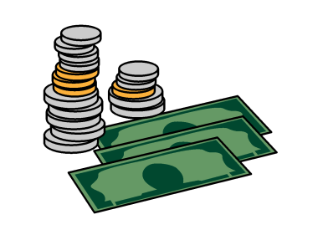Many poorer countries do not have enough money to deal with climate change problems.

But that is unfair because richer countries are causing most climate change problems.

**Climate change problems because of food**

The way that we grow and make food is also causing climate change.

For example, many trees are cut down so the land can be used for making meat or other food.

But that can be bad because trees help to stop climate change.

People often damage plants and animals that can help to stop climate change when they grow food.

A lot of food is sold in other countries. But moving the food can use a lot of gas, oil and coal that is bad for the planet.

**Some good work that countries are doing**

Mauritius is giving money to people to help them grow food on their land.

Mexico is helping to find better ways to grow and make food.

For example, by supporting people to grow food in a better way for climate change.



The Philippines is supporting people who catch fish to deal with climate change problems.

Many countries are making plans about

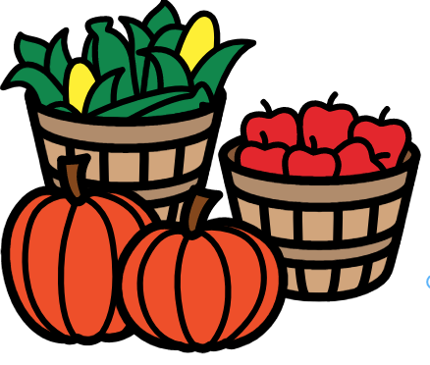how to make sure that people have enough to eat.

And how to change how food is made.

That includes Colombia and Argentina.

**What should happen next**

The things below are for countries and organizations to start work on straight away.

Everyone has a right to food.

Countries should make sure that everyone has enough food to eat now and in the future.

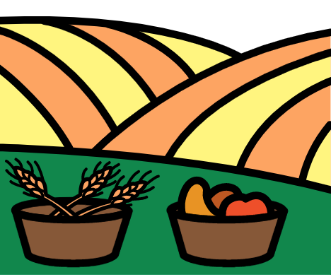

The food should be good enough, safe and healthy.

Countries have promised to make that happen.



Countries should make sure that everyone can get the food they need.

For example, by making sure they have enough money to buy food.

Countries should always work with people to make plans about climate change and food.

That includes women and people who grow things on their land or catch fish.

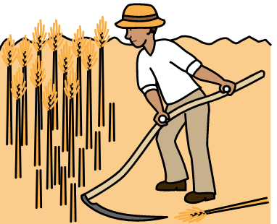

That is to make sure the plans work well for people and their human rights.

For example, it is important that people can use or own their land.

Countries must do more to stop climate change straight away.

For example, by using less coal, gas, oil and other things that damage the planet.

But that is not enough.

Companies must change the way they grow and make food as well.

That is because it is often causing climate change.

Countries should work with people who get and grow food to change how food is made.

Many people know how to grow food in a better way for people, plants and animals.

And they have good ideas about how to stop climate change.

Countries and people can work together on the following things:



Finding better ways to grow food and get fish from the sea.

Finding ways to get and grow food even when there are climate change problems.

Helping people to eat more local food that is grown in a better way for the earth we live on.

Like local plants and vegetables.

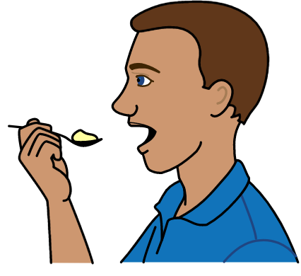Making sure that more food can be used and eaten.

At the moment a lot of food is thrown away.

Making it easier for people who grow food or catch fish to sell their food.

They should have the same chances as big food companies to sell their food.

Countries should stop big food companies from causing climate change or human rights problems.

For example, companies should get and grow food in a way that is good for the planet and keeps forests safe.

Countries should find better ways to use land if the way they are using it causes climate change problems.

For example, countries should use less land for producing meat.

Countries should make sure that people can have their say about climate change in a safe way.

Some people are hurt or killed when they try to have their say.



Richer countries should give more money and support to poorer countries to help them deal with climate change problems.

And to help countries find better ways to grow and make food.

The money should be used to support people who have the most climate change and food problems.



All these things will help to stop climate change.

And they will help to make sure that everyone has enough good food to eat.

**Pictures by The Picture Communication Symbols ©1981–2016 by Mayer-Johnson LLC a Tobii Dynavox company. All Rights Reserved Worldwide. Thousands of resources available for free at** [**www.boardmakeronline.com**](http://www.boardmakeronline.com/)