Input to the Special Rapporteur on human rights and the environment: “Human Rights, Transformative Actions and the UN Sustainable Development Goals”
15 May 2022
Australia’s development program, under Partnerships for Recovery, is aligned with the 2030 Agenda for Sustainable Development. The 27 country and regional COVID-19 Development Response Plans that sit beneath Partnerships for Recovery have performance indicators that track outcomes against the Sustainable Development Goals. Australia’s spending against the Sustainable Development Goals is reported annually through Australia’s Official Development Assistance: Statistical Summary. Figures for 2020-21 are provided in Table 1 below.
Sustainable Development Goal | Total 2020-21 $’000
1.No poverty | 684,363
2.Zero hunger | 234,725
3 Good health and well-being | 989,157
4. Quality Education | 541,427
5. Gender equality | 79,529
6. Clean water and sanitation | 139,046
7. Affordable and clean energy | 76,802
8. Decent work and economic growth | 245,863
9. Industry, innovation and infrastructure | 92,159
10. Reduce inequalities | 141,590
11. Sustainable cities and communities | 173,905
12. Responsible consumption and production | 83,669
13. Climate action | n.a.
14. Life below water | 22,917
15. Life on land | 7,541
16. Peace, justice and strong institutions | 415,429
17. Partnerships for the goals | 107,953
Examples of Australia’s efforts to accelerate progress towards fulfilling the eight SDGs with direct environmental linkages (SDGs 2, 6, 7, 11, 12, 13, 14, 15) and gender equality (SDG 5) are included in Table 2 below.
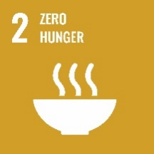 | Australia has supported 57 countries with policy, technical advice and support to build food security capacity.  The community-based fisheries management project in Kiribati, Solomon Islands and Vanuatu increased incomes and supported communities to sustainably manage their fisheries. In Vanuatu, controlled fish harvests have improved food security and enhanced women’s ability to feed their families and ensure the welfare of children.  Australia’s Atoll Food Futures initiative is helping to improve resilience and food security of vulnerable households in Tuvalu, Kiribati, Fiji and Samoa and face challenges in local food production due to rising sea levels, poor soil quality, increasing salinity, access to seeds and planting materials and a lack of land.
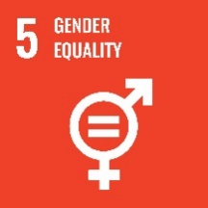 | Australia provided almost $1.5 billion for gender equality activities in 2020-21. Our Pacific Women program reached almost 250,000 women and girls in 2020-21, providing crisis services, training, upskilling, and financial literacy support.  Australia also supports gender-responsive and socially inclusive climate action. Our recent (March 2022) submission on Australia’s implementation of activities contained in the UNFCCC Gender Action Plan provides further details.
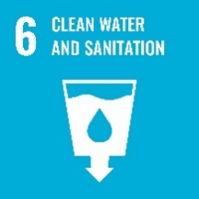 | The Indonesia Water and Sanitation Hibah ($120m, 2009-22) has connected over 800,000 poor households to water and strengthened water utility capability.  In Laos PDR, Australia funds Beyond the Finish Line through the Water for Women program, which is building local government capacity to integrate climate resilience into water, sanitation and hygiene programs for an estimated 229,000 people in Lao PDR.
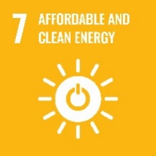 | Through the Australian Infrastructure Financing Facility for the Pacific, Australia is supporting Solar Pacific Pristine Power Inc. to build a solar facility and battery storage system in Palau.  In Papua New Guinea, Australia is contributing approximately AUD96 million in bilateral electrification support, including renewable energy transition assistance. This includes the $25 million Pawarim Komuniti project, an off-grid electrification grant program aimed at supporting access to clean energy services in rural and remote communities.
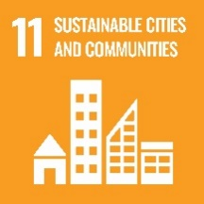 | Australia is working in Cambodia through Investing in Infrastructure (‘3i’) ($51.7 million, 2015-2022) to help companies connect households and businesses to utilities and other services, and to support opportunities for trade-related businesses and industries.  The $60 million (2015-23) Australian Water Partnership is coordinating private sector actors at the basin level to tackle water scarcity and climate change impacts and build resilience in highly populated West Java, Indonesia.
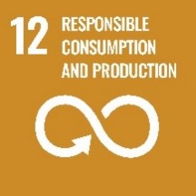 | The Australia-Indonesia Plastics Innovation Hub is a partnership between CSIRO and the Indonesian Ministry of Research and Technology to identify how innovation and technology can help achieve systemic change, and radically transform plastic pollution and waste management in Indonesia.
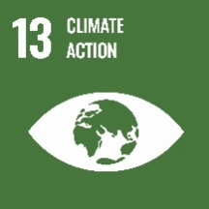 | Australia is providing $2 billion in climate finance over 2020-25, including at least $700 million for the Pacific focussing on climate adaptation and resilience, disaster preparedness and renewable energy projects. Our support is helping build better, climate resilient roads in PNG and making affordable solar energy available to households; building inclusive cyclone resistant markets in Fiji; and improving food and water security in Southeast Asia in the face of climate change.  Australia is also leading the establishment of the Indo-Pacific Carbon Offsets Scheme, providing $104 million over 10 years to support our neighbourhood to access established carbon markets.  Australia co-sponsored the annual resolution on Human Rights and Climate Change at HRC44 (2020), HRC 41(2019) and HRC38 (2018), along with the Resolution on the Special Rapporteur on Climate Change and Human Rights at HRC 48 (2021).
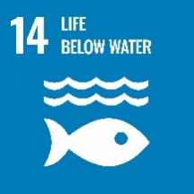 | Australia is providing $16 million to support Secretariat of the Pacific Regional Environmental Program (SPREP) to implement the Pacific Regional Action Plan – Marine Litter 2018 – 2025, which sets the policy context and key actions to minimise marine litter across the Pacific.  Australia is working with Conservation International and Fiji to preserve blue carbon ecosystems (mangroves, sea grasses, salt marshes) for local coastal communities, with benefits for biodiversity, food security, sustainable tourism, fisheries and coastal erosion. By demonstrating these ecosystems’ ability to sequester carbon, Australia aims to develop models for blue carbon projects across Fiji’s 65,000 ha of mangrove forests.
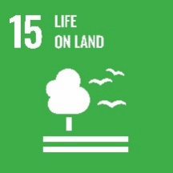 | Australia’s $9.5 million Climate Resilient by Nature program will deliver a portfolio of community-led ecosystem restoration and conservation programs in the Indo-Pacific region – boosting biodiversity, sequestering carbon, and making communities more resilient to climate change and disasters.  To support the uptake of sustainable forestry practices, the Australian Climate Finance Partnership (ACFP) is seeking to provide US$10 million to invest in high sustainability plantation forestry in Indonesia, Laos, Cambodia, Vietnam, and Malaysia. ACFP funding will support outcomes in terms of climate change, biodiversity, livelihoods, community engagement and development.  In Botswana, Australia has helped local communities avoid destructive bushfires and earn carbon credits by promoting traditional Australian indigenous fire management techniques combined with satellite technology.

Sustainable Development Goals (SDGs) can cut across multiple goals and are not mutually exclusive. Data presented in this table reflects the aid investments’ primary goal intent and is not reflective of Australia’s total ODA contribution to sustainable development.
Includes scholarships
Data presented for SDG5 reflects only those aid investments with a primary goal of Support for Women’s Equality Organisations and Institutions (DAC purpose code 15170) or Ending Violence Against Women and Girls (DAC purpose code 15180) and is not reflective of Australia’s total ODA contribution to gender equality which cuts across all SDGs.
Not reported as there is no dedicated DAC sector code for climate change. Instead, the OECD DAC uses Rio Markers to promote mainstreaming of climate considerations in all sectors. In line with this, climate change is integrated across the breadth of Australia’s development assistance. A more comprehensive picture of Australia’s climate change assistance is presented in Table 11 based on Rio Marker reporting methods.

