About GoFor

Youth Organizations Forum (GoFor) was established by 29 youth organizations that came together to become Turkey's National Youth Council. GoFor, which gained its legal status in 2015 and is an umbrella organization, currently has 66 member organizations. GoFor defines youth as between the ages of 18-30, and the board and member organization representatives consist of young people in this age range. Member organizations can be structures such as associations, foundations, and cooperatives with legal personality, as well as initiatives, platforms and societies that do not have legal personality. GoFor has two main purposes. The first of these is to contribute to the preparation of inclusive youth policies at local and national level with the participation of youth groups with a wide variety in Turkey, and the second is to contribute to the strengthening of the capacities of member organizations. For this purpose, GoFor conducts advocacy activities at local, national and international level, training and workshops to strengthen the capacity of member organizations, reporting to make youth rights visible, and supporting activities for member organizations to produce institutional policies.

GoFor is an observer member of the European Youth Forum (EYF) and recognized as National Youth Council of Turkey by EYF the most important youth network in Europe. At the same time, was a member of the EuroMed Mediterranean Youth Network and is a member of the BlackSea Economic Cooperation - Civil Society and Politics Unit.

Overview

In the COVID-19 pandemic that emerged in February 2020, the first case in Turkey was seen on March 10, 2020. In order to reduce the spread of the virus, which spreads rapidly and the effects of which are not fully understood, some measures have been taken in Turkey in parallel with the measures taken around the world. Some of these measures are the curfew over the age of 65, the curfew under the age of 20, weekend curfews throughout the country or in densely populated provinces, the transition to distance education at all education levels, the virus diagnosis of the Credit and Hostels Institution (KYK) student dormitories and those from abroad. It is used as a quarantine area for those entering, banning curfews without masks, remote working and rotating work in public and private institutions.

Young people between the ages of 15-29 make up nearly 25% of Turkey's population. Some of these young people are in formal education, some in higher education institutions, some are in employment, some are neither in education, training nor employment. The measures taken during the pandemic process have also caused many rights violations, since they see the youth as a homogeneous structure-student- and not inclusive. One of the groups most affected by the measures that have not been taken with a rights-based approach has been the youth in Turkey as well as in the rest of the world. Young working people have been exposed to violations such as being dismissed for unjust reasons, salary cuts, not being able to find a job, not being able to receive their salaries. Young people under the age of 20 who have to work are deprived of their right to work within the scope of the curfew. Young people who have been laid off, cannot find a job or have difficulty in meeting their living expenses, have had problems in accessing food, access to basic cleaning materials, and protective materials such as masks and disinfectants. Since the young people in education could not meet the conditions required by distance education, they were deprived of their education rights, they were offered to freeze their education, and the attempts to ensure equality in education were far from effective. Young people who became parents had difficulties in taking care of their children due to the necessity of working, and the burden of childcare was mostly left to women. The housing rights of the students were violated by the closure of the dormitories, and the young people found themselves on the streets overnight. Young people staying in private dormitories are compelled to pay for services they do not use. Young people with chronic health problems, young people with disabilities and young people in need of psychological support could not benefit from health services. Young people had difficulties in meeting their socialization needs and started to experience psychological problems.

It is obvious that the measures taken during the pandemic, which is an extraordinary situation, cannot meet some of the needs of the youth. The epidemic, which has a global impact, has affected every mass in one way or another, and young people with many cuts have been affected at a high level. It is thought that it is important to support the taking of measures sensitive to the needs of the youth during the ongoing pandemic process by reporting the areas where young people are affected and their rights violations.

GoFor conducted two research studies focusing on both individual right violations young people faced during the pandemic and organizational challenges youth organizations faced.
1- Covid 19 Rights Violations Map

Due to the fact that the rights violations suffered by the youth before the pandemic process were not visible, the Covid-19 Youth Rights Violation Map was opened by targeting the violations during the pandemic process.

The Covid-19 Youth Violation Map (https://covid.go-for.org/) designed by GoFor has three main purposes:

- Making visible the rights violations suffered by young people during the pandemic process
- Generating data for advocacy work on rights violations suffered by young people
- Creating data-based resources for youth rights and local governments

At this stage, the Youth Rights Violation Map is only used to evaluate the violations that occurred as a result of the measures taken during the Covid-19 process. However, it is aimed to transform the map into a structure that monitors youth rights violations indefinitely.

Method:
The information was obtained through a mapping system designed online. In order to carry out data-based advocacy activities, it was decided to collect data in a participatory manner and to automatically visualize the data based on geographical coordinates and the map of Turkey. The reason for this is that GoFor member organizations are planning to take ownership of the rights violations in their own region, and to advocate for the relevant local authority through a statement with meaningful data. In the developed mapping system, it is also aimed to inform "Youth Rights' '. When you enter the system, the problems that have been processed before appear before the person first. The title of the problem, its detailed description, the date and location information on the basis of the neighborhood are required to be filled as mandatory fields. Information such as name, surname, mobile phone and e-mail address of the people experiencing the problem is marked as a field that they can fill in, if they wish, based on consent. (Optionally, name, address, and gender information are also included on the map.) It was considered to develop a verification system indicating that the problem was experienced, but later it was decided that it would be healthier for rights to be based on a statement. The map link shared with social networks was used by young people who wanted to report the violation of their rights. In the future, it is planned to establish a more comprehensive violation of rights monitoring system with this infrastructure.

Results:

Between 18 May 2020 - 17 September 2020, 158 violations were entered on the map. 17 violations determined not to have occurred due to the Covid-19 process were excluded from these violations, and a total of 141 violations due to the Covid-19 process were included in the report. In the current 141 violation information, it has been determined that there are 50 information in which more than one right violation is shared in a single entry. For this reason, this information was included in the analysis as separate rights violations by keeping gender, province, district and region information constant. The number of rights violations analyzed in this way was 191.
Validation method is not used in the map.

Although the analyzed 191 rights violations are not sufficient to draw definite conclusions, they are very important in terms of providing representative information about the problems faced by young people.

Gender
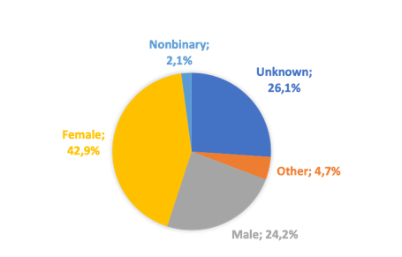Of the young people who shared information on the Covid-19 Youth Rights Violation Map, 82 stated themselves as female, 46 as male, 4 as non-binary (non-binary gender), and 9 as other. 50 users preferred not to specify their gender.
Region

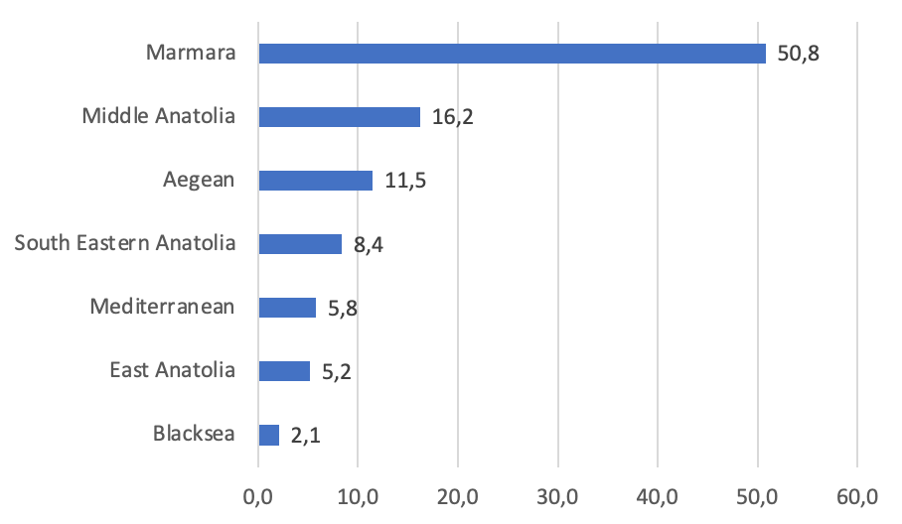When we look at the regions where violations of rights occur, although information about violations is shared from 7 regions, the region where most violation information is entered is the Marmara Region with 97 violations (50%). The Marmara Region is followed by the Central Anatolia Region with 31 violations, the Aegean Region with 22 violations, the Southeastern Anatolia Region with 16 violations, the Eastern Anatolia Region with 11 violations, the Mediterranean Region with 10 violations and the Black Sea Region with 4 violations.

Right Violations

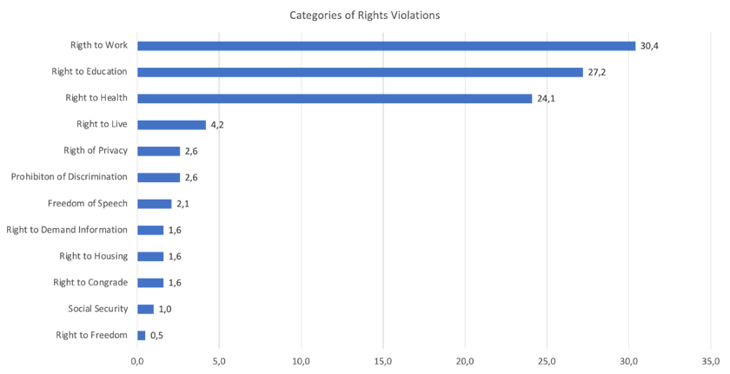
Looking at the categories of violations entered on the map, the first rank is the right to work with 58 violations. The right to work is followed by the right to education with 52 violations and the right to health with 46 violations. One of the striking findings of the study is that 8 information about the violation of the right to life was coded. 5 violations related to the right to privacy and the right to property were shared. 4 information about the violation of the prohibition of discrimination, 3 information about the violation of the freedom of expression, the violation of the right to access information and the violation of the right to shelter, 2 information about the violation of the freedom of assembly and 1 information about the violation of the right to freedom and security were entered. Assuming that this data obtained as such is representative information, it is seen that the rights violations suffered by young people take place in quite different areas.

2- Situation of The Youth Organizations During Pandemic

The research was conducted with the support of Friedrich Ebert Stiftung - Turkey between 2019-2021. The full report is available in Turkish and can be found in here (https://drive.google.com/file/d/1DLmroHBWRMZXwKa5uIr9AD0no5XIheP4/view).
Data were entered into the online survey from 99 different organizations. Since 9 of these organizations are university societies, they were not included in the analysis. The data of 33 organizations that entered the survey were not included in the analysis because they did not complete the survey. The analyzes were carried out on the data of 57 youth organizations that answered the questionnaire fully. The 57 organizations that filled out the questionnaire completely on the website where the organizations were mapped were included in the form of having their self-approved information visible.

Results

It is seen that 57 youth organizations that fully answered the questionnaire are in 6 different forms of organization. 44 of the organizations have association status. While there are three organizations in the status of youth council, initiative and foundation, there are two organizations that operate as platforms and social enterprises.
Looking at the regions where the organizations are registered, it is seen that the density is in the Marmara Region at 28%. The Marmara Region is followed by the Central Anatolia Region with 21%. 17% of the organizations are registered in the Southeastern Anatolia Region, 12% in the Mediterranean Region and Aegean Region, and approximately 9% in the Eastern Anatolia Region. There is no organization registered in the Black Sea Region.

Pandemic Related Results

Nearly 62% of youth organizations continued their activities during the Covid-19 process, while 38% stated that they did not operate during the pandemic process.

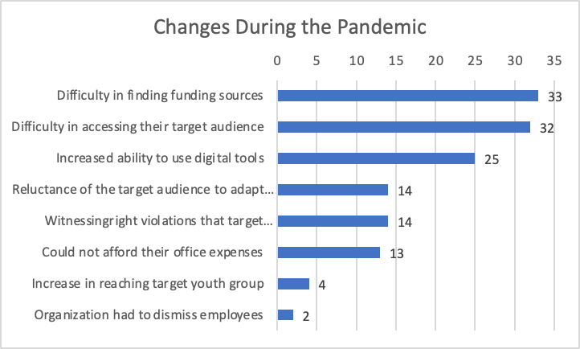

33 of the 57 organizations participating in the survey had difficulty in finding funding sources during the pandemic process. While 32 of the organizations had difficulty in accessing their target audience, 4 organizations stated that their access to young people increased in this process.
It is known that the use of digital tools has increased in civil society studies during the pandemic process. In the research, 25 organizations stated that their dominance in the use of digital tools has increased, while there are 14 organizations that stated that they observed the reluctance of the target audience to adapt to digital transformation.

14 organizations stated that the people they work with witnessed violations of rights, 13 organizations could not afford their office expenses, and 2 organizations stated that they faced dismissal. Among the youth organizations participating in the survey, there was no organization stating that it was not affected by the pandemic process.

3- Advocacy Actions

With the inputs from youth organizations, GoFor organized a movement called #expandthespace (#alanıgenişlet) by inviting national authorities and fund givers to online meeting series where they met with youth organizations. In those meetings stakeholders were informed about the importance of youth inclusion in priority support areas. Also, representatives of youth organizations had a chance to ask their questions and transfer their expectations.

