2022

Children of Prisoners Europe Response to OHCHR Call for Input
Study on the Impact of the COVID-19 pandemic on human rights of young people – Human Rights Council Resolution 48/12

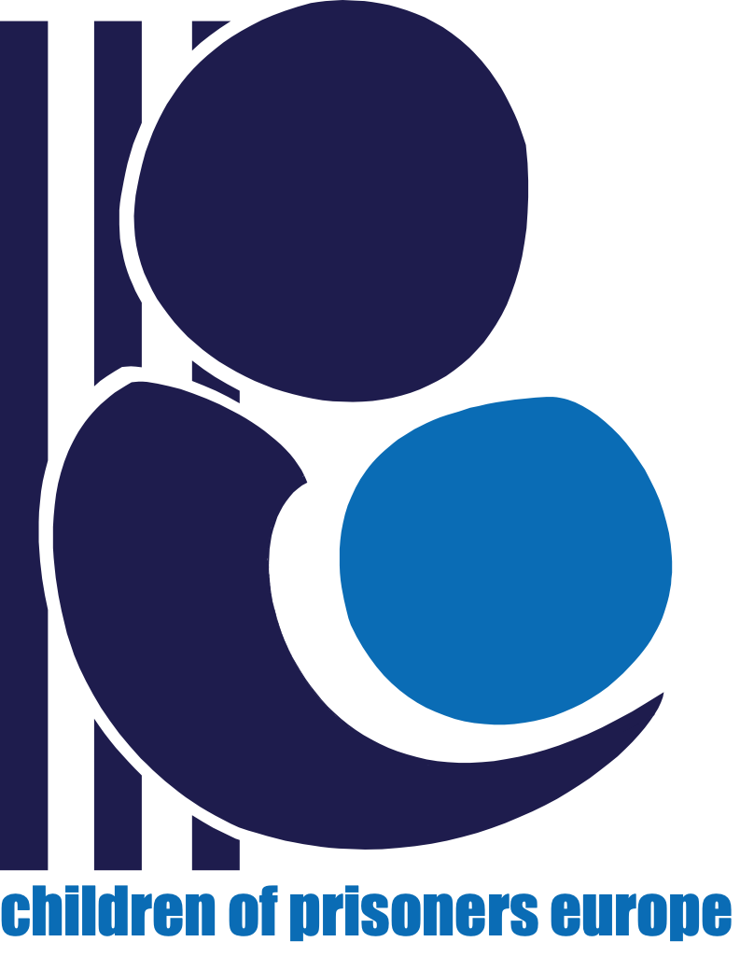
The COVID-19 pandemic has had dramatic effects on everyday life. Measures and restrictions to limit the spread of the virus have had a significant impact on children with a parent in prison. With the suspension of in-person visits in prisons and despite measures to facilitate the continuity of the child-parent relationship (notably video-visits), some children did not have face-to-face contact or hug their parent for close to a year. Even when most public restrictions were lifted in summers 2020 and 2021, and people were able to gather in restaurants and go to the cinema, many children were still unable to visit their parent. As prisons have reinstated visits, there are still restrictions to the number of visitors and the presence of glass or plexiglass barriers has eliminated the possibility for children to hug their parent. Children and their parents in prison are left feeling forgotten and as if no one cares about them. As the re-opening of prisons and in-person visits becomes more frequent, there needs to be a guarantee that the rights and needs of children with a parent in prison will be met and adequately considered in this process.

Children of Prisoners Europe’s 2021 “Not my crime, still my sentence” campaign aimed to provide a platform for children and young people to share the difficulties they've been facing since the beginning of the pandemic and voice their opinions on how to move towards positive changes.

Children were asked the following questions:

- How are you feeling?
- What is the effect of COVID on your life?
- What do you need?
- What was something that worked well or that was ‘good’ about the COVID pandemic that you would like to continue?
- What is something that didn’t work well or that you did not like about the COVID pandemic?
- What information do you need?
- What would you like to see when visits reopen?

Below is a selection of some of the responses received:

Norway

- When prisons reopen people must be able to see those they know in prison. – Girl, 11 years old
- There was nothing good about COVID. We could not get in touch with Dad. – Girl, 11 years old
- COVID meant that I was not allowed to visit my father who lived in another country, I was only allowed to talk to him on the phone and send letters. – Boy, 15 years old
- I did not get the opportunity to visit my father at all, nor was there a solution in relation to meeting on Skype. - Boy, 15 years old
- The prison itself has done nothing to make me feel happy during COVID. My father, on the other hand, often asks how I’m doing. He has sent several letters and spontaneously called to hear if things are going well. - Boy, 15 years old
- When prison visits reopen I think the possibility of Skype should be possible for those who have a family member who lives far away. - Boy, 15 years old

- It makes me happy when my imprisoned family member calls me. Because that is better than nothing, and I just want to hear his voice. – Boy, 15 years old
- When prisons reopen I want to give my brother a big warm hug. – Boy, 15 years old
- I miss my brother who is in prison. I feel that there is always something missing and that Mum is not so well when he does not call often. – Girl, 18 years old
- It makes me happy that my brother stays active and tries to work in prison and get opportunities and not just sit in a cell. It makes me very happy that he is not alone there and that he has someone he can talk to. - Girl, 18 years old
- When prisons reopen I want us to be able to bring our own food so that my brother can have some home-cooked meals that give him joy. I hope that we can play games there, and that more people can come to visit so that the whole family is gathered. - Girl, 18 years old
- I’m fine, I feel that this year has been a bit difficult but we try to do our best based on the situation we are in. - Girl, 18 years old
- COVID has meant that I cannot hang out with the people I want to. – Girl, 11 years old
- With COVID it has been demanding in terms of school. You often sit at home and have to work at home, and do not get help with everything you need. But we are managing well. – Girl, 18 years old
- I wonder if we can go to other countries soon, will it soon be green (Dad is doing time in another country). – Girl, 11 years old

- I have had the opportunity to get to know the family better during the lockdown. Despite the fact I was not allowed to meet my friends, I actually got to know them better as well. – Boy, 15 years old

Poland

- How I feel? In fact, it's a very easy question, and on the other hand, a complicated question. On the one hand, sometimes I feel great, and on the other hand, I feel sad when I remember the whole situation related to my dad's arrest, which unfortunately happened in front of my eyes. Adding to it is the question: "What impact has Covid had on your life?" I can admit that it contributed to the separation of my parents by not visiting and forbidding telephone contact. – Daria, 13 years old

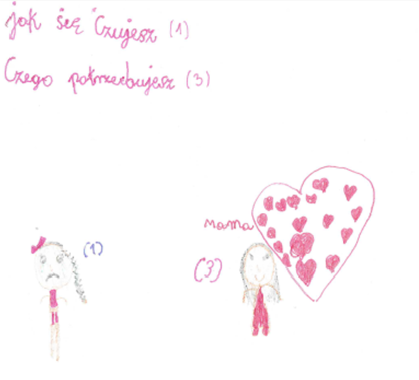

- Jak się czujesz? – How do you feel?
- Czego potrzebujesz? – What do you need?
- Esmeralda, 9 years old

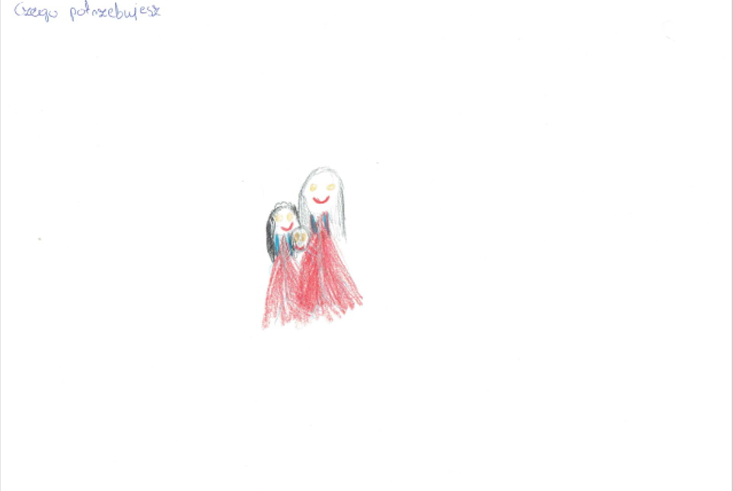

Czego potrzebujesz? – What do you need?
- Darek, 11 years old

Romania

- The pandemic affected me very badly. – Mihai, 11 years old

- The fact that we are not going to the school anymore, and we have online classes is affecting our social life, because I would want to meet with my colleagues from school. – Erica, 12 years old

- The effect of COVID in my life is a negative one, because for one year I have been “isolated” from many people and things like my father, school, parties, going out with some friends. – Maria, 17 years old

- My lifestyle has changed, before I used to be more relaxed, but now I try to protect myself. – Denisa, 13 years old

- With COVID I stayed in the house for a long time and I missed my colleagues. – Mihai, 11 years old

- This pandemic has also brought good things, I learned to appreciate small things that I would not normally be aware of, for example going out in the city and spending more time with my friends. But then, I hated not being able to visit my father in prison. – Maria – 17 years old

- The online courses from school didn’t work well during COVID. – Mihai, 11 years old, Romania & Erica, 12 years old

- The prison did nothing during the pandemic. My father teaches me well, it helps me morally when I talk to him. – Mihai, 11 years old

- The prison allowed us one visit with our father, that made me feel happy. – Erica, 12 years old

- A little thing that made me happy, was to find out that if I can’t visit my father in prison, there is a possibility to see each other online. – Maria, 17 years old

- I can talk to my dad on the phone. When I feel alone and he calls me, I feel like he is next to me at home and taking care of me. – Denisa, 13 years old

- I would like to learn a lot of things, but right now, I would like to know more information about how to stay away from getting COVID and how to get rid of it for good. – Erica, 12 years old

- When visits reopen, I would like to be able to visit my father in prison. – Mihai, 11 years old

- I would like to visit many places, but I would start by going on a trip to the mountainside. Also I would like to visit a museum when the quarantine will be over. – Erica, 12 years old

- When things return to normal, I want to visit more sights that I would normally have done. – Maria, 17 years old

Sweden

- I have always wanted to visit him, always all the time, even during corona, we could have had a screen between us and only hug once. – Boy, 8 years old

- You must have a glass screen between, so you can’t hug, and that does not feel good. – Girl, 13 years old

