UN Women’s SCE inputs for OHCHR report
- The most important challenges and barriers that girls have been facing in the context of the COVID-19 pandemic.
This submission is with regards to adolescent girls and women who are in non-formal and literacy education, for those who have not received a formal education or have dropped out of school. Our submission is informed by mostly anecdotal data collected via UN Women’s Second Chance Education program, currently in implementation in Cameroon, Chile, India, Jordan, Mexico, and Australia.
The global challenge of marginalized women being excluded from education and employment is persistent with almost half a billion women still being illiterate in the world today, a trend that has not changed in 20 years. The current global labor force participation rate for women is 49 percent, compared to 75 percent for men. Investing in women’s education makes economic sense, evidence showing that a 1 percent increase in female education raises the average GDP by 0.3 percent%. Still, global funding mechanisms for the education sector do not prioritize support to young and adult women who have already missed out on education.
Aiming at developing a global model with local solutions to fill this gap, the BHP Foundation and UN Women partnered in 2018 to develop and pilot the Second Chance Education and Vocational Learning (SCE) program for young and adult women who have missed out on education. The SCE program designs solutions for how women can obtain equal access to quality learning opportunities that open the door to continued education, employment and entrepreneurship opportunities. It builds women’s own agency to make better life choices, embark on a path to fulfil their potential, and to actively participate in public life. The SCE program has been piloted in three different contexts to create a broad evidence base for prototyping. The country typology includes a) Low and middle-income countries with high poverty pockets, indigenous groups, exclusion and marginalization; b) Fragile and crisis countries with mass displacement/refugees; c) Developed context with Indigenous, marginalized group.
The COVID-19 pandemic has been the main dominating challenge for the implementation of the SCE program across countries in the last year as it has continued to restrict the face-to-face SCE activities with beneficiaries. However, implementation is advancing with the expected target number of women enrolled in the program already reached, but with beneficiaries’ progression through online learning to employment and income generating activities taking more time. Based on anecdotal evidence, the critical challenges faced by participants in the SCE program have been social and digital.
Social challenges:
- Women have reported increased stress, anxiety, sadness, or anger that women experience as attributed to social isolation
- Women have been facing increased workloads at home, being responsible for their children’s remote learning which is difficult to facilitate particularly for mothers with limited written, numeric and digital literacy, as well as a lack of adequate space for such activities in the home
- Increased GBV has been reported (often referred to as the shadow pandemic)
- Lost livelihoods resulting in lack of access to basic items including food.
Digital challenges:
- Limited access to computers, smart devices and internet connection
Wherever possible, the program has invested in digital access for beneficiaries, but this is not always possible to facilitate in lockdown conditions and is resource intensive. It requires broader commitments by government and private sector to ensure affordable access by those without access.
- Low digital literacy
- Owners of phones have limited understanding of the phone’s capabilities
- Decreased involvement in SCE training programs due to online delivery, despite efforts to increase access to phones/computers/internet and digital skills
- Online implementation requires much more than digitizing content, SCE partners have had to use new methodologies that connect/unite the women
- Pre-pandemic, there was a lack of online content relatable to SCE beneficiaries, which resulted in active creation of content featuring people from relevant communities, correct length (e.g., micro-learning) and materials to foster engagement suitable for the pandemic context
- It has remained difficult to scaffold learning with interactions and peer-based relationships when online.
Below specific examples of challenges faced at the country level
India
In India, 320 million children had been affected by school closures caused by the coronavirus disease (COVID-19). Online classes did not factor in the country’s digital divide where only 16% females had Internet access compared to 36% males according to the National Sample Survey 2017-18. This gap had far-reaching consequences as availability of mobile phones, computers and uninterrupted internet services was key to introduce online education services for children during COVID-19 lockdown. Unfortunately, providing online educational services to the children from rural India still seemed to be a distant dream, given the fact that many parts of urban India continued to remain inadequately prepared. Data on households that lacked computer and internet services clearly indicated that a majority of the states remained vulnerable to meet the challenges of providing online education to children. Except for a few states like Kerala, Punjab, Haryana, Delhi, Himachal Pradesh and Uttarakhand, all other states recorded high and medium level of vulnerability in terms of these two indicators (Refer Map No 27, Annexure13).
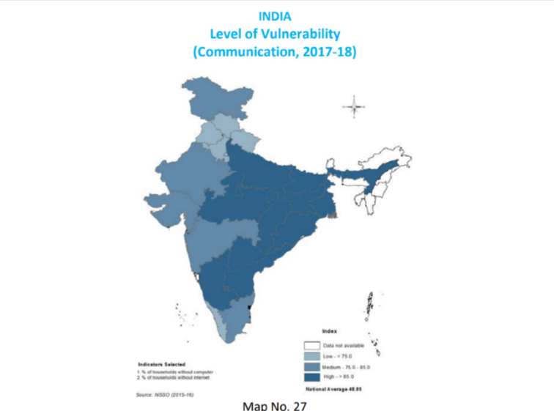
Due to COVID-19, enrollment in the India SCE program has been severely affected. Household incomes have reduced drastically and earning opportunities have become further limited. Under these circumstances, convincing families to pay for a girl’s education has become even more challenging. Many interested candidates are not able to enroll because of a dearth of funds and difficulties around ensuring required documents for registration. Ensuring the fees for women candidates interested in completing school education is difficult in context of the financial crunch in rural India.
Mexico
The SCE program is implemented across three states in Mexico: The State of Mexico, Puebla and Jalisco. In the State of Mexico, the main COVID-19 effects for women participating in the program included the reduction or suppression of income, psychological damage related to confinement, poor access to health services, an increase in domestic violence and the challenges with government coordination. In Jalisco, the main effects were mostly economic in nature due to the loss of employment, low income from self-employment, and the uncertainty regarding the duration of social isolation. Additionally, a need for emotional support for women was identified. In these cases, stress, anxiety, sadness, or anger that women experience is attributed to social isolation and increased workloads at home. In Puebla, the main challenges for SCE implementation revolved around how to operate only virtually and a lack of women’s time to take the virtual training, given the workloads and other priorities. Finally, one of the main risks was that women could not go to the Learning Centers after the lockdowns/quarantine periods because of the need to find an urgent source of income.
Chile
Despite a downward trend before the pandemic, school dropout in Chile is reflected in 186,723 children and adolescents between 5 and 21 years of age being excluded from the education system according to the Ministry Education. The suspension of face-to-face classes in 2020 due to COVID19 has increased the risk of dropping out, particularly for students with lower socioeconomic status, especially women on whom most of the housework and care work fall. To further explore this topic, UN Women conducted a recent study that highlights the urgency to develop measures to address the educational reintegration of out-of-school students through second-chance education programs with an emphasis on strengthened support for situations of teenage pregnancy and/or motherhood.
In addition to the above-mentioned challenges faced by SCE participants in other countries, the percentage of women participating in the technology industry has also been affected by the COVID-19 pandemic. In Chile, UN Women conducted a study to investigate the gender gap in this sector reviewing experiences from a sample of 140 companies. The study found that even in the companies where women have the greatest presence, most are in entry-level positions. In this context, 64% of the companies surveyed had less than 40% women on their payrolls and 57% of companies said that that they had between 0% and 5% women in management positions in technology. The factors that further this situation include the lack of gender-equality policies in recruitment and selection, and the diminution of job experience.
The percentage of women in this specific sector, which could potentially offer significant employment opportunities for SCE participants, has fallen after the onset of the pandemic. The reasons for this include the difficulty of reconciling work with the duties of home life. In Chile, women devote eight hours to caring for their children, against only four hours by men. The study also found that even though recruitment has been affected for both men and women, organizations do not have women-specific recovery plans despite having general employment recovery plans, further showcasing the importance of using a gender perspective to analyse COVID-19 challenges and the plans for recovery.
Australia
The Australian Digital Inclusion Index (ADII) measures digital inclusion across three dimensions of Access, Affordability and Digital Ability. The Index report from 2021 shows that although COVID-19 has driven digital transformation in the country, it has not driven digital inclusion with the digital divide being exacerbated. Where 80% of highly included Australians increased their time spent online, only 42% of highly excluded Australians did the same. Of the highly excluded Australians, only 8% of those upgraded their internet access and only 14% improved their digital skills to help with work, study, or home life. Indigenous Australians living in urban and regional areas have relatively low digital inclusion, with those in remote locations being highly constrained. Sociodemographic groups with ADII scores 10.0 or more points below the national average (63.0) are Australia’s most digitally excluded. In 2020, these groups include: mobile-only users (43.7), people in low-income households (43.8), people aged 65+ (49.7), and people who did not complete secondary school (51.0).

- Concrete measures taken to respond challenges and barriers faced by girls indicated above, at each level of education and in relation to the four elements of the right to education, as a part of the short-term responses to, and mid- and longer-term recovery efforts from the COVID-19 pandemic.
India
The surge of COVID-19 infection rates that overwhelmed the Indian health care system proved the relevance of the SCE program as a contribution in the pandemic response. SCE India partnered with Learnet Skills Limited, one of the largest skill training providers in India to upskill and certify 10,000 nurses and nurse assistants across 20 states. The training built the capacity of these nurses on pandemic management leading to effective and timely patient handling, while ensuring their own safety at work. The entire program was delivered through a self-paced digital module leading to accessibility, standardization, and scalability of the project. In the COVID-19 context where female labor force participation is seeing a steep decline, this SCE intervention did not only help the nurses to have the necessary capacity required, but also ensured their job continuity.
SCE program identified the National Institute of Open Schooling (NIOS) as the platform to reintegrate women and girls into formal education system. NIOS is an autonomous agency under the Government of India and the largest open schooling network in the world. Through a partnership with NIOS, UN Women India reintegrated 2,540 women into formal education system ensuring financial support to pay the fees required.
The SCE program in each district is implemented by district education, skill and entrepreneurship anchor, mentors and learners. The mentors are in-charge of spearheading the entire process at the district level, carry-out the scholastic support to learners based on materials and skill, and entrepreneurship mentors mobilize women and support them in identifying the right skill trade.
These mentors are mostly women who have completed SCE trainings and/or they are now employed and earning incomes and continue to be associated with the SCE program to generate awareness and mobilize other women and girls. Through these mentors, peer groups have been established. These peer groups are informal in nature and during COVID times a lot of them have been formed as WhatsApp groups. These groups are used to share information on education, employment and entrepreneurship activities.
Mexico
In the State of Mexico, the primary responses by the state government were related to food support for vulnerable populations, credits for micro, small and medium-sized businesses, incentives for tourism, reactivation of public infrastructure and support for agricultural production. However, at the local level, the government responses in the municipalities where SCE operates (Huixquilucan and Lerma) support was provided through food pantries and legal assistance for cases of violence against worm and girls through the State Council for Women. Local civil society organisations, among other actions, supported the dissemination of information and training materials in digital format and the psychological support provided remotely. UN Women reinforced this work by preparing materials with relevant information on response to women’s challenges intensified during isolation mandated by COVID-19 response, sharing information on public institutions that provide psychological and legal care, liaising with state authorities to ensure women's access to legal assistance, facilitate the exchange of materials and digital content produced by public institutions and social organizations. Regarding the learning contents of SCE, complementary contents to the existing courses were developed and disseminated via WhatsApp. SCE included new themes related to health emergencies and problems arising from confinement among the courses. These contents were available at the online learning platform titled "health risk by COVID-19" and included five thematic blocks: information and reliable sources, domestic work and mental burden, self-care and emotional regulation, violence against women, and violence against children and adolescents.
In Puebla, SCE program brought online workshops offered by the Ministry of Urban Development and Sustainability to the SCE participants. SEPICJ, the implementing partner, evaluated the content of these workshops for replication through the SCE online platform. Additionally, the implementing partner collaborated with the Municipal Institute for Women and the House of Justice for Women to directly attend to the program participants who face domestic violence situations. Finally, SCE Puebla managed food support (pantries), alternatives sources for training and management of resources for food security through the Ministry of Urban Development and Sustainability. With the support of UN Women, 40 modules of Integral Greenhouses were developed with the Ministry of Welfare and Substantive Equality of Puebla.
Data disaggregated by sex/gender, age, disability, and if possible, also by other grounds, including income, race/ethnicity, geographic location and migratory status has been collected. 47% of SCE Program participants did not finish their compulsory education (less than 12 years of school years) and many of them suffer income poverty (50.6%) or extreme income poverty (37%). They face several gender barriers, such as care work (71%); lack of access to health services (52.6%); and lack of land ownership (89%). Most of participants are between 31 and 50 years old; 53.5% are unemployed, of employed participants (46.5%) before starting the Program, 26% are in low paying jobs (below the income poverty line in rural contexts); and 66.8% with lack of access to health services.
According to a recent study made by Colegio de Mexico (COLMEX), COVID-19 pandemic had a severe impact on the progress of the SCE program. It forced UN Women to rethink the implementation strategy and to set up virtual modalities in a country where connectivity constitutes a considerable obstacle and reproduces existing social inequalities, due to the associated costs and its operation in regions where connectivity is non-existent, unstable, or very weak. The study recommends favoring the self-employment and entrepreneurship learning pathway over formal employment. The participants, considering that in the formal market their possibilities of insertion were essentially reduced to precarious jobs, also reported being subjected to discrimination based on age, class and physical appearance. It also recommends continuing promoting the return to formal education and to continue fostering women’s economic empowerment and their autonomy.
Chile
Due to lockdown and restrictions on movement and the use of public spaces mandated by COVID-19 response, the SCE program (known locally as Tu Oportunidad) adjusted its implementation from face-to-face to online, to contribute to women’s economic empowerment during the economic and social crisis resulting from the pandemic. In this context, a limited pilot intervention was conducted in the first half of 2020 to gather information, learn lessons and discern best practices specifically on methodologies for online training for women.
The SCE Chile model follows a three-stage methodology that lasts approximately two months. First, women participate in a three-week life skills training including awareness of rights, digital skills, and self-assertiveness. After they finish the initial life skills course, the women chose either the entrepreneurship or the employment pathway for another three-week course. For this course, the women are grouped as advanced or beginners, depending on their previous experience and level of education. After this phase, the women proceed to the third stage of a two-week counseling course, depending on their preference, for improving their pitch for business plan/idea and being connected with funding opportunities - for those in the entrepreneurship pathway; or for a successful personal presentation and linkages with employment opportunities, for those in the employment pathway. The women are supported through the whole three stage learning process by tutors and mentors.
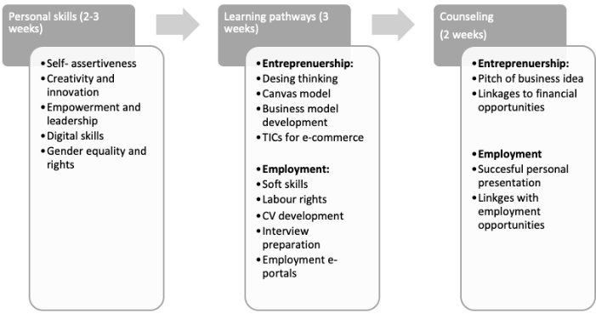
Based on the COVID-19 adaptations made, some of the main lessons learned by SCE program in Chile include online support as a key facet of the program. It is important that participants feel supported and guided during their self-learning process on the platform and that their questions are answered in a timely manner. It is recommended to conduct personalized monitoring of user participation in the program’s activities and provide constant encouragement by tutors so that participants remain interested throughout their online experience. Tutor support is vital to the success of the program and to prevent participant drop-out. Channels of communication are a key element of distance education programs. In this instance, telephone calls, emails and instant-messaging application groups were used. Videoconferences, or live activities, are essential to program implementation, since they are an opportunity for collaborative learning that generates face-to-face interaction between participants in a closer atmosphere. To some extent, these activities replace physical face-to-face sessions. They help to create an environment of trust among participants in which they share their experiences, and participants rate them highly. Even so, there is a clear need to ensure that participants are familiarized with the platform used, so that there is no uncertainty on their part, and it is possible to reduce to the furthest possible extent any technical problems that arise.
Australia
As with other SCE program countries, Australia saw its program delivery shift to focus on access to and utilization of online learning during lockdowns. In working with Indigenous women in Western Sydney and refugee and migrant women in Victoria, significant effort was given to improving access to devices and internet, building digital literacy, producing e-learning content applicable to SCE beneficiaries and scaffolding online learning with technical mentorship, and social support focused on well-being. For this, women were supported to learn how to use common communication tools for messaging, networking and videoconferencing such as WhatsApp, Facebook private groups, Zoom and Google Hangout. In addition, e-learning was implemented through specialized LMS facilitated by UN Women such as Learning Equality’s Kolibri, EdApp in partnership with UNITAR’s Educate for All and the SCE’s own e-portal, mylearningpathway.org. In addition, one implementing partner was supported to develop its own App for mobile only use, using graphical content representative of migrant and refugees in Australia, with slow spoken English and limited text to enable easier access for women learning English as a new language. UN Women also partnered with Open University to build the capacity of implementing partners to create their own micro-learning, localized content for the SCE program. Australian partners also formed partnerships with other vocational trainers to leverage their e-learning content whenever possible, but overall found a lack of appropriate content for women who have missed out on an education.

In 2015, women’s illiteracy remained stubbornly high at 477 million across the globe, falling just 1 per cent since 2000. By 2019, this number had reached 484,991,881 illiterate women in the world. UNESCO Institute for Statistics, http://data.uis.unesco.org
UNESCO, https://unesdoc.unesco.org/ark:/48223/pf0000244959
ILO, https://www.ilo.org/infostories/en-GB/Stories/Employment/barriers-women#global-gap
GPE, https://www.globalpartnership.org/blog/why-educating-girls-makes-economic-sense
UN Women, https://www.mylearningpathway.org/en
UN Women, https://data.unwomen.org/features/ipsos-survey-confirms-covid-19-intensifying-womens-workload-home
UN Women, https://www.unwomen.org/en/news/in-focus/in-focus-gender-equality-in-covid-19-response/violence-against-women-during-covid-19
UN Women, https://www.unwomen.org/en/digital-library/publications/2020/09/gender-equality-in-the-wake-of-covid-19
Globally, 4.1 billion people are now online. But in most countries, women still lag behind men. Less than half (48 per cent) of the world’s female population are using the Internet, compared to 58 per cent of men. This translates to a global Internet user gap of 10 per cent. Between 2013 and 2019, the gender gap widened in Northern Africa and Western Asia, Central and Southern Asia, and sub-Saharan Africa. This is due to the rapid growth in male users, especially in developing countries. Overall, gender equality in Internet use is found in just over one quarter of the world’s countries. UN Women, https://www.unwomen.org/en/digital-library/publications/2020/09/progress-on-the-sustainable-development-goals-the-gender-snapshot-2020
According to ITU, insufficient skills are often mentioned as an impediment to effective ICT use. ITU, https://www.itu.int/en/ITU-D/Statistics/Documents/facts/FactsFigures2020.pdf UNESCO, https://unesdoc.unesco.org/ark:/48223/pf0000373718/PDF/373718eng.pdf.multi
MINEDUC, 2020 in UN Women, https://lac.unwomen.org/en/digiteca/publicaciones/2021/10/desercion-escolar-y-educacion-de-segunda-oportunidad
UN Women, https://lac.unwomen.org/en/digiteca/publicaciones/2021/10/radiografia-de-las-mujeres-en-el-sector-tecnologico-en-chile
CADEM https://cadem.cl/chile-que-viene/
https://www.digitalinclusionindex.org.au/case-study-has-covid-19-been-a-driver-of-digital-inclusion-in-australia-reflecting-on-early-findings/
SEPICJ stands for Servicio de Promoción Integral Comunitario Juvenil and is one of the main implementing partners of the SCE program in Mexico.
COLMEX ”Oportunidades, necesidades, mujeres jóvenes y educación: Evaluación de la implementación del Programa Segunda Oportunidad en México” – upcoming publication

