1 April 2022

Ms. Claudia Mahler
UN Independent Expert on the enjoyment
of all human rights by older persons

Via email: ohchr-olderpersons@un.org

Dear Ms. Mahler:

On behalf of the Southern Poverty Law Center, one the largest civil and human rights organizations in the US, I write in response to your recent call for input on the human rights situation of older persons deprived of their liberty.

SPLC was founded in 1971. Since that time, it has been SPLC’s mission to stand up for the rights of the powerless and exploited. Our work includes representation of incarcerated people across the Southeastern US, a growing proportion of whom are older and thus at greater risk of suffering harms due to the inhumane conditions in US prisons.

1. Key human rights risks and violations.

Years of incarceration, in harsh conditions and with inadequate nutrition and health care, cumulatively work to shorten life expectancy. As people age and begin to suffer more chronic health conditions, lack of adequate care in US prisons takes a heavy toll. Research shows that incarceration increases the pace of physiological aging, causing people to suffer more chronic conditions at an earlier age.

Medical care in prisons across SPLC’s five-state region is very inadequate. Last year, a federal court in Lewis v. Cain, in which SPLC represented plaintiffs, held that inadequate medical care at the Louisiana state prison in Angola was endangering the lives and health of the more than 6000 people living there. An attorney in the case said conditions at Angola were “especially harmful to [people] with disabilities or mobility issues,” who were systematically denied even basic services. SPLC clients at prisons in other states experience similarly terrible conditions. In Braggs, v. Dunn, an Alabama case, an SPLC client in his early 70s had one leg amputated due to poorly managed diabetes, and nearly lost the other leg to the same cause. He has since passed away after more than four decades in prison. In Mississippi, SPLC’s clients endured an atmosphere of neglect so severe that people sometimes set fire to their own cells in an effort to get medical attention.

The World Health Organization says at least 15% of persons aged 60 and over have a mental health disorder. In US prisons, the proportion is substantially higher. This is in large part due to the failure of state governments to replace closed psychiatric institutions with the necessary community based resources to provide mental health care. As a result, people who would formerly have been warehoused in inadequate mental health institutions are instead now warehoused in prisons with even more inadequate care. The Prison Policy Initiative found that 37% of people in US prisons have a diagnosed mental health disorder – and many more are undiagnosed. The figure is as high as 50% according to the American Psychological Association. Unfortunately, states with the least access to mental health care also have the highest rates of incarceration, including Alabama, Mississippi, Georgia and Florida, where SPLC represents incarcerated people. According to the National Alliance on Mental Illness, 63% of incarcerated people with a history of mental illness do not receive treatment while incarcerated. In Alabama, the federal court in a long-running SPLC case found mental health care provided to the prison population “horrendously inadequate.” Five years later, the same court has only recently entered a sweeping order requiring the state to remedy its numerous violations. Alabama is appealing the order, and its implementation is years away – if at all. The lack of adequate mental health care in prisons falls more heavily on older persons, who are more likely to suffer from dementia and other psychosocial disabilities.

Despite studies showing that older people are far less likely to reoffend following release from prison, the states in which SPLC works are devoting far more resources to increasing prison capacity – even using federal COVID relief money to build new prisons – than to reducing the population by releasing older people on parole. Especially in Southern states, parole programs have virtually ground to a halt. The Prison Policy Initiative gave all but one of SPLC’s states a failing grade for giving incarcerated people a fair chance to earn release. According to Redemption Earned, an organization that advocates for parole for older persons in Alabama, of the 2704 parole hearings conducted in 2020, only 544 people were granted parole. None of the people seeking to be released on parole were allowed to attend their own hearing. Between October 2019 and September 2020, Florida granted parole to just 1% of those eligible. SPLC’s series, “Freedom Denied,” shares stories of people denied parole, like that of 76-year old Melvin Mason.

Some states have so-called “compassionate release” laws that are supposed to apply to older people who have a very serious or terminal illness, but processes for obtaining release can be vague, confusing, or unduly restrictive. In Georgia and Mississippi, for example, it is available only to people who are so sick as to be incapacitated. Unfortunately, “compassionate release” is sometimes just a mechanism for authorities to put dying people with expensive care needs out on the street to avoid paying the bills.

Older people who are released from prison also face many challenges with little assistance. Most will not have received much, or any, preparation for life outside prison, and will find few options to obtain medical and mental health care for longstanding, under-treated chronic conditions. They often have no remaining family to house or care for them. In many states, laws bar people with felony convictions from public housing, leading them to become homeless.

2. Figures and data.

Across the US, prison populations are aging. An April 2020 report by the Prison Policy Initiative estimated that an average of 10% of people incarcerated in state prisons were aged 55 or over. This estimate was based on figures gathered from 2013 to 2015 and has continued to grow. Indeed, the number of older people in US prisons increased by 280% from 1999 to 2016. As of 2016, the 55+ population of US prisons exceeded the 18-24 age group for the first time.

The following are more recently available statistics regarding the older prison population in states where SPLC works (each state reports different categories of information):

Alabama | 51-60 4273 | 60+ 2306
Florida | 50+ 22675
Georgia | 50-59 6567 | 60+ 3716
Mississippi | 50+ 633
Louisiana | 50-59 4078 | 60+ 2707

The over-incarceration of older persons is largely due to ill-conceived laws that result in unreasonably long sentences. SPLC detailed the crisis of long-term incarceration in the Southern US in its February 2021 report, Long Road to Nowhere. Mandatory minimum sentencing schemes require very lengthy prison sentences for a wide variety of crimes, including many non-violent drug offenses. “Habitual offender” laws can result in life sentences even for relatively minor, nonviolent crimes. For example, Willie Carter was just 29 years old when he was sentenced by an Alabama court to life without parole for stealing $100 in cash and $4 worth of food stamps. He served nearly 40 years before winning his release.

Across the country, one in seven incarcerated persons – more than 203,000 – is serving a life sentence. According to a recent report by The Sentencing Project, 30% of them – more than 61,000 – are aged 55 or older. There is also a significant racial dimension: although people of African descent typically make up less than a quarter of any given state’s population, they often represent the majority of those serving life sentences. Although a number of jurisdictions have taken actions to change the laws that caused this in recent years, those changes have often not been retroactively applied to people who were sent to prison earlier.

3. The COVID-19 pandemic.

The heightened risk of the COVID-19 pandemic for older persons has not prompted states in SPLC’s region to give the necessary consideration to releasing them to protect their health. In April 2020, SPLC identified more than 1100 people in Alabama prisons who were aged 65 or older, placing them at greater risk of serious illness or death. Many of them had never been convicted of a violent offense or had already served more than 30 years in prison. The first incarcerated person in Alabama to die of COVID-19, just weeks later, was 66 years old and had been in prison since 1976. The second was a 74 year old man who had suffered from chronic health problems for many years. Despite many additional deaths and serious illnesses, Alabama continued to refuse to even process the parole applications of those who were eligible. Prisons in other states and the federal system – where hundreds of people died – have also largely failed to release older people despite the low risk.

I hope this submission is useful in preparing your report. Please do not hesitate to contact me if you have any questions or if there is any further information we can provide.

With best regards,
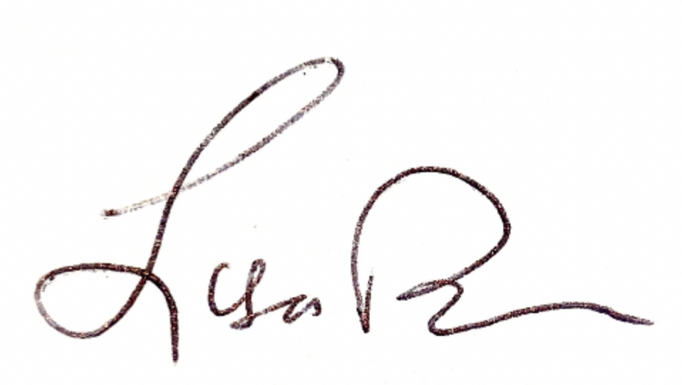
LISA W. BORDEN
Senior Policy Counsel, International Advocacy

