List of mines responsible for contamination with mercury and other chemicals

1. Gold mine of Chinese company Lanxang in Xepon, City Vilabouly , Province Savannakheth
2. Gold mine in Phoubier (mountain beer) from chinesch. Do business in Longxan Village, Xaysomboun Province
3. Gold mine in Provine Attapeu by Vietnamese company
4. Nakadok Nakone Gold Mine by Lao Company : Phonesack, the owner is the son-in-law of former President Choumaly Sayasone, Bolikhamxay Province
5. Phontiu Metal-Aluminum Mine, Hinboun City, Khammouan Province
6. Metal Aluminum Mine, Houaxay City, Bokeo Province
7. Metal-Aluminum Mine in Kasy City, Vientiane Province
8. Metal Aluminum Mine in Pakkouau Village, Boulapha City, Khammouan Province
9. Metal mine from Chinese entrepreneur in Namxan village, Xasomboun province
10.Gold and Bronze Mine by Chinese Entrepreneur in Namoua Village, Kham City, Xiengkhouang Province
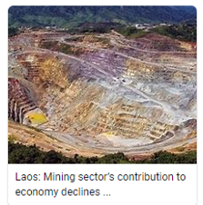
11. Gold mining company Xeponmining by Chinese company in Xepon city, Savannaketh province, it was the first company in this province, later they switched to another company in No. 1 above: Chinese company Lanxang
12. Gold mine in Pakbeng city, Oudomxay province by Chinese company Laoxinlong. The project is the result of an agreement between Laos-China on Feb. 15, 2022 on an area of 111.67 sq km in Packbeng city, but the works started 3 years ago.

Sources from social media:
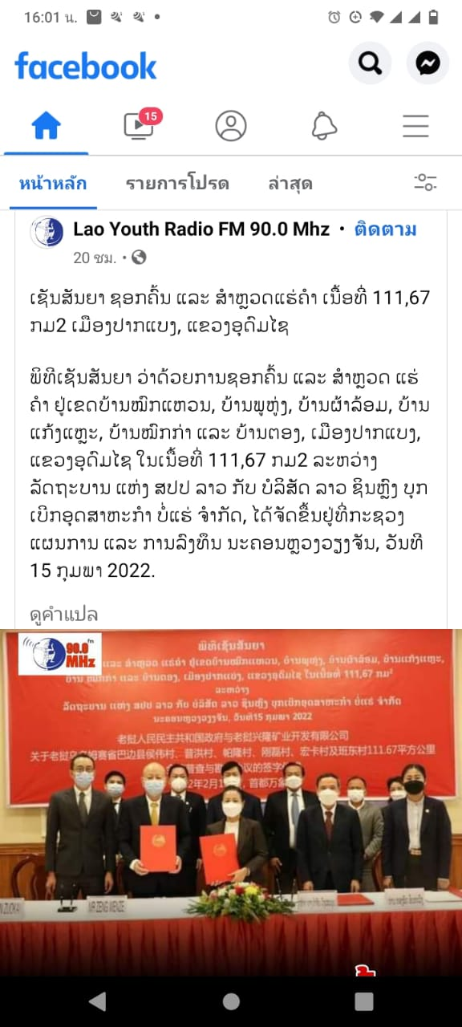

2 Videos in Facebook:
https://www.facebook.com/bounthone.chanthalavongwiese/videos/7146342482103201
https://www.facebook.com/bounthone.chanthalavongwiese/videos/3194150027530629
Photo: Gold Mine in Pakbeng Province Oudomxay:
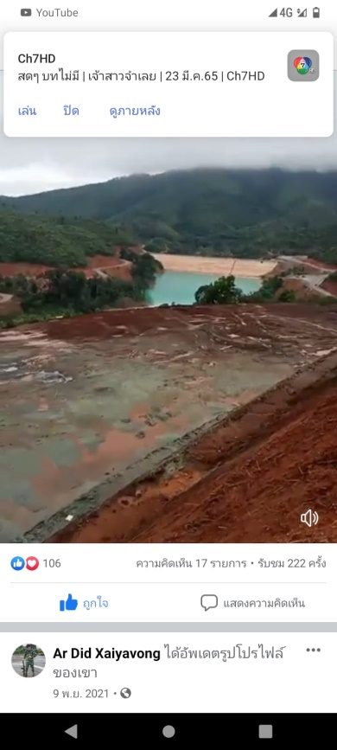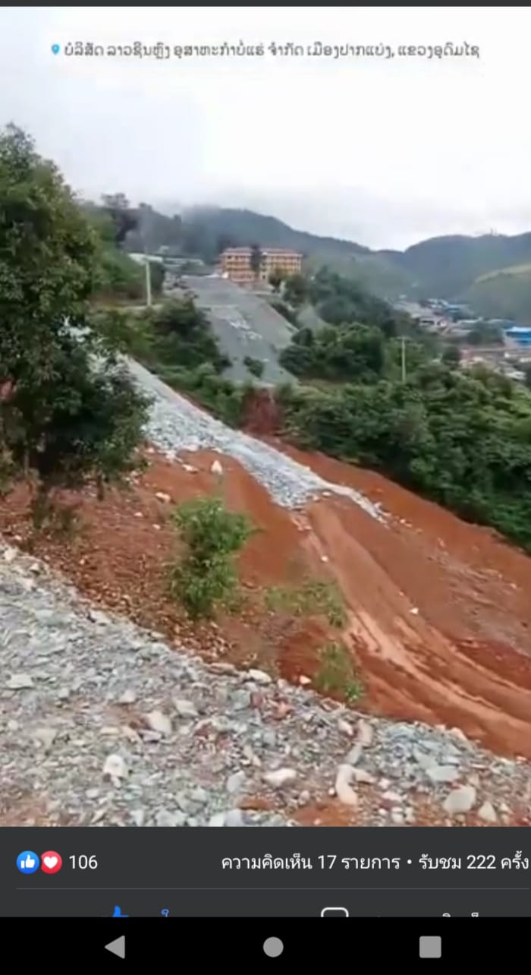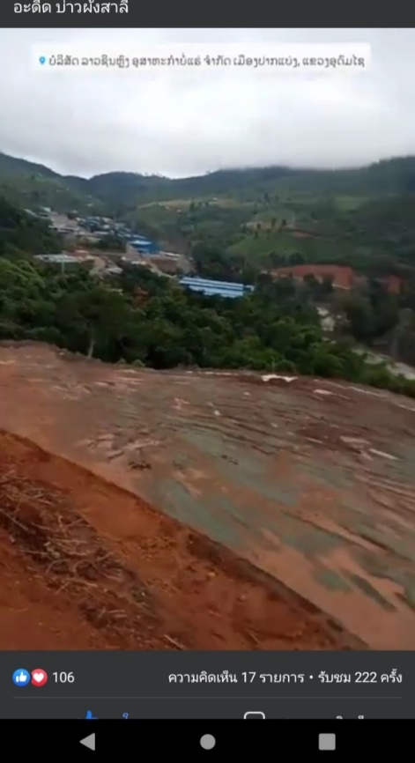
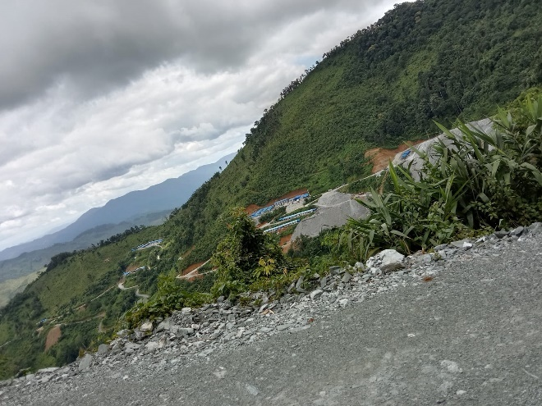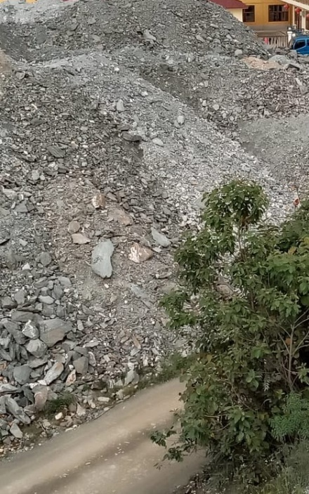
13. Gold mine in City Kaluem Province Xekong by Chinese company: Xinolay with Laotian company Phonesack
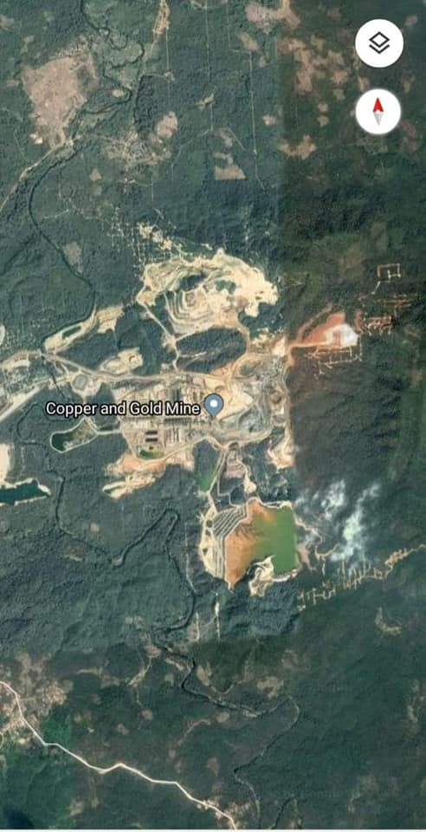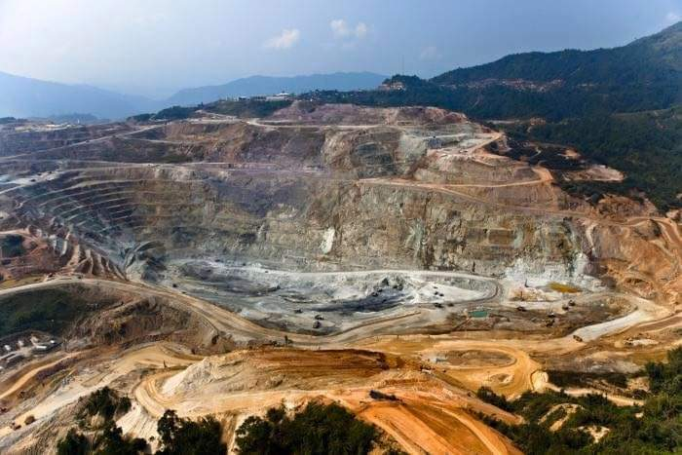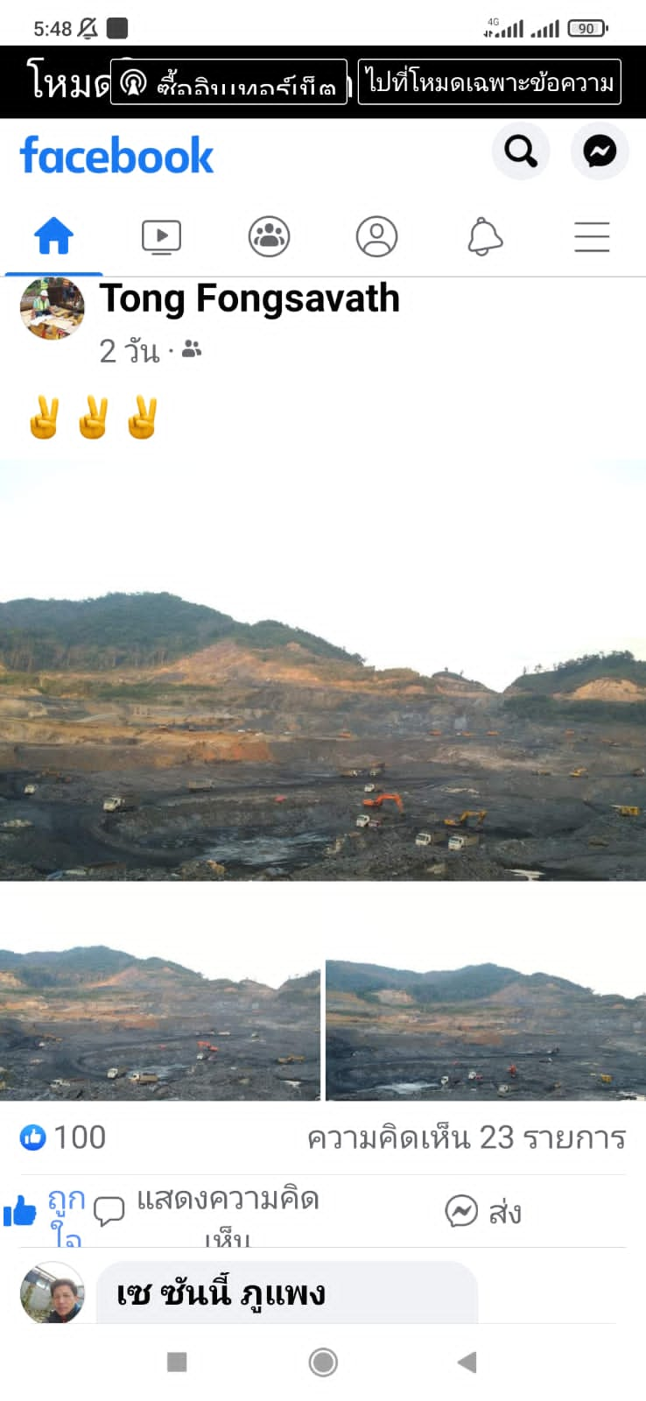

14. And still more in the provinces of Houaphane, Salavan, Bolikhamxay
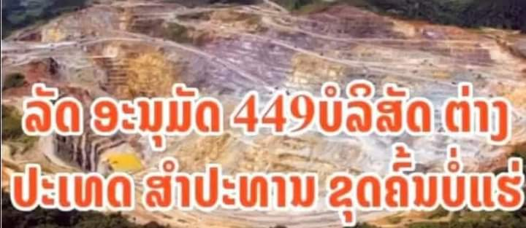
In total there are 449 foreign mining companies in Laos
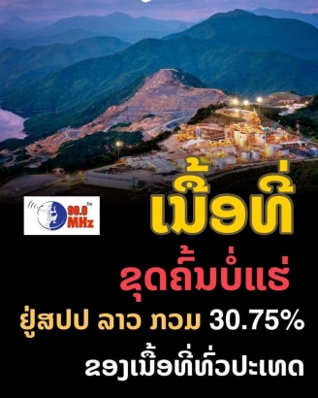
A total of 30.75% of the land area of Laos is open for mining. The workers are mostly Chinese:
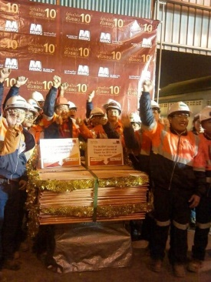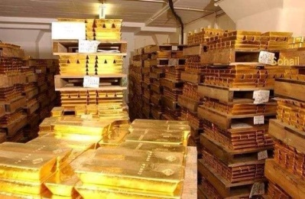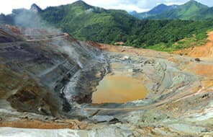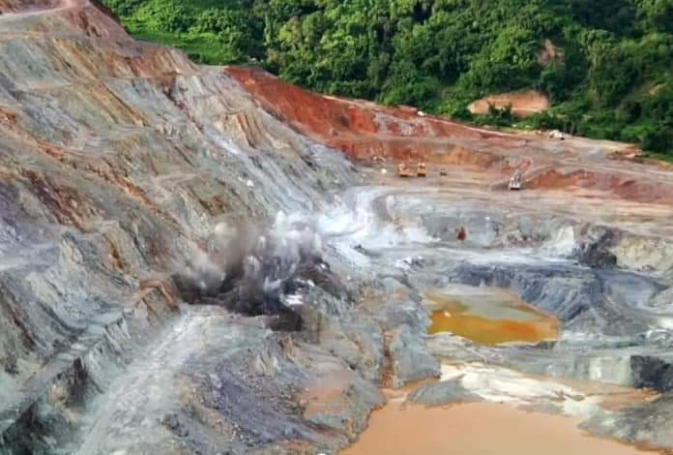

Responsible:
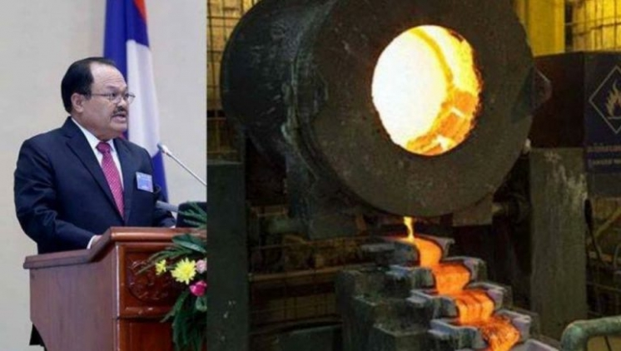
Minister Khammany Inthirath, Former Minister for Energy and Minerals (Mining)
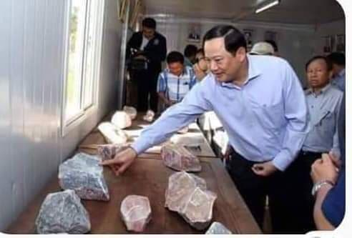
Mr. Sonexay Siphandon, Former Deputy Prime Minister and Minister for Planning and Investment

