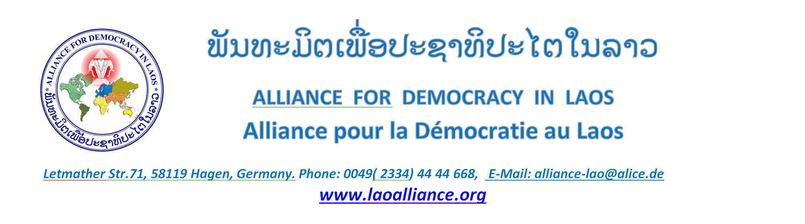

Special Rapporteur on the implications
for human rights of the environmentally
sound management and disposal of
hazardous substances and wastes

Call for submissions “Mercury, artisanal and small-scale gold mining and human rights”

Country : Democratic People’s Republic of Laos
Questionnaire
Controls on Mercury

- Has your country prohibited the a) import or b) export of elemental mercury?
There is a law prohibiting the trade in toxic nerve-damaging drugs

- Has your country prohibited mercury use in artisanal or small-scale gold mining (ASGM) by law or regulation?
No

- What enforcement action and penalties apply to gold miners who use mercury, or to traders who supply mercury for this use, if such use is prohibited? Please share statistics on such actions.
The Toxic Nerve Damaging Drugs Trafficking Prohibition Act provides for penalties ranging from 5 to 10 years imprisonment and fines ranging from 10 to 100 million kip. Statistics specifically on the abuse offenses involving mercury are not available.

- If your country allows import of mercury but prohibits its use in ASGM, how do customs officers determine the end use of mercury at the point of import to ensure it is not directed to ASGM?
The control system is not working because of rampant corruption in Laos.

- Are there tracking or certification processes to ensure that imported mercury is used according to its claimed purpose?
A working tracking or certification process is unknown.

- Are mercury importers registered on a government database and their activities periodically audited including the end use of the mercury they import? Are postal imports of mercury banned?
The controls in Laos are not transparent and mostly ineffective, because of the corruption in the entire state apparatus and because of the ban on criticizing the state authorities. The Toxic Substances Ban Act prohibits imports through the mail.

- What remedies are available to persons in your country for pollution damages related to mercury exposure from ASGM activities?
There is a complaint hotline from the government. In reality, however, this is often not achievable. There is also a complaints management system from Parliament, but the mines have acquired concessions through corruption. However, decree number 117 forbids criticism of state institutions, so it is not the environmental offender but the complainant who is punished.

Illegal Traffic

- What actions has your country taken to prevent the illegal importation, smuggling and distribution of mercury to ASGM activities?
There is a law banning toxic nerve-damaging substances, but in reality there are no controls by the authorities. On the one hand because of corruption; on the other hand due to a lack of specialist knowledge on the part of officials or because of a lack of interest.

- What are the greatest challenges your country faces in preventing illegal mercury imports and smuggling?
Corruption is systemic in Laos and prevents effective enforcement of the trade ban. Since the entire state apparatus is corrupt and the form of government is a dictatorship, the possibilities to change something are zero.

- Has your country established cooperative arrangements with bordering countries or at a regional level to combat illegal transboundary movement of mercury destined for ASGM activity?
There is no effective agreement with neighboring countries.

- Are there instances of corruption among police, military or other officials involving the facilitation of mercury distribution in your country? What measures have been taken to address it?
Corruption exists at all levels of the Lao state apparatus. The governments of Laos have repeatedly announced that they will fight corruption. However, since the fight against corruption is carried out by these same corrupt politicians, the system of corruption continues to exist. In a few cases, lower-level officials have been fined. The common practice, however, is to transfer corrupt officials, so corruption just moves from one place to another.

- Is there any information to suggest local or regional organised crime syndicates are distributing mercury to facilitate gold smuggling in your country?
The state itself works like a criminal syndicate. Foreign investors, mostly from China or Vietnam, openly take advantage of this.
Minamata Convention

- Has your country ratified the Minamata Convention on Mercury and if yes, what measures have been taken to eliminate mercury from ASGM, including its diversion to ASGM?
No it has accessed the Monamata Convention in September 2017, but not signed.

- How could access to capacity building or technology transfer under the Minamata Convention Specific International Programme help your country to eliminate mercury pollution from ASGM?
Pressure must be put on the government of Laos to ratify the agreement. In addition, independent controls must be carried out by the United Nations, since the Lao government will not be able to implement the ban on mercury abuse.

Protections for Indigenous Peoples
- What specific actions has your country taken to directly protect the health of indigenous peoples from mercury contamination related to ASGM?
Nothing

- Has any government or public forum for consultation with indigenous peoples about mercury pollution from ASGM been established?
No

- Have any mercury related health assessments or studies been conducted in your country that relate directly to the exposure of indigenous peoples to mercury pollution from ASGM activities and associated mercury pollution? Please describe or share.
There are no known studies.

- What health services and advice does your country provide to indigenous peoples to either treat high mercury levels or to minimise their exposure to mercury through diet (e.g. fish) or direct exposure via ASGM activity?
Non

- What constitutional or legal rights do indigenous peoples have to prohibit mercury based ASGM in their traditional lands and territories?
No

General

- Please provide any further information that you consider relevant for the purposes of this questionnaire.
Attachment: List of mines responsible for contamination with mercury and other chemicals

________________________________________________________________________________
Office in Germany: Dr. Bounthone Chanthalavong- Wiese, President, Letmather Str.71, 58119 Hagen, Germany
Phone: +49-2334-44 44 668, E-mail: chanthalavong@aol.com
France: Mr.Somphet Vatthanou Vice-President , 2 AV Combattant en a.f.n.69140, Rillieux La Pape,
Phone: +33-6-15192201, E-mail: s.vatthanou@gmail.com
USA: Ms.Khamphene Souvannasane, regional president, ADL chapter of USA , 3837 Rusty Dell St.,
Fortworth, TX 76111, Phone:+1-682- 554- 6675 , E-mail: khamhene@yahoo.com.
Vice regional president: Vieng Savahn: phone 714-305-7748
Canada: Mr.Kambane Anonthisen, regional president, ADL chapter of Canada, 84 Highgatz Rord Kichener , ONT,
Phone:+1-519-58 80 502, E-mail: khambane@hotmail.com
Australia: Mr.Pheng Sacksady, regional president, ADL chapter of Australia, 6 Quambone Place,Isabella Plains A.C.T, Phone+61-41 37 66 216, E-mail: pheng.sone52@gmail.com
New Zealand: Mr. Somchine Sithivong, regional president, ADL chapter of New Zeeland, 6 Ropata Cres, Lower Hutt.
5010 Wellington,phone: +64- 49 34 86 35, E-Mail: xsittivong24@gmail.com

