Joint submission by relevant stakeholders in Brazil on the impact of the COVID-19 pandemic on the realization of the equal enjoyment of the right to education by every girl

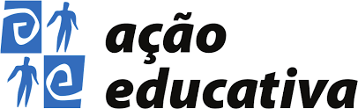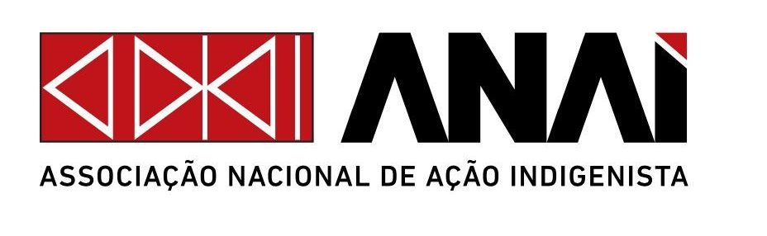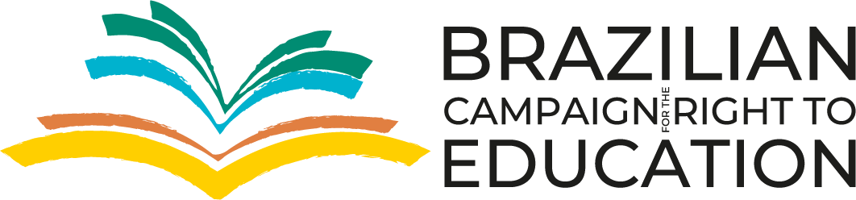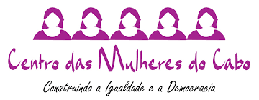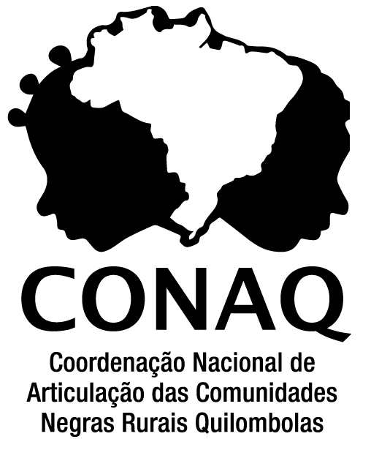
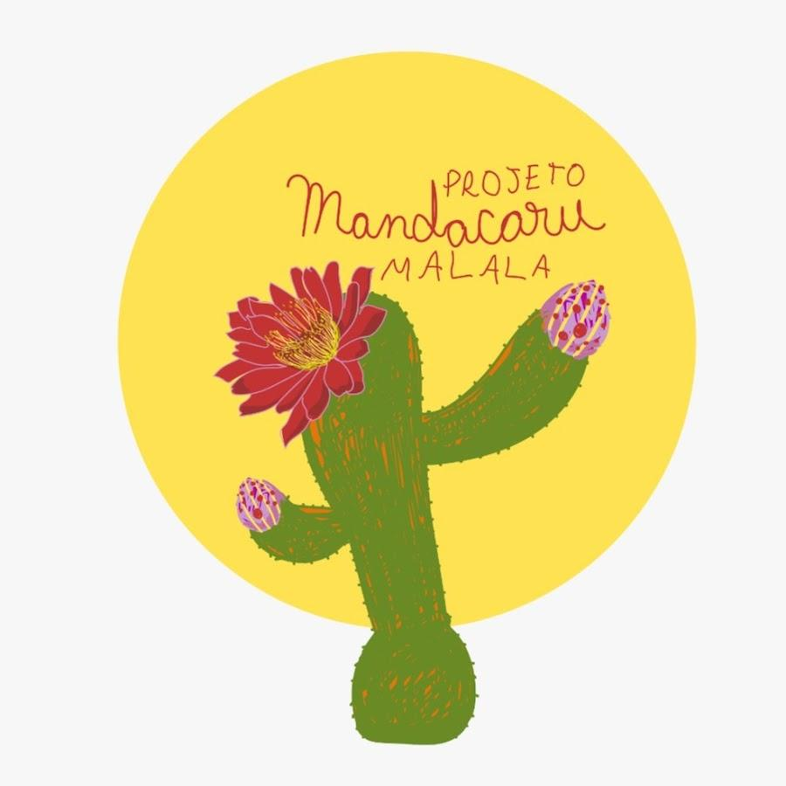

I. Introduction
1. This report preparation was coordinated by the Brazilian Campaign for the Right to Education (BCRE), it has information from studies and monitoring reports and is jointly submitted by BCRE, the NGO Ação Educativa, the National Association for Indigenous Action (Anaí), the Cape Women's Center, the Dom Helder Camara Center for Studies and Social Action (CENDHEC), the National Coordination of Articulation of Rural Black Quilombola Communities (Conaq), the Geledés Institute for Black Women, the Institute of Socioeconomic Studies (Inesc), the Luiz Freire Culture Center (CCLF), the Mandacaru Project, and the NGO Redes da Maré. All of these partner organizations are together on the Education Champion Network.
2. This report aims at providing important and urgent information to OHCHR on the very serious and most updated risks to the equal enjoyment of the right to education by every girl in Brazil in order to support the Human Rights Council at its fiftieth session.
3. With the arrival of the Ômicron variant in Brazil at the end of November 2021, cases of Covid-19 increased again. On February 14, 54,220 new cases were recorded, totaling 638,362 official deaths from the disease in the country. Currently, there is a downward trend in these numbers in eight out of 26 states. On February 3, Fiocruz launched an alert about the rise of severe cases of the disease in a Technical Note on the growth in occupancy rates of Covid-19 ICU beds, especially children's.
4. On February 3, about 150 million Brazilians, equivalent to 70.1% of the population, were already fully immunized against Covid-19. On December 16, Anvisa authorized the vaccine application in children between 5 and 11 years old. The measure is justified by the mitigation of serious forms, sequelae and deaths from Covid-19 in this group, reduction of the virus transmission and constitutes an important strategy to increase safety in the return of school activities to face-to-face mode.
5. Sustainable Development Goal 4 and the UN Universal Periodic Review recommendations to Brazil have not been implemented, are stagnant or in retreat, as demonstrated in several civil society reports (see more in the chapter dedicated to this analysis).
6. The recommendations of the UN Committee on the Rights of the Child and recent resolutions on the right to education and girls' right to education (CRC/C/BRA/CO/2-4; A/RES/74/223; A/HRC /RES/47/6; and A/HRC/RES/47/5) have also not been fully followed by the Brazilian State, many of them threatened.
7. This document presents, firstly, data and information about girls’ right to education in the face of the worsening socioeconomic crisis in Brazil with the Covid-19 pandemic and the lack of government action to guarantee rights. Then, in this context, the report deepens information on the situation of black, quilombola and indigenous girls; and grils from urban locations in conflict situations. Finally, it summarizes the data on non-compliance of the Brazilian State with international education resolutions, recommendations and agendas and brings suggestions for recommendations in the 4A scheme of dimensions of the right to education.

II. Covid-19: a crisis within a crisis
8. According to the report "A suffocated country - balance of the Union General Budget", released by the Institute of Socioeconomic Studies (Inesc), in July 2021, the Education area, in addition to not having received any additional resources as a result of the pandemic, had BRL 7 billion less in financial execution in 2020 than in 2019 - even facing a scenario that required effective measures and innovative ways to guarantee teaching conditions in the midst of the pandemic.
9. Inesc also points out that spending on policies aimed at children, adolescents and young people decreased or disappeared in 2020. Expenses aimed at assisting children and adolescents (BRL 443 million) were 9.4% lower compared to 2019. Amounts spent on early childhood education were almost three times lower in 2020 (BRL 145 million) compared to 2019 (BRL 410 million). In 2020, the federal government did not spend even R$ 300 thousand to fight child labor, which affects 1.8 million children across the country. Resources for Youth and Adult Education (EJA) are disappearing: in 2020 nothing was spent on new resources, only expenses accumulated from previous years.
10. The Brazilian public budget does not present gender-sensitive indicators to understand financing inequalities.
11. According to the State of Education in Brazil report, published by UNESCO in November 2021, in all states, schools have already resumed face-to-face classes (in a hybrid way in some places). However, according to the 2021 School Census,
- only 34% of municipal schools for early childhood education have an adequate bathroom for this stage,
- regarding the public water supply network, only 54% of public schools are covered, and the resource is less common in the north of the country.
12. According to August 2020 data from the WHO and UNICEF Joint Monitoring Program for Sanitation and Hygiene (JMP),
- 39% of schools in Brazil do not have basic facilities for hand washing;
- only 19% of public schools in the State of Amazonas have access to water supply, while the national average is 68%;
- regarding sanitary sewage, the situation is even more critical, since in some states in the North, less than 10% of schools have access to public sewage services.
13. According to WHO and UNICEF data, only 65% of municipal schools and 84% of state schools had piped water, 18% and 14% of municipal and state institutions, respectively, used artesian wells, 13% and 5% cacimba , 6% and 2% river and 3% and 1% had no access to water.
14. Still on infrastructure, no data were found on the ventilation conditions of the classrooms. It is not possible to know, for example, whether all rooms in a particular school have windows or not. Due to the level of disorganization with which the measures to reduce the disease contagion have been carried out, it is possible to infer that basic supplies such as gel alcohol, masks and soap will not reach schools in time and in sufficient quantities so that safety protocols are followed, as there are already reports all over the country - and we are gathering data and more information about it.
15. Inesc/Vox Populi carried out research, in 2021, with high school students from all over Brazil, to understand how education was offered during the pandemic. Some results are very expressive of the inequalities between public and private networks. On average, adolescents from the public network studied 1 hour less per day, compared to the private network. In addition, 60% of them only had their cell phones to follow classes, with internet data packages that, for 16%, did not last the entire month. 34% of the girls were very psychologically affected during the period, not least because they were the ones who took on more domestic or outside activities, as 54% of the students performed other obligations in addition to their studies. Still on inequalities, the research presents the northern region of the country as the most affected by the pandemic effects on education, in addition to black and brown girls.

III. Right to education of black, quilombola, indigenous girls and in urban areas of conflict
15. Data from the National Household Sample Survey - PNAD COVID-19, carried out in 2020, revealed that in September, 6.4 million students, corresponding to 13.9% of the total, did not have access to school activities in Brazil. The same survey showed that black and indigenous students without school activity are three times the number of white students: 4.3 million black and indigenous children and adolescents in public schools and 1.5 million white adolescents, respectively. In fact, accentuated by the pandemic, educational inequalities affect all social groups, however, it is inexorable to recognize that the pandemic expands the existing educational inequalities between non-white and white people in Brazil..

16. Facing this reality, Geledés - Instituto da Mulher Negra carried out the research “The right to education of black girls in times of a pandemic: the deepening of inequalities” in the city of São Paulo, with a focus on race/color and gender. The study showed that many of the girls interviewed do not have adequate space to study remotely (with a chair, table, lighting, for example) and/or do not have a reserved time for school activities and/or do not have adequate material. The percentage of boys who dedicate more than 6 hours to studies is approximately double that of girls. Reduction in financial income, increased dedication to the children and adolescents routine, reduced learning stimulus due to school closures and domestic activities overload are examples of the Covid-19 impact on the lives of black families in São Paulo.
17. Regarding quilombola girls, although they are the target of some social programs and the object of a scarce number of laws, it is very difficult to access them from statistical data. Due to the absence of quilombola populations in the censuses, there is no demographic information available on the profile of children and adolescents residing in quilombo areas in Brazil. Some estimates indicate that, in 2007, quilombola children numbered 900,000 boys and girls. The only way to obtain information about quilombola children is from fragmented and scarce data that reveal, for the most part, the reality of their families..
18. According to a survey carried out by the Secretariat for Promotion of Policies for Racial Equality (SEPPIR) in 2012, 74.73% of quilombola families were in extreme poverty and 24.81% could not read. The secretariat also identified for the same year that a large number of children between 4 and 7 had never attended school and that most educational institutions in those communities were made of mud or straw. The most recent data available refer to the year 2017, a period in which 242,473 enrollments in basic education in quilombo areas were registered in Brazil..
19. Even if limited, the information available on quilombola girls and young women reveals a reality of social vulnerability. In the research “Racism and Violence Against Quilombos”, launched in 2018, the movement draws attention to the aggressions that have affected quilombola children and adolescents.
20. We are aware of the specificities that end up being conditions for indigenous girls to leave school before boys. The main reasons are early pregnancy, child marriage, domestic work, early financial accountability, gender violence on the way or at school, harassment, prejudice, territorial insecurity. Regarding the structures in indigenous school education, the Ministry of Education (MEC) portal informs that:
The operation of units in school buildings reaches 2,316 (69%). The North and Northeast regions have the lowest percentage of schools operating in school buildings – respectively, 65% and 69%. While the Southeast region has the highest rate – 94.59% – of units operating in school buildings. Indigenous schools in the South and Southeast regions have 100% access to electricity, while in the North region they have only 54% access. As for sanitary sewage, indigenous schools in the South and Southeast regions have, respectively, 98% and 90% of access, while in the North region they have only 39.61% of access. Physical structures to support the learning of science, information technology and languages are practically absent in indigenous schools. Only 6.84% of indigenous schools have computer labs, 0.50% have science labs, 8.01% have libraries and 14.73% have internet access.
21.In interviews carried out by the Cunhataí Ikhã project, the girls pointed out the precariousness of their schools in terms of equipment and school supplies. In addition to equipment and school supplies, the girls also pointed out the issue of school lunches, which may be missing due to the inadequacy of transfers from government agencies. Besides that, according to Larissa Tuxá, prejudice against indigenous women is even stronger and causes difficulties for the development of studies. Being an indigenous girl, according to a Pataxó HáHá Hãi girl (whose name has been preserved here) can make it more difficult to study because “most of society wants to see men, boys, go ahead in education and (...) the girl has to stay at home". A Tumbalala girl (whose name has been preserved here) also notes that generally, the universities closest to the villages are private universities, which means that, in addition to the travel and other expenses, the families have to pay the monthly tuition fee. A Tupinambá girl (whose name has been preserved here) draws attention to the overload that girls and women tend to have, which increases in the event of marriage and/or pregnancy, making them often but not be able to reconcile housework and studies, even when they are motivated to study.
22. The study “Girl education and COVID-19 in the Maré Favelas Complex”, a survey with more than a thousand residents of 16 favelas in Rio de Janeiro sought to identify the pandemic impacts on the education of girls. The research shows how Covid-19 has affected the education of girls and women in Maré. More than a third of them – 34.7% – said they did not have access to the internet at home, while 26.6% reported that their schools were not offering remote activities. Even those who had a cell phone or computer with internet ran into the low quality of the internet connection, not to mention the financial difficulties to pay for data packages that lasted until the end of each month. No wonder, only 66.5% of girls and women enrolled in schools were able to maintain a study routine at home, and only 27.7% of them said they were studying five days or more a week.
23. According to the survey, 53.1% of girls aged 6 to 10 did not have a cell phone, and 9.8% of those who did, did not have access to the internet. Altogether, 62.9% of girls were unable or with greater difficulty to follow school activities on their cell phones, since, for this, they depended on the existence and availability of devices from other house residents. It is also important to remember that the range from 6 to 10 years old corresponds to the initial years of elementary school (1st to 5th year), the stage in which literacy occurs. In Maré, only 37.1% of the girls in this age group had a cell phone with internet access.
24. In Maré, the survey indicated that, on average, 66.5% of the students enrolled in the school were able to maintain a study routine at home, while 32.2% were not. The option “sometimes” was marked by 1.3% of respondents. The percentage of girls with a schooling routine drops to 62.7% in the 6-10 age group – as mentioned earlier, the literacy stage – and rises to 77.9% among women aged 25 and over. In the other age groups, the percentages were 66.3% (11 to 14 years old), 66.6% (15 to 17 years old) and 65% (18 to 24 years old).

IV. Non-compliance with international commitments and recommendations on the right to education in Brazil
25. According to the 2021 civil society light report on the Sustainable Development Goals, “education is another SDG extremely impacted by the government’s mishandling of the health crisis”. The number of students enrolled in learning environments was reduced, putting Target 4.1 at risk. We do know school attendance by gender is 93.90% amongst girls and 93.20% amongst boys, meaning Target 4.2 is in a setback. Target 4.3 was reclassified from insufficient progress to setback due to budgetary cuts. Target 4.6 remains stagnant, in addition to stable illiteracy rates since 2011, the functional literacy of adults (15 to 64 year-olds) and youth (15 to 24 year-olds) shows a slight drop. Target 4.7 is in setback since 2019, due to the adoption of contrary government policy, projects such as the insidiously named “Escola Sem Partido” (“Schools Without Party”); illegal lobbying in favour of homeschooling; broken commitments to the UN Human Rights Council on women’s sexual and reproductive health; or sometimes successful attempts to criminalise education on gender, race, and diversity. Target 4.a has been intensely setback due to disparities in school services for people with disabilities and structural inequalities between public and private education networks. Higher education (Target 4.b) was also impacted by defunding, and remains a setback. The percentage of basic educators with adequate training increased marginally, meaning Target 4.c is at risk.
26. According to the Civil Society Monitoring Report 2020 on the Universal Periodic Review in the Context of Covid-19, Recommendations 151, 164, 165, 166, 167, 168, 169, 170, 171, 173, 174 and 175, which focus on the improvement in the quality and fi nancing of education, elimination of discrimination and promotion of an inclusive and intercultural education, are not being implemented. Recommendation 152 was not implemented. It suggests efforts for inclusive education and health that benefit all sectors of the society.
27. The recommendations of the UN Committee on the Rights of the Child and recent resolutions on the right to education and girls' right to education (CRC/C/BRA/CO/2-4; A/RES/74/223; A/HRC /RES/47/6; and A/HRC/RES/47/5) have also not been fully followed by the Brazilian State, many of them threatened.

V. Recommendations
28. We believe that more than a debate, concrete actions are needed to fund girls' right to education and equip schools. The precariousness of infrastructure will not be remedied overnight and, therefore, a national reopening plan is at least necessary, establishing security protocols and making resources available for the necessary changes. In addition, it is also necessary to create subjective conditions of security, so that the girls feel safe to return.
29. Approved by Constitutional Amendment 108/2020, of the new Fund for the Maintenance and Development of Basic Education and for the Valorization of Education Professionals (Fundeb) and developed by the Brazilian Campaign for the Right to Education (BCRE), the Student-Quality Cost (CAQ) is a mechanism that combines quality, social control and education funding. The CAQ is one of the ways to ensure infrastructure in schools for girls across the country and needs to be regulated and implemented.
30. In order to collaborate, BCRE compiled 70 recommendations on education and protection to face the pandemic in 2021. This information synthesis was developed from all the accumulation throughout 2020 and brings context updates in this new year, as well as recommendations for decision-making so that the emergency policies to be developed in 2022 are rights-based.
31. Likewise, BCRE collaborated with the Report on the impact of the COVID-19 crisis on the right to education of the Special Rapporteur on the Right to Education published in 2020 (A/HRC/44/39), presenting a series of recommendations for the education of girls and boys in a remote, hybrid or face-to-face system, back to school. The framework elaborated contemplates the 4A system of the right to education, bringing recommendations on accessibility, adaptability, acceptability and availability.

SECRETARIA DE PROMOÇÃO DA IGUALDADE RACIAL. Programa Brasil Quilombola: relatório de gestão - 2012. Brasília, DF, 2013. p. 9
https://www.gov.br/mdh/pt-br/centrais-de-conteudo/igualdade-racial/diagnostico-de-acoes-realizadas-programa-brasil-quilombola.
https://download.inep.gov.br/educacao_basica/censo_escolar/notas_estatisticas/2018/notas_estatisticas_Censo_Escolar_2017.pdf
http://portal.mec.gov.br/busca-geral/206-noticias/1084311476/75261-mec-trabalha-por-avancos-na-educacao-escolar-indigena
http://repositorio.unicamp.br/jspui/bitstream/REPOSIP/305006/1/Souza_MarciaLuciaAnacletode_D.pdf https://kn.org.br/oq/2007/07/05/i-quilombinho-mobiliza-criancas-e-adolescentes-do-pais/.
https://brasilnaagenda2030.files.wordpress.com/2021/08/en_rl_2021_webcompleto_27agosto.pdf
https://plataformarpu.org.br/storage/publications_documents/QaLfpUb4pyieP0aI5cX5O9WemybRE96coWcsZmbC.pdf
https://bigdata-covid19.icict.fiocruz.br/
https://portal.fiocruz.br/sites/portal.fiocruz.br/files/documentos_2/nota_tecnica_observatoriocovid19_2022-02-02.pdf
https://www.cnnbrasil.com.br/saude/brasil-ja-vacinou-70-da-populacao-com-duas-doses-ou-dose-unica-contra-covid-19/
https://covid19.ibge.gov.br/pnad-covid/
www.geledes.org.br/wp-content/uploads/2021/04/A-educacao-de-meninas-negras-em-tempo-de-pandemia.pdf
https://www.inesc.org.br/baixa-execucao-financeira-e-lentidao-do-governo-asfixiaram-politicas-sociais-em-2020-diz-estudo/
https://www.geledes.org.br/wp-content/uploads/2021/04/A-educacao-de-meninas-negras-em-tempo-de-pandemia.pdf
https://campanha.org.br/acervo/estudo-infancias-invisibilizadas-quilombolas/
Idem, p. 66 - 69; 97;115.
https://www.redesdamare.org.br/media/downloads/arquivos/pesq_covid_mare_PORT_web60369a328ca93.pdf
https://media.campanha.org.br/acervo/documentos/Fundeb2020_NotaTecnica_2020_08_12_CAQ-SenadoFederal_FINAL.pdf
https://www.ohchr.org/Documents/Issues/Education/COVID19/BrazilianCampaignforeducation.pdf
https://www.ohchr.org/Documents/Issues/Education/COVID19/BrazilianCampaignforeducation.pdf
https://pt.unesco.org/fieldoffice/brasilia/covid-19-education-Brasil
https://www.gov.br/inep/pt-br/acesso-a-informacao/dados-abertos/inep-data/estatisticas-censo-escolar
https://www.unicef.org/brazil/media/9721/file/nota-tecnica-saneamento-higiene-na-resposta-a-covid-19.pdf
Data collected in interviews carried out by the Cunhataí Ikhã project, an initiative of the National Association for Indigenous Action (Anaí), with support from the Malala Fund. Implemented in July 2018, the project assists 47 indigenous girls between the ages of 13 and 24 from 9 indigenous peoples in Bahia: Kaimbé, Kiriri, Pankararé, Pataxó, Pataxó Há Hãe, Tupinambá, Tumbalalá, Tuxá and Tuxi.
https://undocs.org/A/HRC/44/39

