UNICEF submission to the UN Special Rapporteur on Extreme poverty and human rights
May 2022
- The nature of poverty and inequality in Kyrgyzstan, including how poverty is or should be defined and measured, its prevalence, and its distribution.

- Monetary poverty
The Kyrgyz Republic has a long history of poverty assessments, with the National Statistical Committee (NSC) publishing official statistics every year. National poverty lines derived from a representative household survey and adjusted annually to inflation, measure both the extent and pattern of poverty in the country and allow for the analysis of distributional effects of social protection policies. The extreme poverty line serves the purpose of identifying households that are extremely poor. Its value is set at the costs of a basic food basket of 2,100 calories, based on the actual food consumption of the Kyrgyz population (derived from KIHS data). The poverty line also accounts for the consumption of non-food goods and services.
Poverty is most often measured through either income or consumption (which is taken as a proxy for income). The distribution and the incidence of poverty are unequal across provinces as well as in urban versus rural settings. Poverty is concentrated across rural populations, especially the rural South. Not only is poverty more frequent in the Southern provinces but it is typically also deeper as demonstrated by the average poverty gap rate. Urban poverty with some fluctuations has been on steady rise since 2006 with a gap between rural and urban being narrowed every year. Poverty statistics is disaggregated by age, rural/urban and provinces. However, disaggregation by ethnicity is not yet available.

http://www.stat.kg/media/publicationarchive/27bf7b42-dfee-44e0-9698-864275e6b3b3.pdf

Source: NSC, 2021
- Child Poverty
As shown in the above graph, child poverty is always higher than total population average by 5-6 percentage point. 31.8% of children or 833,941 lived in monetary poverty in 2020. Prevalence of poverty in children aged 0–2-year-old is higher at 41 %.
This shows the particular vulnerability of children in relation to poverty. Not only children are disproportionately affected, but they are also more vulnerable to its effects. Children who live in poverty may face long-term consequences on their life as adults, in terms of educational outcomes, physical and intellectual development, psychological health, etc. Intergenerational transmission of poverty is also a well-studied phenomenon.
In Kyrgyzstan, children are more likely to be living in poverty if:
- There are three or more children in the household
- There are no working-age women in the household with secondary-school education or higher
- They live in Batken and Jalal-Abad provinces
- They live in a rural area
- Multidimensional poverty in Kyrgyzstan

- Multidimensional poverty in Kyrgzyzstan
Poverty assessment can be done not only by consumption or income estimates, but also applying deprivation approach. Under this approach, individuals are considered poor when their consumption does not meet social standards and do not have access to a certain range of goods and services. The multidimensional approach to poverty assessment in the Kyrgyz Republic focuses on five dimensions (monetary poverty, health, housing conditions, food security and education) and 11 indicators, thus, making it possible to get detailed picture of real poverty and its dimensions. Dimensions and indicators were selected in accordance with several guiding principles: well established multidimensional welfare indices, applicability to the Kyrgyz Republic context, relevance in the context of the Sustainable Development Goals (SDGs) and data availability. There are theoretical and practical justifications for each dimension, emphasizing their importance as major welfare determinants. The National Multidimensional Poverty Index (N-MPI) has been developed by the National Statistical Committee (NSC) of the Kyrgyz Republic in cooperation with UNICEF and UNDP. N-MPI is calculated using the internationally recognized methodology of Alkire and Foster. It is characterized by three main multidimensional poverty indicators. These are multidimensional poverty incidence (H), the average intensity of deprivation among the poor (A) and the National Multidimensional Poverty Index (M). Under these poor are considered those deprived of at least one third of the weighted indicators. The National Multidimensional Poverty Index and its components allow assessing changes in the population’s quality of life over time and dynamics for different groups using the annual household survey conducted by NSC.
50.9 % of children lived in multidimensional poverty according to national definitions and NSC estimates compared with 42.2% of adults (2020) https://sustainabledevelopment-kyrgyzstan.github.io/en/1-2-2/
In 2019 the National Statistical Committee has measured multidimensional child poverty index (C-MPI) based on the latest data from the UNICEF Multi Indicator Cluster Survey (MICS) conducted with support from UNICEF, USAID, UNFPA and government funding in 2018. The MICS data, collected once in four years, has information on child-specific indicators and allows for assessments and international comparison.
C-MPI comprises four dimensions: health and nutrition (1), living standards (2), education (3), social inclusion and protection (4) with number and type of indicators varying across age-groups. Overall, in 2018, 53,9% of children were multidimensionally deprived. Again, as in the case of monetary poverty, prevalence of multidimensional deprivations is higher in children 0-2 years old reaching 85.2%. the risk of multidimensional poverty decreases with increasing age. The full C-MPI report can be found here: https://www.unicef.org/kyrgyzstan/reports/multidimensional-poverty-assessment-kyrgyz-republic
- The impact of poverty on civil and political rights, as well as on economic, social and cultural rights such as the rights to health, housing, food, education, and social security.
Two considerable patterns of unequal deprivation drawn from the measurement of multidimensional poverty are evident in the country.
First, children living in rural areas are more often deprived in every deprivation indicator apart from caloric intake and overcrowding. Moreover, they very often experience more simultaneous deprivations than these living in urban areas. Hence, it is not surprising that multidimensional poverty is more frequent and more intense amongst rural individuals. This worrying pattern of inequality is then reflect at a region level albeit with differences across the set of indicators. Apart from issues of overcrowding and caloric intake, individuals living in Bishkek enjoy a higher standard of living.
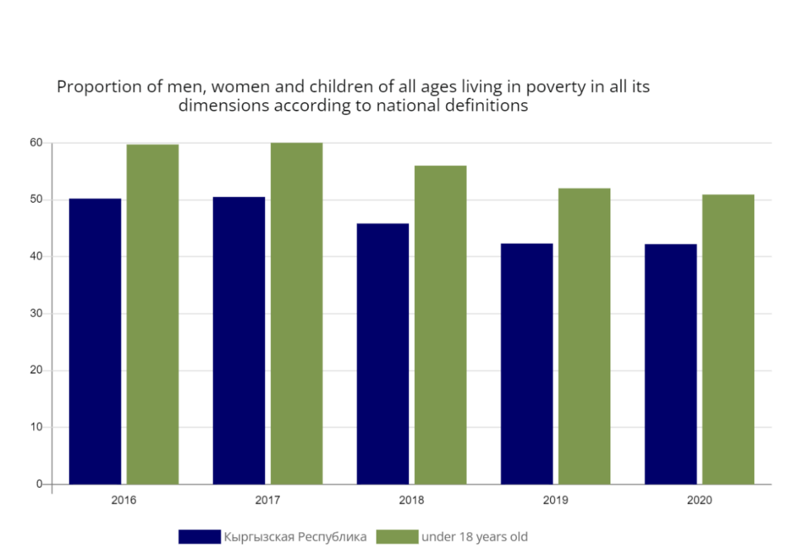
Secondly, the decomposition of multidimensional poverty by age cohort shows a very clear pattern of deeper and more widespread deprivation among children. This, coupled with the fact that children are more likely than any other age group to experience a larger set of multiple deprivations, makes it evident that child poverty is a crucial issue for the future of the country and its population. Moreover, both multidimensional and monetary poverty are prevalent amongst large households showing a substantial correlation between household size and poverty.
Source: NSC, 2021

Proportion of children living in poverty in all it dimensions according to national definitions, 2020:
Monetary poverty: 31.8% live in a household where annual deflated per capita consumption is below the absolute poverty line;
Health dimensions: 8 % of children live in a household where there is no handwashing facility with both water and soap on the premises. 26.4 % of children experience in-door pollution;
Education: 38.5 % of children deprived from age-specific level of education meaning that depending on age they do not attend pre-school and school;
Food security: 21.1 % deprived from household dietary diversity, 53.3 % consume less than the recommended 2,100 kcal per day;
Living conditions: 83.9 % of children do not have access to hot water supply. 83.6 % live in overcrowding households. 34.1 % deprived from drinking water, 68.8% - sanitation. 28.6% experience unstable electric supply.
12% of children under 5-year-old are stunted (Source: MICS 2018). The highest rates of stunting are among rural children (13.1%) and children in the poorest households (14.0%). Prevalence of stunting is the sign of chronic poverty.
- The potential of and challenges facing the existing social protection system to address poverty, inequality, and social exclusion, especially with a view to protecting informal workers, children, ethnic minorities, rural populations, refugees and migrant workers, unregistered/unrecognized citizens, and other groups particularly affected by poverty.
The national social protection sector is relatively comprehensive and has potential for improvement to better mitigate the adverse effects of the income loss having in place normative and institutional frameworks, Management Information System (MIS), state benefits/cash and service programmes, staff across the country, and sustained financing from the Republican Budget (RB).
However, several challenges exist, social protection programmes being too small in scope, existing targeting errors and implementation difficulties. Social assistance, social care service and active labour market programmes are relatively small. Pensions are responsible for an estimated 56 percent decrease in extreme poverty, thanks to their wide coverage and relatively high benefit adequacy. Social assistance suffers from fragmentation, low coverage, and low transfer values – thus, does little to tackle poverty. Social care services have been underdeveloped with prevailing residential care. Outreach and effectiveness of case management need to be improved. Social service workforce needs systemic reform and modernization.
- Non-contributory programmes in the Kyrgyz Republic and role of fiscal spending/ public finance management
There are several non-contributory programs in the Kyrgyz Republic, which are managed by the Ministry of Labor, Social Welfare and Migration (MLSWM) and financed from the republican budget:
- The Monthly Benefit for Poor Families with Children (MBPF), or Ui-Bulogo Komok (UBK) in Kyrgyz;
- A one-off birth grant for all newborns, called Balaga Suyunchu (BS) in Kyrgyz;
- The Monthly Social Benefit (MSB) and supplementary Monthly Social Benefit;
- State cash compensations for privileged groups of the population;
- Energy subsidies/compensations.
From these programs, the UBK and the BS provide cash transfers specifically for children. The former targets children in extremely poor households with a monthly benefit of KGS 865/$ 10, while the latter is a lump sum universal benefit of KGS 4,000/$ 47 provided at the birth of a child. The number of children benefiting from the UBK was 359,547 on 01.01.2022 (Source: MLSWM administrative data, 2022).
The composition of the MLSWM’s own budget for the period of 2017 to 2021 is presented on Figure 1 below. The item comprised by UBK and BS constitutes the largest share in the MLSWM’s expenditure: KGS 5,314 million in 2019 (officially projected by the Ministry to remain the same in 2020). In 2017, the MBPF (which can be seen as the predecessor of UBK) alone accounted for roughly KGS 3,319 million or 0.6% of GDP.
Other programs also take up sizeable shares of the budget. State cash compensations, for instance, cost 1,107 million KGS in 2019. This program provides generous categorical benefits for certain groups of the population which do not by definition experience specific vulnerabilities and can be viewed as an inefficient use of social assistance resources.
Figure 1 Composition of the MLSWM's budget (2017-2021)

Source: MLSWM 2019. Note: other expenses refer to the combined amount spent on all programs that do not fall under social assistance cash transfers.
In summary, social protection constitutes a large share of the general government budget, but two thirds of this are for pension payments. The remaining one third is spent on social assistance and social services. Within the MLSWM’s budget, child benefits (for poor children and for newborns) make up the largest share or expenses.
- Social protection for children living in poverty
In social assistance, the Monthly Benefit for Poor Families with children – MBPF or Yi-Bulogo Komok (UBK) - is currently the only scheme that provides regular, predictable income support to 359,547 children from poor households (Source: administrative data of MLSWM, 01.01.2022). Its narrow design and the inherent shortcomings of verified means-tests result in limited coverage, targeting errors and low benefit value have caused the UBK to have almost negligible impact on poverty. GDP share of UBK never exceeded 0.6%. Several analyses of the Kyrgyz Integrated Household Survey r indicate that nearly 60% of children in the bottom 20% were left out from this benefit (Gassmann & Timar, 2018). Value of UBK is KGS 865/$ 10. This amount represents only 16.4 % of the minimum subsistence level for children (MSL) which stands at KGS 5,282/$63 (2021). The MSL is one of the social standards, which defines the value level of the social assistance programme(s), i.e., UBK.
The recently adopted government “Plan of anti-crisis measures for 2022” makes provision to increase by 50% the amount of UBK or vertical extension. This is a significant effort by the government to respond to the high level of inflation and consequences of the sanctions against the Russian federation. However, in Kyrgyzstan did not yet consider improving the UBK coverage of children living on poverty despite potentially having better impact and relevance for new poor. Main reasons hampering access and increase in coverage are the strict asset filters defining eligibility and cumbersome and somewhat non-transparent application procedures contributing to the pre-existing high exclusion error.
Improving coverage would meaningfully accelerate country achievement of the SDG 1., Target 1.3.: “implement nationally appropriate social protection systems and measures for all, including floors, and by 2030 achieve substantial coverage of the poor and the vulnerable”.
It is important to note that, since 2021, the value of categorical benefit to children with disabilities have been increased twice and is now KGS 8,000/nearly $100 per child per month or 150% of the MSL.
Assessing social protection measures against their gender-sensitivity, inclusiveness and potential to accommodate the needs of existing and emerging vulnerable groups of children is essential.
- Social protection measures in the National Development Programme 2021-2026
UNICEF welcomes the adoption of the National Development Programme (NDP) till 2026, which includes child poverty figure and stipulates the introduction of mother-and-child aged 0-3 benefit linked to public health programmes. This new scheme could be a great development towards the integrated child-sensitive social protection. Social protection for children with disabilities
A comprehensive assessment of the national social protection system is also planned in the NDP and development partners involved in social protection have already started joint planning of this exercise with the MLSWM.
ANNEX
- Regions and cities that should be visited by the Special Rapporteur.
- Internal migrants’ settlements around the capital Bishkek
- Batken or Jalal-Abad provinces

- Individuals and organisations the Special Rapporteur should meet with during his country visit.
  - Vice Chair of Cabinet of Ministers for social issues Mr. Edil Baisalov
  - Minister of Labour, Social Welfare and Migration Mr. Kudaibergen Bazarbaev, Deputy Minister Ms. Zhyldyz Polotova, Head of the State Benefits Department Ms. Miraida Naktaeva +996 312 66 01 07
  - Commissioner for Children’s Rights under the President of the Kyrgyz Republic, Ms Asel Chynbaeva, contact person Ms Gulzina Boobekova, gulzi_bgt@mail.ru
  - National Statistical Committee, Department on statistics of the sustainable development and households, Ms Nazira Kerimalieva and Ms Galina Samohleb nazira.kerimalieva@gmail.com
  - National expert of strategic planning, public administration and social policy, Ms Nazgul Tashpaeva, tashpaeva@mail.ru
  - Local NGO “Center for Protection of Children”, Director Ms Mira Itikeeva, m_itikeeva@mail.ru

https://www.unicef.org/kyrgyzstan/reports/multiple-indicator-cluster-survey-mics-situation-children-and-women-kyrgyzstan
Calculation made by the Department on households’ statistics, NSC for upcoming publication on Child-MPI

