UNDP and the Minamata Convention on Mercury

UNDP has been active in the area of mercury reduction efforts since the 1970s, when it administered the UN Revolving Fund for Natural Resources Exploration (UNRFNRE) from 1975 to 1995 and implemented a number of artisanal and small-scale gold mining (ASGM) projects financed by the revolving fund.

Since then, UNDP has continued assisting developing countries and countries with economies in transition in their efforts to reduce the use and release of mercury. Such efforts have mainly focused on the extractives sector, by supporting the phase-out of mercury used in mining to extract gold, and on the health sector, where we support the phase-out of mercury-containing medical devices and the reduction of mercury emissions. In addition, the adoption of the Minamata Convention on Mercury with the Global Environment Facility (GEF) as its financial mechanism has created new avenues and opportunities for providing financial and technical support to countries to assist them in reducing releases of mercury.

To assist countries meet their commitments under the Minamata Convention and reduce releases of mercury from various sectors and release sources, UNDP, with the financial support of the GEF, supports countries in:

- Conducting Minamata Initial Assessment (MIA) activities and ASGM National Action Plans (NAPs). MIAs include mercury inventories and assessments of the legal and regulatory frameworks as well as institutional and technical capacity needs.
- Reducing emissions of mercury and mercury compounds to the atmosphere from point sources (e.g. coal-fired industrial boilers, incinerators, smelting and roasting processes used in the production/recycling of non-ferrous metals).
- Phasing-out mercury-containing products in the healthcare sector (e.g. thermometers, blood pressure meters, dental amalgam, etc.).
- Lifecycle management (LCM) of mercury, mercury-containing products and wastes (including treatment and storage).
- Reducing and eliminating the use of mercury in ASGM, and minimizing mercury releases to the environment from mining and processing.

UNDP has already provided support or is initiating support to a total of 41 countries to implement mercury-related projects through national, regional and global projects. UNDP’s current mercury portfolio amounts to $141 million in GEF grants.

UNDP is also participating in the PlanetGOLD and GOLD+ programmes, which are programmatic approaches to tackle the use of mercury in the ASGM sector. These programmes involve three UN agencies and one NGO and support activities in countries that can help them generate global environmental benefits that correspond to more than one global environmental convention or GEF focal area, by tackling the underlying drivers of environmental degradation. Utilizing a programmatic approach offers more opportunities for exploring development links to multi-sectoral approaches, multi-stakeholder engagements and platforms, and increases the potential for delivering socio-economic co-benefits along with enhancing the sustainability of the associated investments. As one of their main goals, the programmes will develop and connect responsible ASGM producers to international markets through transparent supply chains. Another key objective is to increase the access of small-scale miners and their communities to investment and finance for social and environmentally-friendly practices. Direct funding from the GEF is $89 million, with co-financing of more than $337 million from governments, sustainable finance institutions and the private sector.

UNDP’s activities are underpinned by a social and environmental safeguards framework, which includes an assessment of their impact on the human rights of the communities they serve. This framework is applied during the development, implementation and monitoring and evaluation stages of the projects that UNDP implements to reduce the use of mercury in the ASGM sector.

UNDP’s key approaches to assisting countries to advance the sound management of mercury include:

Advocacy and Awareness Raising - Campaigning among stakeholders, decision-makers and population groups at risk on the importance of mercury reduction, phase-out and its management.

Capacity Building – Identification of innovative and successful practices; policy, regulatory and institutional enhancements to help countries put in place mercury management systems; identification of financing needs and options; application of lessons learned and experiences from other countries; and development and application of guidelines and tools to facilitate the management and monitoring of mercury.

Technical Assistance – Supporting countries in identifying and introducing Best Environmental Practices (BEP) and Best Available Technologies (BAT), along with customized training for their use and application, which have proven successful elsewhere and will help address national challenges and constraints with regards to the sound management of mercury.

Monitoring – Assisting countries to assess their situation relating to mercury and tracking their progress towards reducing its use and releases.

The Sustainable Development Goals (SDGs) and the Minamata Convention on Mercury

The Minamata Convention aims to protect human health and the environment from anthropogenic emissions and releases of mercury and mercury compounds. Supporting countries in their efforts to prepare for and meet their future commitments under the Minamata Convention is an important component of UNDP’s efforts to achieve sustainable, inclusive and resilient human development through the SDGs, which were adopted in September 2015. Some of the key linkages between UNDP’s work in support of the Minamata Convention’s efforts to reduce the use/phase-out of mercury and the SDGs are highlighted below.

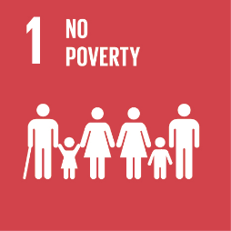
SDG Goal 1: End poverty in all its forms everywhere
The urban and rural poor routinely face unacceptably high risks of exposure to mercury because of their occupations (e.g. mercury mining, artisanal and small-scale gold mining, waste management, recycling), living conditions (proximity to dumpsites and incinerators) and lack of knowledge of potential health impacts of exposure to mercury. At the same time, ecosystems that provide essential resources for the survival of the rural poor, are affected by mercury contamination. UNDP-supported interventions assist partners in introducing alternatives, best practices and techniques to minimize the use and release of mercury, and also address the underlying socio-economic challenges that are at the core of existing practices that use mercury.

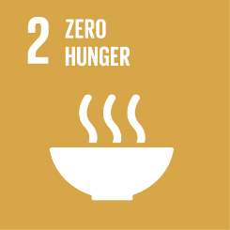
SDG Goal 2: End hunger, achieve food security and improved nutrition and promote sustainable agriculture
One of the main sources for exposure to mercury is through consumption of mercury-contaminated fish and shellfish. The consumption of fish containing high levels of mercury, in particular those high on the food chain as mercury bioaccumulates, can have serious health consequences (see SDG 3). This causes health concerns, in particular for pregnant women, the child in utero and young children, as well as for poor communities relying on subsistence fishing. UNDP helps countries decrease the use of mercury and its release into the environment from various sectors, indirectly halting and reducing the build-up of mercury in the food chain.
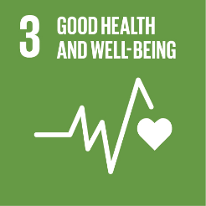
SDG Goal 3: Ensure healthy lives and promote well-being for all at all ages
Mercury is toxic to human health, posing a particular threat to the development of the child in utero and early in life. Human exposure occurs mainly by inhaling elemental mercury vapors during industrial processes and by consuming contaminated fish and shellfish, and can lead to mercury poisoning. Mercury exists in various forms: elemental; inorganic; and organic, which all have different toxic effects, including on the nervous, digestive and immune systems, and on lungs, kidneys, skin and eyes. UNDP supports governments, the private sector and other partners, to reduce or preferably phase-out the use of mercury and mercury-containing products, and minimize its releases, to ultimately protect human and environmental health.

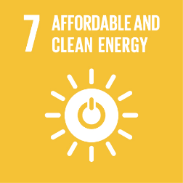
SDG Goal 7: Ensure access to affordable, reliable, sustainable and modern energy for all.
Coal burning, and to a lesser extent the use of other fossil fuels to generate energy, is the second most significant anthropogenic source of mercury emissions into the atmosphere. Use of air pollution controls and more stringent regulations, combined with improved combustion efficiency, can offset most of the mercury releases associated with the increase in coal use, particularly in Asia and South America. However, reductions in current mercury releases will only be achieved after a shift to cleaner and more sustainable energy sources and the introduction of more efficient technologies and products (e.g. mercury-free energy-efficient lighting). UNDP supports countries in strengthening their regulatory frameworks, revising outdated industrial processes and technologies to reduce releases and increase efficiency and, most importantly, in adopting clean energy solutions.

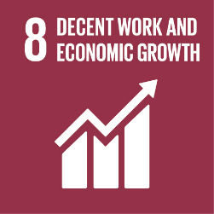
SDG Goal 8: Decent work and economic growth
Exposure to mercury can occur through the inhalation of mercury vapors. Such exposure is most likely to happen in the workplace. Among the most dangerous professions and livelihoods in terms of mercury exposure are artisanal and small-scale gold mining, waste handling and recycling, mercury refining, and health and dental care. Phasing-out the production and use of products and processes which use mercury is the main way to reduce worker exposure. We assist governments and various sectors introduce mercury-free products and processes, while also supporting the development of workplace safety standards and procedures, introducing personal protective measures, and addressing the underlying socio-economic causes that led to the use of mercury and products containing mercury.

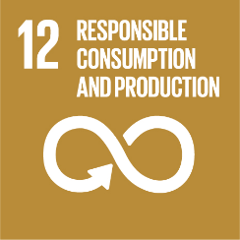
SDG Goal 12: Ensure sustainable consumption and production patterns
Sustainable consumption and production aims at “doing more with less,” increasing net welfare gains from economic activities by reducing resource use, degradation and pollution, while increasing the quality of life. An important aspect of our work is the reduction of mercury pollution and mercury-containing wastes by introducing alternative products, processes and technologies that are mercury-free, cost-effective and in line with best available technology guidelines. Such interventions are aligned with those that increase resource efficiency, use clean and renewable energy, and reduce waste generation, all of which have important mercury reduction co-benefits.

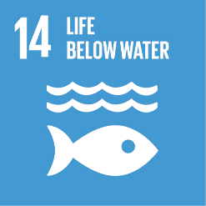
SDG Goal 14: Conserve and sustainably use the oceans, seas and marine resources for sustainable development
Over three billion people depend on marine and coastal biodiversity for their livelihoods, which are being threatened by marine pollution reaching alarming levels. Mercury levels in certain types of fish (e.g. bluefin tuna, swordfish) have become so high that some Governments advise against consumption or have introduced import bans. UNDP helps countries decrease the use and release of mercury from various land-based activities, prevent mercury from entering water sources, and reduce the build-up of mercury in the food chain.

In some cases, the management of mercury is a small component of a larger project focusing on reducing/phasing out other chemicals.

