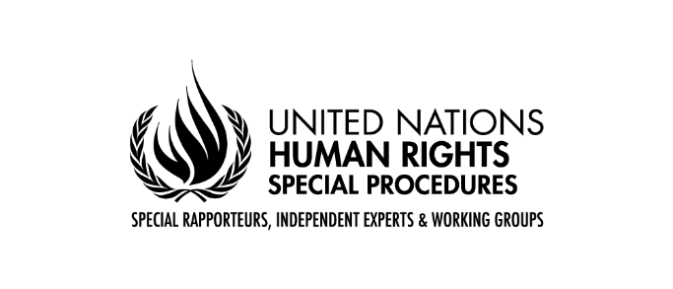
UN Permanent Forum on Indigenous Issues, 21st Session
Human Rights Dialogue
Special Rapporteur on Toxics and Human Rights, Marcos A. Orellana
27.04.2022

Muchas gracias, Señor Presidente. Excellencies, distinguished delegates, colleagues. I am very pleased for the opportunity to be here with you today in my capacity as the UN Special Rapporteur on Toxics and Human Rights.
The toxics and human rights mandate was created in 1995 by the then Human Rights Commission to address the grave environmental injustices arising from the dumping of hazardous wastes in poor countries. Since its inception, environmental justice has been at the core of the toxics mandate. This focus is today more significant than ever, given the toxification of the planet and the disproportionate impacts of chemicals and wastes on persons, groups, and peoples in vulnerable situations.
Exposure to toxic substances particularly affects Indigenous Peoples. Extractive industries poison the land with cyanide and mercury and have left a legacy of severely contaminated sites; oil and gas exploration, extraction and transport contaminate rivers with lead, cadmium and other noxious chemicals; plastics and microplastics expose communities around the world to the myriad toxic additives they contain; highly hazardous pesticides such as paraquat, glyphosate and mancozeb have been sprayed on Indigenous lands, not only by the agro-industrial complex but also by irresponsible governments trying to eradicate illegal crops in what is really a self-destructive war against plants that reflects the alienation of humanity with nature.
The list of toxic exposures on indigenous peoples is long and unfortunately it goes on to this day. This is despite normative instruments, such as the UN Declaration the Rights of Indigenous Peoples and Convention 169 of the International Labor Organization. Exposure of Indigenous Peoples to toxics continues despite the increasing recognition of key rights and protections, such as the right of free and prior informed consent, and the right to a clean, healthy, and sustainable environment, which was recognized by the Human Rights Council in its last October session.
A rights-based approach calls for urgent and priority attention to people in vulnerable situations. In previous years, the toxics mandate has focused on the rights of children, and it has also produced a set of principles on workers and toxics. The resolution that renewed my mandate in October 2020 explicitly highlights the vulnerable position of Indigenous Peoples that are exposed to toxic substances.
I intend to continue this approach and focus my next thematic report to the United Nations General Assembly, to be presented in October of this year, on Indigenous Peoples and Toxics.
In this regard, I wish to thank Francisco Calí, Special Rapporteur on the rights of Indigenous Peoples, for his support and collaboration, not only on my forthcoming thematic report, but also on several letters we have jointly sent to Member States involving Toxics and Indigenous Peoples.
My next thematic report to the UN General Assembly will document the grave adverse impacts of toxics on Indigenous peoples. It will also identify gaps and shortcomings in international instruments in the chemicals and wastes cluster with respect to the rights of Indigenous Peoples. I wish to offer a couple examples.
Highly hazardous pesticides should be phased out because they impose unacceptable risks and harms to several internationally protected human rights. But there is no international instrument designed to do this. The Rotterdam Convention, which establishes certain controls for industrial chemicals and pesticides, has been paralyzed by the failure of its Conference of the Parties to list certain hazardous pesticides such as paraquat, despite the repeated advice of its scientific body. Similarly, the International Code of Conduct for Pesticide Management, of the Food and Agriculture Organization and the World Health Organization, does not refer to the rights of Indigenous Peoples, and, in any event, it is a voluntary instrument.
Similarly, the use of mercury in small-scale mining is allowed by the Minamata Convention on Mercury. It was argued during those negotiations that miners are poor and need mercury to make a living. But this argument cannot justify the impacts of this activity on the rights of Indigenous Peoples. No one has the right to harm another person to make a living. We cannot forget that mercury is among the most hazardous substances known to humans. And small-scale mining is actually the largest world-wide emitter of mercury to the environment. The environmental injustice of this is ostensible. And it must come to an end. I will be focusing on this issue in my next thematic report to the Human Rights Council, and I wish to thank the Indigenous communities that have sent inputs for this report.
I also wish to thank the Indigenous Peoples that have sent inputs in response to my call for my thematic report on Toxics and Indigenous Peoples. I am pleased to announce that the timeline for this call for inputs has been extended until May 23. I would encourage you to disseminate this call widely. Such inputs are invaluable to reflect the realities and concerns of Indigenous communities, so that my report can also be your report.
To conclude, Mr. Chairperson, toxics are a form of violence against the land and its people. Exposure to toxics interferes with the rights to physical integrity, culture, and a clean and healthy environment, among other rights that are central to a life of dignity. Toxics disproportionately affect Indigenous Peoples, and focused action is needed to confront this reality as a matter of priority.
The Toxics and Human Rights mandate was created precisely to address the environmental injustices resulting from exposure to hazardous substances. I sincerely hope my forthcoming thematic report on Toxics and Indigenous Peoples can help in this effort. I look forward to our continued engagement and collaboration.
Thank you very much.

