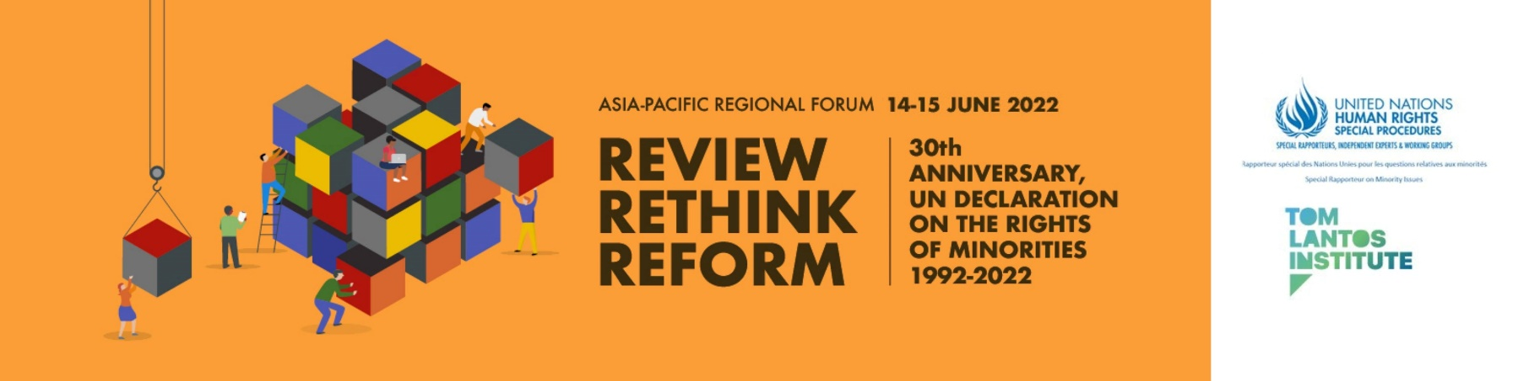

Programme of Work

(DRAFT – subject to change)

Day 1 14 June 2022
07:00-08:00 (UTC/GMT+02:00 - Geneva) Opening Session
10:00-11:00 (UTC/GMT+05:00 - Islamabad)
13:00-14:00 (UTC/GMT+08:00 - Kuala Lumpur)
17:00-18:00 (UTC/GMT+12:00 - Wellington)

Welcoming remarks

Anna-Mária Bíró, Director of the Tom Lantos Institute

Opening Remarks
TBC
Fernand de Varennes, United Nations Special Rapporteur on minority issues

Rules and Guide to Proceedings

Anna-Mária Bíró, Director of the Tom Lantos Institute, will set-out the process and explain the rules of proceedings for the forthcoming sessions.

08:00-08:30 (Geneva, UTC +2) Technical Break

08:30-10:30 (Geneva, UTC +2)
Thematic Session 1: Normative framework: existing norms and interpretations
11:30-13:30 (UTC/GMT+05:00 - Islamabad)
14:30-16:30 (UTC/GMT+08:00 - Kuala Lumpur)
18:30-20:30 (UTC/GMT+12:00 - Wellington)

Moderator: TBC

Panel: TBC

10:30-11:30 (UTC/GMT+02:00 - Geneva) Break

11:30-13:30 (UTC/GMT+02:00 - Geneva)
Thematic Session 2: Implementation: Institutions, Mechanisms, Policies, and Programmes
14:30-16:30 (UTC/GMT+05:00 - Islamabad)
17:30-19:30 (UTC/GMT+08:00 - Kuala Lumpur)
21:30-23:30 (UTC/GMT+12:00 - Wellington)

Moderator: TBC

Experts: TBC

Interactive dialogue

Day 2 15 June 2022

07:00-09:00 (UTC/GMT+02:00 - Geneva)
Thematic Session 3: Minority participation as a procedural and substantive right and process
10:00-12:00 (UTC/GMT+05:00 - Islamabad)
13:00-15:00 (UTC/GMT+08:00 - Kuala Lumpur)
17:00-19:00 ((UTC/GMT+12:00 - Wellington)

Moderator: TBC
Experts: TBC
Interactive dialogue

09:00-10:00 (UTC+02:00 – Geneva) Break

10:00-12:00 (UTC/GMT+02:00 - Geneva)
Thematic Session 4: Moving Forward: Reforming the Protection and Implementation of the Minority Rights Framework
13:00-15:00 (UTC/GMT+05:00 - Islamabad)
16:00-18:00 (UTC/GMT+08:00 - Kuala Lumpur)
20:00-22:00 (UTC/GMT+12:00 - Wellington)

Moderator: TBC
Experts: TBC

Interactive dialogue

12:00-13:00 (UTC/GMT+02:00 - Geneva) Break

13:00-13:30 (UTC/GMT+02:00 - Geneva) Presentation of Recommendations
16:00-16:30 (UTC/GMT+05:00 - Islamabad)
19:00-29:30 (UTC/GMT+08:00 - Kuala Lumpur))
23:00-23:30 (UTC/GMT+12:00 - Wellington)

In this session, the proposed recommendations developed during the four thematic sessions will be made available to participants to consider.
The session will be introduced by Fernand de Varennes, UN Special Rapporteur on minority issues, following which Marcus Oda, Programme Manager at the Tom Lantos Institute, will present the list of recommendations.
Participants can make any final comments on specific recommendations using the Zoom chat function.
Moderator: Anna-Mária Bíró, Director of the Tom Lantos Institute

13:30-14:00 (UTC/GMT+02:00 - Geneva) Concluding remarks
16:30-17:00 (UTC/GMT+05:00 - Islamabad)
19:30-20:00 (UTC/GMT+08:00 - Kuala Lumpur)
23:30-00:00 (UTC/GMT+12:00 - Wellington)

Fernand de Varennes, UN Special Rapporteur on Minority Issues

Simultaneous interpretation is anticipated in English and Bahasa Malay

