Reasonable Accomodation Request User Manual
Memo store form
United Nations Office of the High Commissioner for Human Rights

Contents
Revision History ii
Create a request for reasonable accommodation 0
Send the document to the reviewers 3
Submit the document for clearance: 4

Revision History

Author | Date | Purpose | Version
Wieland Jean-Marc | 28/09/2021 | Initial draft | 1.0

Create a request for reasonable accommodation
The request of reasonable accommodation has 3 steps :
- Reasonable accommodation form
- E-Memostore process
- Evaluation of reasonable accommodation
1. Reasonable accommodation form
Step 1: You will need to send the following link to the person requesting accommodation (« Requestor »)
Link: https://ohchr-survey.unog.ch/index.php/218271?lang=en
Step 2: With the information received, you will engage in an interactive dialogue with the person with disability concerned, where you will listen to their needs and you can identify a solution of support.
For example, a person may require assistance for travel, higher class of travel, assistive technology to participate in a meeting, sign interpretation, among others.
Step 3: Once you have agreed to the support solution, you will initiate the E-Memostore process
2. EMemostore process
The memo store can be accessed from the following urls :
MemoStore (msappproxy.net) with the Multi Factor Authentication (MFA) with your OHCHRAPPS credential.
MemoStore (ohchr.org) from the Office or with the VPN with your OHCHR credential.
Do not use your UN.ORG account.The home page displays statistics of documents in draft, clearance, approved and rejected.
In the ‘create correspondence page’, you can initiate a new correspondence.
There are four steps to generate the document.
1st Step: Enter basic information
- Subject - Type a subject that will help you identify and search your correspondence.
- Section - This information will be automatically selected; based on your user profile in the Access Control management system (ACM).
- Select “Reasonable accommodation” as document category, “Reasonable accommodation” as document sub category, and “Request for reasonable accommodation” as action (type of document), and the language of the document that you wish to create.
- Document Reviewers - is optional; this could be any OHCHR staff that will have read/edit access rights on the request and the related documents while it’s status is ‘Draft’ or ‘Rejected’.
- Select approver for stage 1 - Select the different groups of approvers for the different stages. It is mandatory to add approvers for at least one stage. After selecting the 1st approver, click on “Add stage 1 approver” button to be able to select the 2nd approver then you will be able to select the 3rd one.
It is possible to remove/modify only the latest approver. For example. If you have 3 approvers, and you wish to delete the 2nd one, you will have to first delete the 3rd approver, then you will have the option to remove the 2nd approver and select a new one. Then you can again add the 3rd approver.
- Once you have completed all information, click in the “Next step” button.
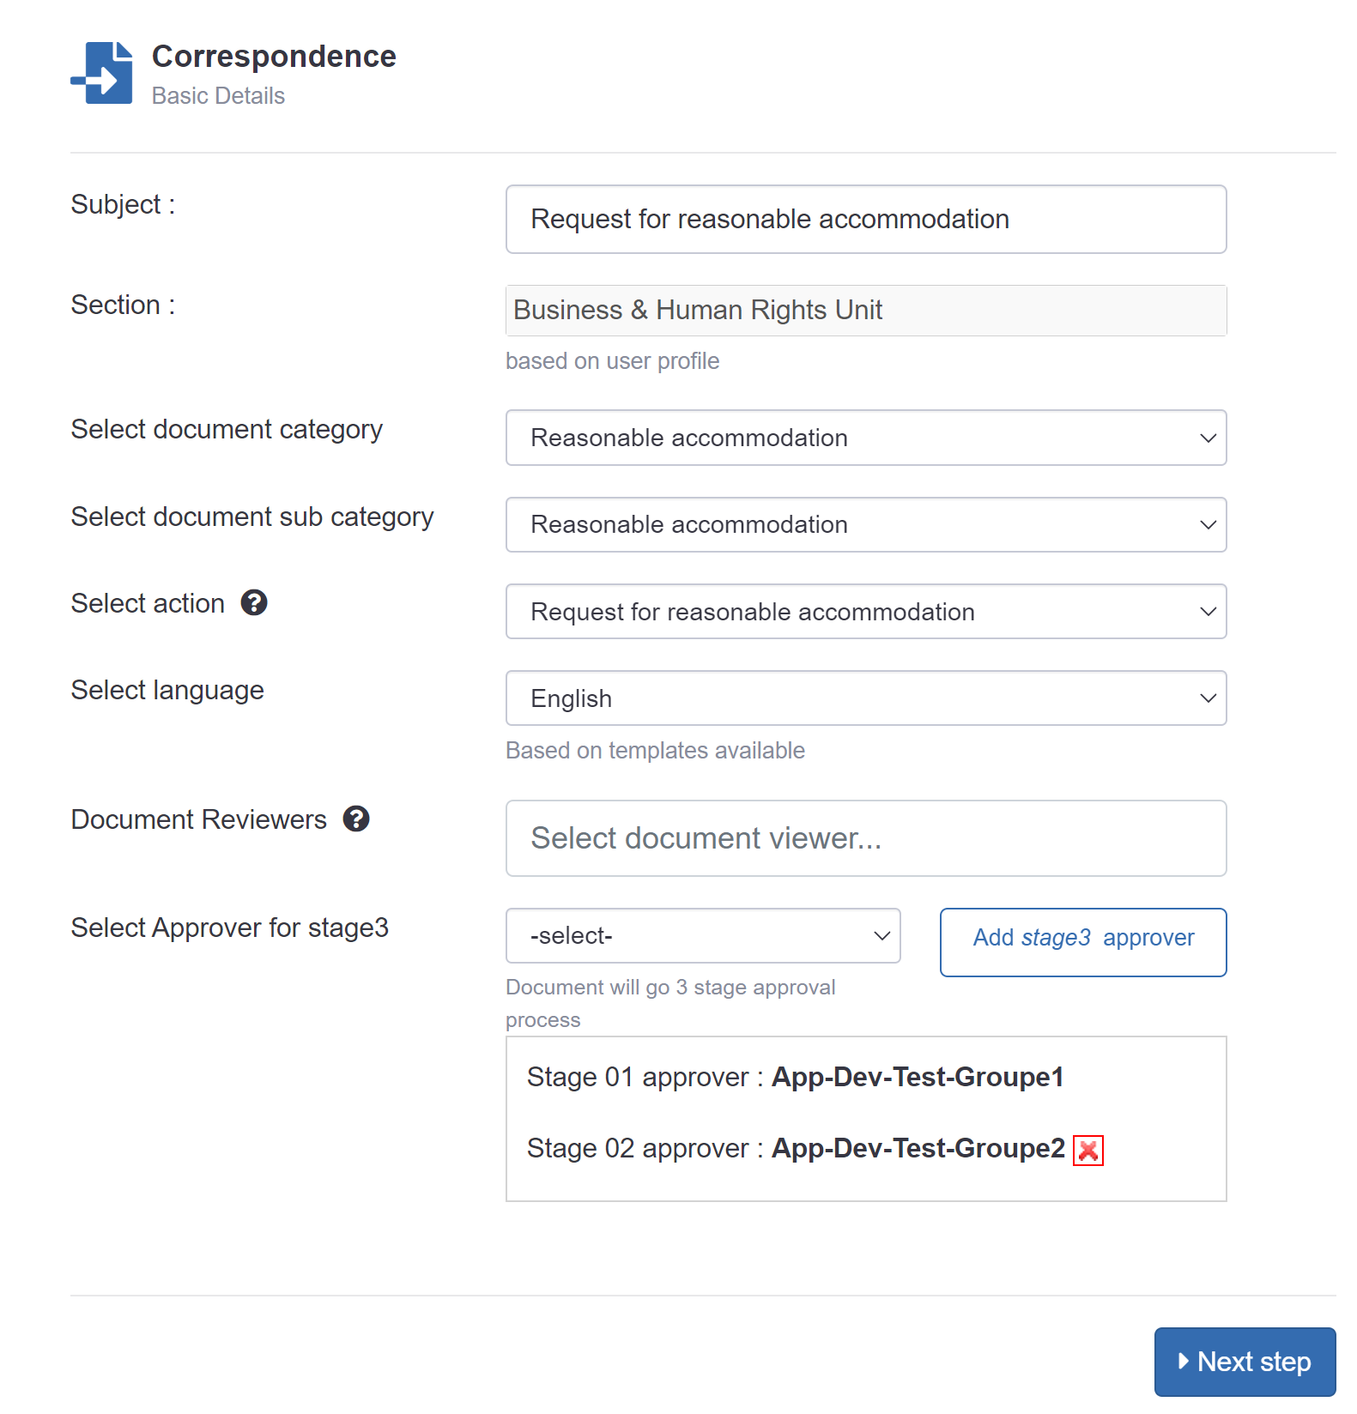
2nd Step: Information required for the Memo
In the second step, you are prompted to enter information specific to the request. The information you enter here will populate the Word document when generated. The fields with the red asterisk * are mandatory.
First Name of Originator: free text field
Last Name of Originator: free text field
Email of Originator: free text field
Role of Originator: free text field
Section of Originator: drop down list
Branch of Originator: drop down list
Division of Originator: drop down list
Location of Originator: free text field
Email of Requestor: free text field
First Name of Requestor: free text field
Last Name of Requestor: free text field
Status of Requestor: free text field
If staff member, intern or consultant, position and section: free text field
Adapted schedule: free text field
Adapted space: free text field
Adapted equipment: free text field
Software (e.g. screen reader Jaws): free text field
Hardware or equipment (Braille typewriter): free text field
Adapted travel arrangments: free text field
Live support (e.g. personal assisstant): free text field
Other (please specify): free text field
Any other relevant details regarding the request: free text field
Was there an ‘interactive dialogue’ or exchange (e.g. email exchange, minutes of a meeting, etc.) with the individual making the request?: drop down list (Yes/No) with free text field

Once you have completed the form, click on the “Next step” button.
3rd Step: Attachments
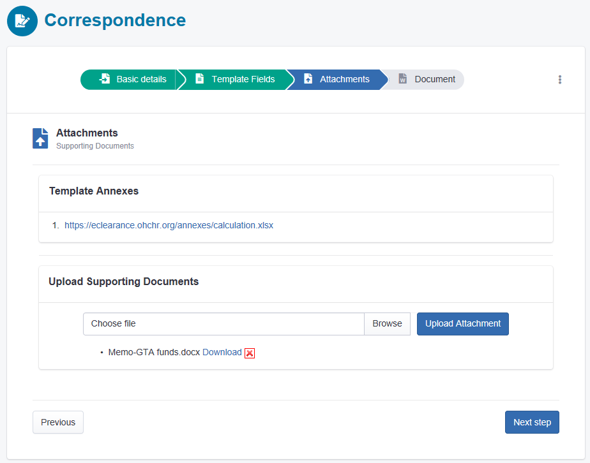
In the third step, you have the option to upload one or more attachments. The reviewers and the approvers you selected in the first step will be able to see the attachments. Then click on the “Next step” button.
4th Step: Generate Correspondence
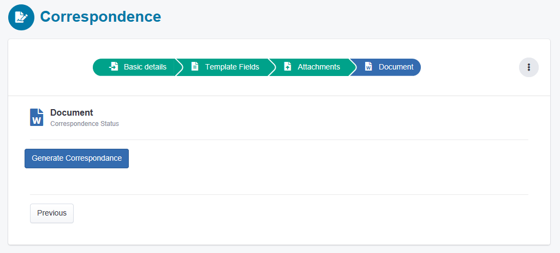
Now that you have completed all the necessary information, click the button “Generate Correspondence” to generate the document.
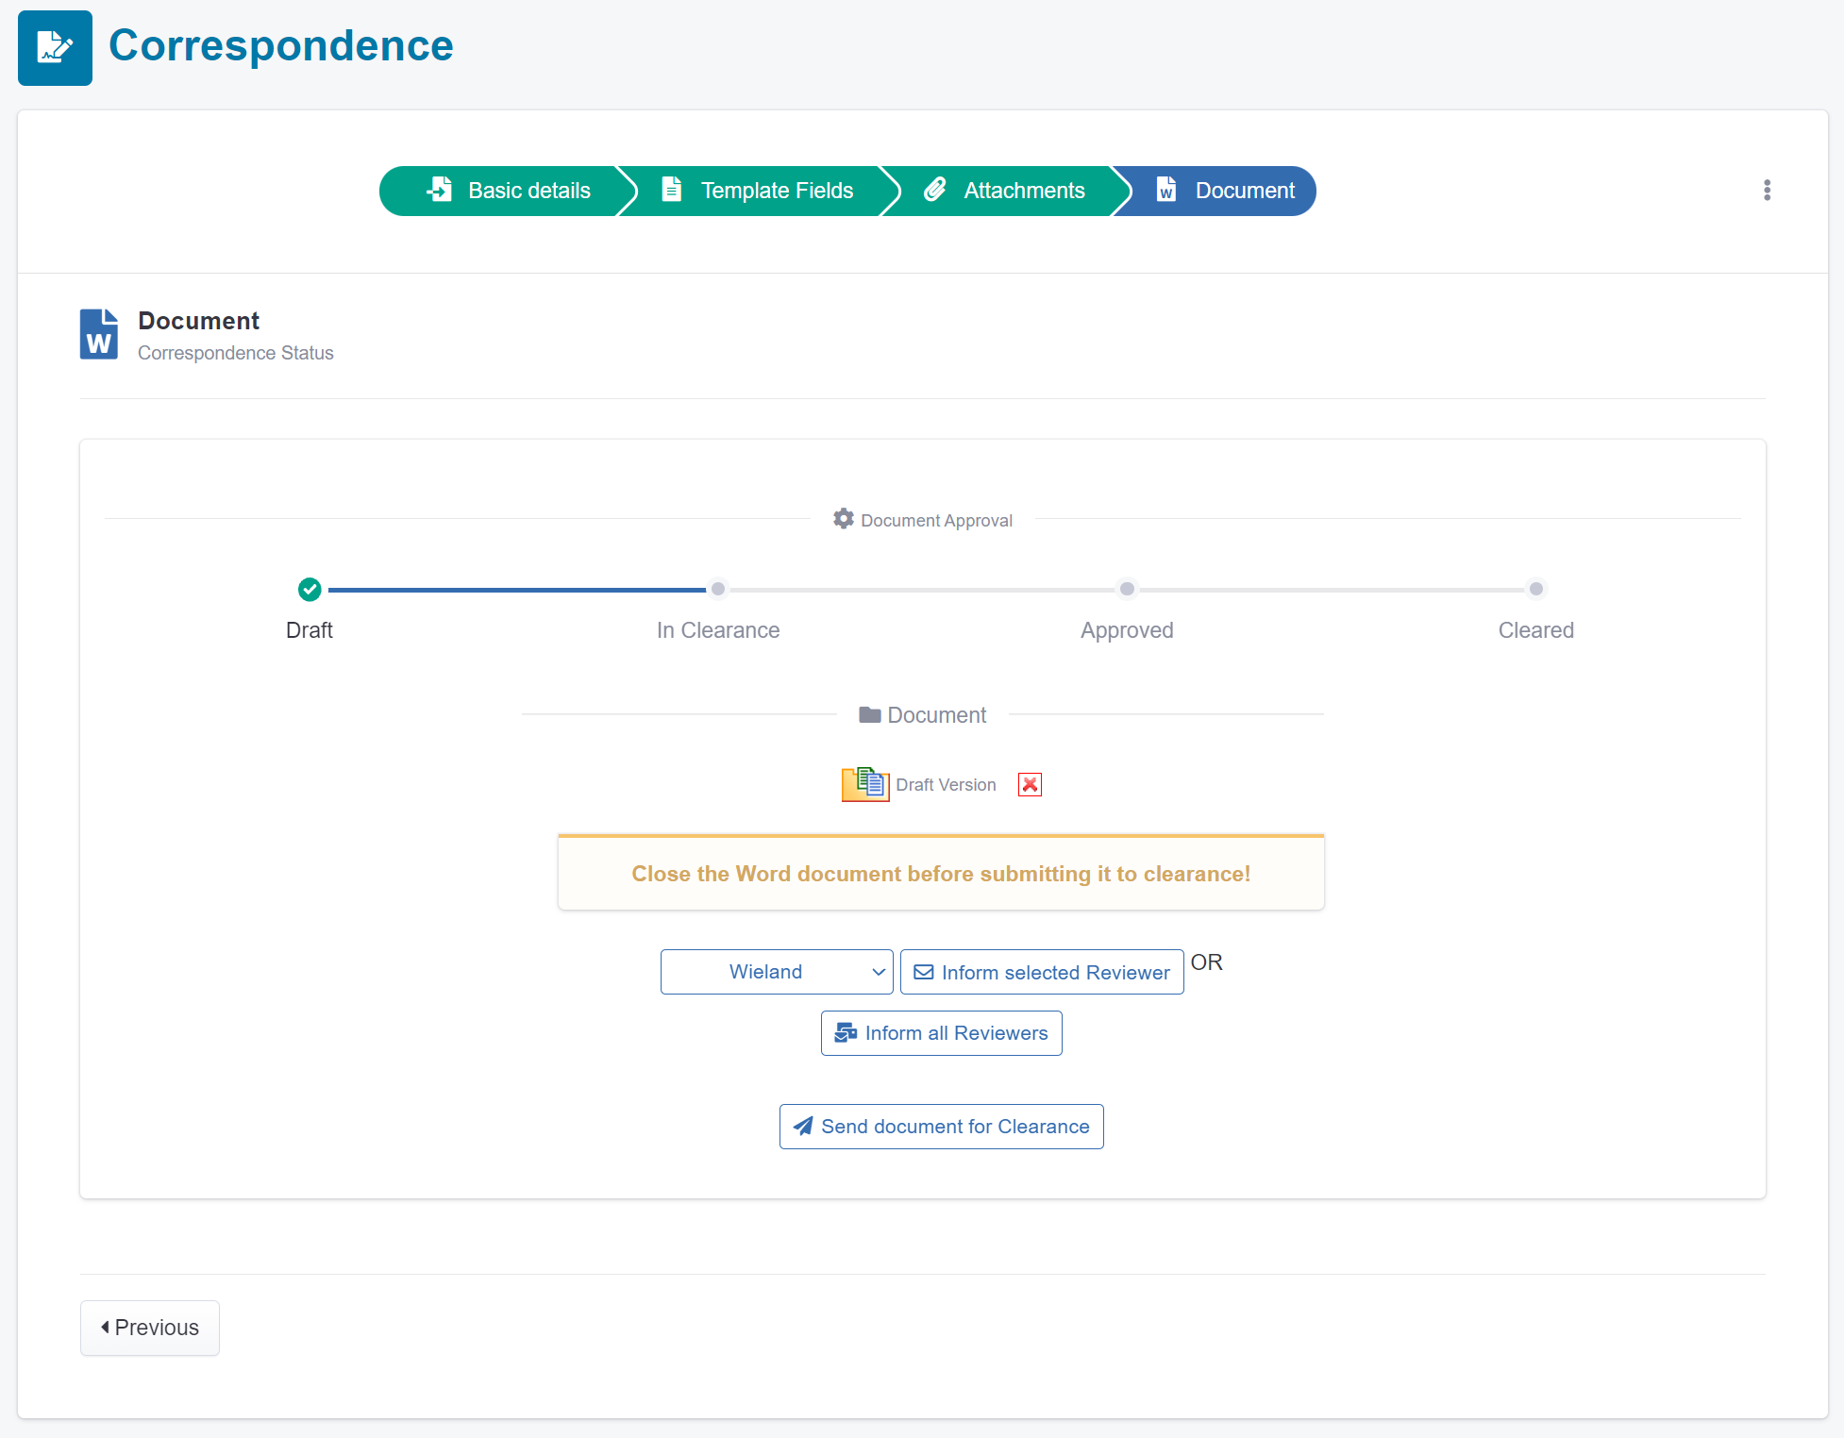
Once generated, you can edit the document:
- Click the icon “Draft version” to open the document in Microsoft Word where you can work on it.
- Once you have finalized the document, click the save button in Word and wait for it to finish saving back to SharePoint before closing Microsoft Word.
Send the document to the reviewers:
- You can send the document to all reviewers at once by clicking the button “Inform all reviewers” or you can send it to each reviewer separately by selecting the reviewer and clicking the button “inform selected reviewer”.
IMPORTANT: The reviewers can edit the documents only when it has the status “Draft” or “Rejected”. Once it is in clearance, they can only open it in read only mode.
Moreover, it is not a multi editing system, only one reviewer can edit the document at a time.
The reviewers will receive an email with a link to open the Word document. Once they have completed the review they will send you an email.

Submit the document for clearance:
IMPORTANT: Close the document before submitting it for clearance, because SharePoint locks the document when still open, and the system will not be able to submit the document to the 1st approver.
- Click the button “Send document for Clearance”. The document will be submitted to the 3-signature approval and the 1st approver will be notified by email that a document is pending approval. And it will no longer be possible to edit the document.
If the document is rejected, the drafter will be notified by email and the file will be available for editing. Open it in Word and you will see the comments made by the approver in the track changes. Then re-submit the document when it is ready.
On the screen you will see the status of your document. The page displays also the history of your document in the 3-signatures system.
Once the last approver has approved the document, then the signatures of the different approvers will be added to the document and it will be converted to pdf and returned to the Memo Store. The drafter will be notified by email that the document has been approved.
Important: The Memo Store will only keep your document for 30 days after it has been cleared. Then it will be automatically be deleted. It is your responsibility to move it to a Share drive.

3. Evaluation of the reasonable accommodation request
The requestors will have an opportunity to evaluate the service provided by the office. The originator should send the following evaluation online form link to the requestor.
Link: https://ohchr-survey.unog.ch/index.php/228486?lang=en

“requestor” is the person with disability requiring the accommodation
“status” be: participant, mandate holder, staff, intern, consultant, etc.

