19 February 2022

Office of the High Commissioner for Human Rights
Via e-mail: lynn.gentile@un.org
Re: Call for inputs into the High Commissioner’s report on Human rights in the context of HIV and AIDS (pursuant to Human Rights Council resolution 47/14)
Dear High Commissioner Michelle Bachelet,

In the spirit of community and civil society inclusion, the Love Alliance welcomes the opportunity to provide input to the Human Rights in the context of HIV and AIDS Report of the United Nations High Commissioner for Human Rights (pursuant to Human Rights Council Resolution 47/14 Human Rights in the Context of HIV and AIDS), to be presented to the Human Rights Council at its 50th Session.

The Love Alliance is a strategic partnership of seven community-led organisations that are part of local, national, regional and global movements of LGBTIQ+, sex worker, people who use drugs and people living with HIV (PLHIV), working with the Global Network of People Living with HIV (GNP+) and Aidsfonds. To inform the High Commissioner’s report, our input reflects on the current gaps in the HIV response in terms of human rights and recommendations to take the 10-10-10 targets on societal enablers outlined in the Resolution from global rhetoric to national realities.

Human Rights as the key to the HIV response’s success:
As outlined in the Resolution, we have always known the link between HIV and human rights in terms of enabling access to health services and to fully realise the right to health. At the 2021 High Level Meeting on HIV, we campaigned tirelessly for the elimination of the structural barriers in the HIV response. We thus welcomed the commitment of the 10-10-10 targets on societal enablers and the target that 60% of these programmes should be delivered by community-led organisations.

Research by our partners at the HIV Policy Lab’s shows that the world is lagging behind on the 10-10-10 targets globally, while the evidence to support policy change is clear: structural barriers, criminal laws and discrimination hinder the HIV response and outcomes for people living with HIV and key populations (sex workers, LGQBTI and people who use drugs). A study found that in countries where same-sex sexual acts were criminalised, the portion of PLHIV who knew their HIV status was 11% lower and viral suppression levels 8% lower. Sex work criminalisation was associated with 10% lower knowledge of status and 6% lower viral suppression. Drug use criminalisation was associated with 14% lower levels of both. Criminalising all three of these areas was associated with approximately 18%–24% worse outcomes.

We also know that 62% of new HIV infections being in key populations, including sex workers, drug users, transgender people and men who have sex with men, and yet, less than 2% of funding for HIV programmes target key populations.

The role of communities and civil society in the HIV response cannot be overstated. Globally, community groups and civil society have proved to be critical in advancing the HIV and AIDS agenda by improving access to services, supporting prevention and treatment services and programmes, advocating for financial resources, improving HIV and AIDS governance and programming, and moving forward on human rights issues.

Despite this vital role, evidence shows that key populations, communities and civil society organisations face structural, institutional and social challenges, restrictions and violations which negatively affect their rights to assemble, associate and express themselves while responding to HIV and AIDS in closing civic space. In only 76 countries (39%) are NGOs and civil society organisations able to register, seek funding and operate freely under national law. These restrictions of civic space and community leadership threaten the achievement of the 10-10-10 targets and must be addressed urgently.

We make the following recommendations to realise the laudable 10-10-10 targets on societal enablers:

Direct funding for Communities and Key Populations:
Communities are the best placed to deliver programmes that address the social barriers they are facing, but these programmes must be financed. After forty years, there is ample evidence that the way to reach key populations and those in situations of vulnerability is through programmes led by those populations. Strong links between community-led programmes and systems for health and social protection can achieve better outcomes for those left furthest behind.

The 30-80-60 targets on community service delivery outlined in the Global AIDS Strategy aims for 60% of societal enabler programmes to be delivered by community-led organisations However, many countries do not finance community-led organisations or human rights programming. For the 10-10-10 targets to be realised, financing institutions such as the Global Fund, PEPFAR and individual donors will need to lead in financing work in-country on these programmes. This could be achieved by portioning funds for this work and to be directed to community groups directly, or all country proposals being required to include a minimum of human rights programming, or through strategic initiatives that provide direct funding to communities.

Coordination and accountability from global to local:
There is an urgent need to focus all the stakeholders’ attention now on the level of investments and accountability mechanisms required to meet the 10-10-10 targets at a national level. This will require stakeholders coming together in-country to estimate the country-specific funding to know what actions and financial gaps are needed to achieve them at national level.

We call on each country to convene relevant stakeholders including governments, UNAIDS country and regional offices and communities and civil society to map out these needs. Such national translation of global targets would not only provide the baseline for progress monitoring but would also assess gaps and barriers to such progress, including financial gaps. We also recommend that countries update their National Strategic Plans for HIV and/or Human Rights Plans to reflect the ambitions of the 10-10-10 targets.

In addition, there is a need for functional accountability for investments and progress to enact political commitments taken by Member States in the 2021 Political Declaration on HIV/AIDS. Current accountability mechanisms must be reviewed at national and global levels to establish if new functional accountability mechanisms need to be introduced or existing accountability mechanisms at national and global levels need to evolve to ensure timely progress towards and investments in the 10-10-10 targets and to address “roadblocks” preventing progress and generation of collective solutions to removing any barriers.

Community-Led Monitoring:
Communities can play a crucial role in accountability mechanisms through community-led monitoring. For the 10-10-10 targets to be reached globally, functional progress review and accountability mechanisms to track the achievement of the global targets at national level must be established. Governments, donors and institutions such as PEPFAR and the Global Fund must directly invest in community-led responses and community-led monitoring of service, policies and investments, so that communities are an essential part of the accountability mechanisms and process.

Decriminalisation:
Despite the harms of the criminalisation of HIV and key populations, the world is lagging behind dismally in removing laws that create legal barriers and discrimination. Research by the HIV Policy Lab shows that in only 56% (109 countries) is same-sex sex not criminalised. 77% of countries criminalise sex work and 88% of countries criminalise drug use, while 23% of countries have not adopted national laws or policies that include protections from discrimination on the basis of sexual orientation, gender identity and HIV status.

We call on global financing institutions and donors to use their diplomatic voice to advocate for countries to remove these legal barriers and discriminatory laws, and for advocacy for decriminalisation by community-led organisation to be financed to ensure the 10-10-10 targets are realised.

In conclusion, the 10-10-10 targets on societal enablers and their sub-targets clearly outline the actions that are needed to be taken to eliminate all human rights barriers in the HIV response. We know that legal barriers and harmful norms hinder progress and that communities are best placed to implement advocacy and programmes to address these. There is a myriad of examples of where and how this has worked, which we are always available to provide further evidence and resources of. What is needed now is the financing and political will to translate these targets at the national level from targets to realities.

We wish the High Commissioner all the best in the compilation of this report.

Sincerely,

The Love Alliance
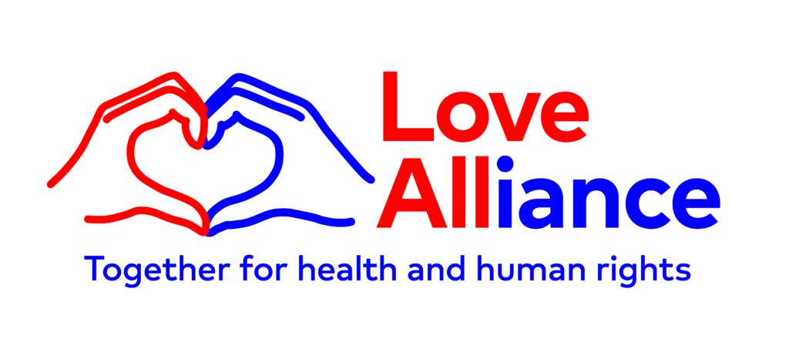

The Love Alliance is made up of GALZ, SANPUD, Sisonke, UHAI EASHRI, AFE, ISDAO, Global Network of People Living With HIV (GNP+) and Aidsfonds.
Kavanagh, M. et al. Law, criminalisation and HIV in the world: have countries that criminalise achieved more or less successful pandemic response? BMJ Global Health 2021 Vol. 6 Issue 8. Available at: https://gh.bmj.com/content/6/8/e006315.info
PITCH, Bridging the Gaps, Aidsfonds. 2019. Fast-track or Off-track?: How insufficient funding for key populations jeapordises ending AIDS by 2030. Available at:https://aidsfonds.org/assets/resource/file/AF%20off-track%20report_A4_V2_I%20%289%29.pdf
CIVICUS, PITCH, Aidsfonds, Frontline AIDS and the Ministry of Foreign Affairs of the Government of The Netherlands, Activism and AIDS: Protect Civil Society’s Space to end the Epidemic. 2020. Available at: https://aidsfonds.org/assets/resource/file/HIV%20Report%20final_0.pdf
https://hivpolicylab.org/map/

