Human Rights and the Global Fund

Background

History: Human rights have a long history at the Global Fund. Already in the Global Fund’s Framework Agreement, human rights principles are firmly embedded. Since 2012, they have been a strategic priority. In the 2017 to 2022 strategy, promotion and protection of human rights is, together with gender equality, one of four strategic objectives.

Focus: To deliver on this strategic objective, since 2017 we have been focusing on the one area in which the Global Fund is uniquely positioned to make a major difference: efforts to introduce and scale up programs that have been shown to reduce human rights-related barriers to services. For the first time in the history of the response to the diseases, we are attempting to move from ad hoc, small scale investments in programs to reduce human rights-related barriers to services to evidence-based, integrated and comprehensive programming.

Until that point, a lot of work had already been done to integrate human rights considerations into the grant cycle and to ensure that the Global Fund does not fund programs that infringe human rights. However, what we had been less successful in doing was to increase investment in programs to reduce human rights-related barriers to services. In NFM1, only 0.7% of Global Fund investments in HIV were going to these programs. For TB, only 0.08% of investments.

Relevance: As a health financing institution we fund concrete programs and initiatives that have been demonstrated to reduce human rights-related barriers to health services not only because it is the right thing to do, but primarily because removing these barriers increases the impact of our investments, by increasing uptake of services as well as retention in them. We are acutely aware that until human rights (and gender)-related barriers to access are overcome, many of the communities we serve will remain unable to realize their right to health and have inequitable access to health. This work is therefore not a nice to do but rather a must do.

Approach: While doing this work, at each step of the way, we are guided by the vision of ensuring a better and safer experience for communities on the ground – including those who are often the most marginalized, criminalized or left behind in current responses. Throughout the process, working alongside these communities, as well as broader stakeholders, is central to our approach.

Our approach is practical and it is programmatic and pragmatic. It recognizes what the Global Fund can and cannot hope to achieve in terms of promoting and protecting human rights.

Key components

The Breaking Down Barriers Initiative
Since 2017, the Global Fund to Fight AIDS, TB and Malaria (Global Fund) has implemented a bold initiative to translate human rights principles into concrete programmes that have actual impact in the lives of those affected by HIV, TB and malaria. This initiative, the Global Fund Breaking Down Barriers initiative, seeks for the first time ever to fund and implement at scale programmes that remove human rights-related barriers to HIV, TB and malaria health services. By taking such programmes to scale, the Global Fund supports countries to have the means by which to meet the targets of less than 10% of countries having punitive legal and policy environments that deny or limit access to services; less than 10% of people living with HIV and key populations experiencing stigma and discrimination; and less than 10% of women, girls, people living with HIV and key populations experiencing gender inequality and violence.

Building on years of experience with the AIDS epidemic, the Global Fund, with partners, has identified the main human rights-related barriers to HIV services: stigma and discrimination; punitive laws, policies, and practices; gender inequality and gender-based violence; and poverty and socio-economic inequality. The human rights programmes that have proved to be effective in removing these barriers have been recognized by UNAIDS, civil society and others, and have been committed to by States in the Political Declarations on HIV/AIDS. They comprise: stigma and discrimination reduction; training for health care providers on human rights and medical ethics; sensitization of lawmakers and law enforcement agents; legal literacy (“know your rights”); legal services; monitoring and reforming laws, regulations and policies relating to the diseases; and reducing HIV-related gender discrimination, harmful gender norms and violence against women and girls in all their diversity. These can be and are being implemented for and by people living with HIV, women and girls, sex workers, people who use drugs, LGBTI persons, prisoners, migrants, refugees and internally displaced persons, indigenous populations and the disabled.

For many years of the HIV epidemic, NGOs and community-based organizations were implementing these programmes without sufficient political and financial support. Their efforts, though laudatory, were often ad hoc, small-scale and not integrated into national HIV prevention and treatment strategies. Thus, these efforts had little chance of significant impact, and human rights action in the context of HIV remained largely rhetorical. Through the Breaking Down Barriers initiative, the Global Fund seeks to change that by funding these programmes at national scale and documenting their impact.

The Breaking Down Barriers initiative has supported the following action: (a) documented the human rights-related barriers experienced by key and vulnerable populations and the programmes already in place to address them; (b) defined what a comprehensive response would look like and supported countries to develop a comprehensive plan; (c) supported countries to build a human rights culture, context and funding stream that will result in programmes being implemented strategically at scale and of quality; (d) documented at mid-term of the initiative lessons learned and impact as countries move toward a comprehensive response; and (e) provided technical guidance and support to countries on how to implement and take to scale these human rights programmes. All documents related to the initiative, whether baseline or mid-term assessments or the plans/strategies to reduce human rights-related barriers to HIV and often also TB services that countries have adopted can be accessed via https://www.theglobalfund.org/en/human-rights/.

As the initiative has progressed, countries have increasingly owned this human rights programming. They have provided significant national funds to match catalytic funds offered by the Global Fund (see Figure 1), have held multi-stakeholder meetings to agree on a comprehensive human rights plan and have put in place technical working groups to provide oversight of the roll out of the comprehensive plans to remove human rights-related barriers.

The programmes being taken to scale are designed to empower both rights-holders and duty-bearers, particularly people living with HIV, women and girls and other key and vulnerable populations. They are most effective when implemented in combination and as part of the national strategies to reach key and vulnerable populations with HIV prevention and treatment. For instance, to reduce stigma and discrimination in health settings the Global Fund promotes implementation of the following programmes in combination: (a) training of health care workers on human rights and medical ethics; (b) development of patients’ rights materials and human rights literacy programmes; (c) community-based monitoring of health care delivery; and (d) deployment of peer human rights and HIV educators who work with communities and support people to take up prevention and treatment and to secure their human rights.

In the 20 countries part of the Breaking Down Barriers initiative, Global Fund investments in programs to reduce human rights-related barriers have increased more than 10-fold, with an increase from 10.6 million in the Global Fund’s 2014-16 funding cycle (NFM1) to 78.2 million in 2017-19 (NFM2) to approximately 130 million in 2020-22 (NFM3).

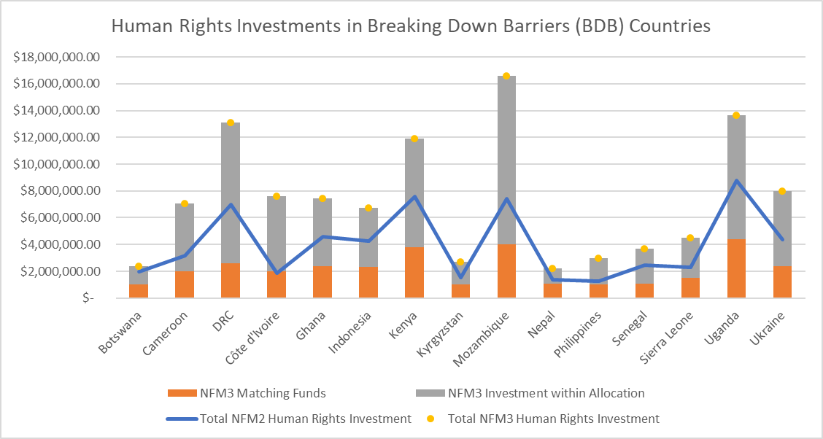
Figure 1: NFM3 human rights investments in 15 Breaking Down Barriers (BDB) initiative countries, disaggregated by investment within allocation and supplementary matching fund, compared with NFM2 human rights investments.

Never before has there been this much funding to support the implementation of comprehensive programs to remove human rights-related barriers to HIV. Progress towards the achievement of comprehensive programs is being tracked through: (a) milestones that include both process and results; (b) a scorecard completed for each program area at the time of baseline, mid-term and end-term assessments; and (c) proxy quantitative indicators. As demonstrated by the aggregated scores below and compared against baseline scores, all 20 (100%) BDB countries demonstrated significant progress between baseline and mid-term for both HIV and TB-related programs. On average, HIV-related human rights programs had progressed from 1.7 (one-off activities) to 2.6 (ongoing, small-scale activities.
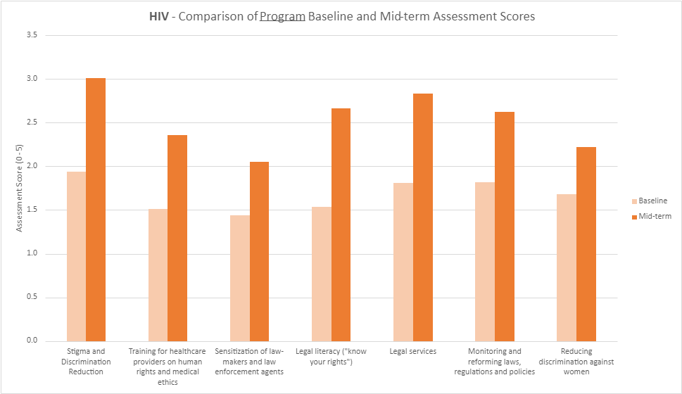
Figure 2: Comparison of human rights program scoring between baseline and midterm, for HIV, as an average score across all Breaking Down Barriers (BDB) initiative countries.
Mid-term assessments also documented emerging evidence of impact in the form of implementer case studies. Case studies have highlighted efforts to address criminalization, strengthen anti-discrimination laws, improve the legal landscape around harm reduction programs, work with law enforcement, and engage community representatives in dialogue on stigma and discrimination. All documented cases benefited from increased engagement of civil society organizations and representatives of key population who have been critical in steering activities at community, subnational and national levels. Two other drivers of success in these areas have been the identification of senior government officials or law enforcement officers whose leadership has positively influenced members of their institutions, as well as earmarked financing for the establishment and scale-up of dedicated human rights programming.

COVID-19 continues to disrupt interventions that address human rights-related barriers to HIV and TB services and to divert the efforts and focus of national partners. The risk of underperformance is real in many contexts, particularly where rights-related barriers have increased due to pandemic-related policies and practices. In 2022, a number of actions are being taken to mitigate the impact of COVID-19, as well as to respond to arising bottlenecks or opportunities for improved performance. These include:
- The Global Fund continues to scale-up the provision of technical assistance to implementers of programs to reduce human rights-related barriers.
- The Global Fund will host a regular community of practice for human rights technical assistance providers to facilitate south-south learning and collaboration between implementers as a means of strengthening sustainable and local solutions.
- The Global Fund will continue to leverage partnerships, such as through the Global Fund’s co-convening of the Global Partnership, and leadership within the new Focal Countries Collaboration with PEPFAR and UNAIDS.
- The Global Fund will conduct comprehensive end-term assessments in late 2022 to early 2023 to document impact and outcomes of scale-up, as well as to inform country-level action planning and further Global Fund funding requests.

Beyond the Breaking Down Barriers initiative
Beyond that, efforts have focused on scaling up programming to reduce human rights-related barriers to HIV services across the full Global Fund portfolio (with a KPI 9b target of 2.85% of the HIV allocation in MICs going to such programs in NFM2 (compared to 0.7% in NFM1); and a revised target of 3% of the HIV allocation across the portfolio going to such programs in NFM3). As of January 2022, this target was being met. The level of investment in the 90 countries that had Board-approved grants by that time (representing 90% of the entire investment) increased to 3.03%, compared to 1.73% in the 2017-2019 allocation cycle. In absolute terms, this translated into an increase from $87m in 2017-2019 to $172m in 2020-2022.

From the outset, the effort to scale up programming to reduce human rights-related barriers has also included TB, with a particularly ambitious (in light of the baseline of 0.08%) KPI 9b target of 2% of the TB allocation in a subset of TB priority countries going to programs to reduce human rights-related barriers to TB services in NFM2, and the same target, but for a larger cohort, aligned with the TB Missing People SI, in NFM3.

Another key component of the human rights work has been an effort aimed at ultimately increasing domestic spending on human rights programs and key population prevention programs, which is key to the sustainability of these programs. At first, this effort focused on establishing a baseline in a subset of countries. More recently, as the related KPI 9c target was recalibrated, it shifted to establishing benchmarks and targets for human rights and key population prevention domestic spending and to undertaking efforts at country level to ensure these are met.

Finally, other important strands of work have focused, among other things, on responding to human rights crisis situations, with a focus on ensuring safety and security of clients and providers of Global Fund-funded services and on continuing such services, wherever possible; and on work with the Risk Department to update the human rights risk categories and root causes and develop indicators for informing risk assessment, as well as mitigation actions to reduce human rights risk.

Moving forward: An Even Greater Focus on Human Rights in the new Global Fund Strategy (2023-28)

Broadly speaking, the input received during consultations for the next Global Fund Strategy was that the Global Fund should further increase its emphasis on protecting and promoting human rights and gender equality and have a greater focus on health equity.

Many called for greater attention to and support for
- programs that address stigma and discrimination
- efforts to remove laws, policies and practices that are criminalizing, discriminatory, and/or increase vulnerability or create other barriers to an effective response against the diseases
- policies, programs and practices that promote gender equality.

Many called for “scaling up” the Breaking Down Barriers initiative.

There was universal recognition that reducing stigma and discrimination, increasing access to justice, and most of all, removing criminal and other punitive laws and policies takes time and a sustained effort.

As a result, in the new Strategy that was adopted by the Board in November 2021, human rights features under the primary goal, “End AIDS, TB and malaria”, as a sub-objective under HIV (as well as TB and malaria).

For HIV, the sub-objective reads as follows: “Advocate for and promote legislative, practice, program and policy changes to reduce HIV-related stigma, discrimination, criminalization, other barriers and inequalities and uphold the rights of PLHIV and KVPs”

Human rights also feature as one of the “mutually reinforcing contributory objectives “, namely “Maximizing health equity, gender equality and human rights”, with the following sub-objectives:
- Scaling up comprehensive programs and approaches to remove human rights and gender-related barriers across the portfolio
- Supporting comprehensive SRHR programs and their strengthened integration with HIV services for women in all their diversity and their partners
- Advancing youth-responsive programming including for AGYW and young KVPs and their partners
- Deploying quantitative and qualitative date to identify drivers of HTM inequity and inform targeted responses, including by gender, age, geography, income and for KVPs
- Leveraging the Global Fund`s diplomatic voice to challenge laws, policies and practices that limit impact on HTM

See Political Declaration on HIV/AIDS (2011, 2016, 2021); Key Programmes to Reduce Stigma and Discrimination and Increase Access to Justice in National HIV Responses, Guidance Note, UNAIDS/JC2339E (English original, May 2012); ISBN: 978-92-9173-962-2.
Additional programs for TB include: mobilizing and empowering patient and community groups; ensuring privacy and confidentiality; interventions in prisons and other closed settings; and reducing gender-related barriers to TB services.
See Global Fund Technical Brief on HIV, Human Rights and Gender Equality, at https://www.theglobalfund.org/media/6348/core_hivhumanrightsgenderequality_technicalbrief_en.pdf
Comprehensive” programs have been defined by the Global Fund Technical Working Group on Human Rights Monitoring and Evaluation as programs that: (a) comprise a set of activities that are internationally recognized as effective in reducing human rights-related barriers to health; (b) are accessible or serve the majority of the estimated numbers of key and vulnerable populations affected by such barriers; and (c) are adequately resourced to move from non-existence or one-off/small-scale activities to a level of implementation likely to significantly reduce human rights-related barriers to services (a sustained, mutually-reinforcing, broadly protective package at scale).

