The Kyrgyz Republic is a landlocked country in Central Asia, whose economy is heavily dependent on labor migration and remittances, which, in turn, affect poverty and the food security situation in the country through several channels. In addition to remittances, migration contributes to the sustainability and development of communities, and is also an important strategy used by households to overcome the risks of income uncertainty and food insecurity.
A study of the socio-economic consequences of the COVID-19 pandemic for returning migrants in the Kyrgyz Republic showed that the pandemic had a negative impact on migrants and their families in the form of border closures and temporary business closures, reduced their opportunities for income-generating activities, and deprived them of food security. It is obvious that more effective management of remittances, provision of livelihood opportunities for returned migrants and households dependent on remittances, can contribute not only to the immediate reduction of poverty and food insecurity, but also to ensuring sustainable livelihoods and improving food security and nutrition of migrants and their families in the long term.
By improving employment opportunities, vocational training and financial integration of migrants and their families, as well as through regular research and monitoring of migration, food security and nutrition, IOM and WFP together see socio-economic stability and prosperity in the Kyrgyz Republic.
External migration. The population of the Kyrgyz Republic is 6.6 million people, and by 2020 774,000 Kyrgyz citizens lived outside the country. Approximately 800,000 to 1,000,000 Kyrgyz citizens (about 40 percent of the country's workforce) regularly work abroad, while about 50,000 Kyrgyzstanis leave the country for work every year. They work in various sectors, including retail, hotels, restaurants, taxi services, construction and agriculture. About 76% are under 35 years of age and 53% are women.6 Female migrant workers mainly work in the service sector, catering, clothing production and as domestic workers.
Migrants go to the Russian Federation and, to a lesser extent, to Kazakhstan and Turkey. The main reasons that Russia and Kazakhstan are preferred destinations are geographical proximity, language, relatively less competition in employment and strong diaspora networks. In addition, the widespread practice of informal employment exposes migrant workers to the risk of exploitation and abuse, including human trafficking.
Analysis of problems and solutions and further joint actions
In order to better understand the complexity and interrelationship of migration, food security and nutrition, an analytical tool for problems and solutions was used. Problem diagram (Fig. 3)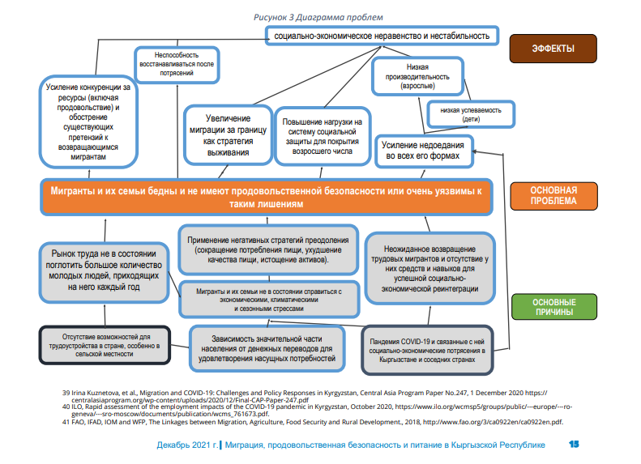 It helps us to identify the main root causes and consequences of poverty and food insecurity of migrants and their families. As explained in sections 1 and 2, the lack of employment opportunities in the country, dependence on remittances and socio-economic shocks caused by the pandemic are the main factors of poverty, food insecurity and the general vulnerability of migrants and their families. This can seriously affect their nutrition and ability to recover further, making them dependent on the social protection systems of a country that currently does not have sufficient capacity to fully support migrants and their families (for example, there is no registry for returned migrants). Moreover, this vulnerability may lead to an increase in (i) the need to find a livelihood elsewhere, which will lead to a potential increase in unregulated migration, and (ii) competition for resources in the country, exacerbating discontent with returning migrants. IOM and WFP are the leading UN agencies in the field of migration and food security and nutrition. In Kyrgyzstan, for more than a decade, IOM and WFP have been actively engaged in providing assistance to vulnerable populations through various types of direct assistance and training, including food and cash distribution, reintegration assistance and skills acquisition. The combined efforts of IOM and WFP will be able to create synergies in addressing the root causes of food insecurity among migrants and their families, such as poverty and lack of systematic inclusion. Therefore, IOM and WFP are joining forces to address the specific vulnerability of returned migrants
and migrant families (Figure 4). Areas of work may include: 1) Providing reintegration support to returned migrants, including support in improving their skills to have better employment opportunities abroad; 2) Creating new income opportunities for households dependent on remittances to improve their livelihood opportunities and resilience to shocks, including the termination or reduction of remittances; 3) Increasing the financial involvement of migrants and their families and investing remittances in sustainable agriculture, rural development, adaptation to climate change and sustainable livelihoods can also solve the problem of unfavorable factors of migration from rural areas (i.e. rural poverty, food insecurity, lack of opportunities for decent work, inequality, depletion of natural resources and climate change);
5. Increasing migrants' access to social protection by reducing barriers preventing migrants from registering their status, as well as by facilitating the digitization of the social passport (currently it is issued on paper and used as a social register). Digitization of the social register can improve the overall coverage of the social protection system for migrants and their families; Improving research and data collection on migration, food security and nutrition to better understand the impact of migration on the latter can serve as a basis for taking public policy measures to promptly and comprehensively address the vulnerability of migrants and their families, including through nutrition-sensitive measures to ensure that migrants and their households have access to healthy nutrition.

