Women’s Human Rights International Association
WHRIA
23 rue du départ 75014 Paris France
e-mail : whria@club-internet.fr
3 December 2021

Introduction
This leaflet has been prepared for the Special Rapporteur on the Independence of Judges and Lawyers.
Below are statistics collected from various sources in response to questions five and six Questionnaire for civil society and bar associations:

Gelaleh Vatandoost a lawyer summoned to and interrogated at Marivan Intelligence Bureau
https://www.hra-news.org/2021/hranews/a-29017/
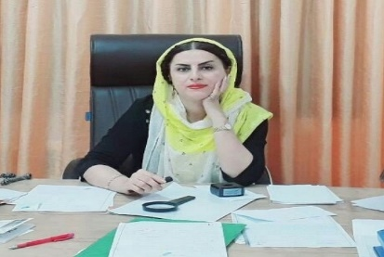
On Monday February 22, 2021, Gelaleh Vatandoost a lawyer, was summoned to Marivan Intelligence Bureau and was interrogated. This summoning was in relation with a post on social media which defended women’s rights. In recent months, she has published material that criticizes the violation of women rights in Iran and addresses the problem of unemployment in Kurdistan in cyber space. (Human Rights Activists in Iran – Feb. 25, 2021)

Lawyer sentenced to 95 days in jail
https://www.hra-news.org/2021/hranews/a-30109/
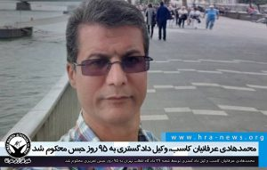
Mohammad-Hadi Erfanian-Kaseb a lawyer was sentenced by the Revolution Court to jail. According to this ruling issued by branch No.29 of Tehran Revolution Court and imparted to him last week, Mohammad-Hadi Erfanian-Kaseb is sentenced to three months and five days of jail term on charge of “propagating against the Nezam”. An instance of this charge is his interviews about the murder of his client, Alireza Shirmohammad-Ali, political prisoner, at the Great Tehran Prison, with domestic media and its republishing by Persian Language media abroad. His first trial session was on September 26, 2020; the second session on November 28, 2020; and the last one on April 6, 2021, at this branch.
On February 4, 2020, IRGC Intelligence forces searched his office and confiscated some of his personal belonging such as the hard drive of one of his computers and his cellphone. Then they went to his house and searched there too.
Mohammad-Hadi Erfanian-Kaseb has been a lawyer to many political prisoners including Mrs. Raheleh Rahemipoor, Ms. Haleh Rostami, Ms. Marjan Davari, and Alireza Shirmohammad-Ali who was murdered at the Great Tehran Prison. He was also the lawyer of many detained students and Baha’i citizens. (Human Rights Activists in Iran – May. 16, 2021)

Informing the charge of a lawyer in Arak court
https://www.hra-news.org/2021/hranews/a-30876/
On Saturday, July 3, 2021, Mohammad Najafi, a lawyer imprisoned in Arak Prison, was charged in Branch 5 of the Arak Public and Revolutionary Prosecutor's Office. During this interrogation, Mr. Najafi was charged with "propaganda against the state."
Najafi has been returned to prison after being granted bail.
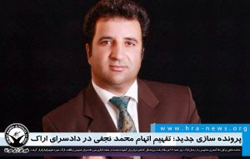
Examples of charges against him include a video on the subject of boycotting the presidential election, the signing of a 231-person letter on the subject of boycotting the election, the abolition of the constitution, and the removal of the supreme leader.
Mohammad Najafi was sentenced to six months in prison in February 2020 in another case for giving a speech at a ceremony at the house of Gohar Eshghi (mother of the late blogger Sattar Beheshti). (Human Rights Activists in Iran – Jul. 09, 2021)

Court jails secretary of National Unity Party’s Kurdistan branch
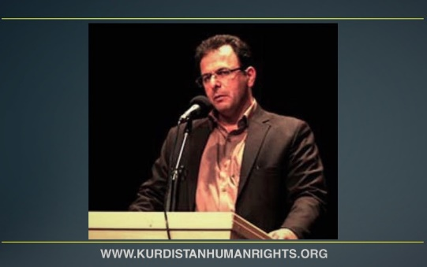
https://kurdistanhumanrights.org/fa/?p=16340
The Public and Revolutionary Court of Sanandaj has summoned the secretary of the Kurdistan branch of the National Unity Party and lawyer Farhad Mohammadi on 14 July and sent him to Sanandaj Central Prison to serve a 10-month sentence.
Security forces had arrested the Kurdish activist on 4 January 2019, during a large wave of arrests of Kurdish environmental activists and members of the Kurdistan branch of the National Unity Party in Sanandaj and Kamyaran.
He was held for nearly five months in solitary confinement in the detention centre of the Ministry of Intelligence in Sanandaj and was pressured to make a forced confession.
After being interrogated, Mohammadi was transferred to the quarantine ward of Sanandaj Central Prison on 25 May 2019.
Contrary to the standard procedure of commuting detention into release on bail in similar cases, his temporary detention was illegally extended following an objection by the prosecutor of the Islamic Revolutionary Court of Sanandaj.
During his entire detention, while his young daughter was hospitalised due to a severe illness, he was allowed to have only a brief visit with his family in the presence of interrogators.
One month after the lawyer’s arrest, 59 of his fellow lawyers issued an open letter and demanded his release, emphasising his professional background and reputation.
On 9 July 2019, he was released from Sanandaj Central Prison on a bail of 500 million Iranian Tomans – nearly 20,000 USD – after six months of detention.
In June 2020, Branch 1 of the Islamic Revolutionary Court of Sanandaj – presided over by Judge Saeidi – sentenced Mohammadi to four years in prison for “acting against national security”. In mid-March 2021, Branch 4 of the Court of Appeals of Kurdistan province commuted this sentence to 10 months in prison.
Also, the activist’s license to practice law was suspended after his temporary release from prison. (Kurdistan Human Rights Network – Jul. 15, 2021)

Tehran Revolution Court sentences a lawyer to 30 years in Prison
https://www.hra-news.org/2021/hranews/a-31151/
Despite the revocation of the sentence of 30 years imprisonment and 111 lashes of Amirsalar Davoodi in the Supreme Court; Amir Raisian, the defense attorney of Amirsalar Davari, announced that the sentence was upheld by Branch 28 of the Revolutionary Court of Tehran. Amir Raisian wrote in a memo in his personal page: "Branch 28 of the Revolutionary Court of Tehran, believing that the ruling of the Supreme Court was wrong, confirmed the original ruling (Branch 15)."
The trial of Amirsalar Davoodi was held on July 13, 2021, in Branch 28 of the Revolutionary Court of Tehran. Amirsalar Davoodi was arrested by security forces on November 20, 2018. He was transferred to Evin Prison after being charged. Prior to his arrest, officers searched his office and home and confiscated a number of his personal files and belongings. The imprisoned lawyer was sentenced to 30 years in prison and 111 lashes on June 1, 2019, according to a verdict issued by Branch 15 of the Revolutionary Court of Tehran. The maximum sentence of 15 years in prison is applicable. The sentence was identically upheld in mid-summer of the same year. (Human Rights Activists in Iran – Jul. 31, 2021)

Amir Salar Davoodi: The main reason I was sentenced is because I defended the dissidents of the regime for free
https://iranintl.com/%D8%AA%D8%A7%D8%B2%D9%87-%DA%86%D9%87-%D8%AE%D8%A8%D8%B1/%D8%A7%D9%85%DB%8C%D8%B1%D8%B3%D8%A7%D9%84%D8%A7%D8%B1-%D8%AF%D8%A7%D9%88%D9%88%D8%AF%DB%8C-%D8%AF%D9%84%DB%8C%D9%84-%D8%A7%D8%B5%D9%84%DB%8C-%D9%85%D8%AD%DA%A9%D9%88%D9%85%DB%8C%D8%AA%D9%85-%D8%AF%D9%81%D8%A7%D8%B9-%D8%B1%D8%A7%DB%8C%DA%AF%D8%A7%D9%86-%D8%A7%D8%B2-%D9%85%D8%AE%D8%A7%D9%84%D9%81%
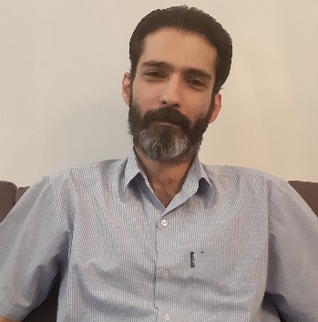
Amir Salalr Davoodi, lawyer and human rights activist who has been recently sentenced to 30 years in prison in an upheld decree, wrote that the main reason for his sentence is his human rights activities and being the defense lawyer of the dissidents for free.
In his writing he points to the controversies of his case and said that he was lured to go to the court.
This lawyer said that the main reason of his condemnation is “12 years of defending the political dissidents and dissident prisoner of conscience” of the regime “for free” and his “widespread human rights activities”.
In a part of his memo he wrote: “Judge Salavati had many grudges. He spites me and many other human rights lawyers that have defended regime’s dissidents for years.”
Formerly, Amir Raisian, the lawyer of Mr. Davoodi, has announced in his twitter account that branch No.28 of Tehran Revolution Court has upheld a sentence of 30 years in prison for Mr. Davoodi.
Branch No.41 of the court has ruled out the previous sentence and has ordered a simultaneous probe.
This human rights activist has been sentenced in his primary trial in 2019 to 30 years in prison and 111 lashes. (Iran International– Aug. 02, 2021)

Javad Alikurdi, confined at Mashhad Vakil-Abad Prison, sentenced
https://www.hra-news.org/2021/hranews/a-31182/
Javad AliKurdi a lawyer is serving his term at Mashhad Vakil-Abad Prison for establishing and administrating a Telegram group. After the issuance of the indictment by branch No. 109 of Mashhad Revolution Court, investigation department, and during the primary process conducted by branch No.4 of Revolution Court, being tried on charges of “establishing and administrating a Telegram group with the aim of overthrowing the government” (Hope, knowledge and Freedom Telegram Group), he is sentence to six years and six months in prison.
He is also sentenced to 8 months in jail for propagating against the IRI. On charge of “insulting the leader”, he is sentenced to a year and 5 months in prison.
According to the decree he is also sentenced to two years of ban in teaching in any educational institute or at a university, two years ban of leaving the country and two years ban of membership in political and social parties or groups. This citizen was detained on April 22, 2020, by the forces of Mashhad Intelligence and was confined more than 30 days at the detention center of this security organ. (Human Rights Activists in Iran – Aug. 02, 2021)

7 Lawyers and Civil Activists Arrested
https://iranhr.net/fa/articles/4857/
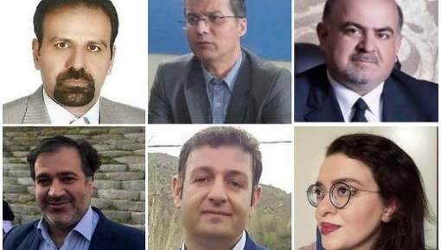
On Saturday, August 14, 2021, security agents arrested seven lawyers and civil activists who were planning to file a complaint against the Coronavirus Headquarters and the first person in the country (Ali Khamenei), at the Office of the Association for the Protection of Civil Rights in Tehran, two of whom were released hours after their arrest, and five remain in detention.
Names of Lawyers and Civil Activists: Arash Keykhosravi, Mostafa Nili, Mehdi Mahmoodian, Mohammad Reza Faghihi, Mohammad-Hadi Erfanian-Kaseb, Ms. Maryam Afrafaraz, and Ms. Leila Heidari.
After a few hours, Mohammad-Hadi Erfanian-Kasab and Leila Heidari, both lawyers, were released. However, five others remain in custody.
"These lawyers and civil activists wanted to file a complaint with the government employees' court against the leadership regarding the management of the Coronavirus crisis," said Mohammad Hossein Aqasi, a lawyer and human rights activist.
Another source, speaking on condition of anonymity, said: "At a meeting held at the Office of the Association for the Protection of Civil Rights, suddenly 15 people arrived with two investigators and arrested them." (Iran Human Rights – Aug. 15, 2021)

The house of Mohammadreza Faqihi, lawyer in Tehran searched
https://www.hra-news.org/?p=331151
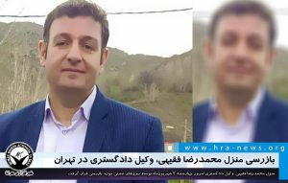
Today, on Wednesday, August 25, 2021, Security forces searched the house of Mohammadreza Faqihi a lawyer.
Saeed Khalili, lawyer, wrote in his account: “This morning as the family of my dear colleague, Mr. Faqihi, had asked me, I went to Evin Courthouse to introduce myself as his lawyer. Right at the entrance, they told me that we do not accept a lawyer for him and we will not release him on bail. While I was coming back, I heard that the agents have raided his house and searched it.”
On Saturday, August 14, Mr. Faqihi and eight other lawyers and civil activist including Arash Keykhosravi, Mostafa Nili, Mehdi Mahmoodian, Mohammad Hadi Erfanian Kaseb, Ms. Maryam Afrafaraz and Ms. Leila Heydari were detained while having a meeting at the office of The Association in Support of Civil Rights in Tehran and were taken to an unknown location.
The informed source said: “The agenda of this meeting was to study the potential delinquencies in regard with the spread of coronavirus and the issues laid out by the authorities. If they could determine the consequences of these delinquencies, then they wanted to determine that according to what article of law they can pursue it and file a complaint against some of the officials. But they had not reached any conclusion at the time of their detention yet. (Hrana- August 25, 2021)

Iran charges lawyers protesting COVID-19 negligence with “disrupting order”
سخنگوی قوه قضاییه: سعی می‌کنیم مطالبی که به استحضار مردم می‌رسد منطبق با واقعیت باشد • وکلاپرس (vokalapress.ir)
Iran charges lawyers protesting COVID-19 negligence with “disrupting order” - Iran News Wire
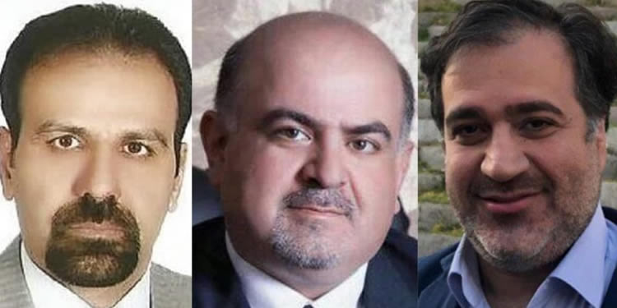
Iran’s Judiciary spokesman said in a press conference on August 31 that lawyers who were detained in mid-August were charged with “disrupting order”.
According to a state-run judiciary website, the lawyers and civil activists were charged with “disrupting order” and other opposing state security charges. The spokesman said there were nine lawyers and civil activist detained, four of which were later released.
On August 14, the Human Rights News Agency reported Arash Kikhsarvi, Mostafa Nili, Mehdi Mahmoudian, Mohammadreza Faqihi, Mohammad-Hadi Arefian Kaseb, Maryam Afrafaraz, and Leila Heidari were detained by security forces in Tehran. Their personal belongings including their smartphones were confiscated. Mehdi and Mostafa were detained in their office.
According to reports, the arrests were carried out without a warrant. Ali Mojtahedzadeh, an Iranian lawyer, said in a tweet on August 15 that the lawyers planned to sue Iranian officials for negligence related to the COVID-19 pandemic. Some reports said they planned to sue Iran’s Supreme Leader, Ali Khamenei.
Amnesty International also said in a tweet that they were arbitrarily detained for holding a meeting to discuss possible legal action in support of people’s right to lifesaving COVID-19 vaccines and that they must be immediately released.
The Human Rights News Agency wrote yesterday that Arash Kikhsarvi, Mostafa Nili, and Mehdi Mahmoudian were kept in Section 241 of Evin Prison and were banned from phone calls from the first day. (Iran News Wire via VokalaPress state-run website – Sep. 2, 2021)

Lawyers and civil activists’ family protest their holding in solitary confinement
جرم زندانیان ما جز دادخواهی چیست؟/ روا نیست در بی خبری مطلق بمانیم | امتدادنو (emtedad.news)
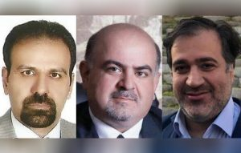
More than three weeks have passed since the arrest of a number of lawyers and civil society activists in Tehran. Despite the indictment and referral of the case to the Revolution Court of Tehran, Mostafa Nili, Arash Keykhosravi, and Mehdi Mahmoudian continue to be held in solitary confinement in ward 241 of Evin Prison under the supervision of the Judiciary's Information Protection.
The families of the three citizens wrote a letter to the President, the Head of the Judiciary, and the Speaker of the Parliament in which they pointed out that the validity, sentence and the detaining institution of the detainees were not known: "Despite the verbal announcement by the respected investigator of Branch 2 of the Evin Courthouse that the interrogation is over, and indictment is issued and the case is introduced to the court, our children, lawyer Arash Keykhosravi, lawyer Mostafa Nili and civil society activist Mehdi Mahmoudian, continue to be held in solitary confinement without the right to contact with their family and having a trusted lawyer.
In part, the letter noted that the families "have followed all avenues of litigation by referring and submitting petitions to the People's Office of the Judiciary, the Tehran Prosecutor's Office, Tehran's Judiciary Protection, and the Supervision of the Evin Court House", saying: "We have received only one answer that in temporary detention everything depends on the investigator of the case and we have no right to interfere, so where is the position of the supervisory bodies? Isn’t the investigation over and the case referred to the court, then why are our loved ones still kept in solitary confinement." (Emtedad website- Sep. 10, 2021)

Lawyer, Farzaneh Zailabi, sentenced to a year in prison
https://t.me/emtedadnet/58262
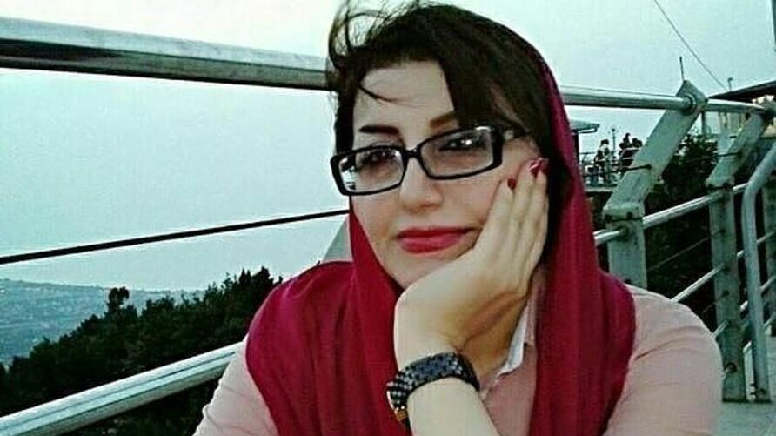
Ms. Farzaneh Zailabi, an attorney in the Haft Tappeh case, was sentenced by the Ahvaz Revolution Court to one-year imprisonment and two years' ban on leaving the country. Nasser Zarafshan, her defense lawyer, announced that the sentence has been issued at a preliminary stage in the Revolutionary Court. He stated: "My client has been acquitted of charges of assembly and collusion, spreading lies and insulting the Supreme Leader in the Revolution Court, and has been sentenced to one-year imprisonment and two years' ban on leaving the country regarding the charge of propaganda against the state”. (Emtedad- Sep. 13, 2021)

Letter by Mostafa Nili, Arash Keykhosravi and Mehdi Mahmoudian not accepted in Evin Prison
https://www.hra-news.org/2021/hranews/a-32007/
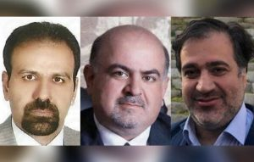
Arash Keykhosravi's lawyer, Abuzar Nasrollahi, announced the writing of a letter addressed to the judiciary by detained lawyers Mostafa Nili and Arash Keykhosravi, as well as civil society activist Mehdi Mahmoudian. Regarding the contents of the letter, the lawyer said: "Following a call from my client from prison, they announced that they prepared a letter entitled "Report of violations of the law to the Central Supervisory Board of the Enforcement of the Law respecting legitimate freedoms and civil rights..."
Pointing out that the letter was written on 9 points, Mr. Nasrollahi added: "The first point: deprivation of personal freedom and the denial of the right to seek justice and access to judicial authorities is the failure to protect the individual and social rights of citizens by the relevant authorities and the abuse of power.
“The second point: moral, ethical and legal violations by the judiciary's information protection officers, who are not considered judicial bailiffs.
“The third point is the issuance of an illegal arrest order, and the fourth point of this report was the investigator's departure from the principle of impartiality. The fifth point was the lack of immediate indictment. The sixth point was violation of the law and the lack of attention to their repeated requests for access to lawyers.
"The seventh point: Failure to provide justice and issuance of temporary detention is against the law, and on the eighth point, they have referred to being held in solitary confinement for 23 days.
"The ninth and final point is the disregard for the privacy and search of the homes of detainees."
"The arrested lawyers and Mr. Mehdi Mahmoudian have prepared this letter. No official can refuse to accept the letters under any pretext, the addressee of this letter is the official organs of the judiciary, and any reason for not accepting this letter is unjust," emphasized Mr. Nasrollahi.
Also, Abuzar Nasrollahi, the lawyer of Arash Keykhosravi, stated: "The time of the trial of these individuals has been determined and it is scheduled to take place on October 13. (HRANA – Oct. 06, 2021)

