Questionnaire
Protection of lawyers in the free and independent exercise of the legal profession
Submission of SLOVAKIA

- Taking into consideration the guarantees for the functioning of lawyers, contained in principles 16-22 of the Basic Principles on the Role of Lawyers, please describe the constitutional, legal, administrative and policy measures adopted in your country to enable lawyers to exercise their professional activities in favour of their clients in a free and independent manner.

The independent legal profession was established pursuant to Act No. 132/1990 Coll on Advocacy that became effective on July 1, 1990. Nowadays Act No. 586/2003 Coll, dated 4 December 2003 on the Legal Profession as amended, which implemented also the EU lawyers’ sectoral directives, is valid and in effect.
The Slovak Bar Association is a single, independent, self-governance body of lawyers, currently associating cca 6336 lawyers and 1888 trainee lawyers. The legal profession helps to exercise the individual´s and legal entity´s rights and interests in accordance with the Slovak Constitution and the laws. Right to legal protection and assistance is one of the constitutional rights derived from the Slovak Constitution (Articles 46 to 50) which must be fully guaranteed. This would be, however, impossible for lawyers without independence from all subjects and Slovak Bar Association independence in the area of disciplinary competence.

Act no. 586/2003 establishes rules of conduct for lawyers and disciplinary sanctions for their breaches (including disbarment). In addition, the Slovak Bar Association adopts the Rules of Disciplinary Procedure, which supplement the provisions of the Act.

In accordance with the Art. 47 par. 2 of the Slovak Constitution everyone has the right to legal aid in proceeding before the courts of other state bodies or public administration from the beginning of the proceedings and under the condition laid down by law. This right is a significant element of the rule of law.

In accordance with the art. 2 par.3 of the Act No. 586/2003 Coll. legal profession is a liberal profession, which may be practised and pursued only under this Act.

Section 2 para. 2 of the Act on the Legal Profession: When providing his legal services, each lawyer shall act independently, shall be bound by the generally binding legal rules, and within the limits of the same also by the client´s instructions.

Section 66 para. 2 of the Act on the Legal Profession: The Bar is an independent professional organisation associating all the practising lawyers admitted to the Bar.

Section 2 para. 3 of the Slovak Bar Association Rules of Professional Conduct: The lawyer may render legal services only within the limits of his independent and liberal practice of law. The lawyer may neither participate in any activities of persons, who render legal services without a statutory authority and licence, nor support such activities. Section 38 of the Slovak Bar Association Rules of Professional Conduct: The lawyer shall act before the courts and any other authorities in such a way so as to avoid any interference with his independence. He shall show due respect towards courts and other competent authorities. His behaviour including his appearance add to the honour and credit of any act he is involved in, as well as to the status and dignity of the entire legal profession.

Independence of lawyers is intertwined with the independence of the bar association. The legal profession in Slovakia is governed by the Slovak Bar Association, a self-governing organization which through its bodies has powers to develop and implement code of professional conduct and to adopt internal regulations in order to govern its members. Other functions pursued by the Bar are described in more detail in question 4.

- Please describe the entities and/or mechanisms that are in place to prevent and/or punish interferences with the free and independent exercise of the legal profession, whatever the source of the interference.

Legal profession in Slovakia is governed by the Act on the Legal Profession and internal (ethical) regulations adopted by the Bar. Based on them, it is the duty of the lawyer to act independently. Violations of the Act and regulations by lawyers themselves (which may also include a breach of the duty to act independently) are assessed and punished in individual cases by the Bar in disciplinary proceedings. If a violation is found, a disciplinary measure may be imposed on the lawyer according to the Act (written or public reprimand, fine, suspension of practice, disbarment). Disciplinary proceedings belong to the competence of independent bodies of the Slovak Bar Association (Disciplinary Committee and Disciplinary Committee of Appeal). Final decisions of disciplinary bodies may be subject to judicial review by the Supreme Administrative Court of the Slovak Republic (cassation principle). Ministry of Justice has powers to file a complaint or submit a petition to directly initiate disciplinary proceedings.

Different situation arises with regard to alleged external interference with the independent exercise of legal profession. If there is a violation of law other than the Act on the Legal Profession, the lawyer may initiate the relevant proceedings, which is in the competence of public authorities (e.g. law enforcement authorities, courts, etc.) for example arguing the misuse of powers, corruption, unlawful detention, etc. The lawyer concerned may equally file a constitutional complaint or application to the European Court of Human Rights.

The Slovak Bar Association also responds to legislative initiatives that could affect the independence of lawyers or the Bar itself. For this purpose, the Slovak Bar Association is actively involved in the legislative process in many areas and maintains a dialogue with representatives of both the legislative and the executive bodies.

- Please describe the role of the national bar association(s) in protecting lawyers and the free exercise of the legal profession. Is the bar association de jure and de facto independent from the State?

The Slovak Bar Association is de facto and de iure independent from the State. The Slovak Bar Association serves as the guardian of lawyers' independence and in order to do so it must be independent itself.

The Slovak Bar Association is recognised as independent by law which, as required by the international standards, lays down the principles of independence, professional ethics and the avoidance of conflict of interests. It provides for the effective operation of professional associations of lawyers, the proper qualification and training of lawyers and administration of proper disciplinary proceedings.

The Slovak Bar Association serves as an institutional guarantee of independence of lawyers on several layers:
  - Preventive phase:
- Bar Association Presidency Council on a monthly basis issues positions on requests addressed to the Bar by lawyers, trainee lawyers and other subjects that require interpretation of law related to the legal profession (the Slovak Bar Association Working Group on core issues of the profession) and on compatibility of legal practice with other activities (the Slovak Bar Association Working Group on Compatibility). Any activity that causes doubts in relation to the independence of lawyer or legal profession must be declared incompatible regardless of its legal form, circumstance, scope and length, remuneration or lack of it.
- In March 2020 the Slovak Bar Association standardised the rules for assessment of compatibility of other activities with ethical principles of the legal profession.
- The Slovak Bar Association provides mandatory training on deontology to all trainee lawyers and deontology is part of the lawyers´ exam.
- The Slovak Bar Association adopts resolutions and internal regulations that delineate duties and responsibilities of lawyers vis-a-vis their clients, courts and other institutions.

  - Reactive phase:
- The Slovak Bar Association is responsible as self-regulated professional body for decision-making on the professional misconduct of its members and issues disciplinary sanctions.
- The Supervision Committee, Disciplinary Committee and Disciplinary Committee of Appeal deal with any breach of obligation addressed to it or on its own initiative. The Slovak Bar Association Rules of Disciplinary Procedure provide for the strict system of disciplinary procedure and disciplinary sanctions, including striking a person of the list of lawyers.
- For the past ten years the Slovak Bar Association have been issuing Collections of Disciplinary Findings that provide for transparent, consistent and foreseeable decision-making, as well as to raise awareness of the ethical nuances.
- In 2017 additional detailed rules related to standards of disciplinary decision-making and sanctions were approved by the General Assembly of Lawyers
There has been an ongoing discussion about possible reform of the Slovak legal profession. In this matter the Minister of Justice of the Slovak Republic, Madame Mária Kolíková decided to seek assistance from the Venice Commission to make sure there is no interference with the principle of the rule of law and democracy.

Question one:
Would it be in accordance with the principles of the rule of law and democracy if the Supreme Administrative Court serves as a second instance appellate body reviewing non-final disciplinary decisions of the disciplinary body of the Slovak Bar Association (whereas at present only final decisions of the disciplinary bodies of the Slovak Bar Association are reviewed by the administrative judiciary)?

Question two:
Would it be in accordance with the principles of the rule of law and democracy if the law allowed for the establishment of several professional chambers of attorneys or several Bar Associations based on the decision of attorneys themselves, reflecting either the regional principle or the sectorial principle (whereas at present only a single Slovak Bar Association with compulsory membership of attorneys is established)?

The opinion of the Venice Commission on this matter is available online and can be found: https://www.venice.coe.int/webforms/documents/?pdf=CDL-AD%282021%29042-e

- Please provide detailed information on the number of lawyers that have been subject to criminal, administrative or disciplinary proceedings in the last five years for alleged violations of standards of professional conduct. How many of them were found guilty? How many of them were ultimately disbarred?

Statistics on disciplinary proceeding and disbarment show a number of final decisions adopted by the Disciplinary panels in the given time period, number of decisions that declared that there was a misconduct committed by the lawyer and number of disbarments in the given year.

 | 2016/2017 | 2017/2018 | 2018/2019 | 2019/2020 | 2020/2021
Final decision | 93 | 108 | 69 | 53 | 84
Misconduct | 76 | 88 | 52 | 45 | 71
Disbarment | 2 | 0 | 0 | 2 | 1

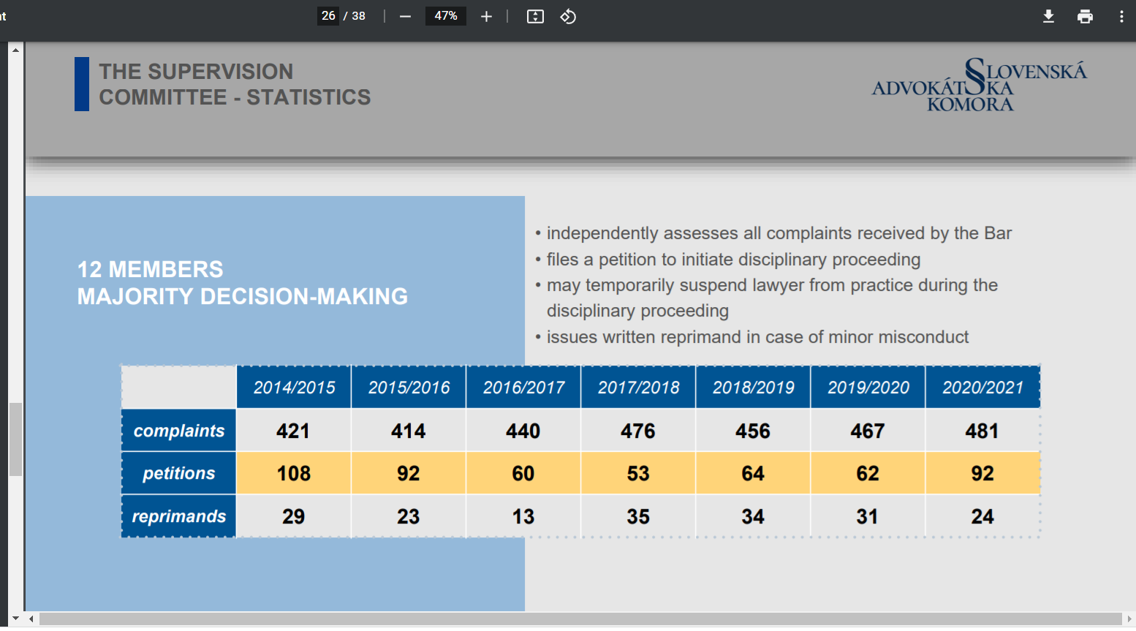

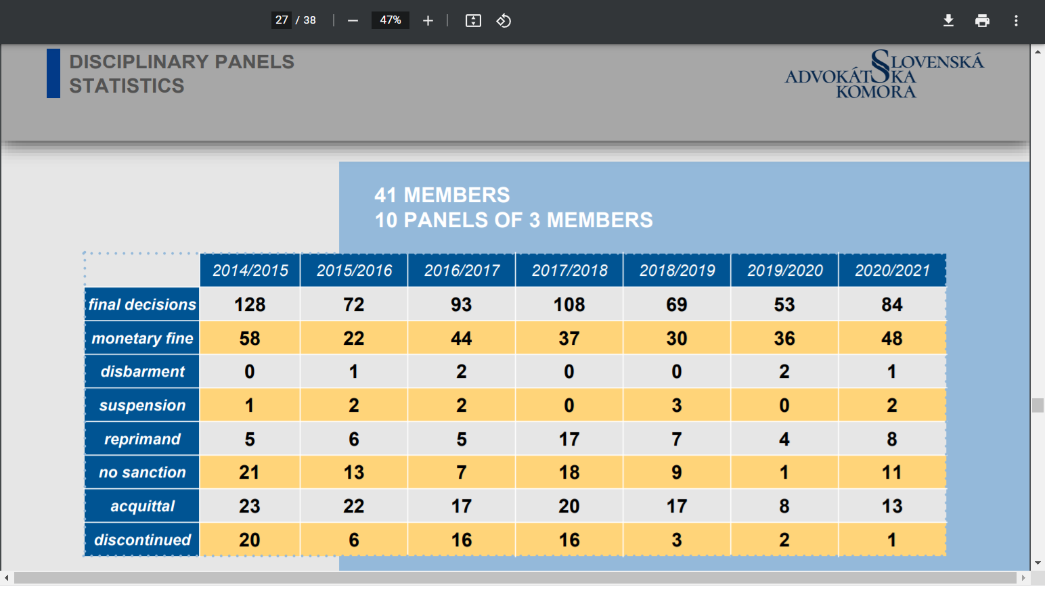

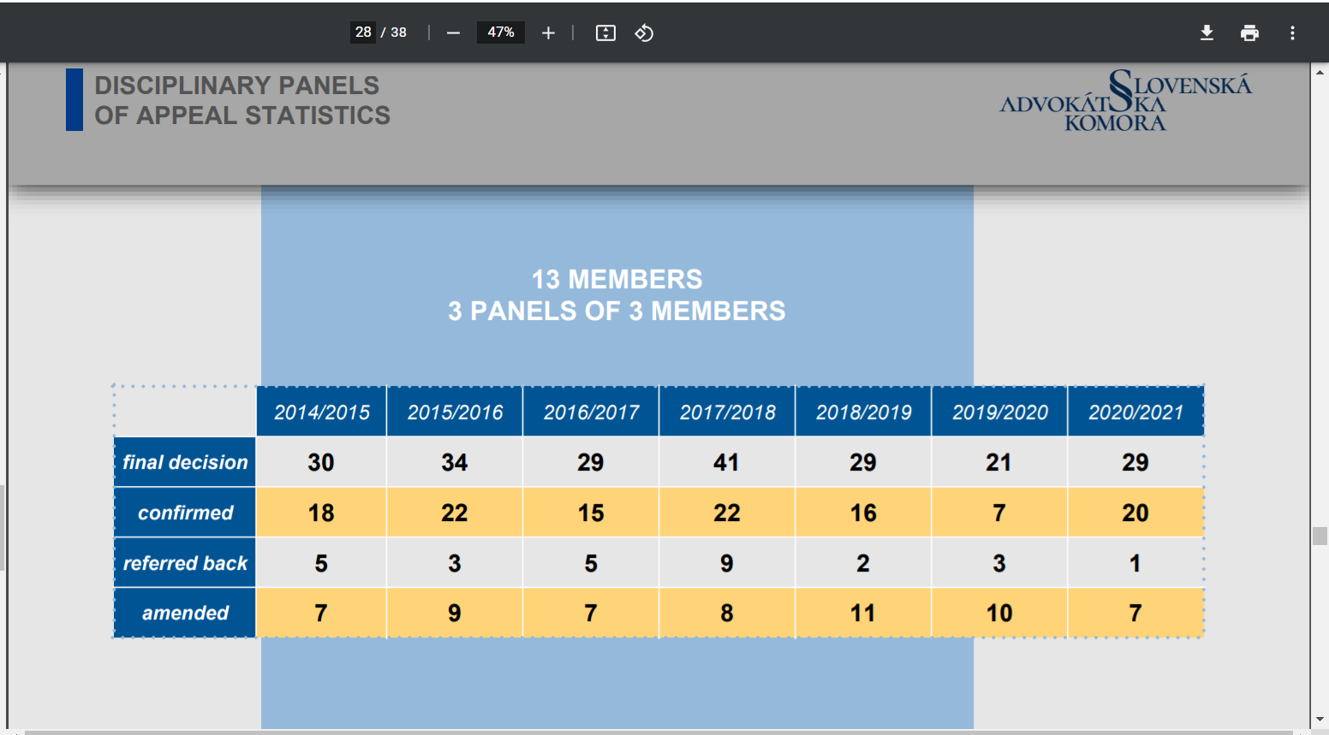

Source: https://www.sak.sk/web/sk/cms/document/benatska/benat/1/id2/_getFile

- Please provide information on any case where lawyers in your country have been subject to intimidation, hindrance, harassment or improper interference, whether from State authorities or non-State actors, for action taken in accordance with their recognized professional duties. Please also describe the measures that State authorities have taken to investigate and bring perpetrators to justice.

In the current Slovak legislative environment, lawyers have no special position in terms of their protection. However, the proposed amendment to the Criminal Code includes a new special motive "for the exercise of an occupation, profession or function".
With respect to police activity, protection can be provided to lawyers on the basis of the two institutes i.e. witness protection or interim protection, if the person qualifies for such protection. Within these institutes, the issue of providing protection to persons included in specific groups. In terms of effective protection of lawyers, the emergency line of the integrated emergency system is available in the Slovak Republic, which brings together all emergency services, including the police. Apart from this, the 158 emergency line of the police is in place for receiving reports made by the public in the event of an emergency in which life, health, property or the environment is at immediate risk. Pursuant to the applicable legislation on criminal proceedings in the Code of Criminal Procedure, criminal investigations (including attacks against lawyers) are exclusively in the competence of law enforcement agencies (a police officer and prosecutor) and the imposition of measures in criminal proceedings falls within the competence of courts in the Slovak Republic.

According to the Slovak Bar Association, in recent years, there is a growing concern that lawyers are targeted (and also under surveillance) because they provide legal services to certain persons. There are cases when lawyers have been put in collusive custody, their offices were searched and they were associated with their clients in media, without concrete foundations. Particularly in the past two years this have had a chilling effect on the legal profession. It is not necessary to have a high figure of cases of this kind, even a few cases may have impact on the whole legal profession.
In the past the appointment of ex offo defence counsel by judges was perceived as having negative effect on the principle of independence. Judges used to appoint only a certain circle of lawyers in the region. This was changed by a new legislation the introduced an automated system of appointments of lawyers that guaranteed even distribution of cases without any interference of judge.

Lawyers in Slovakia are facing an indirect threat to their independence in two forms: first being the threats and harassment of lawyers from persons encountered in the course of their practice, and second, identification of lawyers with their clients, which is especially problematic in case of defence lawyers.
The purpose of defence is still misinterpreted and misunderstood by the media and society. Unfortunately, media often use expressions that intensify the wrong impression of lawyers and the concept of defence of rights. Fulfilment of lawyer´s obligation to represent a client does not mean that the lawyer approves of the client´s doing and lawyers cannot be harassed or prosecuted for the fulfilment of their statutory and constitutional duties.

Any gap in communication between the media and the profession can contribute to the erosion of the perception of lawyers’ role in society, through portrayals of lawyers in ways that could undermine the credibility and the overall image of the profession.

6. To what extent has, the legislation and/or measures adopted in your country because of the Covid-19 pandemic, affected the exercise of the independence of the legal profession or security of lawyers. Please explain.

According to the Slovak Bar Association, the COVID-19 crisis undoubtedly places major demands on all institutions involved in decision-making. However, the measures should be taken in such a way so that a certain level of legal certainty is met. Slovak Bar Association has stated that since COVID-19 measures, including various lockdowns and restrictions were often adopted last minute, leaving often only a few hours to study, interpret and prepare for implementation of regulations.

The Slovak Bar Association also pointed out difficulties with visits of clients in detention or prison because of various restrictions during the pandemic. Online consultations were often not facilitated and access to prisons was frequently cancelled, conditioned on negative test or counsels were requested to limit their visits.
In court proceedings the Slovak Bar Association noted that court rooms are in principle very small and therefore there were time periods during pandemics when lawyers were uneasy as other participants often refused the use masks or due to insufficient ventilation.

7. Please describe the measures and policies you would suggest to better protect and guarantee the free exercise of the legal profession.

Based on the information provided by the Slovak Bar Association, we feel measures are needed to improve communication and overall image especially of the role of defence counsellors in criminal proceedings.

3 December 2021

https://www.sak.sk/web/sk/cms/document/benatska/benat/1/id2/_getFile
https://www.sak.sk/web/en/cms/sak/profile?web/en/cms/closeBanner=1

