Questionnaire for civil society and bar associations on the Protection of Lawyers

Reply by the Swedish Bar Association

Question 1
Taking into consideration the guarantees for the functioning of lawyers, contained in principles 16-22 of the Basic Principles on the Role of Lawyers, please describe the constitutional, legal, administrative and policy measures adopted in your country to enable lawyers to exercise their professional activities in favour of their clients in a free and independent manner.
  - Formal structure/organisation of the Swedish Bar Association
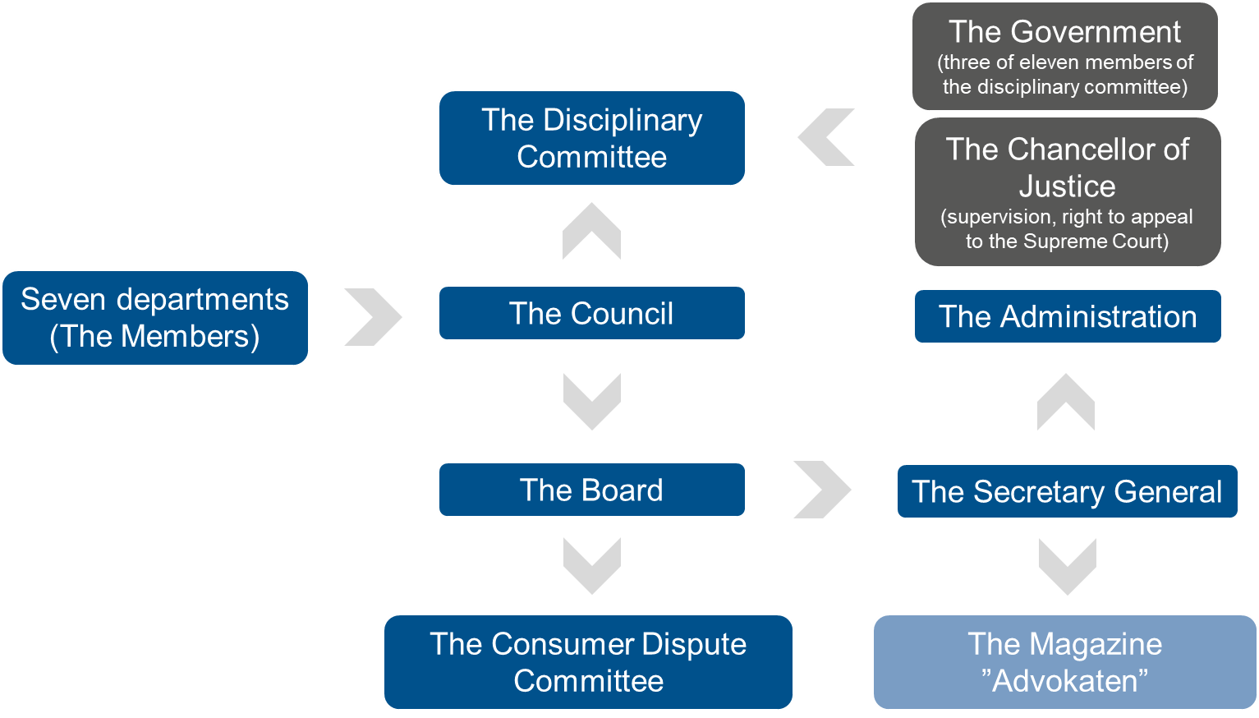

  - Legal status and independence of the Swedish Bar Association
The Bar Association was originally formed as a private association in 1887. At the beginning the Bar was a voluntary association of academically trained lawyers. Its principal task from the start was to improve the administration of justice and to increase the prestige of the legal profession. When the current Swedish Code of Judicial Procedure entered into force in 1948, the Bar Association gained official recognition. According to Chapter 8, Section 1 of the Code of Judicial Procedure, there shall be a general Bar Association and the regulation of the Association (the Charter) shall be confirmed by the government. The Bar Association can be characterized as an association under private law, bearing a number of characteristics of a public law body.
The objects of the Bar Association are, in accordance with Section 1 of the Charter of the SBA, to maintain high ethical and professional standards in the legal profession (e.g. admittance, discipline and continuing professional training); to monitor the development of the law and to ensure that the development of the law is beneficially influenced by the experience of the Bar (legal opinions on legislative proposals, commissions, etc.); to safeguard the general professional interests of its members (insurance, independence, information, etc.); and to further unity and consensus between members (large law firms v. sole practitioners, etc.).
The public administrative functions – granted in the Code of Judicial Procedure, Chapter 8 – involve the exercise of public authority. Such authority includes requirements for membership and the admission process (incl. administration of the Bar examination), supervision of the professional activities of advocates and taking disciplinary measures against members (the disciplinary committee). The SBA has since 2016 a Consumer Disputes Committee regarding lawyer fees and other disputes between clients (consumers) and their lawyers, as a result of the implementation of directive 2013/11/EU (on alternative dispute resolution for consumer disputes and amending Regulation). Other functions of the SBA are in short legislative influence, public information and influence, professional training and support of the members and international relations.
The Swedish Bar Association is independent from the State, the Government and the Ministry of Justice. The only role the Government (the Ministry of Justice) has in relation to the Swedish Bar Association is when it confirms changes in the Charter of the SBA proposed by the SBA itself. In this way the changes and the Charter becomes Swedish law as it receives legal status as regulation. The Government cannot itself initiate changes in the Charter of the SBA. Furthermore, the Chancellor of Justice (a state authority of the Government) supervises the decisions of the Disciplinary Committee of the SBA.
The SBA and its members have an important role as watch dogs for human rights. Individual fundamental rights and freedoms (personal integrity, etc.) according to the ECHR, the EU Charter of Fundamental Rights and the UN Universal Declaration of Human Rights, especially in relation to Rule of Law issues (fair trial, due process and rights of suspects, access to justice, quality of legislation, independence of the Judiciary, independence and self-regulation of the Bar, threats to core values of the profession; e.g. confidentiality and client loyalty as a result of inter alia anti money laundering legislation, etc.).
Furthermore, the SBA is totally independent of the Legislative powers (the Swedish Parliament) and Judiciary powers (the Swedish courts and State authorities).
Regarding protection of the individual lawyer, law firms have a general labour law responsibility to have an administration that secures the protection of individual lawyers. Furthermore, there are specific Swedish laws that stipulates the safeguard of lawyers and the client-attorney privilege (e.g. the Act on Anti Money Laundering and the Code of Judicial Procedure).

Question 2
What entities and/or mechanisms are in place to prevent and/or punish interferences with the free and independent exercise of the legal profession? Please briefly describe them and specify whether they are independent bodies or if they belong to the administrative structure of the State.
  - The Parliamentary Ombudsmen
Regarding state interference with the SBA and its members, please see question 1 above.
It can be noted that the Parliamentary Ombudsmen (JO) are appointed by the parliament to ensure that public authorities and their staff comply with the laws and other statutes governing their actions. JO may review the implementation of laws and other regulations in the public sector on behalf of the parliament and independent of the executive power. This review includes courts of law and other public authorities, as well as their employees. JO may review the authorities with regards to client-attorney privilege (e.g. a recent cases where JO directs criticism towards the Prison and Probation Service due to their management of a dispatch from a lawyer, decision of 10/5/2021, case number 6952-2020, or when The Police Authority has mistakenly denied a lawyer to be present as counsellor during a questioning pursuant to section 16 of the Police Act, decision of 9/29/2021, case number 4794-2020).

Question 3
Please indicate if there are any legislative, administrative, or institutional barriers that have hindered the work of lawyers and the exercise of the legal profession in your country, and describe them.
  - Current political pressure and budget plans
Due to recent events of a couple of highly unusual disciplinary cases regarding criminal lawyers accused of passing on unauthorised information during a preliminary investigation to other persons in a criminal network. The two Bar Members were unanimously disbarred by the disciplinary committee due to unethical conduct.
The debate of a current increase of street shootings with connection to organised crime and the unusual disciplinary cases has resulted in voices to be raised from primarily national conservative/populist right wing parties to undermine the independence of the SBA and to take control of the admission process and the disciplinary committee under a new state controlled authority. The proposals have not been approved by the current legislative majority but raises concerns regarding the independence of lawyers and the principle to not be identified with their clients or their clients' causes as a result of discharging their functions.
In connection with the aforementioned debate, the parliament has contributed extra funds to parts of the legal system, mainly the police authorities (almost a 40 % increase in budget expenses). The courts however have not seen the same increase in budget expenses (15 %) and the budget proposal regarding state reimbursement for public counsels for the years 2023-2024 are seeing a significant decrease (almost 40 %). The economic challenges for public counsels have of course an impact on the clients’ possibility to be represented by an independent counsel.

Question 4
Please describe the role of the national bar association(s) in protecting lawyers and the free exercise of the legal profession. Is the bar association de jure and de facto independent from the State?
  - Answer
Regarding the SBA’s independence, please see answers above.

Question 5
Please provide detailed information on the number of lawyers that have been subject to criminal, administrative or disciplinary proceedings in the last five years for alleged violations of standards of professional conduct. How many of them were found guilty? How many of them were ultimately disbarred?
  - The Disciplinary Committee and disciplinary proceedings
Advocates are required to observe certain specific duties. Among the most important are the duty of loyalty to the client, the duty to observe professional independence, and the duty of confidentiality. These duties are safeguarded in different ways. The independence is e.g. protected by the prohibition for a member of the Bar to be employed by someone outside the Bar or to form a company with such a person. Most important however, is the general duty for a Bar Member always to conduct his or her business in accordance with the professional and ethical standards developed and adopted by the SBA (the Code of Professional Conduct for members of the Swedish Bar Association; “Vägledande regler om god advokatsed”). A member is obligated to comply with the ethical standards according to the Code of Judicial Procedure, Chapter 8, Section 4.
Professional ethics are not defined by statutory provision. The ethical standards are instead defined by the decisions of the Disciplinary Committee of the Bar and by the Council of the Bar by in special pronouncements on matters of principle. A compilation of the professional and ethical standards are published in the Bar Associations Code of Conduct.
The Council and the Disciplinary Committee are empowered with the task to supervise Bar members and to ensure that they satisfy the professional duties of an advocate. The different sanctions available are: reminder, warning, warning combined with a fine, and disbarment. A member, who in his or hers practice intentionally commits a wrong or otherwise act dishonestly, may be expelled from the Bar. If the circumstances of the case so warrant, the Committee may instead chose to issue a warning. A member of the Bar who in any other respect neglects his professional responsibilities may be given a warning or a reminder. In such cases, and if the circumstances are extraordinarily serious, he may be expelled from the Bar. A warning may be combined with fine of not less than 1 000 SEK and no more than 50 000 SEK (approx. 4 900 €). If it is considered sufficient, the Disciplinary Committee, instead of issuing a reminder, may issue a statement to the effect that his act or omission was wrongful or otherwise inappropriate. It can be noted that the SBA has recently revised the fine in a report suggesting the fine should be changed to an interval not less than 10 000 SEK and no more than 250 000 SEK (approx. 990 € up to 24 700 €). The adjustment is motivated due to both monetary inflation and systematic proportionality arguments to decrease the threshold from the maximum fine and disbarment.
The procedure is mainly conducted through written preparation although the Disciplinary Committee may decide that oral proceedings are to be held in a matter before the Committee. A member against whom a complaint has been made is under a duty to submit a written statement, produce the documents the Disciplinary Committee or the Secretary General orders him to supply and to appear before the Committee if ordered to do so.
The complaint/matter will considered by the Disciplinary Committee, usually by an Adjudication Division in the first instance. Should the Adjudication Division agree that no disciplinary action is called for and if the members agree as to the content of the decision, the Adjudication Division may decide the matter. Otherwise the matter must be referred to the Disciplinary Committee.
If a member against whom a complaint has been made is considered to be in need of defence counsel but does not instruct any such counsel, the Disciplinary Committee may appoint defence counsel to act for him in the proceedings before the Committee. The fee for defence counsel appointed by the Committee will be paid by the Bar Association, the amount to be determined by the Disciplinary Committee. The same applies to the fee for defence counsel appointed by a member against whom a complaint has been made if the Committee considers the nature of the matter to necessitate counsel for the member’s defence. The Committee may order the member against whom a complaint has been made to reimburse the Bar Association for all or part of the cost of his defence.
A decision by the Disciplinary Committee is not subject to appeal by the complainant. A disbarred member may appeal directly to the Supreme Court. Other sanctions are not possible to appeal. The Chancellor of Justice also has supervisory powers with regards to advocates. He may request that disciplinary measures be implemented by the Disciplinary Committee against a negligent member, or by the Council in respect of members who no longer fulfils the formal requirements for membership. The Chancellor of Justice may also appeal decisions by the Disciplinary Committee to the Supreme Court.
The SBA is continuously publishing yearly reports regarding statistics of disciplinary cases. As a median, the disciplinary committee is deciding in around 600 cases (including complaints from the opposing party) whereas around 130 of them result in some kind of disciplinary measure.
Of the 130 disciplinary measures, a reminder is the most common one (around 70-85 decisions) followed by a warning (20-30 decisions) and warning with a fine (20-30 decisions). Disbarment is usually between none to two decisions yearly, however some years stand out (e.g. six disbarments of the year 2016).

Question 6
Please provide information on any case where lawyers in your country have been subject to intimidation, hindrance, harassment or improper interference, whether from State authorities or non-State actors, for action taken in accordance with their recognized professional duties. Please also describe the measures that State authorities have taken to investigate and bring perpetrators to justice.
  - The Parliamentary Ombudsmen
Regarding improper interference by authorities, please see above regarding the supervision of the Parliamentary Ombudsmen.

Question 7
What activities does your organization carry out to promote the independence of the legal profession? Do you co-ordinate with other organizations with similar functions in other countries or regions? Are you part of a network for this purpose? Please give examples.
  - Legislative influence
A mandatory part of the Swedish legislative process is the Government inviting comments on draft bills from various bodies in society. The SBA has a frequent role as consultation body in the legislative process (the referral process). The SBA annually submits legal opinions and comments on some 120 – 130 legislative proposals.
Advocates and representatives of the SBA are also frequently appointed as experts in commissions of inquiry (appointed by the Government) and participate in hearings, legal debates and discussions (media, conferences, seminars, etc.). The SBA has well- functioning professional contacts and continuous meetings with the Government and Government officials, especially with the Ministry of Justice and the Parliamentary Standing Committee on the Administration of Justice. The SBA also work hard to influence the European Union legal agenda (CCBE ./. EU-Commission) and International legal agenda (IBA ./. UN).
The Swedish membership in the European Union has increased both the speed in the legislative process and in the number of drafts. The SBA considers it especially important to monitor issues relating to the Rule of Law, the respect for human rights, access to justice, the observance of due process and technical quality of the legislation. The SBA is also addressing concerns of the members to the authorities, government departments and law makers ensuring terms for an independent and free practise of the members.

  - Public information
The Bar Association publishes the legal magazine, “Advokaten” (“The Advocate”). It is published nine times annually and is distributed to all members and their associates, to the courts, to the prosecutors’ offices etc. The magazine is also available online. The web site of the Bar Association contains information on various issues of interest to the public and the members of the Bar. One of the major features is the possibility for the public to access the Directory of Members. The Administration is open daily to answer questions regarding the work of the Bar Association or the disciplinary system. The Secretary General is a strong voice in both traditional and social media addressing issues relating to the Rule of Law, the respect for human rights, access to justice, the observance of due process and technical quality of the legislation.
  - International relations
The Bar Association entertains a broad co-operation with the Bar Associations of the Nordic countries. The Secretary Generals of the Bar Associations of Sweden, Denmark, Finland, Norway and Iceland meet on a regularly basis and once a year a meeting is held with the participation of the Presidents and Vice Presidents.
The Bar Association is deeply involved in the work of the CCBE (the Council of Bars and Law Societies of Europe). All the national Bars and law societies of the European Union and the European Economic Area are members of the CCBE. Another important organisation on a European level is CEEBA (Chief Executives of European Bar Associations), which regularly meet to discuss issues of mutual interest. The Swedish Bar Association took active part in the formation of ILAC, International Legal Assistance Consortium, and is represented on the Board of ILAC. ILAC’s purpose is to facilitate and assist domestic and international efforts to improve the efficacy and credibility of legal institutions, focusing on situations of conflict. Apart from what is mentioned above, the Bar Association is also represented in other international bodies, such as the International Bar Association (IBA). Since 2009 The Bar Association – in co-operation with the International Bar Association (IBA) and ILAC – has annually awarded the Stockholm Human Rights Award to an individual or an institution for outstanding contributions to the rule of law and the promotion and protection of human rights. International cooperation also occurs in relation to the IILACE (International Institute of Law Association Chief Executives) and the ICJ (International Commission of Jurists).

Question 8
To what extent has, the legislation and/or measures adopted in your country because of the Covid-19 pandemic, affected the exercise of the independence of the legal profession or security of lawyers. Please explain.
  - Covid-19 related issues
The SBA noted that in the beginning of the pandemic, before reasonable adjustments could be made, a lot of cases were brought to a standstill and hearings in less urgent cases were cancelled resulting in much longer processing times. This also affected the law firms financially which led to some redundancies resulting in a higher threshold to access to justice in due time for the client.
The SBA has noted an increase of use of video conferencing even today when restrictions are lifted which ultimately may have a negative long term effect on legal security. In cases where assessment of credibility of parties and witnesses are crucial, a widespread use of video conference may undermine the parties’ possibility to effective cross examination and the courts ability to assess the evidence.

Question 9
Please describe the measures and policies you would suggest to better protect and guarantee the free exercise of the legal profession.
  - Legislative status and budget
The SBA has raised the question to incorporate some of the provisions of the SBA in the Code of Judicial Procedure into the Swedish constitution providing a legal safeguard for lawyer independence.
The SBA is working for better financial opportunities, especially regarding public counsels and legal aid, to ensure the clients possibility to be represented by a professional and independent counsel regardless of the clients’ financial situation.

/JS/

