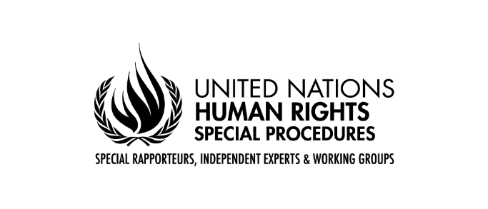
Questionnaire for States

Call for submissions “The impact of toxics on Indigenous peoples”
Mandate of the Special Rapporteur on toxics and human rights

The Special Rapporteur on toxics and human rights, Marcos Orellana, wishes to thank States, Indigenous peoples, civil society organisations, academic institutions, businesses, international organisations and other stakeholders for the continued engagement with this mandate. He launches the process of gathering inputs from States and other stakeholders to inform his thematic report on the impacts of toxics on Indigenous peoples and human rights. The report will be presented at the 77th session of the United Nations General Assembly in October 2022. The Special Rapporteur kindly requests States, UN agencies, civil society organizations, academics, business enterprises and all other interested parties to share views and relevant information, which could feed his work, as explained below.

Introduction

Indigenous peoples throughout the world are disproportionately affected by toxics and hazardous waste. Indigenous peoples maintain a deep connection to the environment, and therefore environmental pollution severely affects their bodies and cultures. The dumping of hazardous wastes in Indigenous lands is a direct assault on their rights and wellbeing.

Often, Indigenous peoples live in territories rich in natural resources, which are often exploited by business entities in irresponsible ways that contaminate the land and expose Indigenous peoples to hazardous substances. For example, artisanal and small-scale mining is causing widespread environmental toxification with mercury. Other extractive industries, such as uranium mining, have serious adverse effects on Indigenous peoples’ rights. In addition to extractive industries, agro-businesses use highly hazardous pesticides that compromise the enjoyment of human rights.

Exposure of Indigenous peoples to hazardous substances and waste infringe on their collective and individual human rights. These rights include free prior and informed consent, self-determination, lands and resources, health and well-being, culture, development, a healthy environment, water, food and subsistence, life, and security of person.

In light of these considerations, and pursuant to the Human Rights Council resolution 45/17, which calls for monitoring of “adverse consequences for persons and groups in vulnerable situations, including indigenous peoples,” the Special Rapporteur on toxics and human rights has decided to focus his upcoming thematic report to the 77th Session of the United Nations General Assembly on the impact of toxics on Indigenous peoples.

The following questionnaire seeks information on how toxics have affected Indigenous peoples’ rights and how States are taking steps to eliminate the effects of toxic exposure on Indigenous peoples. This information may include ways that Indigenous peoples are being exposed to toxics, ways that countries are preventing Indigenous peoples’ exposure to toxics, and the legal rights and remedies available to Indigenous peoples exposed to toxics and hazardous waste.

Questionnaire

You can choose to answer all or some of the questions below

- Are Indigenous communities in your country suffering from the adverse effects of hazardous substances and toxic wastes? Please describe the case and circumstances of these effects in detail, including the source of the toxic exposure, the types of hazardous substances Indigenous peoples are being exposed to, the degree of government and company consultation and consent to relevant activities, as well as any efforts made by the government and companies to provide effective remedies.

- What are the adverse impacts of toxic and hazardous waste on Indigenous communities’ collective and individual rights, such as their rights to lands, resources, culture, health, livelihood, political and economic involvement, etc.?

- Is the government implementing a right to free, prior, and informed consent regarding exposure to toxics and hazardous substances on Indigenous communities’ lands and territories?

- Are companies responsible for producing the toxics and hazardous waste implementing dialogue with regards to those substances and their consequences with Indigenous communities?

- Have Indigenous peoples tried to take action (either legal action, advocacy campaign, etc.) to raise awareness on the issue and/or have they tried to obtain compensation?

- What are the most significant challenges to eliminating exposure to toxics in Indigenous communities?

- What community education does your country, or the responsible company, provide for Indigenous peoples living in areas with high exposure to toxic and hazardous waste?

- What specific actions has your country taken to protect the rights of Indigenous persons exposed to toxics, in particular women and children?

- Are there any national health assessments or studies that your country conducts to measure the rate of toxic exposure that Indigenous peoples do experience?

- Does your country provide any services to Indigenous peoples and individual persons exposed to toxics, such as health care, education, etc.?

- Do Indigenous peoples and individuals in your country have a constitutional or legal right against the exposure of toxics on their persons or their traditional lands and territories, or are there any environmental laws/policies that require environmental remediation?

- What are the available remedies for Indigenous peoples and individuals exposed to toxics that have experienced damages (in the form of land, health, livelihood, etc.), and what are the challenges to obtaining these remedies in your country?

- Is traditional Indigenous knowledge and medicine available in their communities to treat people exposed to toxics?
*****

