Civil society submission on the
Questionnaire in relation to Human Rights Council resolution 47/24 on human rights and climate change
______________________
Submitted to the
The Office of the United Nations High Commissioner for Human Rights

November 30, 2021
Submitted by:
International Campaign for Tibet

1825 Jefferson Place NW
20036, Washington, DC, USA
Contact: Kai Müller
Kai.mueller@savetibet.de

This submission provides examples of how climate change in Tibet has adversely affected the human rights of Tibetans, who are on the front lines of climate change.

The Tibetan plateau is a fragile and strategically critical ecosystem that is extremely sensitive to climate change. It is strategically important because it is the source of Asia’s eight major river systems and home of the largest volume of ice outside the poles. Changes in the Tibetan plateau ecosystem significantly impact regional and global weather patterns, the water resource for over 1.4 billion people, and the region’s rich biodiversity.
Tibet is currently at the frontline of climate change with temperatures rising 2-4 times higher than the global average. Current predictions report 36 per cent of the glaciers along the Hindu Kush and Himalayan range will be gone by 2100, if global warming is limited to 1.5 degrees Celsius. If emissions are not cut, the loss increases to two thirds. Such changes are expected to increase the frequency and intensity of extreme weather conditions such as snowstorms, floods, and droughts. Warmer temperatures will also lead to increased permafrost subsidence, which can cause landslides and avalanches. In the short-term, glacial lakes will expand, with water run-off in the off-season slowly declining in the long-run.
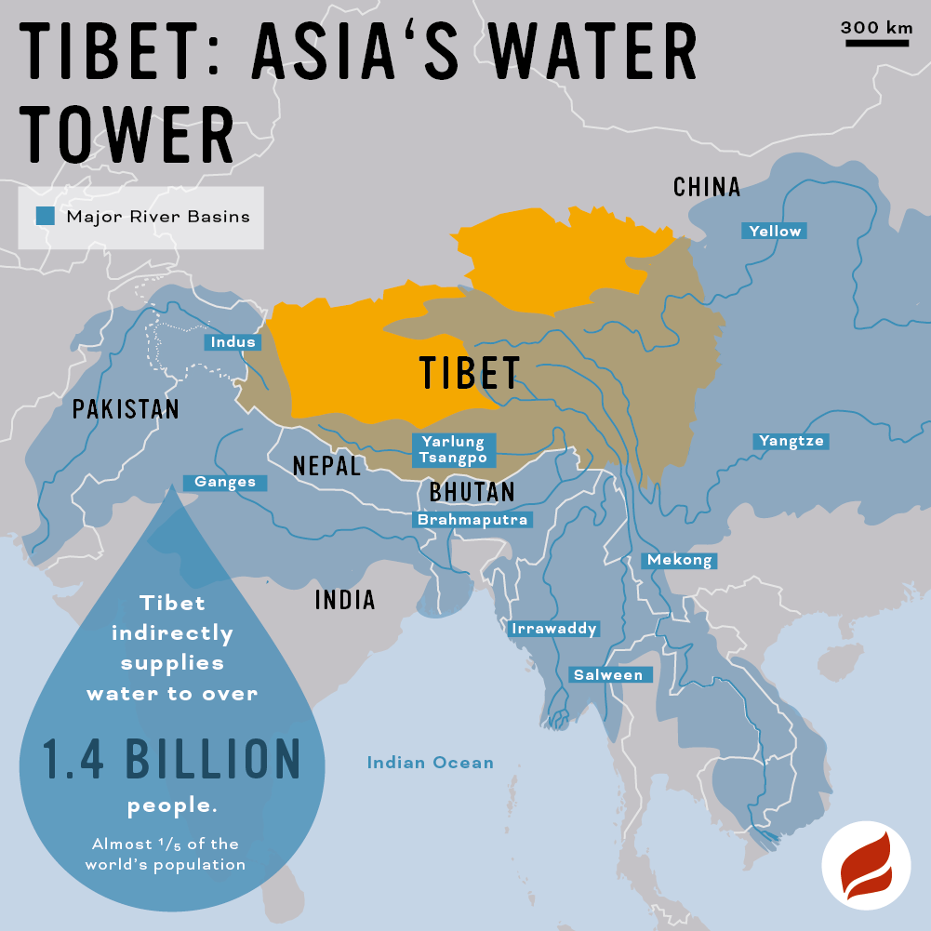
Many of the environmental challenges facing Tibet have been caused and/or exacerbated by the political disempowerment of Tibetans, who have been under rule of the People’s Republic of China (PRC) since 1949/50. Prior to the Chinese invasion, Tibet’s environment historically enjoyed protection by natural geographic barriers and approximately six million Tibetan inhabitants whose subsistence lifestyles and animistic and Buddhist traditions have promoted coexistence with nature.
While atmospheric warming is a global phenomenon, numerous Chinese government policies have exacerbated the causes and effects of climate change in Tibet. These include policies that have re-engineered the Tibetan landscape through large infrastructure projects, resource extraction, nomad relocation and urbanization, Han in-migration and the creation of enclosed nature parks. The inability of Tibetans to shape local environmental policies remains the most pressing challenge to climate change mitigation and adaptation. Dr. Yonten Nyima, a Tibetan geographer highlights the glaring political, and not technical, challenge to environmental issues in Tibet. Speaking on nomad resettlement policies, he notes:
“The role of China’s authoritarian political system, including the absence of participatory governance and the imposition of uniformity over diversity, cannot be overstated. A fundamental problem in Tibetan pastoralism vis-à-vis the Chinese state is that Tibetan pastoralists are entrapped into accepting decisions made by others, with little space for participation in policy-making. Hence, the problem is political rather than technical in nature.”
- Please describe the impacts of the adverse effects of climate change on the full and effective enjoyment of the human rights of people in vulnerable situations. Where possible, please share specific examples and stories.
According to the 6th IPCC report, climate change in Tibet will continue to cause extreme weather conditions such as droughts, floods, and snowstorms. Warming temperatures are also causing glacial melt and permafrost thawing, which lead to glacial lake expansion and landslides, respectively. These adverse effects of climate change limit Tibetan people’s right to life, liberty and personal security, the right to the highest attainable standard of physical and mental health, right to an adequate standard of living, right to housing, to adequate food, and right to participate in cultural life, right to a healthy environment, and equality. A hazardous environment also creates prohibitive logistical barriers to enjoying civil and political freedoms, as well as additional rights such as the right to education and development.

Tibetans are both geographically and politically vulnerable to the adverse effects of climate change. As an ‘ethnic minority’ group within a state that treats Tibetans with suspicion and discrimination, Tibetans are subject to potential arrest for undertaking ‘splittist’ activities when expressing grievances. As a result of their status as a distinct ethnic group under the occupation of the Chinese government, Tibetans are subject to being silenced, dismissed or incarcerated, even when airing legitimate environmental or climate change related concerns.

Case study 1: Glacial melt and glacial lake expansion inundating pastures nearby Lake Serling

Warming temperatures across the Tibetan plateau has resulted in increased glacial melt and permafrost thaw, which has contributed to the expansion of lakes across Tibet. From 1970 to 2010, the total lake area on the Plateau increased by 34% due to glacial melt, permafrost thaw, high precipitation, and decreased evaporation. Lake Serling, a closed-basin salt lake, is one lake that has expanded significantly. Since doubling in size from 1970 to 2010 (2349km2), Lake Serling is now the second largest Lake in Tibet. Located in Nagchu, Tibet Autonomous Region, the lake expansion has adversely impacted local pastoralists by inundating their grazing lands and properties (livestock pens or houses). Research conducted over 12 months in Jagshung Village, Shungme township, Shentsa County assessed the impact of the lake expansion on locals. It found that 50 out of the 56 households lost either their pastures, livestock pens or houses to lake expansion in 2003. Livestock productivity was also impacted, as salt water degraded surrounding vegetation and water sources, and therefore the health of the livestock. The village leader estimated that since 2003, 120km2 of their rangeland had been lost, amounting to about 45% of the villages total allocated rangeland areas (267km2). By 2016, 14 out of the now 85 households had resettled.

The adverse effect of climate change has therefore impacted their ability to enjoy their right to an adequate standard of living, right to housing, right to a healthy environment, and equality in treatment.

Case study 2: Extreme weather events such as snowstorms

The 6th Intergovernmental panel on climate change (IPCC) report also reports that there will be decreased frequency, but increased mean intensity of snow storms across the Tibetan plateau. This means that snowstorms across the plateau will occur with greater intensity.
From late December 2018 to March 2019, several extreme snow storms hit Yushul Prefecture in Qinghai Province. China’s official news outlet, Xinhua news reported 120,000 people and over one million livestock were affected, with at least 26,000 livestock dead. The economic loss was estimated at US$12.6 million. While severe snowstorms are part of the Tibetan climate, the intensity appears to be increasing, with reports of severe snowstorms reported in areas across Tibet in 2008 and 2012.

When Tibetans are unable to respond to these environmental hazards with traditional coping mechanisms such as communal land and labour sharing practices, their right to adequate housing, right to participate in cultural life are unfairly and unjustly limited. In limiting their ability to adapt to climate-induced hazards, Tibetans are indirectly limited from enjoying the right to health, education, and development, as well as their civil and political rights, such as the right to freely assemble, associate, and express their opinions.

2. Please describe any specific policy, legislation, practice or strategy that your Government has undertaken, in compliance with applicable international human rights law, to promote an approach to climate change mitigation and adaptation, as well as loss and damage that ensures the full and effective enjoyment of the human rights of people in vulnerable situations. Please also note and identify any relevant mechanisms for ensuring accountability for these commitments including their means of implementation.
N/A
3. Please share a summary of any relevant data that captures how the adverse effects of climate change have affected people in vulnerable situations, taking into account multiple and intersecting forms of discrimination (i.e. discrimination based on a combination of multiple grounds, including disability, gender, race, colour, sex, language, religion, nationality and migration status).

In the case of Tibetans, when faced with climate change-induced hazards such as lake expansion, glacial lake outburst floods, landslides, and extreme weather events, their ability to advocate for locally designed solutions or responses are severely limited. While some Tibetan villagers can receive emergency relief funds to compensate for losses from extreme weather events, they are unable to advocate for institutional or systematic changes that would better equip their community to withstand new climate change induced hazards. An example of this is a return to communal grazing rights (as opposed to privatized household rights). Tibetan nomads, who are disproportionately affected by climate change-induced hazards prefer communal grazing practices as it enables the community to share risk, share benefits and adapt to changing conditions more quickly.

4. Please describe any mechanisms and tools that are in place to measure and monitor the impacts of climate change on the full and effective enjoyment of the human rights of people in vulnerable situations.

We do not know of any such mechanisms or tools. The preliminary task of monitoring climate change science on Tibet remains a major challenge, as gathering such information is difficult due to the political limitations to accessing the region for research and sharing information on the area. The absence of information on climate change in remote areas is in fact just as damaging to the effective enjoyment of human rights. When we do not know what is changing in the environment and climate, we are unable to understand the full picture of what local residents are facing, and how their human rights are being adversely affected.
5. Please identify and share examples of good practices and challenges in the promotion, protection, and fulfilment of the human rights of people in vulnerable situations in the context of the adverse effects of climate change.

Good practices in promotion of human rights and climate change

- The Principle 10 of the Rio Declaration on Environment and Development (1992) protects the rights of local and concerned citizens in accessing procedural rights, including the right to information, participation, consultation, justice and redress. Principle 10 states:
“Environmental issues are best handled with participation of all concerned citizens, at the relevant level. At the national level, each individual shall have appropriate access to information concerning the environment that is held by public authorities, including information on hazardous materials and activities in their communities, and the opportunity to participate in decision-making processes. States shall facilitate and encourage public awareness and participation by making information widely available. Effective access to judicial and administrative proceedings, including redress and remedy, shall be provided.”
This principle in the Rio Declaration on Environment and Development (1992) is a valuable reference document for environmental and development related policy, but the principle needs to be further institutionalized in new climate-related agreements to strengthen these human rights norms.
- The Ecosystem approach to climate management – a human focused rights-based approach
The Ecosystem approach (from the environmental conservation movement) is an approach to environmental resource management that recognizes humans as an integral component of ecosystems. It treats ecosystem management as a social process that must involve communities in decision-making, and seeks to balance the conflicting goals of conservation and economic and social interests.
The Ecosystem approach has many advantages. First, as an approach that accounts for the complex and unbounded nature of the natural world, the approach aligns with more traditional conceptions of nature. For example, the Ecosystem approach is more consistent with Tibetan conceptions of the environment, which perceive nature and all its components as an interdependent.
Second, the focus on the biological unit of ecosystems allows countries to focus on understanding and more effectively managing critically important ecosystems, which play significant roles in the global climate system. This approach creates opportunities to progress from nationally-focused climate responses to regional, transboundary responses. In the case of Tibet and the Tibetan Plateau ecosystem, institutionalizing the Ecosystem approach can facilitate the creation of a regional environmental council for the wider Tibet region that discusses and mitigates environmental issues facing the Hindu-Kush Himalayan Mountains and the Tibetan plateau.
Third, and perhaps most critically, the Ecosystem approach recognises the importance of involving local communities in the decision-making process, and the need to balance the conflicting needs of conservation and consumption.
Challenges in the promotion of human rights and climate change

- Lack of climate change information due to political sensitivity of the area, as well as remote location
Despite the serious environmental risks facing Tibet and the wider region, very little is known about the Tibetan plateau’s unique ecosystem, its dynamics, and the processes affecting it. Due to geographic and political barriers to access, the region is known as a “white spot” – an area for which there are “little to no data”. The lack of scientific data and knowledge poses serious risks for future generations and downstream countries, as it limits the development of predictions and policies to adapt to anticipated changes in the Himalayan region.

To understand the dynamics of climate change, scientists need to have access to data and physical sites to survey the landscape. All stakeholders should advocate for the opening up of environmentally important regions such as the Tibetan plateau for scientific research and international collaboration. The need to protect and promote scientific freedom, and in particular to promote data sharing and international scientific collaborations has been outlined by the Committee on Economic, Social and Cultural Rights in their General comment No.25 (2020) on science and economic, social and cultural rights (article 15[1] [b], [2], [3] and [4]).

Scientific research in combination with local Tibetan engagement is urgently required to improve our understanding of the ecosystem and to facilitate sustainable local solutions that protect rather than further erode human rights.

- Lack of research and attention on traditional knowledge and resource management practices and an over-emphasis on technical scientific knowledge.

In Tibet, valuable environmental knowledge is preserved and passed on through stories in Tibetan language. Despite this source of knowledge, there are serious threats to the survival and also embrace of such knowledge. Not only is there a failure to protect the study and use of Tibetan language in China, but the knowledge that is currently available is not being appreciated and embraced. Huatse, a Tibetan anthropologist and former nomad, highlights the dangers of losing the intimate knowledge of the habitat and its animals, and the long-term costs to Tibet’s environment.
“What concerns me the most is that people who know a lot about their land, namely Tibetan pastoralists, have been treated as the destroyers of their land mainly in the name of overgrazing. People who know so little about the land on the Tibetan Plateau are so confident in their own perceived “scientific” knowledge of the land that very much shape the land policies in pastoral Tibet today.
Local solutions for grassland degradation and desertification such as using yaks to sow seeds into degraded grasslands exist, but little attention is given to projects that are not large-scale, top-down, geo-engineering interventions. Such uniform interventions are not suitable for regions like Tibet, where conditions differ greatly across the landscape.
6. Please include examples and good practices that highlight international and multilateral cooperation and approaches that are implemented through close consultation with and active involvement of people in vulnerable situations.

A counter example for a bad case of international and multilateral cooperation is the creation of nature reserve parks in Tibet, which not only expel Tibetans from their land, but also fail to protect real areas of biodiversity. International organizations, including INGOs should refrain from participating in such policies or programs, as they are transferring and legitimizing bad practices that further marginalize vulnerable communities in Tibet.

7. Please provide any additional information you believe would be useful to support climate action that promotes the full and effective enjoyment of the human rights of people in vulnerable situations.

Apart from protecting basic principles of rule of law, such as transparency and accountability, environmental and/or development policies in Tibet should urgently be implemented in accordance with principles of Free, Prior and Informed Consent (FPIC). Coercive policies such as the settlement of Tibetan nomads and herders run counter to such principles and should be addressed by the international community.

The Tibetan plateau is warming up at an average of 0.4 degrees Celsius a decade. See Op. cit., Bollasina and Benedict, 2004 and The Huffington Post, 13 December 2016: ‘Climate change is melting ‘The roof of the world’, http://www.huffingtonpost.com/entry/tibet-melting-glaciers-avalanches_us_584e552de4b04c8e2bb061ee.
IPCC, 2019, ‘Special Report on the Ocean and Cryosphere in a Changing Climate’, https://www.ipcc.ch/srocc/download-report/, page 149 (chapter 2, page 18).
The Hindu: Business Line, ‘Global warming reaches Tibet; extreme weather on plateau’, March 23, 2014, https://www.thehindubusinessline.com/news/world/Global-warming-reaches-Tibet-extreme-weather-on-plateau/article20740057.ece.
Nyima, Y. Review of Tibetan Pastoralists and Development: Negotiating the Future of Grassland Livelihoods edited by Andreas Gruschke and Ingo Breuer. Pastoralism 9, 17 (2019). https://doi.org/10.1186/s13570-019-0154-8.
UN Intergovernmental Panel on Climate Change, 7 August 2021, ‘Climate Change 2021: The Physical Science basis,’ https://www.ipcc.ch/report/ar6/wg1/downloads/report/IPCC_AR6_WGI_Full_Report.pdf.
Yan, Zheng, and Qi, 2017 in Yonten Nyima & Kelly A. Hopping (2019) Tibetan Lake Expansion from a Pastoral Perspective: Local Observations and Coping Strategies for a Changing Environment, Society & Natural Resources, Vol. 32:, No. 9, page 966.
Li et al. 2014 and Yan et al 2017 in Nyima and Hopping, 2019, page 967.
Ibid, page 970.
Ibid, page 971.
Ibid.
Ibid, 2021, 6th IPPC report.
Tibetan Review, ‘Snowstorms affect 120,000 people, over 1 million livestock in Qinghai’, March 5, 2019, https://www.tibetanreview.net/snowstorms-affect-120000-people-over-1-million-livestock-in-qinghai/.
CNN, ‘7 killed in Tibet's 'worst snowstorm'‘, October 31, 2008, http://edition.cnn.com/2008/WORLD/asiapcf/10/31/tibet.snowstorm/.
RFA, Snow Kills Tibetan Herds‘, March 14, 2014, https://www.rfa.org/english/news/tibet/snow-03142012140635.html.
Emily Yeh, Yonten Nyima, Kelly Hopping, and Julia Klein, 27 November 2013, ‘Tibetan Pastoralists’ Vulnerability to Climate Change: A Political Ecology Analysis of Snowstorm Coping Capacity’, Human Ecology, Vol. 2014, No. 42, pp 61-74.
United Nations Environment Programme, 2021, ‘Principle 10’, https://www.unep.org/civil-society-engagement/partnerships/principle-10.
Shepherd, Gill. (2004). The Ecosystem Approach: Five Steps to Implementation. IUCN, Gland, Switzerland and Cambridge, UK, https://portals.iucn.org/library/sites/library/files/documents/CEM-003.pdf.
USAID (2010). Malone, E.L. Changing glaciers and hydrology in Asia addressing vulnerabilities to glacier melt impacts, http://pdf.usaid.gov/pdf_docs/PNADU628.pdf.
United Nations Environment Programme: Environmental Change Hotspots, September 2012: ‘Measuring glacier change in the Himalayas’, https://na.unep.net/geas/getUNEPPageWithArticleIDScript.php?article_id=91.
United Nations, 30 April 2020, ‘General comment No. 25 (2020) on science and economic, social and cultural rights (article 15 (1) (b), (2), (3) and (4) of the International Covenant on Economic, Social and Cultural Rights) *’ (E/C.12/GC/25), Committee on Economic, Social and Cultural Rights.
Environmental Futures – University of Colorado, Boulder, 4 April 2021, ‘Huatse Gyal and Sangjie Zhaxi’, https://www.colorado.edu/project/environmental-futures/2021/04/04/huatse-gyal-sangjie-zhaxi.
Environmental Futures – University of Colorado, Boulder, 4 April 2021, ‘Huatse Gyal and Sangjie Zhaxi’, https://www.colorado.edu/project/environmental-futures/2021/04/04/huatse-gyal-sangjie-zhaxi.

