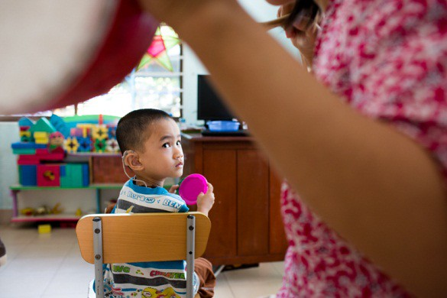

# **LAUNCH OF JOINT STATEMENT ON THE RIGHTS OF CHILDREN WITH DISABILITIES**

21 MARCH 2022

10– 11 am CET

ROOM xxiii

PALAIS DES NATIONS

live webcast:

[UN Media](https://media.un.org/en/asset/k13/k13lq4ab2q)

*WITH ONLINE PARTICIPATION OF STAKEHOLDERS*

**Moderator**

Mr. Jorge Cardona, Lead Consultant

**Opening Remarks**

• Ms. Rosemary Kayess, Chair CRPD

• Ms. Mikiko Otani, Chair CRC

**Panel Discussions**

• UNICEF representative

• Ms. Velina Todorova, Coordinator of the JWG CRC

• Mr. Jonas Ruskus, Coordinator of the JWG CRPD

**Q&A with participants**

**Launch of the Joint Statement**

*The event will have simultaneous interpretation in English, French and Spanish.*

*Captioning and International Sign available.*

The Convention on the Rights of the Child and the Convention on the Rights of Persons with Disabilities contain legally binding obligations relating in general and specific terms to the rights of children with disabilities.

By virtue of their complementary mandates and shared commitment to strengthening protection of all children with disabilities**, the Committee on the Rights of the Child (CRC) and the Committee on the Rights of Persons with Disabilities (CRPD)** adopted a Joint Statement on the Rights of Children with Disabilities.

The Joint Statement harmonizes issues related to the respect, protection and realization of the rights of children with disabilities and their interpretation in accordance with the two Conventions.