Response to the Call for Comments and Textual Suggestions on the Draft Convention on the Right to Development

January 2022, Geneva, Switzerland

Submission by:

ADF International
Rue Pré-de-la-Bichette 1
1202 Geneva, Switzerland

Web: www.ADFinternational.org
Email: UN@ADFinternational.org

ECOSOC Special Consultative Status (2010)

Introduction
- ADF International is a faith-based legal advocacy organisation that protects fundamental freedoms and promotes the inherent dignity of all people before national and international institutions. As well as having ECOSOC consultative status with the United Nations (registered name ‘Alliance Defending Freedom’), ADF International has accreditation with the European Commission and Parliament, and the Organisation of American States. ADF International is also a participant in the FRA Fundamental Rights Platform.

- In response to the call for inputs issued by the Working Group on the right to development (hereinafter, the ‘Working Group’) following the conclusion of its 22nd Session, ADF International wishes to submit comments and textual suggestions on the draft convention on the right to development (hereinafter, the ‘draft convention’).
- This written contribution, which complements ADF International’s submission to the Working Group of August 2021, addresses: the draft convention’s use of the term ‘gender’ in its Articles 8 and 16; the competence of the Conference of States Parties to receive State Parties' periodic reports in Article 24; the composition and functions of the implementation mechanism, including particularly the scope of its general comments or recommendations in Article 26.
- Gender Terminology
- ADF International wishes to draw the Working Group’s attention to the concerns expressed in our previous submission, and widely echoed by Member State delegations and civil society organisations upon consideration of Part III of the draft text during the 22nd session of the Working Group, regarding the concurrent listing of ‘sex’ and ‘gender’ in the general non-discrimination clause contained in Article 8, paragraph 1 of the draft convention.

- It is recalled that the current formulation of this provision would result in an unprecedented conceptual separation of these two notions in a United Nations treaty, and that such an understanding is neither supported expressly by treaty nor tacitly by custom. While reiterating that there is no universally accepted definition of ‘gender’ under international human rights law, the term is generally understood to be synonymous with sex. Moreover, if it is intended for ‘gender’ to be distinct from ‘sex’, that would represent a marked departure from current consensus among all international human rights treaties adopted by the United Nations.
- Accordingly, ADF International notes that the inclusion of both ‘sex’ and ‘gender’ in Article 8, paragraph 1 of the draft convention would, at a minimum, be overlapping and redundant. At worst, it could materially undermine legal certainty by producing a vulnus in the predictability of its eventual parties’ obligations.
- In the absence of agreement as to the meaning of the term ‘gender’, and in the interest of both ensuring the widest possible signature and ratification of this draft convention and minimizing the adverse impact of treaty reservations on the coherence of the international human rights regime, it is therefore advised that the list of prohibited grounds for discrimination contained under Article 8, paragraph 1 of the draft convention be aligned with the wording of the relevant provisions of the all the ‘core’ international human rights instruments.
- The aforementioned concerns also extend to Article 16 of the draft convention, titled ‘Gender Equality’, whose principal objective is to ensure women are empowered to be agents and beneficiaries of development on an equal footing with men. Similarly to what has been stated above in relation to the lack of a codified definition of ‘gender’ under international human rights law, it is unclear why said formulation should be preferred over clear and unambiguous terms such as ‘equality between women and men’, ‘equality of rights between women and men’ or ‘equal rights for women and men’ that are mainstreamed in several core international human rights instruments, including but not limited to the Convention on the Elimination of All Forms of Discrimination against Women (CEDAW).
- The principle of equal rights for women and men has been central in the development and implementation of states’ obligations under international human rights law. The ‘faith … in the equal rights of men and women’, first proclaimed by the peoples of the United Nations in its founding Charter and subsequently reaffirmed in the Universal Declaration of Human Rights, was soon translated into the specific obligation, set out in the two Covenants, to ensure the equal right of men and women to the enjoyment of all civil and political, and economic, social, and cultural rights respectively. Along with the listing of ‘sex’ among the grounds of prohibited discrimination in these and any other core human rights treaty subsequently adopted under the auspices of the UN, the content of this obligation has been further articulated in CEDAW, which is widely regarded as constituting the standard in the promotion and protection of women's equal enjoyment of all human rights and fundamental freedoms.
- While it is acknowledged that the term ‘gender equality’ has been historically construed according to the traditional understanding of the term ‘gender’, i.e., as inherently linked to biological factors, and thus used as a synonym for ‘equality between men and women’, its ordinary meaning has recently been speciously called into question as reflective of a system of oppression, discrimination and exclusion, and watered down by attempts to shift away from its original focus on women’s and girls’ enjoyment of equal rights and opportunities with men and boys.
- With specific reference to the wording ‘full gender equality for all women and men’ contained in Article 16, paragraph 1, of the draft convention, ADF International stresses that the term ‘gender equality’ is redundant and unnecessary in light of the Working Group’s own explanation that for the purposes of this treaty, and as commented upon by the Committee on the Elimination of Discrimination against Women, the term ‘gender equality’ is to be interpreted as ‘synonymous with the terms ‘equality between men and women’ employed on multiple occasions in CEDAW.’
- In light of the above, and unless an explicit definition of ‘gender equality’ as meaning ‘equality between women and men’ is provided under Article 2 of the draft convention, ADF International therefore strongly supports the view that, in order to avoid any regression or ambiguity as well as to retain the specific focus of Article 16 on women and girls, the title of this provision be changed into ‘Equality between women and men’.
- Along similar lines, it is recommended that the reference to ‘gender equality’ contained in its paragraph 2, subparagraph (c) be replaced with ‘equality between women and men’. Finally, in paragraph 2, subparagraph (d), the term ‘gender perspectives’ should be replaced with ‘the perspectives of women and girls.
- Conference of States’ Parties

- Under Article 24, paragraph 2, subparagraph (a) of the draft convention, the competence to ‘periodically examine reports by States Parties on the implementation of their obligations under the Convention and the obstacles that they face in the realization of the right to development’ would be entrusted to the Conference of States Parties. This runs in direct contradiction to the institutional setup established by each of the core international human rights instruments, according to which the exclusive responsibility for the periodic reporting process lies with the relevant monitoring bodies. Besides raising genuine doubts as to the ability of an intergovernmental body to perform such function effectively and with the required absolute impartiality and objectivity, conferring competence on the Conference of States Parties to consider States Parties’ reports carries obvious risks of duplication with other state-driven human rights review processes, such as the Universal Periodic Review.
- Furthermore, the provision that the Conference of States Parties ‘may [emphasis added] refer such reports to the implementation mechanism contemplated under article 26 of the present Convention’ would not only effectively compromise the primary raison d’être of the implementation mechanism, that is, to monitor progress made by each State Party in ensuring compliance with their treaty obligations; it would also be in flagrant violation of the principle of independence of human rights treaty bodies, which is essential for the performance of their duties and responsibilities.

- Based on the foregoing, it is essential that the competence to periodically examine reports by States Parties be removed from the Conference of States Parties and instead vested exclusively in the implementation mechanism established under Article 26 of the draft convention, in the manner indicated in the paragraph below. Accordingly, ADF International calls for the deletion of Article 24, paragraph 2, subparagraph (a) of the draft convention.

- Implementation Mechanism

- ADF International regrets that Article 26 of the draft convention does not explicitly provide that the independent experts composing the implementation mechanism shall be nominated by States Parties among their nationals and subsequently elected by the Conference of States Parties. In this regard, it is particularly concerning that the Working Group has strongly recommended that States Parties mandate the Expert Mechanism on the Right to Development – a mechanism of the Human Rights Council – ‘to also act as the implementation mechanism under the draft convention.’

- In this respect, it is recalled that, as with all special procedures mandate-holders, the selection of the five members of the abovementioned Expert Mechanism is carried out in accordance with the ad hoc procedure established in the so-called ‘Institution-building package’ of the Human Rights Council. If such mechanism was mandated to act as the implementation mechanism under the draft convention, this would imply, inter alia, that nominations of candidates could be put forward by any government as well as by international organisations, non-governmental organisations or individuals, and that the appointment of the members of the implementation mechanism would ultimately depend on the 47 Member States of the Human Rights Council instead of the States Parties to the treaty.
- It is important to stress that, while treaty monitoring bodies are considered an integral part of the UN human rights system, they are not UN bodies themselves. Accordingly, to provide for a Human Rights Council mechanism to serve as the implementation mechanism under the draft convention would constitute a serious interference with the requirement of independence of human rights treaty monitoring bodies.
- In light of the above concerns, and to ensure that the implementation mechanism would meet the same standards of other existing treaty monitoring bodies, ADF International therefore requests that, in Article 26, paragraph 2 of the draft convention, the words ‘elected by States Parties from among their nationals’ be added after ‘independent experts’.

- With reference to paragraph 3, subparagraph (a) of the same article, pursuant to which the implementation mechanism shall ‘adopt general comments or recommendations to assist in the interpretation [emphasis added] or implementation of the provisions of the Convention’, ADF International wishes to stress that the recognition of an institutional competence on the part of the implementation mechanism to assist in the interpretation of the treaty would be unprecedented for an international human rights instrument adopted within the framework of the United Nations. From a careful reading of the relevant provisions of all the core international human rights treaties – and in spite of a worrying trend whereby general comments or recommendations are misused to promote revisionist interpretations of treaty obligations – it is indeed evident that the adoption by existing treaty monitoring bodies of such general comments or recommendations shall be based strictly on, and related to, the examination of the periodic reports received from States Parties.

- Without an express conferral of competence to consider the periodic reports submitted by States Parties, and in the absence of a requirement that the content of general comments or recommendations be based on the information contained in such reports, the implementation mechanism would not only lack the necessary experience, but also the legitimacy to issue ‘authoritative’ interpretations of the draft convention’s relevant provisions.
- Moreover, unlike each of the core international human rights treaties, the draft convention gives no consideration whatsoever to the eventual dissenting observations States Parties may wish to make regarding any such general comments or recommendations. Although such observations were originally envisaged to enable States Parties to react to the findings of monitoring activities carried out by the treaty bodies, in recent years they have also been submitted to challenge both the legitimacy and normative validity of certain overreaching interpretations of treaty obligations. For example, in its observations on Human Rights Committee General Comment No. 31 on the nature of the general legal obligation imposed on States Parties to the Covenant, the United States rejected the Committee’s interpretation of the geographical scope of application of the Covenant and criticized the general comment’s ‘demonstrated indifference to the precise wording of this carefully negotiated text.’ Similar objections have been raised by France with respect to Human Rights Committee General Comment No. 36. Likewise in its observations on Human Rights Committee General Comment No. 33 on the obligations of States parties under the Optional Protocol to the ICCPR, the United States reiterated that ‘the Committee does not have the authority to issue views that are “authoritative,” “determinative,” or “judicial” in character” nor it can 'arrogate to itself a legal authority that is unsupported by the texts or negotiating records of either the Covenant or its Optional Protocol.’
- In light of the above, and in line with the relevant provisions of the various ‘core’ international human rights instruments, ADF International calls for a thorough reformulation of Article 26, paragraph 3, as follows:
'3. The implementation mechanism shall:
(a) Periodically examine reports by States Parties on the implementation of their obligations under the Convention, and in this regard to make such suggestions and general recommendations on these reports as it may consider appropriate;
(b) Adopt general comments or recommendations to assist in the interpretation or implementation of the provisions of the Convention In order to foster the effective implementation of the Convention and to encourage international cooperation in the field covered by the Convention, make suggestions and general recommendations based on information received pursuant to subparagraph (a);
(c) Transmit to any State Party concerned and report to the General Assembly its suggestions and general recommendations under subparagraphs (a) and (b), together with comments, if any, from States;
(b) (d) Review obstacles to the implementation of the Convention at the request of the Conference of States Parties;
(c) (e) Review requests by rights holders to comment on situations in which their right to development has been adversely affected by the failure of States to comply with their duty to cooperate, as reaffirmed and recognized under the present Convention:
(d) (f) Undertake any other functions that may be vested by the Conference of States Parties.’

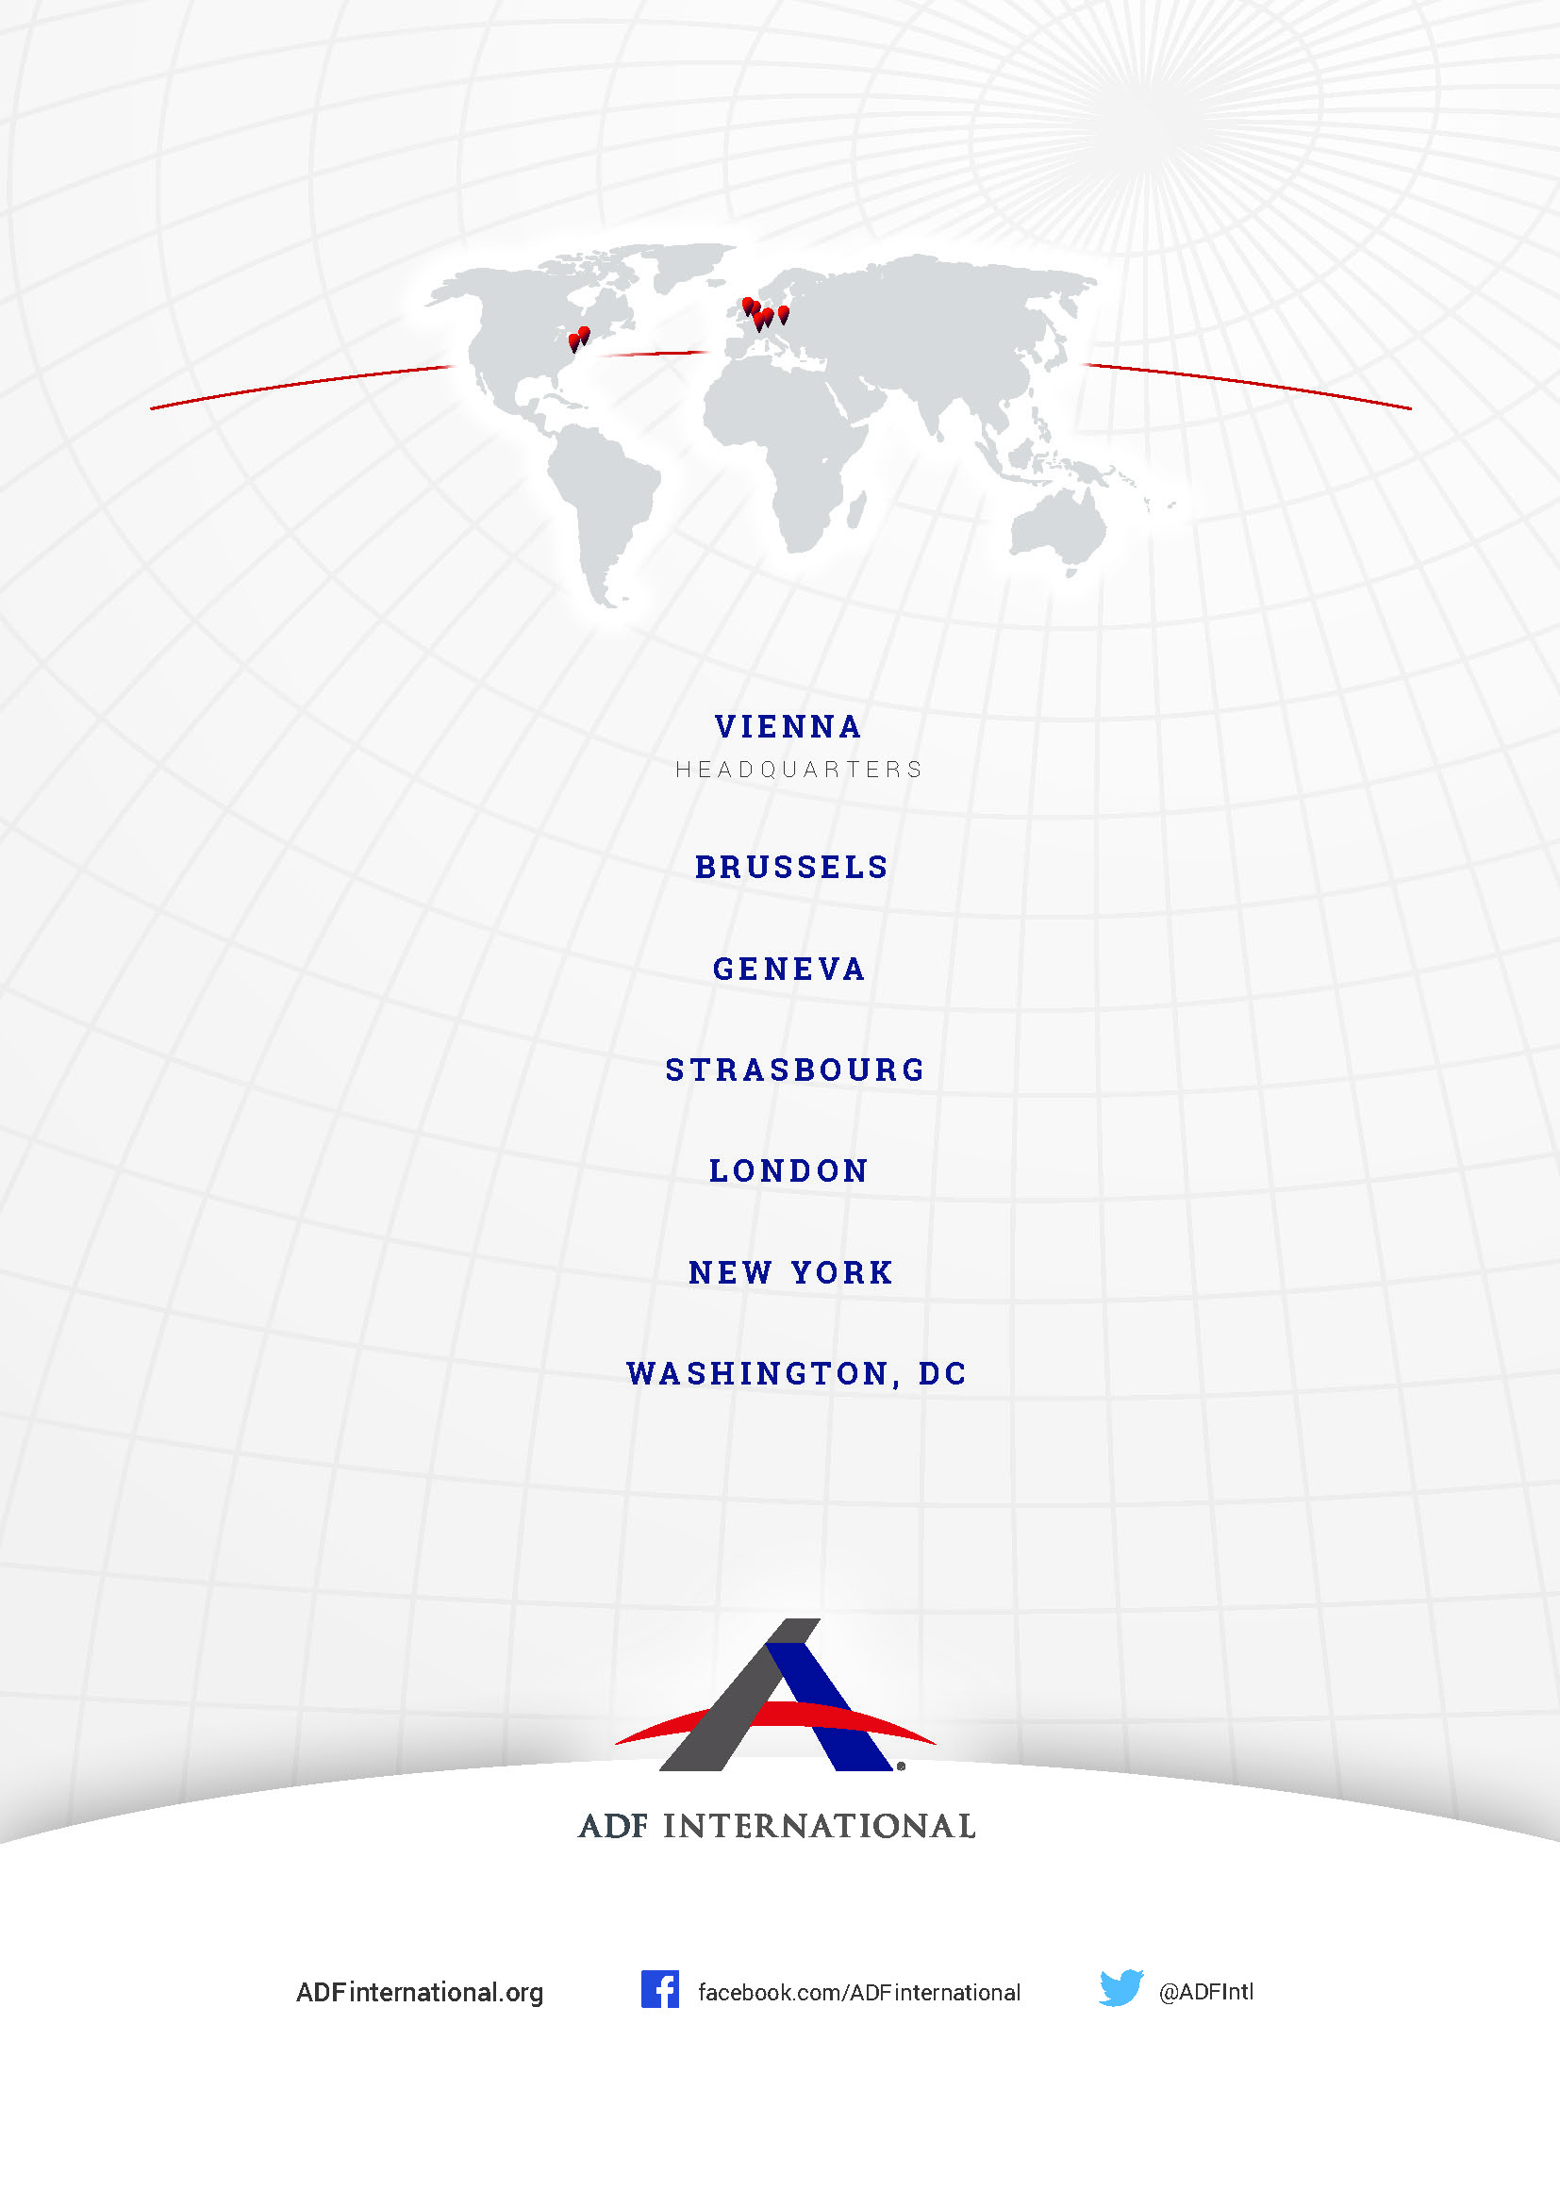
© 2022

UN Human Rights Council, Draft convention on the right to development (Draft Convention), 17 January 2020, A/HRC/WG.2/21/2, art. 8(1).
Id. art 16.
Convention on the Elimination of All Forms of Discrimination Against Women, opened for signature, Dec. 19, 1979, 1249 U.N.T.S.
UN General Assembly, Report of the Special Rapporteur on the Right of everyone to the enjoyment of the highest attainable standard of physical and mental health, Sexual and reproductive health rights: challenges and opportunities during the COVID-19 pandemic, 16 July 2021, A/76/172.
UN Human Rights Council, Report of the Special Rapporteur on freedom of religion or belief, Gender-based violence and discrimination in the name of religion or belief, 24 August 2020, A/HRC/43/48.
UN General Assembly, Report of the Independent Expert on Sexual Orientation and Gender Identity, Protection against violence and discrimination based on sexual orientation and gender identity, 15 July 2021, A/76/152.
UN Human Rights Council, Draft Convention on the Right to Development, with commentaries, A/HRC/WG.2/21/2/Add.1, art. 16 commentary para 1.
Draft convention, supra note 1, art. 24(2)(a).
Guidelines on the independence and impartiality of members of the human rights treaty bodies (“the Addis Ababa guidelines”), A/67/222.
Draft Convention on the Right to Development, with commentaries, supra note 7, art. 16, commentary para 2.
UN Human Rights Council, Institution-building of the United Nations Human Rights Council, A/HRC/RES/5/1.
Observations by the United States of America on Human Rights Committee General Comment 31: Nature of the General Legal Obligation Imposed on States Parties to the Covenant, Dec. 27, 2007.
Observations by France on Human Rights Committee General Comment 36, June. 14, 2019.
Observations of the United States of America on the Human Rights Committee’s General Comment 33: The Obligations of States Parties under the Optional Protocol to the International Covenant on Civil and Political Rights Dec. 22, 2008.

