Check against delivery

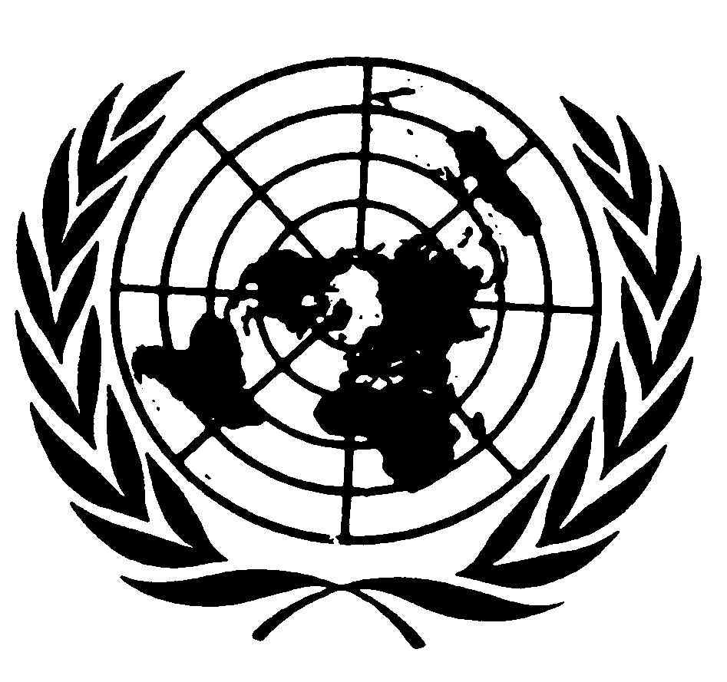

Presentation by
Karima Bennoune

SPECIAL RAPPORTEUR IN THE FIELD OF CULTURAL RIGHTS

76th session of the General Assembly
Third Committee
Item 72 (a-d)

NEW YORK
21 October 2021

Distinguished Delegates, Your excellencies, good afternoon.

I am honoured to share with you my final report as Special Rapporteur in the field of cultural rights which focuses on cultural mixing and mixed cultural identities. To paraphrase the words of Haitian poet Jacques Stephen Aléxis, we are all the children of “an infinity of cultures.” The need to understand and respond to that reality is a critical task for the field of cultural rights.

In recent years, increasingly monolithic notions of culture and identity and purist views of the interrelationships of diverse cultures have taken hold in various sectors across the political spectrum around the world, and have been advocated by some Governments. In response, I call for greater recognition of human rights-respecting cultural mixing and syncretism, and increased respect for mixed and multiple cultural identities. I do so while recognizing that cultures do not always mix from a position of equality.

To write this report, I carried out global virtual consultations with experts from most regions of the world, in particular with the cooperation of the Coalition for Religious Equality and Inclusive Development, and with the Malaysian NGO Pusaka. These are high priority issues in so many different countries.

Cultural mixing and syncretism, or the combining and merging of various cultural elements have been constants in the accretion of dynamic hybrid human cultures throughout history. Understanding and acknowledging such patterns is closely related to promoting coexistence.

Diverse examples of cultural mixing and syncretism from all regions of the world can and should be celebrated and studied. One prominent example is creolité or creolization, which subverts an originally colonial notion and emphasizes the composite nature of cultural and other identities. One of its most famous theorists, Édouard Glissant of Martinique, stressed the interdependence of the social world, recognizing that all identities are relational, and changing. His observations remind us that our cultural lives and rights are all connected.

Such understandings of syncretism are rooted in the lived reality and practices of people on the ground. This type of syncretism stands in contrast to assimilation and rejects homogenization. It suggests an acceptance of joy around culture, such as through mixed holiday celebrations. It reaffirms the potential of intercultural solidarity.

The rights to mix, borrow, traverse and fuse cultures and to engage in syncretic cultural practice, in a rights-respecting manner, should be understood as cultural rights. Moreover, the human rights impacts of the issues covered in the present report are wide-ranging, affecting also the rights to development, to education, to freedom of religion or belief, to freedom of expression, and to freedom of peaceful assembly including the right to assemble around cultural practice.

In order to handle the challenges in this area, a human rights framework needs to be applied that, rather than constraining people by assigning them to narrow identity categories, recognizes their internal diversities and their agency to engage in cultural exploration and development. This framework should be firmly grounded in equality, and encourage the active participation and consultation of all affected constituencies.

Cultural mixing and syncretism have resulted both from positive human interactions, cooperation and sharing, but also from inequalities and violence. However, even in contexts of domination and colonization, cultural hybridizing has been multidirectional, and mixing of cultural forms has been a tactic of cultural resistance by marginalized peoples. An honest appraisal of the relevant histories and the underlying structural questions is critical. In any case, if we now imagine pasts when there was no cultural mixing or fusion, or when there was a “pure” culture, we are denying human history. Syncretism and cultural sharing are among the usual forms of cultural production.

Purity and authenticity-based approaches to culture and to relations between (and within) diverse cultures undermine the reality of cultural heterogeneity with a range of negative consequences for human rights. The insistence on cultural purity can lead to the decimation of those deemed to taint that purity, to obliteration of individuals and groups. Many actors may attempt to police assumed cultural borders they have themselves erected in their imaginations. There have been deliberate attempts to erase histories of fusion and syncretism.

Refusal to respect cultural mixing or mixed cultural identities leads to many human rights violations. For example, rejection of syncretism has led to attacks on religious sites and relics important for some Afro-Brazilians, (such as the destruction of terreiros from Umbanda and Candomblé). Essentializing cultures and identities and viewing them as static are also significant obstacles for achieving gender equality.

Today, under the control of the Taliban, the rich cultural diversities of Afghanistan, in heritage, in women’s dress, and in music which has now been banned, are threatened with obliteration. To quote Afghan academic Muska Dastageer, “the fear of this death burns…in many hearts. It is the death of Afghan culture. A specific syncretic way of life.” To respond to this well-founded fear, the international community must offer asylum to Afghan cultural workers forced to flee and support those who remain, while resolutely demanding the Taliban respect cultural rights without discrimination.

As we move to more fully embrace cultural mixing, the international community must also recognize and respond to histories of and ongoing realities of cultural hegemony, and cultural assimilation, and their impacts, in particular, on indigenous peoples and minorities. Syncretism may be challenged by those who argue that it has not been voluntary in some settings.

Cultures and cultural expressions often do not meet and mix on a level playing field. Rights-respecting cultural mixing should happen within a framework of equality. This is a project that has to be constructed by overcoming inequalities and challenging those cultural consequences of dominant modes of globalization from above that are negative.

In many places in the world, people face multiple exclusions due to their mixed identities. The quest to ensure the human rights of people with pronounced mixed identities and in mixed marriages often personifies the issue of cultural mixing. When the concept of being mixed is viewed as “impure,” they are more likely to be excluded from equal participation in cultural life.

Meanwhile, their contributions to our understanding of the complexities of identities, and the possibilities of cultural life are considerable. In fact, we must recognize that everyone has multiple identities to some degree; this is simply more pronounced or obvious for certain people. (“Everyone can be métis”) “Tout le monde peut être métis.”
Human rights must also increasingly recognize “a mosaic of multiple languages.” I regret that two quotes in another language which I used in the English version of the report - to practice what the report preaches - were deleted by UN editors because multilingualism is prohibited in UN documents.

In conclusion, let me stress that we cannot take cultural mixing for granted in a world where it is often under attack. In April 2021, two Indian medical students, a man and a woman from different religious backgrounds, made a video of themselves dancing together to a song by Euro-Caribbean pop group Boney M, which went viral. For daring to dance across cultures, the two young people received an outpouring of support, as well as tirades and hate speech on social media that may have been motivated by Hindu fundamentalism, even accusing them of “dance jihad”. The reply from the students to the criticism was: “We will still dance together.” This must be our collective reply. The only way to guarantee the cultural rights of everyone without discrimination in the 21st century is to creatively and vigorously defend open and multiple understandings of culture and identity, and rights-respecting cultural mixing and syncretism.

Thank you.

