|  |  |  |  |
| --- | --- | --- | --- |
|  |  | A/HRC/49/93 | |
|  | **Advance Edited Version** | | Distr.: General  17 March 2022  Original: English |

**Human Rights Council**

**Forty-ninth session**

28 February–1 April 2022

Agenda item 10

**Technical assistance and capacity-building**

Report of the Chair of the Board of Trustees of the United Nations Voluntary Fund for Technical Cooperation in the Field of Human Rights[1]*, [2]**

|  |
| --- |
| *Summary* |
| In its resolution 18/18, the Human Rights Council invited the Chair of the Board of Trustees of the United Nations Voluntary Fund for Technical Cooperation in the Field of Human Rights to present a comprehensive report on the Board’s work on an annual basis, starting from the twentieth session of the Council. Pursuant to Council resolution 36/28, the present report is submitted to the Council at its forty-ninth session, in March 2022. It provides an update on the work of the Board of Trustees of the Voluntary Fund since the previous report of the Chair of the Board ([A/HRC/46/70](http://undocs.org/en/A/HRC/46/70)). |
|  |

I. Introduction

A. Background

1. The United Nations Voluntary Fund for Technical Cooperation in the Field of Human Rights, established by the Commission on Human Rights in its resolution 1987/38, receives voluntary contributions from Governments, organizations and individuals. The objective of the Voluntary Fund is to provide financial support for technical cooperation aimed at building and strengthening national and regional institutions, legal frameworks and infrastructure that will have positive long-term impacts on the implementation of international human rights standards.

2. The Board of Trustees has been operational since 1993, and its members are appointed by the Secretary-General for a three-year term, renewable once. The mandate of the Board is to assist the Secretary-General in rationalizing and improving the technical cooperation programme. It meets twice a year and reports on its work to the Secretary-General and the Human Rights Council. Its current members are Morten Kjaerum (Denmark) (Chair), Valeriya Lutkovska (Ukraine), Santiago Corcuera-Cabezut (Mexico), Azita Berar Awad (Islamic Republic of Iran) and Nozipho January-Bardill (South Africa). Ms. January-Bardill was nominated in January 2021 to replace the seat vacated by Esi Sutherland-Addy (Ghana). The position of Chair is held on a rotational basis, covering at least two sessions of the Board and an annual Council oral update. The Board elected, at its fifty-third session, Ms. Berar Awad as the new Chair starting from 1 April 2022.

B. Mandate

3. The refocused approach of the Board of Trustees, as set out in the annual report of the Secretary-General to the Human Rights Council,[3] continues to expand opportunities for proactive specific guidance on technical cooperation and to animate the sharing of good practices among Member States. The guidance provided through the Board’s seven components for good technical cooperation in the field of human rights, as well as the increased support provided through resources of the Voluntary Fund to assist States in developing their national capacities to promote the effective implementation of human rights obligations, continued to be appreciated during the period under review. The Board is particularly pleased with the increasing willingness of Member States to share good practices and results achieved through human rights technical cooperation with the Office of the United Nations High Commissioner for Human Rights (OHCHR) and other United Nations organizations, as well as with bilateral, regional and international partners. This willingness was reflected by Member and observer States of the Council and national partners with whom the Board met, as well as in relevant Council resolutions, such as the recently adopted resolution 48/24. In 2021, the Board continued to provide advice to OHCHR and other United Nations partners on ways to strengthen technical cooperation, including in areas identified as emerging human rights concerns (“frontier issues”), in the programme of work of OHCHR for 2018–2021.

4. The sessions of the Board continued to be partially affected throughout 2021 by travel restrictions imposed due to the coronavirus disease (COVID-19) pandemic. Throughout this period, the secretariat of the Board applied innovative approaches to overcoming the challenges posed by the ongoing travel restrictions and explored alternatives for engagement and the sharing of practices with the Board. Nonetheless, the Board is convinced that visits and discussions with OHCHR field presences, United Nations entities, and national and regional partners continue to be key tools for providing sound policy advice. For this reason, the Board resumed its sessions in countries where OHCHR has a presence as soon as it was possible.

5. As members also of the Board of Trustees of the Voluntary Fund for Financial and Technical Assistance in the Implementation of the Universal Periodic Review, members of the Board offer policy guidance and advice to OHCHR in order to enhance the effectiveness of technical assistance and financial support provided to States for the implementation of the recommendations made in the context of the universal periodic review and other international mechanisms. In 2021, the Board continued to particularly support the efforts made by OHCHR to continue to optimize the provision of guidance also to United Nations partners for the implementation of the universal periodic review outcomes in line with the practical guidance on maximizing the use of the universal periodic review. The review and other international human rights mechanisms continue to be important entry points with Member States and to provide valuable guidance for United Nations and OHCHR initiatives in supporting them.

6. In 2021 there was an increased demand for OHCHR in-country presence and support, including the establishment of new country offices, such as in Burkina Faso. There have also been requests for the deployment of human rights advisers to the United Nations resident coordinators’ offices and other types of technical support projects. The Board is encouraged by the increasing number of requests by States, including at Human Rights Council sessions, for technical cooperation and advisory services from OHCHR.

7. The Board’s seven components of good practices in the context of the technical cooperation presented and analysed in each of its annual reports to the Human Rights Council[4] have continued to facilitate the sharing of experiences. The seven components have inspired and encouraged States to expand partnerships with OHCHR and often with other United Nations entities and bilateral partners in order to receive advisory services and technical assistance in the field of human rights.

8. The Board continues to be concerned about the impact of COVID-19 on the general human rights situation and on efforts to address inequalities around the world. The Board discussed with OHCHR ways to enhance partnerships focusing on the impact of the pandemic and to build up solid programmes to address the costs of widespread inequalities and human rights gaps. It underscored the heightened importance of technical cooperation programmes strengthening the protection of all human rights, including civil, political, economic, social and cultural rights, and making full use of the innovative work developed within the OHCHR Surge Initiative.

II. Activities of the United Nations Voluntary Fund for Technical Cooperation in the Field of Human Rights and the Board of Trustees

9. The Board of Trustees held its fifty-second session online on 1 and 2 June 2021. The session served to provide advice and views in the context of the extension of the OHCHR Organizational Management Plan for 2022 and 2023. Discussions with the United Nations Deputy High Commissioner for Human Rights and relevant senior OHCHR staff also focused on the ongoing implications of the COVID-19 pandemic for OHCHR programmes, the adjustments being made and the resources that the Voluntary Fund could provide to continue to support measures aimed at minimizing any disruptions to the implementation of programmes on the ground and to funding. The fifty-third session was held in Chad from 16 to 19 November 2021 as the Board resumed its in-person sessions and visits to countries where OHCHR has a field presence. At that session, the United Nations High Commissioner for Human Rights, the Deputy High Commissioner, experts and partners discussed in-country programmes of OHCHR, programmes relevant to the Sahel region and the implications of the COVID-19 pandemic for programmes across all regions.

10. The sessions were chaired by Mr. Kjaerum. The Board reviewed the status of implementation of the workplan and cost plan for the Voluntary Fund, and reviewed in detail the status of implementation of the funding covering the Voluntary Fund’s cost plan for 2021. At its fifty-third session, the Board endorsed the proposed workplan for 2022. During the sessions, the Board highlighted the vision of the High Commissioner for the Organizational Management Plan for 2022 and 2023, namely to align an ambitious plan for the promotion and protection of human rights with a proven results-based programming framework. The Board stressed the relevance and importance of the extension and updating of the priorities, results and strategies that have guided OHCHR over the period 2018–2021. These are pertinent in supporting global efforts to advance the enjoyment by all of civil, political, economic, social and cultural rights, in particular considering the damaging effects of the COVID-19 pandemic on many hundreds of millions of people.

A. Fifty-second session

11. Due to the global health situation, the Board had to postpone once again the holding of its session in New York. The session had been planned to coincide with the development segment of the annual session of the Economic and Social Council, in order to synergize the stocktaking of the good experiences of the previous 20 years for the promotion and protection of human rights. It has been rescheduled for the second quarter of 2022.

12. The fifty-second session was held online, as the second and third waves of the COVID-19 pandemic were peaking in many countries. The Board focused the session on lessons learned by and practices of OHCHR in supporting States over the previous four years of the implementation of the Organizational Management Plan for 2018–2021. Board members discussed experiences gained through the technical cooperation programmes supported by the United Nations Voluntary Fund for Technical Cooperation in the Field of Human Rights and the Voluntary Fund for Financial and Technical Assistance in the Implementation of the Universal Periodic Review and beyond, and the ongoing efforts to strengthen responses to the COVID-19 pandemic, including the development of recovery plans.

13. For the part of the session dedicated to lessons learned in relation to the Organizational Management Plan for 2018–2021, the Board invited former Board members who had contributed over the previous four years to the enhancement of the technical cooperation programmes. The Board welcomed the opportunity to focus the session on providing inputs for the extension of the Organizational Management Plan, drawing on experiences and exchanges with former members. The Board has observed through its engagement at country and regional levels how “The highest aspiration: a call to action for human rights” of the Secretary-General represents a key reference for all in the United Nations and the international community for strengthening and mobilizing respect for human rights. The Board also noted how, over the previous four years, its support had contributed to a better understanding of the unique type of technical cooperation that OHCHR was best placed to deliver. In particular, its monitoring role will be a crucial element for the effective promotion and implementation of the Secretary-General’s call to action in the coming years.

14. The Board and former members concurred that the process of extending the Organizational Management Plan for 2018–2021 to 2022 and 2023 provided an excellent opportunity to update the focus of the various elements of the human rights programme. The updated Plan will continue to be a strong guiding tool for OHCHR, including with respect to the COVID-19 crisis and the post-crisis efforts for “building forward fairer”. The Board reaffirmed the importance of the six pillars of the organizational management plans (accountability, participation, non-discrimination, development, peace and security) and the work of international human rights mechanisms. These pillars, as well as the flexibility that the framework of the Organizational Management Plan has demonstrated throughout the COVID-19 crisis, continue to be critical in providing States with responses and required support during these critical times for human rights in all regions of the world.

15. The differential and disproportionate impact of the COVID-19 pandemic between countries and within populations of countries has demonstrated the importance of strong systems for the protection of human rights. Some countries are already building a post-pandemic future, while many others are still struggling with the daily realities of the pandemic. In all situations, the pandemic has deepened pre-existing inequalities. The extended Organizational Management Plan enables the integration of human rights perspectives into the various rescue and recovery programmes and into building more resilient societies. The integration was deemed pertinent by numerous partners with whom the Board has met. The outcomes of the universal periodic review and other international human rights mechanisms continue to be important entry points, and the focus on spotlight populations is a key contribution to ensuring that no one is left behind.

16. The shift to a focus on prevention offers an opportunity to continue to demonstrate that attention paid to human rights contributes to early warning and early action to stop the deterioration of situations on the ground. The Board welcomes the efforts to ensure that the increase in risks to uphold economic, social and cultural rights are addressed, in particular in a context where the cracks in the social fabric continue to widen. The Board has observed in practice how the OHCHR Surge Initiative has efficiently served to increase the provision of specialized human rights advice on integrating human rights into economic policies and strategies, including by optimizing efforts of the entire United Nations system on the ground. By expanding specific support on the ground, the initiative has clearly resulted in enhanced capacities through technical cooperation.

17. The narrowing of human rights space, including when linked to measures taken to address the COVID-19 pandemic, which has an impact on the democratic gains of the past 30 years, is an issue of major concern for the Board. In this regard, the Board stresses the importance of widening the global constituency for human rights and demonstrating the critical importance of maintaining and expanding legal and political frameworks; guaranteeing freedom of expression; and enabling civil society to contribute fully to human rights-based recovery plans.

18. The issue of corruption must continue to be addressed across all human rights programmes in view of its impact, not only on the progressive realization of economic, social and cultural rights, but also on the erosion of civil and political rights and some of the solid democratic gains. The Board welcomes the vision that focuses on the obstacles that corruption brings to achieving the Sustainable Development Goals and to addressing inequalities.

19. The Board is impressed by the way OHCHR, through its renewed Organizational Management Plan, has been able to expand spaces for engagement with new civic movements. These opportunities are essential to promote structural societal transformations, for example, in the fight against racism. The inclusion of people of African descent as a particular spotlight in the Organizational Management Plan is much welcomed. The lessons learned from addressing the structural discrimination they suffer have the potential to benefit groups that face discrimination on other grounds.

20. Throughout this challenging period, OHCHR continued to demonstrate the essential guiding role that it can play in supporting States to address the pandemic’s devastating effects while raising alerts about shortfalls in upholding and protecting human rights. In the Board’s view, the extended Organizational Management Plan represents a key tool to support States to overcome the current formidable challenges to human dignity, justice and social progress, and to build better standards of living that are fully anchored in respect for human rights. The latter is also crucial in addressing the entrenched inequalities exacerbated by the pandemic.

B. Fifty-third session

21. In accordance with its practice of holding one of its two sessions each year in a State where OHCHR has a field presence or where it is working with key partners in support of its overall programme, the Board held its fifty-third session in N’Djamena. This was the first time that the Board held a session in the Sahel region. Its main purpose, as in the case of previous visits to country offices, was to gather observations in situ of the role and added value of OHCHR on the ground, to increase its understanding of the type of technical cooperation that OHCHR provides, and to give relevant guidance on related situations across the Sahel region.

22. The Board particularly welcomed the opportunity to assess the challenging political transition process in Chad on the ground, the unprecedented opportunities for change that it could potentially unleash and the support provided by the OHCHR country office in this regard. During this visit, the United Nations High Commissioner for Human Rights and the United Nations Deputy High Commissioner for Human Rights held online sessions with the Board.

23. The session in Chad provided the Board with an excellent opportunity to observe first-hand the type of technical cooperation that OHCHR could offer in such challenging circumstances, in particular based on the results of its monitoring role. Using its technical expertise and close interactions with actors on the ground, the country office gathers evidence-based information and credible, validated data on the human rights situation and challenges. It subsequently designs appropriate responses for, and suggests programmes to, key partners on the basis of that information. In large part, this work has perhaps been made possible by the strengthened management in the Chad office over the past 12 months, which has seized the opportunities that the political transition has opened up.

24. The Board observed in particular how OHCHR supports, in practice, national partners in their efforts to ensure the integration of all civil, political, economic, social and cultural rights in spite of the enormous challenges in all of those areas. The approach taken in Chad demonstrates the importance of strategically and holistically addressing all rights, as well as their interdependence and interrelatedness. This is particularly important in such a complex and evolving political situation and in a country entrenched in deep poverty and with tremendous economic and social challenges. OHCHR has been able to put in place a programme that is highly relevant to the context, developing key partnerships with national institutions, civil society and the United Nations family to optimize the achievement of results.

25. Despite the relatively short period since the opening of the country office and its limited size, OHCHR in Chad has managed to cover key situations in the country in a sustained manner, even during uncertain times. It has clearly managed to build trust across institutions and stakeholders through the continuous provision of high-level technical support and by being strategic with regard to priorities. The Board was impressed with the level of appreciation expressed by all partners, which highly value the unique mandate. The transition, with all its challenges, is opening critical windows of opportunity for dialogue and for the increased consideration of human rights issues that are crucial to the future of the country. The transition is providing an opportunity for the population of Chad to participate in laying new foundations for the future of their country, anchored in the respect for and protection of all their rights. In the context of this time-bound transition, OHCHR is considered a reliable and key partner by different actors with whom the Board met.

26. The critical role that OHCHR plays as a main partner in supporting the State in its obligations to promote and protect human rights was brought up in all the meetings that the Board held. Particularly evident was the space that OHCHR provides for dialogue, cooperation and the search for durable solutions for long-standing challenges. The Board advises that, in addition to the support already being provided by the country office in the transition process, OHCHR further strengthen partnerships with civil society organizations in general and with women’s groups in particular.

27. The Board was impressed by the recognition of the role of OHCHR in addressing some of the frontier issues. OHCHR has been investing in a number of areas identified as requiring deeper attention, such as the question of corruption linked to the enjoyment of all human rights and the achievement of the Sustainable Development Goals. The Board met with the minister in charge of reconciliation and national dialogue, the Minister of Security and Immigration, and representatives from many authorities and groups, including the Ministry of Justice, the National Human Rights Commission, women’s organizations and civil society organizations, all of whom expressed their deep appreciation for, and expectations relating to, the role and support that OHCHR could and should provide in that area.

28. The support provided through the Surge Initiative to the Chad programme is facilitating the development of new rights-based approaches to long-standing challenges and conflicts, such as challenges for, and conflicts between, farmers and herders, exacerbated by climate change. The Board can avail itself of the preliminary findings of this initiative and is pleased that the United Nations team expressed support for the approach. The expertise and efforts are important not only for Chad but for countries in the Sahel facing similar challenges. The Board has recommended that the initiative continue to receive some support through the Voluntary Fund in order to establish dedicated capacity in the country. The issue of environmental transition is at the root of exacerbated economic and social conflicts, including those of farmers and herders, and is an area requiring further emphasis in the support provided by OHCHR in the region.

29. All interlocutors of the Board recognize the opportunities that an OHCHR country presence provides to fully understand the situation, challenges and opportunities on the ground. Its monitoring and reporting roles, combined with information-sharing and the proposal of sound technical cooperation options, provide national partners with impartial information that they can use to intervene and act quickly, evaluating the impact of their policies on the ground and addressing shortcomings where they exist.

30. The guidance provided by OHCHR, in particular to United Nations partners, for the implementation of the universal periodic review recommendations, for example, the practical guidance on maximizing the use of the review, reflects the importance of the review and other international human rights mechanism recommendations and outcomes, as important entry points to support Member States in the implementation of their commitments and pledges. The support being provided to the Ministry of Justice of Chad through the Voluntary Fund for Financial and Technical Assistance in the Implementation of the Universal Periodic Review is key in accompanying the efforts of the Government in crucial areas, such as the strengthening of the national preventive mechanism and the adoption of a law on human rights defenders.

31. The legislative efforts made by Chad to integrate human rights standards into national normative frameworks are highly appreciated. The momentum should be seized to support and monitor the effective implementation of laws adopted in various domains.

32. In the Chadian context, the intersectionality between human rights, development and peace and security is highly visible. The Board was briefed by the United Nations Resident Coordinator and representatives from several United Nations entities operating in the country on the opportunities that the transition offers, to increase the prioritization of and coordinated work on human rights under the Resident Coordinator and OHCHR leadership. The importance of active and meaningful participation by all sectors of society, the enormous challenges in meeting the targets of the Sustainable Development Goals, the role of young people, the importance of the judicial reforms and institution-building, and the challenges that corruption poses are all key issues in Chad. The Board was encouraged by the leading role of the Resident Coordinator in the country, who did not shy away from existing challenges and ensured adequate considerations and chances to achieve tangible results in the field of human rights. The Board appreciates how OHCHR, together with the United Nations Development Programme and the United Nations Population Fund (UNFPA), is supporting the transition, with funding from the Peacebuilding Fund, and how OHCHR, together with the Food and Agriculture Organization of the United Nations and UNFPA, is implementing the newly approved technical project to support the establishment of a gender equity observatory.

33. The High Commissioner confirmed the commitment of OHCHR to continue to strengthen support and partnerships with countries in the Sahel region and to preserve hard-won democratic and human rights gains. The effective protection of democratic space is a must for ensuring that people are able to air their grievances and aspirations, and to participate in meaningful dialogue in order to work towards addressing the many crises not only in Chad but also in other countries in the region, such as Burkina Faso, which is hosting the newest OHCHR country office. COVID-19 and transitions like the one in Chad may just act as enablers, but the delivery of results is more critical than ever in such situations for sustained progress, sustained peace and development. The newest Organizational Management Plan of OHCHR, for 2022 and 2023, provides the agility and connections needed to respond to and support all States and United Nations partners efficiently. The Board noted the importance of the momentum in the country and in the region. Chadians are facing opportunities that were previously unthinkable. The commitment to and the energy of the political transition should lead to meaningful results based on broad and inclusive dialogue and consultations, and to the embracing of a comprehensive development agenda in order to lay the foundations for the future.

34. The Board is of the firm view that OHCHR, given its expertise, experience and capacity to respond to complex situations, is the strongest possible reference point for guiding partners on the ground, including those within the United Nations system, on human rights. The results achieved have been possible from an office that is based in the capital city. Should the presence of OHCHR be expanded to other parts of the country, it could significantly expand the technical support provided and multiply the effects on human rights. In meetings with national partners, the importance of expanding support from the country office beyond the capital was reiterated. The Board hopes that increasing financial contributions to OHCHR could ensure a more sustained financial basis for the presence in Chad so that the team is able to strengthen the thematic and operational capacities required to deliver its programme at this critical juncture.

35. The United Nations system and national partners highlighted the key support that the country office provides in the analysis of protection challenges and the support for the United Nations prevention role on the ground. The convening role of OHCHR and the trust it has earned can also be pivotal in continuing to highlight and propose, through technical advice, new approaches to address the question of corruption and its connection to the democratic transition and to access to and the enjoyment of basic social services in such a challenging development environment. The issues were raised in several meetings with ministers and other officials and met with an openness that should be further explored.

36. In a context of considerable gaps across socioeconomic indicators, the Board observed that all programmes, including those of United Nations entities and the international community, could be further expanded, in particular to address young people’s and women’s political, economic and social rights and opportunities.

37. The key normative role of OHCHR – to provide States in the region with critical advice to assist their efforts in integrating human rights into all policies and practices – should continue to be supported politically and financially. For this reason, the Board is appreciative of the expanded support in Chad and in the Niger, and of the newly established presence in Burkina Faso. The Board welcomes in particular the complementarity between the areas OHCHR has prioritized over the previous two years and the expectations of the host countries. The priority areas have been strategically and tactically developed in view of the specific challenges and opportunities to promote human rights-based change in the respective countries.

38. The Board paid particular attention to the way in which OHCHR in Chad facilitated the engagement of a broad range of stakeholders with different human rights mechanisms and how it supported the follow-up to their work. For example, through its capacity-building programme and in partnership with the United Nations Children’s Fund (UNICEF), OHCHR provided technical assistance to the Government, which, in December 2021, submitted two initial reports. Of particular importance is the support for the reports on the implementation of the Optional Protocol to the Convention on the Rights of the Child on the involvement of children in armed conflict and on the implementation of the Optional Protocol to the Convention on the Rights of the Child on the sale of children, child prostitution and child pornography. The Board appreciates the Government’s efforts to catch up in submitting reports to treaty bodies.

39. With support through the OHCHR Surge Initiative, the office in Chad initiated and conducted a pilot study on the root causes of conflicts between farmers and herders and their impact on the enjoyment of human rights of these socioprofessional and cultural communities, using the legal framework of the right to food and other related rights. This study, which was being finalized at the time the Board held its session in Chad, allowed for individual and focus group interviews with actors at the centre of farmer-herder conflicts in two selected departments. The analysis from a human rights perspective should allow for the identification of current complex bottlenecks and the proposal of possible sustainable solutions to the Chadian authorities and future support for their implementation, should they be adopted. This is a subject area of high relevance to other countries; the systematic documentation and the sharing of good practices across countries in this region and even globally will be of critical importance to promote and ensure the intersectionality of civil, political, economic, social and cultural rights.

40. The Board used the session in Chad as an opportunity also to learn about the work and engagement of the relevant regional office with countries in the region. The OHCHR regional representative for the Subregional Centre for Human Rights and Democracy in Central Africa, also referred to as the OHCHR regional office for Central Africa, and the chiefs of branch and section discussed with the Board the support being provided through technical cooperation. In the context of the efforts to address the impact of the COVID-19 pandemic, the OHCHR regional office for Central Africa facilitated a dialogue in Cameroon focused on: the human rights impact of fiscal and other policies adopted to address the effects of COVID-19, the integration of a human rights-based approach to COVID-19 response and recovery, and measures to leave no one behind, taking into account States’ obligations under ratified international human rights instruments. Participants, which included representatives from the Government, civil society and specific affected groups, drew a road map for the integration of human rights into the COVID-19 response. The Board also learned about the support provided by OHCHR together with the Ministry of Justice of Cameroon to enhance the ability of judges to use international standards to promote fairness in trial processes. A series of strategic training workshops were held, aimed at strengthening the capacity of judges and stressing the importance of using international human rights law and international humanitarian law in the judicial response to human rights violations.

41. Support for the establishment and/or reinforcement of national human rights institutions in conformity with international standards is also a major area of technical cooperation work. A capacity-building programme and activity organized in Libreville sensitized participants from the entire region on the role and responsibility of national actors (Governments, parliaments, national human rights institutions and civil society organizations) in the creation and functioning of national human rights institutions, and encouraged the adoption and implementation of road maps for actions to be taken for the creation or strengthening of those institutions. After the regional activity, States pledged to ensure that national human rights institutions met international standards. Equatorial Guinea and Sao Tome and Principe have expressly requested follow-up assistance from the Centre in the creation of a commission that meets international standards.

42. During the fifty-third session, the Board continued to learn about the support provided by human rights advisers, which is always a key item on the Board’s agenda. During the session, the Board met with the Resident Coordinator a.i. in Equatorial Guinea and the newly deployed human rights adviser. The briefing was useful in highlighting how the human rights adviser is optimizing the use of the technical expertise of OHCHR to assist the Resident Coordinator and the entire United Nations system on the ground with sound human rights analysis.

43. The Board is pleased with the strategic direction and management of the Programme of Advisory Services and Technical Assistance in the Field of Human Rights. The programme has reached the highest level of coverage yet, with deployments of United Nations resident coordinators and United Nations country teams currently in 54 countries. The Board appreciates the way the funding sources (the United Nations Voluntary Fund for Technical Cooperation in the Field of Human Rights and the multi-donor trust fund) are complementing each other so as to ensure the sustainability and predictability of this key support for the reformed United Nations development system. With the ongoing strategy to enhance field work, the expansion of thematic and programmatic capacities in regional offices should be a key way to better support human rights advisers to perform their duties.

III. Technical cooperation

A. Technical cooperation in the field of human rights: key components of sound technical cooperation programmes

44. The Board notes with appreciation the references in Human Rights Council resolutions, most recently in Council resolution 48/24, to its components to ensure the effectiveness of the technical cooperation efforts of OHCHR and other United Nations entities, launched in 2012 and elaborated further in all of its annual reports to the Council.

45. These components of technical cooperation and the identification of good practices serve to encourage States to solicit and benefit from the technical cooperation capacities of OHCHR. During 2021, the Board continued, with OHCHR, to expand the awareness of these components, including in thematic panel discussions held during the sessions of the Human Rights Council. Particularly relevant to the current context of the COVID-19 pandemic was the annual thematic panel discussion on technical cooperation and capacity-building, held on 12 July 2021 on the theme of “Technical cooperation to advance the right to education and ensure inclusive and equitable quality education and lifelong learning for all”, where the components were perhaps used to guide discussions and the sharing of good practices among States.

46. Ms. Sutherland-Addy, former Chair of the Board, addressed the panel during the discussion. She stressed the real problems affecting young people and children during the pandemic, which would also have a deep impact on future generations. In education, issues of gender parity relating to access, persistence and performance had been recognized and had led to innovative interventions. Over the past 30 years, the world had inched forward in recognizing the intrinsic value of education as a human right, including formal and livelihood-based education, as well as education for the empowerment of girls and women. That demonstrated how the right kind of education translated directly into measurable positive indices and empowered girls and women to recognize, claim and benefit from their human rights. Policymaking in education did not escape the gender lens. That was why the threatened reversal of 30 years of work by COVID-19 appears so dramatic, with millions of adolescent girls being blocked from returning to school, as they had become pregnant during school closures. The inevitable descent into precarious socioeconomic circumstances might go beyond one generation of pupils. A multipronged approach would be required to continue to enhance the participation and empowerment of women and girls. The Board found that the theme for the annual panel discussion for 2022, namely “Technical cooperation on the full and effective participation of women in decision-making and in public life and on the elimination of violence, with a view to achieving gender equality and the empowerment of all women and girls” was particularly timely. It hoped that a sharing of experiences and practices through technical cooperation would boost the future expansion of work in that critical area.

47. The pandemic has elevated the importance of strengthening human rights protection, which is at the centre of debates on recovery and rebuilding. The expanded and updated Organizational Management Plan for 2022 and 2023 provides – through the six thematic pillars and “shifts” that underpin the global efforts of OHCHR to advance the enjoyment by all of all civil, political, economic, social and cultural rights – a renewed opportunity to continue to strengthen the transformations States sought to achieve through expanded technical cooperation and advisory services. The Plan recalibrates, renews and introduces work areas to sharpen the engagement of OHCHR, generates immediate opportunities and challenges, and continues to create opportunities for stronger partnerships.

48. The Board has been adding its voice to the many alarming calls over the previous two years regarding the devastating effects that the global pandemic has had on human rights and the impacts of inequality. Noted already in the previous report of the Board,[5] the levels of inequality have continued to expand, with larger gaps in the provision of public services, making more visible the impact of corruption on the promotion and protection of all rights, in particular of those most left behind and marginalized. The recent outcomes and reports from the human rights mechanisms, including treaty bodies, special procedures and the universal periodic review, have included specific, critical recommendations that can be the basis for triggering the required transformations. Technical cooperation programmes must first and foremost be based on the universality and indivisibility of all human rights – civil, political, economic, social and cultural rights – and must include elements for the protection and promotion of human rights. The Organizational Management Plan for 2022 and 2023 provides expanded concrete opportunities for OHCHR to work together with States in the area of inequalities to ensure contributions to the implementation of the commitments made under Our Common Agenda and the Secretary-General’s call to action for human rights to overcome the inequality challenge.

49. One of the areas that the Board has been stressing as critical for the United Nations system and for OHCHR is increased investment in data analysis and data collection in order to better support decision-making and policymaking, analysis, assessment and advocacy. A critical step is the vision of the Secretary-General, as expressed in his recent policy documents, to position the United Nations as a data-driven organization, where data are at the centre of all strategies, lead to innovation, are integrated across United Nations systems, and deliver optimal value for the Organization, people and the planet. For this reason, the Board, which welcomed the efforts of OHCHR to enhance its information management work, welcomes in particular the emphasis by OHCHR in its Organizational Management Plan for 2022 and 2023 to expand and reinforce its data components.

50. Technical cooperation programmes should be formulated and implemented with the broadest possible participation of all elements of society. Decisions on policies and programmes that do not reflect voices, realities and rights, in particular of those left behind, have proven to be not sustainable. As the United Nations High Commissioner for Human Rights expressed in her opening statement at the forty-sixth session of the Human Rights Council, the pandemic ripped the mask off the deadly realities of discrimination and inequalities largely ignored by many policymakers across regions. The neglect of the importance and relevance of meaningful participation processes endangers any progress that technical cooperation in the field of human rights seeks to achieve. Technical cooperation and advisory services should continue to promote and protect participation and civic space. The Board highly values the emphasis in the Organizational Management Plan for 2022 and 2023 on ensuring that participation and civic space are addressed, especially in the work of OHCHR in the areas of inequalities, corruption, discrimination and the digital space. The Plan also has the potential to alleviate grievances, prevent conflict and contribute to eliminating impunity.

51. The updated programmatic priorities of OHCHR will continue to strengthen the capacities of United Nations entities to expand their work together to integrate human rights into relevant programmes and to support national efforts in a coordinated way.

B. Measuring the results of technical cooperation and the response of the Office of the United Nations High Commissioner for Human Rights

52. The Board, during its session in Chad, expressed its appreciation for how the OHCHR performance monitoring system continued to prove to be relevant and timely in planning, monitoring and assessing the status of the implementation of programmes. The Board appreciates in particular how the system has expanded opportunities to optimize the efforts of the various parts of OHCHR, integrating all tools and possible contributions across planning entities. The Board encourages OHCHR to continue to support the use of the system for programme information analysis and for sharing practices, ideas and lessons learned across OHCHR presences around the world.

IV. Status of funding and donors

53. At its fifty-second and fifty-third sessions, the Board was provided with updates on the overall financial status of the Voluntary Fund. It discussed and analysed the status of implementation of the workplan for the Voluntary Fund for 2021 and it endorsed the plans for 2022. An analysis of funding trends between 2008 and 2021 (see annex I) showed an increase in 2021. The increase, which follows the trend recorded since 2019, continues to be a good reflection of the strategic vision and enhanced capacity of OHCHR to communicate the crucial results achieved in supporting States. Increased financial resources continue to be welcomed by the Board, as they are much needed to maintain support for States, as the requests for support continue to grow. The Board emphasizes once again the importance of unearmarked funds, which provide the flexibility and predictability OHCHR requires to respond to the needs and demands of the human rights situations on the ground.

54. The total expenditure of the Voluntary Fund as at 31 December 2021 was $21,947,415 against an estimated cost plan of $27,171,453. The cost plan increase in 2021 was due to the increase in voluntary contributions received by OHCHR in 2021, in particular relating to the expansion of the coverage of the human rights advisers deployed under the United Nations Sustainable Development Group strategy launched in 2012, as well as increased contributions from States to the technical cooperation work of OHCHR. As at 31 December, the Voluntary Fund had received a total of $22,706,350 in contributions, which added to the balance from 2020, thereby providing the increased predictability of resources for greater stability of the programmes that the Board has been advocating for. The balance between contributions and expenditures as at 31 December continued to reflect, as was the case in 2020, the late receipt of some large contributions, the impact of the COVID-19 pandemic on a number of planned activities and the need to secure an adequate level of reserves to ensure the continuity of work into 2022. The Voluntary Fund has followed the trend of the past few years in respect of its reserves (in accordance with the Financial Regulations and Rules of the United Nations, trust funds must ensure a reserve of 15 per cent of projected expenditure). The increased funding has allowed the Board to propose allocations to expand support to, for example, the country offices in Chad and the Niger and the opening of the newest country office in Burkina Faso, as well as the work on inequalities. The Board continues to call upon States to increase their contributions in support of the technical cooperation work of OHCHR in general and not to tightly earmark them to specific projects, with a view to securing the required degree of flexibility to adequately cover programmes across regions.

55. The Voluntary Fund provided resources for technical cooperation programmes designed to build strong human rights frameworks at the national level in 64 regions, States and territories (up from 53 in 2020), through 54 human rights advisers and human rights mainstreaming projects in Argentina, Bangladesh, Barbados, Belarus, Belize, Bolivia (Plurinational State of), Bosnia and Herzegovina, Brazil, Burkina Faso, Burundi, the Congo, Costa Rica, the Dominican Republic, Ecuador, El Salvador, Equatorial Guinea, Eswatini, the Gambia, Guinea-Bissau, Guyana, Jamaica, Jordan, Kazakhstan, Kenya, Lesotho, Madagascar, Malawi, Malaysia, Maldives, Mongolia, Montenegro, Nepal, the Niger, Nigeria, North Macedonia, Papua New Guinea, Paraguay, Peru, the Philippines, the Republic of Moldova, the Russian Federation, Rwanda, Serbia, Sierra Leone, Sri Lanka, Timor-Leste, Samoa, Suriname, Tajikistan, Trinidad and Tobago, Uruguay, Zambia and Zimbabwe, as well as in the South Caucasus region (Georgia); six human rights components of peace missions in Afghanistan, the Central African Republic, Haiti, Libya, Somalia and the Sudan (Darfur); and four country and stand-alone offices in Chad, Mauritania, Mexico and the State of Palestine.

56. Through the Voluntary Fund, in-country human rights expertise has continued to expand through the joint United Nations Sustainable Development Group framework for the deployment of human rights advisers and in response to an increased demand for OHCHR country presences. OHCHR has continued to facilitate national efforts to incorporate international human rights standards into national laws, policies and practices. During the past year, it has paid particular attention to the human rights dimensions of the global health crisis and to supporting policies and practices aimed at addressing the impact of COVID-19 and growing inequalities in particular. Support for the follow-up to the recommendations made by international human rights mechanisms, particularly in the context of the third cycle of the universal periodic review, has also expanded.

57. The global health crisis and the difficulties in achieving the Sustainable Development Goals continued to trigger interest in the technical advisory services of OHCHR to support States’ efforts to implement the 2030 Agenda for Sustainable Development. Some programmes financed through the Voluntary Fund have benefited from the enhanced technical capacity that OHCHR has provided through its Surge Initiative, and in 2022 the Voluntary Fund will expand its financial support in this area. OHCHR has, through the Voluntary Fund, also contributed to the establishment and strengthening of national structures, institutions (including national human rights institutions) and capacities to ensure adherence to international human rights standards. For example, the National Human Rights Commission of Mauritania was accredited as being fully compliant with the principles relating to the status of national institutions for the promotion and protection of human rights (the Paris Principles). Detailed information on the cost plan for the Voluntary Fund and on the financial status of the Voluntary Fund for 2021 and a list of donors and contributors are contained in annexes II–IV to the present report.

58. Despite the challenging situation and through its sessions, both online and in person, in 2021, the Board continued to cooperate with the OHCHR External Outreach Service to maximize opportunities to expand the visibility of the results of OHCHR technical cooperation support. Outreach events, such as those during the session in Chad, provide a useful way for the Board to communicate its views and observations and to engage partners to expand the donor base of the Voluntary Funds and support the work in the region in particular. There is growing interest on the ground in the Board’s findings and suggestions regarding engagement with OHCHR for technical cooperation, and Board members are increasingly invited to share experiences and views relating to the lessons learned across regions.

V. Main findings and recommendations

59. **The COVID-19 pandemic is leaving behind an undeniable legacy of a rise in inequalities, greatly challenging the progress and advances achieved. The Board wishes to emphasize through unequivocal advocacy the need to join forces to achieve the transformations required to dismantle the inequalities through real significant investment. The disproportionate consequences for the most disadvantaged groups will continue to pose crucial challenges to stability and prosperity for all. The crisis and its impact on resources has also made clear the eroding effect that some key challenges, such as corruption, have on the safeguards of democracy, good governance and respect for the rule of law, and in the end, on the ability to access basic rights, including health and education.**

60. **Our Common Agenda, launched by the Secretary-General, is timely and welcomed as an action-oriented tool designed to make the tangible difference in people’s lives that is so needed during the post-pandemic recovery. The pandemic has exposed human rights concerns and exacerbated deep fragilities and inequalities, as stressed by the Secretary-General. The 2030 Agenda for Sustainable Development and the Sustainable Development Goals are at the core of Our Common Agenda. Technical cooperation in the field of human rights is a key tool to protect, and to prevent the denial of, human rights, especially of those left furthest behind in societies. The Board stresses the urgency, in the light of gaps and delays caused by the COVID-19 pandemic, to take the opportunities to move ahead with the required renewed social contract, anchored in a comprehensive approach to human rights.**

61. **The visit to the OHCHR country office in Chad and the discussion with State authorities and partners have been revealing for the Board. Factors that highlight the critical importance of continued support through effective programmes, not only for Chad but in the entire Sahel region are: the data and the realities regarding extreme poverty; the lack of funding to respond to the humanitarian needs of over 5 million people (including an increasing refugee population); humanitarian requirements to combat children’s malnutrition; effects of climate change and environmental transition, including on economies and livelihoods, including in agriculture; the insecurity; the situation of women’s rights and challenges for their participation in decision-making; and the limited opportunities for education, skills development and decent work for large cohorts of young women and men. The Board wishes to commend OHCHR staff for the commitment, professionalism and continuous enthusiasm they have demonstrated despite challenging circumstances; their continued efforts allow OHCHR to remain a reliable partner in this critical democratic and development juncture.**

62. **The Board notes with appreciation the acknowledgement by the Human Rights Council and States of the usefulness of its contributions. It is also encouraged by the increasing number of requests from States for OHCHR in-country support, in particular with the opening of the new country office in Burkina Faso, and the most recent requests from United Nations country teams for human rights advisers in the Congo, the Gambia, Kazakhstan, Samoa and Tajikistan. Technical support for the realization of human rights is more relevant than ever as countries start to move ahead with post-pandemic recovery efforts and to bring investments back on track towards the realization of the 2030 Agenda, including the Sustainable Development Goals. The period under review has demonstrated the power of the indivisibility and interdependence of human rights around the world. The Board reiterates that one set of rights cannot be enjoyed fully without the other and that investment in the realization of economic, social and cultural rights is essential.**

63. **The Board welcomes the increase in contributions achieved through the various financial instruments managed by OHCHR in 2021, including the Voluntary Funds. It continues to emphasize the importance of ensuring the sustainability, predictability and flexibility of resources, while also underscoring the need to expand the funding basis for OHCHR so that it has the flexibility and adaptability necessary to cover the overall OHCHR programme. The Board would like to thank donors who have increased their contributions to the Voluntary Fund during these challenging times and especially those ensuring multi-year commitments. Looking forward, in 2022, the Voluntary Fund will expand support to the network of OHCHR regional offices in order to increase their capacities to provide enhanced technical cooperation. OHCHR regional offices play a critical role in the provision of technical cooperation and advisory services and in linking these with the results of its analyses to increase the understanding of human rights situations, challenges and opportunities.**

Annex I

Contributions to the United Nations Voluntary Fund for Technical Cooperation in the Field of Human Rights and expenditure trends   
(2008–2021)

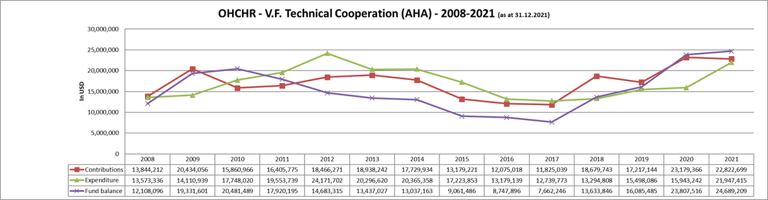

Annex II

 United Nations Voluntary Fund for Technical Cooperation in the Field of Human Rights: cost plan for 2021

Annex III

Financial status of the United Nations Voluntary Fund for Technical Cooperation in the Field of Human Rights (2021)

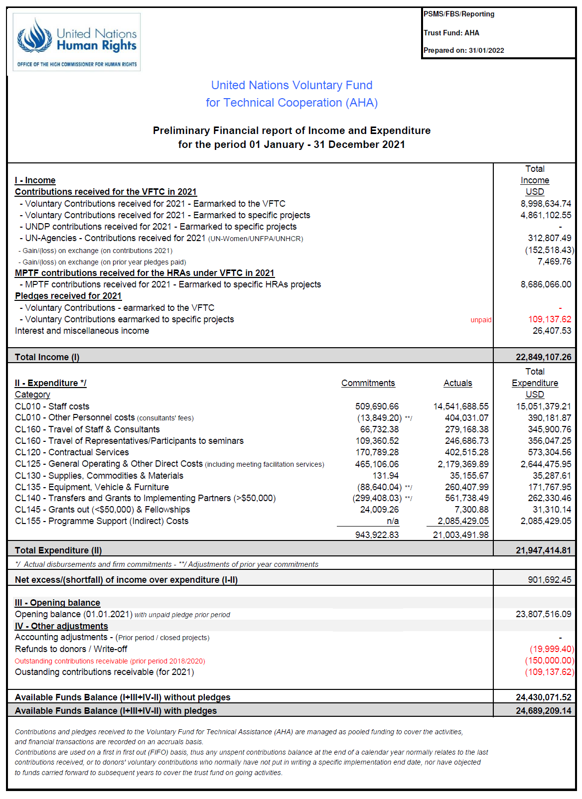

Annex IV

Donors and contributors (2021)

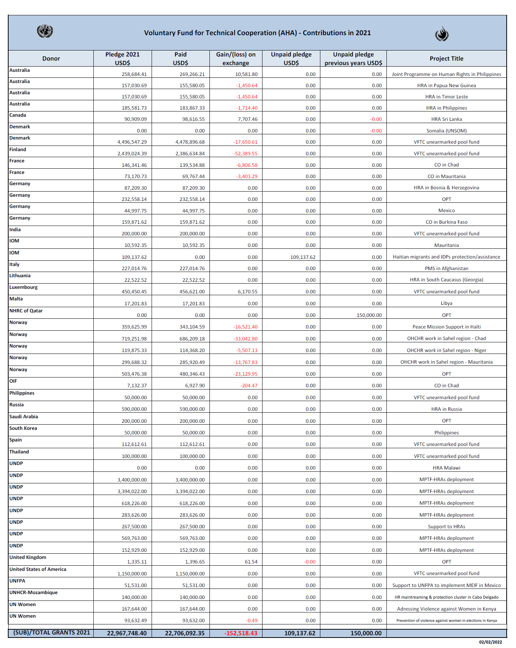

1. * The present report was submitted after the deadline so as to include the most recent information.
2. ** The annexes to the present report are circulated as received, in the language of submission only.
3. See [A/HRC/16/66.](http://undocs.org/en/A/HRC/16/66)
4. See [A/HRC/37/79.](http://undocs.org/en/A/HRC/37/79)
5. See [A/HRC/46/70.](http://undocs.org/en/A/HRC/46/70)