QUESTIONNAIRE

“Violence and its impact on the right to health”

I have the honour to address you in my capacity as Special Rapporteur on the right of everyone to the enjoyment of the highest attainable standard of physical and mental health, pursuant to Human Rights Council resolution 42/16.

I would like to invite you to respond to the questionnaire below. Submissions received will inform my next thematic report on “Violence and its impact on the right to health”, which will be presented to the Human Rights Council in June 2022.

The questionnaire on the report is available at OHCHR website in English (original language) as well as in French, and Spanish: (https://www.ohchr.org/EN/Issues/health/pages/srrighthealthindex.aspx).

All submissions received will be published in the aforementioned website, unless it is indicated that the submission should be kept confidential.

There is a word limit of 750 words per question. Please submit the completed questionnaire to ohchr-srhealth@un.org. The deadline for submissions is: 18 January 2022.

Tlaleng Mofokeng
Special Rapporteur on the right of everyone to the enjoyment of the highest attainable standard of physical and mental health

Contact Details

Please provide your contact details in case we need to contact you in connection with this survey. Note that this is optional.

Type of Stakeholder (please select one) | Other (please specify) International Network
Name of State  Name of Survey Respondent | Global  Network Coordinator – Ruth Birgin
Email | ruth@whrin.site
Can we attribute responses to this questionnaire to your State publicly*?  *On OHCHR website, under the section of SR health | NA as global network but happy to have results in public domain  Comments (if any):

Background

Within the framework of Human Rights Council resolution 42/16, the Special Rapporteur on the highest attainable standard of physical and mental health has identified sexuality, gender based violence and femicide as one of her priorities during her tenure (See A/HRC/47/28 paras 50-64). In compliance with her mandate and in line with this priority she has decided to devote her next thematic report to the 50th session of the Human Rights Council in June 2022 to the theme of “Violence and its impact on the right to health.”

Objectives of the report

The Special Rapporteur intends to shed light on who is seen as victims of violence, and who is affected by what type of violence, with emphasis on the violence experienced by women, children, LGBTI persons and conflict related gender based violence. She will also explore the role of men as perpetrators and their experience as victims of violence. Her analysis will look into the responses that survivors of violence receive with a focus on good practices, as well as the obligations, responsibilities, and protections that arise under the right to health framework and other relevant human rights in this connection. She will also report on emerging trends related to the impact of COVID-19 on all forms of violence and related responses.

In her report, the Special Rapporteur will address, inter alia, issues related to gender based violence, (including inter-personal and intimate violence), as well as structural violence. She will also assess the impact of the criminalization of sex work, same sex relations, transgender persons, abortion, drug use etc. on the enjoyment of the right to health. The Special Rapporteur would like to identify good practices and examples of comprehensive health responses to survivors of violence, and to identify lessons learned at the community, national, regional and international levels.

Key questions

You can choose to answer all or some of the questions below. (750 words limit per question).

When responding to the questions below, please use the glossary with definitions at the end of the questionnaire, and refer to all or some of the forms of violence in focus for this study as applicable in your country, countries or region in focus:

- Please describe, share data and information on the characteristics, number of cases, and the profile of victims and perpetrators in your country/ies or region(s) regarding:
It has been well established that gender-based violence increases the risk of HIV infection among women. Adding to already inflated risks of HIV transmission, women who use drugs have a much higher risk of gender-based violence than women in the general population. WUD experience intimate partner violence as well as violence at the hands of police, prison guards, doctors and from staff in unregulated ‘treatment’ centres and, due to the criminalization of their drug use, they lack recourse to report abuse and access justice. Violence is linked to elevated rates of syringe sharing, inconsistent condom use, fatal overdose and barriers to care. Women who use drugs and engage in sex work are subject to particularly high rates of violence and have very limited access harm reduction and HIV prevention services, while COVID-19 lockdown conditions have resulted in increased rates of GBV, homelessness, poverty and dislocation among WUD as even greater limitations in harm reduction service availability emerge.

- Please describe whether the legal framework prohibits and sanctions these forms of violence and the definitions and forms of violence included in the legal system. Please explain redress options for survivors of violence, (the pathway they go through if they decide to file a complaint), levels of impunity and if access to comprehensive physical and mental care for GBV-survivors is recognized as a form of reparation.
Punitive drug policy perpetuates stigma, criminalization and violence and has a differentiated impact on women, heightening their risk of HIV and other blood borne virus transmission and inhibiting access to health and social services. Decriminalization and reforms of draconian drug laws can reduce rights violations and violence experienced by women while enabling access to essential health and social services.
Perpetrators of violence against women who use drugs commonly act with complete impunity. Women rightly fear reporting to the police with concern that their drug use status will be prioritised over any reporting of GBV – with legal and other repercussions – imprisonment, fines, loss of child custody and other forms of harassment. Gender n on-conforming people who use drugs experience similar lack of recourse with systems designed to punish rather than support violence survivors who use drugs. Globally, the number of women in prison increased by 50% between the year 2000 and the year 2015. Pre-trial detention and mandatory minimum prison sentences contribute to this dynamic. Some women are held in pre-trial detention for years – sometimes for longer than their potential sentences. Harm reduction services are rarely available in prison and generally they are only available for men, and there are only ten countries globally where harm reduction services are available in at least one prison setting. In addition to imprisonment, prohibition inhibits women’s access to health and social services and also subjects women to high levels of violence and harassment from law enforcement. In addition to violence at the hands of law enforcement, women and gender non-conforming people who use drugs often experience arbitrary detention, denial of legal aid and lack of due process. The infographic below summarises some of the key issues.
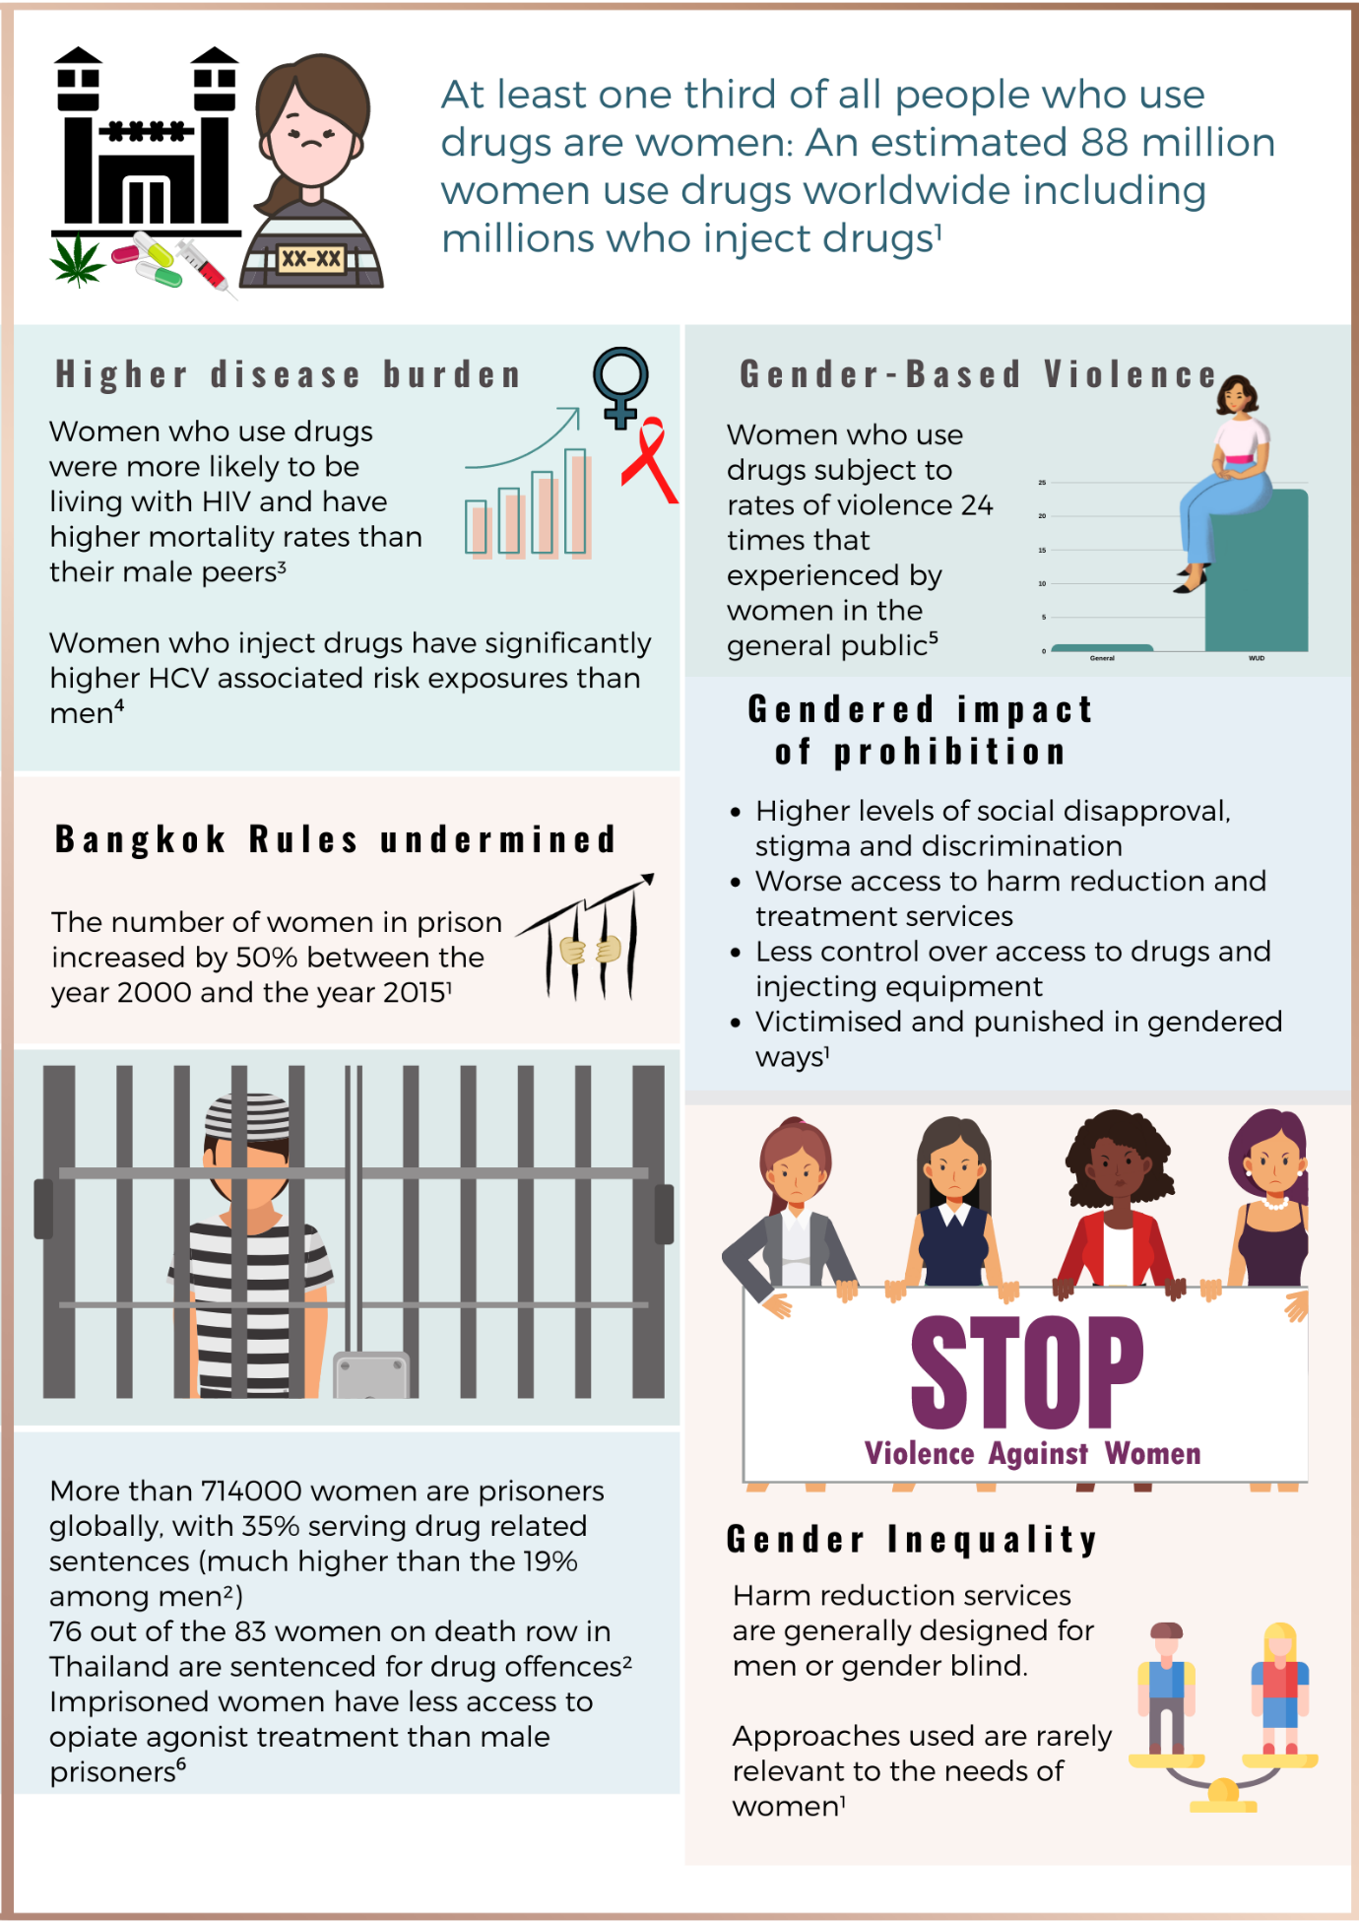

- Please share examples of the types of structural and institutional violence with origins within the State, (perpetrated or condoned by the State) or perpetrated by those not representing or affiliated to the state in your country/ies of region, and who is affected. In particular, describe structural/institutional violence in medical settings against women and girls, LGBTI persons and persons with disabilities or any other individuals or groups relevant in your country/ies or regions.

In addition to the types of structural violence touched on above, it is clear that criminalization of drug use underpins much and wide-ranging violence against women and gender non-conforming people who use drugs, including in medical settings.
In some countries, pregnant illicit drug users face criminal sanctions if they continue to use prohibited drugs. For example, in the United States of America, cocaine users have been convicted on a number of charges including foetal abuse, delivering drugs to a minor, and even murder. This is despite evidence showing that heroin and cocaine use are less harmful to the foetus than alcohol use during pregnancy.
Contrary to current research in this area, misinformation, stigma and discrimination contribute to the promotion of ideas that any type of drug use during pregnancy will result in harm to the foetus. Criminalisation, stigma and discrimination associated with illicit drug use during pregnancy also results in many women keeping their pregnancy concealed and prevents them from accessing a range of services, such as antenatal care, harm reduction services including voluntary drug treatment programs, and interventions to prevent vertical transmission of HIV. International guidelines oppose forced withdrawal, while significant evidence shows that treatments, such as methadone or buprenorphine, are safe for use during pregnancy and are recommended. Such antenatal care and drug-specific support protects both the woman and the foetus from potential harms caused by an unregulated drug market, drug withdrawal and poor nutrition. However, some nations make no provision for opioid substitution therapy (OST) at all, much less for pregnant women. Where drug treatment is available, it may exclude women living with HIV, or may not be provided in women-friendly facilities. Strict regulation or a lack of formalised systems may make it difficult for women who use drugs to receive treatment in maternity hospitals or other health care settings.
Women who continue to use drugs throughout pregnancy can be exposed to many risks during their pregnancy, including violence, pressure to terminate their pregnancy, increased risk of sexually transmitted infections due to changes in partner’s sexual behaviour, changing drug use patterns, changing body mass and consequently variability in the effects of drugs. Health care providers in some regions are inadequately educated about the effects of drug use on women in general and during pregnancy in particular. This often leads them to deny services or provide appropriate care, increasing distress and harm to the mother and foetus.

- Please also share information on the impact of criminalization of sex work, same sex relations, transgender persons, abortion, drug abuse, harmful practices in obstetric care, female genital mutilation on the violence experienced by the affected individuals and their enjoyment of the right to health.
In addition to the information above – the impact of criminalization can be linked as direct or indirect cause of GBV and myriad human rights violations against women and gender non-conforming people who use drugs. Women who use drugs, including trans and gender non-conforming people, are subject to extreme levels and a wide range of physical and psychological harm due to punitive prohibition of some substances. State-driven stigma, criminalisation and corruption drive substantive health and safety harms and act as barriers between women who use drugs and critical harm reduction and gender-based violence (GBV) service. Women who use drugs (WUD) experience GBV at up to around 25 times the rate experienced by other women in the general public. This violence includes, (but is not limited to) extra judicial killing and capital punishment, forced and coerced sterilisation and abortion, rape, sexual harassment, loss of child custody, imprisonment for mere personal possession or use, penalisation for drug use in pregnancy and other types of gendered violations, stigma and discrimination.

Woman who use drugs around the world can face arbitrary detention, extortion, police violence, torture and ill-treatment, with over a third of women in prison incarcerated for drug offences globally. Due to the war on drugs, women survivors have little recourse and often no support, particularly in cases of violence from police, prison guards and compulsory treatment centre staff. The experiences of violence against women who use drugs are even more extreme for those facing intersecting discrimination, such as women of colour, sex workers, or trans women.

These conditions have only worsened during COVID 19 restrictions which have created contexts that have escalated GBV without matching responses for women at risk or being exposed to violence. For more detail on the impact of the pandemic and responses designed for women who use drugs (globally, very few!) please see: https://whrin.site/ourpublication/country-examples-of-covid-hr-responses-for-wud/

- Please share information on the health and other type of responses provided by the State and/or other actors in your country/ies or regions in focus to survivors of each/some of the aforementioned forms of violence. Please assess what works well and not so well, and whether COVID-19 impacted the response and how.
Different responses have occurred in different country contexts. The best of course involve women who use drugs themselves. WUD groups and networks are themselves indignantly responding to these violations with efforts to address gender-based violence in advocacy and information campaigns around the world. For example, the Elimination of Violence Against Women who Use Drugs (EVAWUD) campaign coincides with the international 16 Days of Activism against Gender-Based Violence campaign to draw attention to the unacceptable prevalence of violence against WUD. Over the last three years, women who use drugs from over twenty countries have rallied, together with other allies, through the EVAWUD campaign. For example, a Nigerian WUD-led effort successfully organized a social media campaign and soccer match with female police officers highlighting the need for police practice reforms in the country. In Spain, NGO Metzineres launched radio discussions and art activities with a focus on homeless women, trans women and sex workers who use drugs, leading to positive reactions among members of society. In several locations, the EVAWUD activity precipitated: the establishment of resource packs for women who use drugs; expanded referral networks; on-going meetings of women who use drugs geared towards building advocacy actions; the founding of new networks of women who use drugs; and the strengthening of women’s roles in existing networks of people who use drugs.
Service responses to GBV against WUD should: include support and information about where and how to report on police misconduct; offer survivors of sexual assault clinical care, access to post-exposure prophylaxis and emergency contraception; offer STI services along with psychosocial support; and support the development of safety strategy and violence prevention sessions for WUD. In addition, harm reduction programmes can assist in the development of community-based online instruments to document and report cases of police violence; support the use of human rights mechanisms to advocate against police violence; and organize dialogue with stakeholders, media and decision makers to present data and negotiate improved protection systems. Anti-violence strategies that are implemented by the WUD community can be very effective. For example, the Women Initiating New Goals of Safety (WINGS) initiative has helped keep women who use drugs alive in Georgia, Kyrgyzstan, Kazakhstan and Ukraine .
Again, regarding COVID responses – what is effective and what is not etc please see: phttps://whrin.site/ourpublication/country-examples-of-covid-hr-responses-for-wud/
Over 2020 and 2021, WHRIN ran a survey to document the first global mapping of services for women who use drugs: https://whrin.site/ourpublication/global-mapping-of-harm-reduction-services-for-women-who-use-drugs-english/ The mapping is a tangible outcome of the very gendered impact of prohibition compounded by gender inequality, where resources and political attention are either thin or non-existent.

- Please specify the budget allocated in your country/ies in focus, to health related response to survivors of all/some forms of violence mentioned above. Please indicate the percentage of the national budget devoted to this; the percentage of the international aid provided or received for this. Please explain the impact of Covid 19 to the funding of responses to all/some forms of violence in your State/institution.

At the global level we can objectively measure the relative lack of attention to women who use drugs in global planning and action around GBV. Even less attention has gone to awareness raising on the structural violence driver or criminalization – yet where evidence has been collected, it has been unsurprising to note that rates of violence experienced by women who use drugs are much higher than those experienced by women in general. However some of the research is strangely skewed towards identifying drug use itself as a driver of violence rather than unpacking the climate of vulnerability created not by the drugs themselves, but by punitive drug policy and its gendered negative impacts.

Again, regarding COVID responses –including the section on funding of respoinses and capacity to apply for grants etc please see: https://whrin.site/ourpublication/country-examples-of-covid-hr-responses-for-wud/

- Please describe the needs of survivors of the abovementioned forms of violence as identified by your State/institution. Please share survivor-self identified needs and those of their families, with a focus on health emergency and long-term needs.

- Please share examples of good practices and examples of comprehensive health responses to survivors of violence and indicate efficient multi-sectorial efforts at the community, national, regional and international levels by State or non-State actors.

- Please describe State and other actors initiatives and measures to prevent these forms of violence, specific budget allocated to prevention, and good practices in this regard.

Advancing the sexual and reproductive health and rights of women who use drugs. Frontline AIDS. 2019 https://frontlineaids.org/resources/advancing-the-sexual-and-reproductive-health-and-rights-of-women-who-use-drugs/
Report to the Special Rapporteur on torture and other cruel, inhuman or degrading treatment or punishment on Accountability for Torture and other Cruel, Inhuman or Degrading Treatment or Punishment. HRI. 2021 https://www.hri.global/files/2021/05/14/HRI_Conectas__Accountability_for_torture_submission.pdf
Degenhardt L; Peacock A; Colledge S; Leung J; Grebely J; Vickerman P; Stone J; Cunningham EB; Trickey A; Dumchev K; Lynskey M; Griffiths P; Mattick RP; Hickman M; Larney S; Global prevalence of injecting drug use and sociodemographic characteristics and prevalence of HIV, HBV, and HCV in people who inject drugs: A multistage systematic review. The Lancet. Global health. 2017 https://pubmed.ncbi.nlm.nih.gov/29074409/
Argento E; Chettiar J; Nguyen P; Montaner J; Shannon K; Prevalence and correlates of nonmedical prescription opioid use among a cohort of sex workers in Vancouver, Canada. The International journal on drug policy. 2015. https://pubmed.ncbi.nlm.nih.gov/25148695/
Country examples of covid HR responses for WUD. WHRIN. 2021 https://whrin.site/ourpublication/country-examples-of-covid-hr-responses-for-wud/
Walmsley R. World Female Imprisonment List. Institute for Criminal Policy Research. University of London. 2015. https://www.prisonstudies.org/sites/default/files/resources/downloads/world_female_imprisonment_list_third_edition_0.pdf
Punitive drug laws: 10 years undermining the Bangkok rules. IDPC. 2021 https://idpc.net/publications/2021/02/punitive-drug-laws-10-years-undermining-the-bangkok-rules
Report of the International Narcotics Control Board, Chapter 1 Women and Drugs. INCB. 2016 https://www.incb.org/documents/Publications/AnnualReports/Thematic_chapters/English/AR_2016_E_ChapterI.pdf
Shirley-Beavan S; Roig A; Daniels C; Csak R; Women and barriers to harm reduction services: A literature review and initial findings from a qualitative study in Barcelona, Spain. Harm Reduction Journal. 2020 https://harmreductionjournal.biomedcentral.com/articles/10.1186/s12954-020-00429-5
Punitive drug laws: 10 years undermining the Bangkok rules. IDPC. 2021 https://idpc.net/publications/2021/02/punitive-drug-laws-10-years-undermining-the-bangkok-rules
Office of the High Commissioner for Human Rights (OHCHR) Implementation of the joint commitment to effectively addressing and countering the world drug problem with regard to human rights. HRC. 2018 https://ap.ohchr.org/documents/dpage_e.aspx?si=A/HRC/39/39
Punitive drug laws: 10 years undermining the Bangkok rules. IDPC. 2021 https://idpc.net/publications/2021/02/punitive-drug-laws-10-years-undermining-the-bangkok-rules
Advancing the sexual and reproductive health and rights of women who use drugs. Frontline AIDS. 2020 https://frontlineaids.org/resources/advancing-the-sexual-and-reproductive-health-and-rights-of-women-who-use-drugs/
Indonesia, Burundi, Ukraine, Nigeria, Greece, Mexico, Spain, USA, Mauritius, Nepal, Lithuania, Kenya, Thailand, Spain, Greece, Seychelles, Portugal, Australia, Italy, Myanmar and Poland
The Elimination Of Violence Against Women Who Use Drugs (EVAWUD). WHRIN. Campaign Report. 2020 https://whrin.site/campaign/the-elimination-of-violence-against-women-who-use-drugs-evawud-2020-campaign-report/
Addressing the specific needs of women who inject drugs. UNODC. 2016. https://www.unodc.org/documents/hiv-aids/2016/Addressing_the_specific_needs_of_women_who_inject_drugs_Practical_guide_for_service_providers_on_gender-responsive_HIV_services.pdf
Position statement: Women who use drugs and the violence of law enforcement. TalkingDrugs. 2019 https://www.talkingdrugs.org/position-statement-women-who-use-drugs-and-the-violence-of-law-enforcement

