QUESTIONNAIRE

“Violence and its impact on the right to health”

I have the honour to address you in my capacity as Special Rapporteur on the right of everyone to the enjoyment of the highest attainable standard of physical and mental health, pursuant to Human Rights Council resolution 42/16.

I would like to invite you to respond to the questionnaire below. Submissions received will inform my next thematic report on “Violence and its impact on the right to health”, which will be presented to the Human Rights Council in June 2022.

The questionnaire on the report is available at OHCHR website in English (original language) as well as in French, and Spanish: (https://www.ohchr.org/EN/Issues/health/pages/srrighthealthindex.aspx).

All submissions received will be published in the aforementioned website, unless it is indicated that the submission should be kept confidential.

There is a word limit of 750 words per question. Please submit the completed questionnaire to ohchr-srhealth@un.org. The deadline for submissions is: 18 January 2022.

Tlaleng Mofokeng
Special Rapporteur on the right of everyone to the enjoyment of the highest attainable standard of physical and mental health

Contact Details

Please provide your contact details in case we need to contact you in connection with this survey. Note that this is optional.

Type of Stakeholder (please select one) | Member State  Observer State  Other (please specify)
Name of State  Name of Survey Respondent | Amicus (a Mexican civil society organization)  Pablo de los Cobos Alcalá and Juan Pablo Delgado Miranda
Email | pablodeloscobos@gmail.com
Can we attribute responses to this questionnaire to your State publicly*?  *On OHCHR website, under the section of SR health | Yes No  Comments (if any):  Answers are in bold below the respective question

Background

Within the framework of Human Rights Council resolution 42/16, the Special Rapporteur on the highest attainable standard of physical and mental health has identified sexuality, gender based violence and femicide as one of her priorities during her tenure (See A/HRC/47/28 paras 50-64). In compliance with her mandate and in line with this priority she has decided to devote her next thematic report to the 50th session of the Human Rights Council in June 2022 to the theme of “Violence and its impact on the right to health.”

Objectives of the report

The Special Rapporteur intends to shed light on who is seen as victims of violence, and who is affected by what type of violence, with emphasis on the violence experienced by women, children, LGBTI persons and conflict related gender based violence. She will also explore the role of men as perpetrators and their experience as victims of violence. Her analysis will look into the responses that survivors of violence receive with a focus on good practices, as well as the obligations, responsibilities, and protections that arise under the right to health framework and other relevant human rights in this connection. She will also report on emerging trends related to the impact of COVID-19 on all forms of violence and related responses.

In her report, the Special Rapporteur will address, inter alia, issues related to gender based violence, (including inter-personal and intimate violence), as well as structural violence. She will also assess the impact of the criminalization of sex work, same sex relations, transgender persons, abortion, drug use etc. on the enjoyment of the right to health. The Special Rapporteur would like to identify good practices and examples of comprehensive health responses to survivors of violence, and to identify lessons learned at the community, national, regional and international levels.

Key questions

You can choose to answer all or some of the questions below. (750 words limit per question).

When responding to the questions below, please use the glossary with definitions at the end of the questionnaire, and refer to all or some of the forms of violence in focus for this study as applicable in your country, countries or region in focus:

- Please describe, share data and information on the characteristics, number of cases, and the profile of victims and perpetrators in your country/ies or region(s) regarding:

  - gender based violence against women
  - gender based violence and other forms of violence against children:
  - gender based violence against LGBTI or other persons based on real or imputed sexual orientation, sex characteristics, and gender identity:
  - violence against persons with disabilities, including GBV.
  - gender based violence against men
  - conflict gender based violence, including sexual violence
  - Please share analysis and available evidence on the impact of COVID on the above

Mexico lacks a comprehensive information system regarding gender based violence against LGBTI people. This reality motivated Amicus to develop Visible, the first online platform to report acts of violence and discrimination against LGBTI people in the country. Reports can be made both by victims and witnesses answering a confidential questionnaire. This platform generates an open database from these reports aiming to influence the decision-making processes in public and social organizations. Visible is also a way of empowering victims offering them a safe space to express and report acts of violence and discrimination, as well as a way to link them with other social and public organizations with which we have alliances in their respective states/regions.

From October 2018 until December 2021, we have received 934 reports of violence or discrimination against LGBTI people. Although in some cases there could be more than one type of violence, 248 of the reports were about principally verbal abuses, 130 about killings, and 87 about physical violence. Discrimination as a form of violence has also been prevalent: 119 reports were about people being denied to enter into some place or were negated a service/right. Arbitrary detentions, sexual assaults, harassment, bullying, and hate speech have also been reported, among other types of violence.

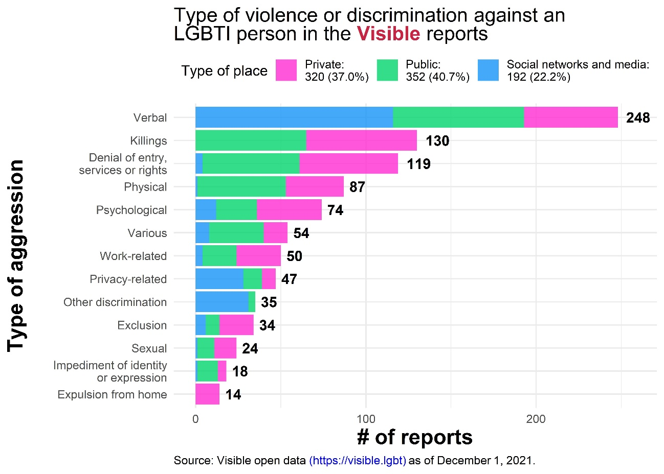

Most of these reports have been made by witnesses (66.7%), specifically NGOs who have reported about 51.8% of the overall incidents. The rest were made by the victims themselves. Although the age range of the reported victims varies, most cases involve young people: 38.3% were 18 to 25 years old, and 20.9% were 26 to 30. Cases involving young victims have a higher proportion of self-reports compared to reports of older persons, which are mostly made by witnesses. Visible has documented reports in reference to 9 different sexual orientations; the main victims’ categories are gay (40.3%), lesbian (9.2%), and bisexual (5.6%). From the 13 victims’ gender identities referred to in the reports, the most common were cisgender men (31.6%), trans women (27.8%), and cisgender women (9.3%). On non-normative sex characteristics, so far we have not received reports regarding intersex people. Aggressions have been committed by non-public sector actors in 42.3% of the cases, while 20.9% have been made by a government official. In 36.8% of cases, the aggressor was not identified.

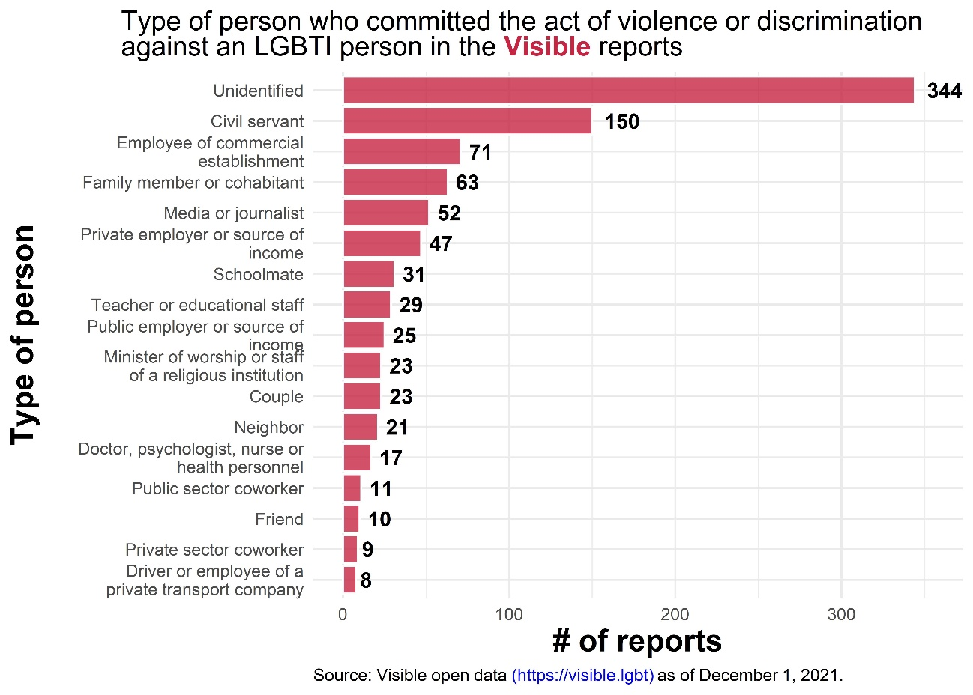

Cases had occurred mainly in public (39.8%) and private places (37.5%), although cases both in social networks and media have also taken place (22.7%). Expectedly, during the first two national waves of COVID-19, the proportion of cases in this last place grew considerably as it was the one with the highest prevalence. Besides, reports that took place in social networks and media were reported faster: the time between when the event occurred and when it was reported in Visible has a median of 19.5 days, in contrast with 33 in private spaces and 39 in public ones.

Visible has received reports from all Mexican states, although they concentrate mainly in Mexico City, Jalisco, the State of Mexico, Guanajuato, and Veracruz. Prevalence reflected in our database does not necessarily mean that such places have higher rates of victimization. Among others, population size, greater media coverage, and the presence of alliances within certain States could be factors to explain higher reporting rates. Similarly, we have received reports from 197 municipalities, Guadalajara, León, Toluca, Cuauhtémoc (Mexico City), and Monterrey, the ones with the higher prevalence.

Detailed information on each case could be found in our open data section, which does not contain personal information.

- Please describe whether the legal framework prohibits and sanctions these forms of violence and the definitions and forms of violence included in the legal system. Please explain redress options for survivors of violence, (the pathway they go through if they decide to file a complaint), levels of impunity and if access to comprehensive physical and mental care for GBV-survivors is recognized as a form of reparation.

60.5% of the victims that made a report in Visible did not make a previous report elsewhere, so the information collected is extremely important not only because of the systematization and openness, but because it would not be possible to find it anywhere else. The main reasons to not make a prior report than the one made in Visible were because victims did not know where to report it or that they could do it (22.8%), they did not believe that there would be consequences (19.9%) and they were afraid to report (13.5%). This information can give insights into understanding the (lack of) interaction of victims with authorities and the reasons behind it. As of today, a total of 18 States have included provisions in their criminal legislation that are related to crimes based on prejudice motivated by the sexual orientation and/or gender identity of the victims.

- Please share examples of the types of structural and institutional violence with origins within the State, (perpetrated or condoned by the State) or perpetrated by those not representing or affiliated to the state in your country/ies of region, and who is affected. In particular, describe structural/institutional violence in medical settings against women and girls, LGBTI persons and persons with disabilities or any other individuals or groups relevant in your country/ies or regions.

We have received 33 reports of cases of violence and discrimination against LGBTI persons in medical settings. One of the most common types of segregation is the impediment to gay persons to donate blood. In some cases, it is a public guideline towards the entire population, while in other cases it is a decision made after questions by health personnel in specific cases.

Similarly, we have documented cases where health care personnel formulate stigmatizing questions to LGB victims regarding their identities, which leads to the extreme of holding patients responsible for their diseases given their sexual orientation. There is indeed fear of expressing the own sexual orientation due to the consequences it can bring, such as the refusal to perform certain procedures, such as sexual and reproductive ones in the case of lesbian and bisexual cis women.

The other most common type of segregation is the refusal to attend an LGBT person arguing personal/religious beliefs or fear of infection. This last motivation is of great importance since, in an investigation carried out by Visible for its annual report, we noticed that public agencies at the state level in Mexico conceive the right to health of LGBTI persons consisting only on providing HIV treatment (although the population is a key population of attention, this is not the only aspect to consider in their access to the right). In this report, measuring state-level health ministries, we observe that only 7 out of 32 states had at least a partial fulfilment in training their medical staff in health care protocols for LGBTI people. Only 3 states said they had information on hormonal treatments, gender affirmation surgery or pregnancies of trans men, or the birth of intersex people. The latter, even when Mexico’s Federal Government has issued a Protocol for the Provision of Health Care Services to LGBTTTI Persons without Discrimination.

Based on our reports, trans people are particularly affected in their attempt to access health care because, in addition to being misgendered, health personnel do not always have the training or awareness to understand their need to carry out clinical studies commonly associated with a gender expression. It is common to hear phrases such as “women do not need testosterone tests” or “men do not get HPV” and suggestions to get their appointments at night “so as not to drive away other patients who go during the day”.

- Please also share information on the impact of criminalization of sex work, same sex relations, transgender persons, abortion, drug abuse, harmful practices in obstetric care, female genital mutilation on the violence experienced by the affected individuals and their enjoyment of the right to health.

- Please share information on the health and other type of responses provided by the State and/or other actors in your country/ies or regions in focus to survivors of each/some of the aforementioned forms of violence. Please assess what works well and not so well, and whether COVID-19 impacted the response and how.

- Please specify the budget allocated in your country/ies in focus, to health related response to survivors of all/some forms of violence mentioned above. Please indicate the percentage of the national budget devoted to this; the percentage of the international aid provided or received for this. Please explain the impact of Covid 19 to the funding of responses to all/some forms of violence in your State/institution.

- Please describe the needs of survivors of the abovementioned forms of violence as identified by your State/institution. Please share survivor-self identified needs and those of their families, with a focus on health emergency and long-term needs.

- Please share examples of good practices and examples of comprehensive health responses to survivors of violence and indicate efficient multi-sectorial efforts at the community, national, regional and international levels by State or non-State actors.

- Please describe State and other actors initiatives and measures to prevent these forms of violence, specific budget allocated to prevention, and good practices in this regard.

Glossary of definitions for the purpose of this questionnaire
- Gender based-violence, is violence directed toward, or disproportionately affecting someone because of their gender or sex. Such violence takes multiple forms, including acts or omissions intended or likely to cause or result in death or physical, sexual, psychological or economic harm or suffering, threats of such acts, harassment, coercion and arbitrary deprivation of liberty. Examples include, sexual violence, trafficking, domestic violence, battery, dowry related violence, coerced or forced use of contraceptives, violence against LGBTI people, femicide, female infanticide, harmful practices and certain forms of slavery and servitude. Gender-based violence may be perpetrated against women, girls, men, boys, and non-binary persons. Gender-based violence, including sexual violence, may linked to a conflict.

- Gender based violence against women (including girls) refers to violence that is directed against a woman because she is a woman or that affects women disproportionately. (CEDAW, General recommendation 19, 1992). It includes acts that inflict physical, mental or sexual harm or suffering, threats of such acts, coercion and other deprivations of liberty. Gender based violence affect women to different degrees depending on their experience of varying or intersecting forms of discrimination including on the basis of ethnicity/race, socioeconomic status, age, disability, being lesbian, bisexual, transgender or intersex, etc. (CEDAW, General recommendation 35, 2017).

- Violence against children refers to all forms of physical or mental violence, injury or abuse, neglect or negligent treatment, maltreatment or exploitation, including sexual abuse against children. (CRC, General Comment No. 13, 2011). Violence experienced by boys and girls may also be a form of gender-based violence.

- Gender based violence perpetrated against LGBTI or other persons based on real or imputed sexual orientation, gender identity, and /or sex characteristics includes killings, imposition of death penalty for homosexuality, death threats, beatings, corporal punishment imposed as a penalty for same-sex conduct, and/or transgender persons, arbitrary arrest and detention, abduction, incommunicado detention, rape and sexual assault, humiliation, verbal abuse, harassment, bullying, hate speech and forced medical examinations, including anal examinations, and instances of so-called “conversion therapy” and forced/coerced medically unecessary procedures on intersex children and adults. (Report of the Independent Expert on protection against sexual orientation and gender identitiy, (A/HRC/38/43, 2018, OHCHR, Born Free and equal, OHCHR, Background note on human rights violations against intersex perople).

- Conflict related gender-based violence: Conflict can result in higher levels of gender-based violence against women and girls, including arbitrary killings, torture, sexual violence and forced marriage. Women and girls are primarily and increasingly targeted by the use of sexual violence, including as a tactic of war. Men and boys have also been victims of sexual violence, especially in contexts of detention. Conflict related sexual violence refers to rape, sexual slavery, forced prostitution, forced pregnancy, forced abortion, enforced sterilization, forced marriage, and any other form of sexual violence of comparable gravity perpetrated against women, men, girls or boys that is directly or indirectly linked to a conflict. That link may be evident in the profile of the perpetrator, (often affiliated with a State or non-State armed group, which includes terrorist entities); the profile of the victim, ( frequently an actual or perceived member of a political, ethnic or religious minority group or targeted on the basis of actual or perceived sexual orientation or gender identity); the climate of impunity, (generally associated with State collapse, cross-border consequences such as displacement or trafficking, and/or violations of a ceasefire agreement). The term also encompasses trafficking in persons for the purpose of sexual violence or exploitation, when committed in situations of conflict”. (Report of the Secretary General S/2019/280, 2019.)

- Systemic or institutional violence refers to institutional practices, laws or procedures that adversely affect groups or individuals psychologically, mentally, culturally, economically, spiritually, or physically. This violence has its origins within or outside the state, and is a major obstacle for the realization of the right to health, a right which is interconnected with rights to the underlying determinants of health.

