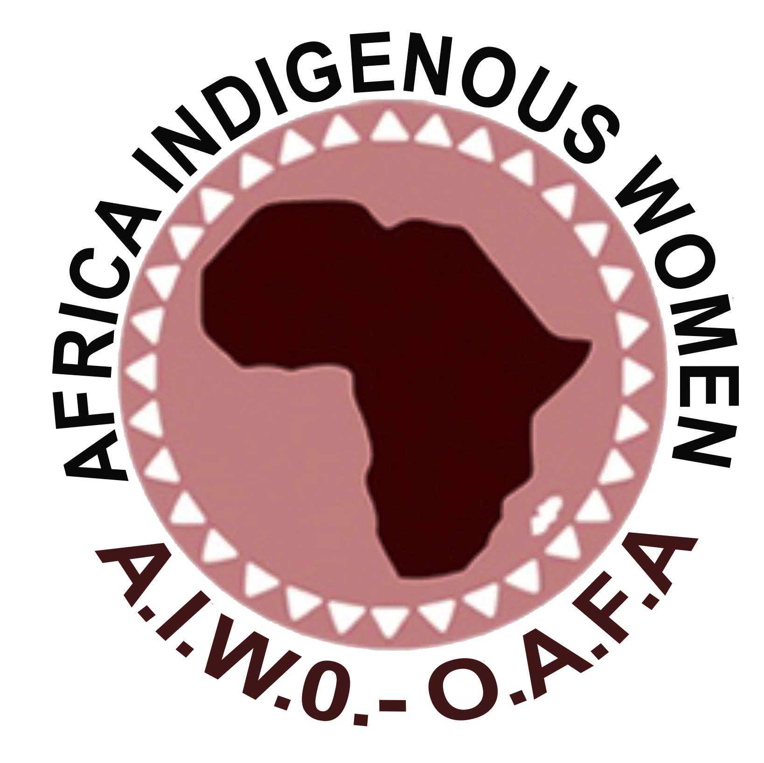
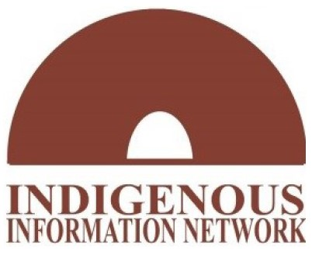

Dear Members of the Committee on the Elimination of Discrimination against Women,
On behalf of the Africa Indigenous Women’s Organization and Indigenous Information Network, we congratulate the Committee on drafting the General Recommendation No. 39 on the rights of Indigenous Women and Girls. We would like to submit this document with our comments for the committee’s consideration as you receive inputs on the Draft General Recommendation on Indigenous Women and Girls.

¶4. An intercultural perspective considers the cultural diversity of indigenous peoples, their worldview, culture and languages.

Comment: Include ‘beliefs and values’ after ‘their worldview, culture,.

¶7. Indigenous women and girls play a key role in their communities as leaders; transmitters of culture custodians; food producers and guardians of native seeds; and workers involved in food and water security; and advocates for a clean, healthy, and sustainable environment.

Comment: Include ‘and knowledge’ after transmitters of culture

¶8. The Committee recognizes that indigenous women and girls face intersecting forms of discrimination and persistent barriers to the full enjoyment of their human rights. These forms of discrimination affect them in and outside of their indigenous territories. Such discrimination is often founded on their indigenous origin or identity, sex, gender, age, disability, and is rooted in systemic racism and negative stereotypes

Comment: include ‘realization and’ after face intersecting forms of discrimination and persistent to the full
Include ‘poverty’ after identity, sex, gender, age, disability

¶10. The Committee calls on States parties to promptly engage in data collection efforts to fully assess the situation of indigenous women and girls, and the forms of discrimination and gender-based violence they face

Comment: Include ‘in both rural and urban areas’ and the forms of discrimination and gender-based violence they face…

¶11. The Committee acknowledges that the vital link between indigenous women and their lands often forms the basis of their culture, identity and survival.

Governments and third-party actors frequently implement investment, development, tourism, mining, logging, and extraction activities in indigenous territories without undertaking consultation processes designed to secure the consent of the indigenous peoples affected in line with international human rights standards and environmental sustainability.

Comment: include ‘beliefs, values’ after basis of their culture, identity and ‘free prior and informed consent’ after undertaking consultation processes designed to secure the…

¶12 ……Without status as nationals or citizens, indigenous girls are often marginalized, deprived of the right to vote or run for public office, denied access to public benefits, a choice of residence, and free movement.

Comment: include ‘social services’ after denied access to public benefits…

¶13. Moreover, states should take into consideration indigenous environmental knowledge to preserve biodiversity and a clean, healthy, and sustainable environment, as key to the respect of all human rights of indigenous women and their culture.

Comment: include ‘restore and’ after ‘Moreover, states should take into consideration indigenous environmental knowledge too.

¶14. It is critical for States parties to address the consequences of historic injustices and to provide support and reparations to the affected communities as part of reconciliation and the process of building societies free from discrimination against indigenous women and girls.

Comment: Include ‘Justice’ after reparation to the affected communities as part of….

¶17. The Committee recognizes self-determination as a key element to ensure that indigenous women live free from gender-based violence and discrimination based on sex, gender, indigenous origin or identity, race, age and disability.

The effective participation of indigenous women and girls in political and public life is a prerequisite for the full enjoyment of their rights under the Convention.

Comment: include ‘poverty’ after indigenous origin or identity, race, age, and also insert ‘full and’ after effective participation of indigenous women and girls and add ‘realization’ before the full enjoyment of their rights.

¶22. Indigenous women still face weak legal protection of their land rights, which frequently exposes them to dispossession, displacement, expropriation, and exploitation.

Comment: include ‘or no’ after indigenous women still face weak. Many indigenous women and girls have no access to legal protection.

¶23. Indigenous women also experience challenges in holding, controlling, and inheriting land, in particular when they are widowed;

Comment: Add ‘or unmarried’ at the end of the sentence ‘controlling and inheriting land in particular when they are widowed…. Being unmarried may cause an indigenous woman or girl to remain under the guardianship of her male relations.

¶27. Indigenous women and girls – and indigenous peoples in general – have suffered the burden and effects of forced assimilation and integration policies, which have contributed to destroying their cultures, worldviews, and heritage

Comment: add ‘traditions’ after the words which have contributed to destroying their culture…

¶28 (a) those in situations of poverty; rural indigenous women; and displaced, refugee and migrant indigenous women.
Comment: Include ‘and Urban’ after rural
¶28 (b) Provide information on legislative, judicial, administrative, and other measures specific to indigenous women and girls in their periodic reports to the Committee;
Comment: Include a call to states to include in their reports under the Conventions information about the nature and extent of attitudes, customs and social norms that perpetuate discrimination and, on the measures, guided by the general recommendation that they have implemented in relation to indigenous women and girls.
A call to states to incorporate in their reports under the Conventions specific rights-based indicators and information on indigenous women and on the measures guided by the present joint general recommendation/general comment that they have implemented.
¶28 (f) Adopt legislation to ensure indigenous women and girls’ rights to land, water, and other natural resources on an equal basis with men, including their right to a clean, healthy, and sustainable environment, irrespective of their marital status or of a male guardian or guarantor, and that their full legal capacity is recognized and respected. States should ensure that indigenous women in rural areas have equal access as men to ownership and possession of and control over land, water, forests, fisheries, aquaculture and other resources that they have traditionally owned, occupied, or otherwise used or acquired, including by protecting them against discrimination and dispossession.
Comment: This recommendation should also include a call to states to not only adopt and implement effective legislation and other appropriate measures to advance Indigenous women's rights to land and natural resources.
Should include "urban indigenous women and girls" since indigenous women also live outside their territories.
¶28 (h) Protect indigenous women and girls from discrimination by both state and non-state actors in and outside of their territories, especially in the areas of education, employment, health, social protection, and justice;

Comment: Update the recommendation to also call on states to take measures to include in the educational curriculum information with a human rights approach, including those of women and children, gender equality and self-awareness and contribute to eliminating gender stereotypes and for fostering an environment of non-discrimination and awareness raising programmes. Childhood, and early adolescence are good entry points for assisting both girls and boys and supporting them to change gender-based attitudes and adopt more positive roles and forms of behavior in the home, at school and in wider society.
Include a call to states to take measures should also include addressing women's civil, political, economic, social and cultural rights, as well as to promote women’s empowerment, agency and voice
¶28 (i) Adopt measures to legally recognize and protect the lands, territories, and natural resources of indigenous peoples, including indigenous women; take steps to fully respect the right to free, prior, and informed consent, and the effective participation of indigenous women and girls in decision-making on matters affecting them;
Comment: Include after indigenous women "and indigenous women and Indigenous women’s organizations" after consent include " must participate fully, effectively and meaningfully in all decision making on matters affecting them including in land ownership and governance at all levels". Indigenous women are guardians of their traditional and have gender specific knowledge as well indigenous youth are the present and future generations, hence must. States must not only adopt but also implement measures that give Indigenous women legal recognition.

¶28. (J) Adopt measures to eliminate and prevent all forced assimilation policies. This includes the prompt investigation of and accountability for past and present assimilation policies, the establishment of truth and reconciliation bodies, and ensuring access to justice and reparations for the victims involved.
Comment: Include ‘justice’ after truth in the establishment of the truth and reconciliation bodies.

Comments on Access to justice and plural legal systems
¶29. Access to justice for indigenous women requires a multi-disciplinary and holistic approach, understanding that their access to justice is linked to other human rights challenges they face, including racism and racial discrimination; sex- and gender-based discrimination; disability-based discrimination; barriers to access their lands, territories, and natural resources; and lack of adequate health and education services.
Comment: Include ‘language barriers’ after ‘sex- and gender-based discrimination; disability-based discrimination’

¶39 (g) Guarantee that judicial institutions, remedies and services are available in proximity to indigenous territories
Comment: Recommendation should include the consideration of having mobile judicial institutions and services to indigenous territories. This is important for indigenous peoples that are nomadic or in hard-to-reach areas with no government infrastructure.

Comments on the Prevention of and protection from gender-based violence against indigenous women and girls (articles 3, 5, 6, 10 (c), 11, 12, 14, 16)
¶47 (a) Adopt legislation prohibiting gender-based violence against indigenous women and girls incorporating a gender, indigenous women and girls, intersectional, intercultural, and multidisciplinary perspective, as defined in paragraph 4 of this General Recommendation;
Comment: Include a call to States to establish multisectoral and holistic approaches to combat the various forms of violence against women and girls and states to take measure to address and eradicate the stereotypes, prejudices, customs and practices that condone or promote gender-based violence against indigenous women and underpin structural inequality of women with men.
- Recognize all forms of gender-based violence against indigenous women and girls, including environmental, spiritual, and cultural violence.

Comment: include ‘psychological, economic’ violence as a form of violence against indigenous women and girls.

¶47 (e) Ensure that support services, including medical treatment, psychosocial counselling, professional training, as well as reintegration services and shelters are available and accessible to indigenous women and girls who are victims of gender-based violence against women, which are culturally relevant and appropriate. All services should be designed with an intercultural and multidisciplinary approach, as described in paragraph 4 of this General Recommendation.
Comment: Under this para include a call to states to promote the delivery of culturally acceptable and appropriate services to address gender based violence and a call to states to ensure the integration of indigenous women’s rights into national and sub national strategies on gender-based violence .
¶47 (f) Systematically collect data and undertake studies, in collaboration with indigenous communities and organizations, to assess the magnitude and gravity of gender-based violence against indigenous women and girls, to inform measures to prevent and respond to such violence.
Comment: Include a call to states to establish a monitoring mechanism to address violence against indigenous women and girls, including assassinations, assassination attempts, rapes and other intimidation and persecution against indigenous human rights defenders. Article 22 of the United Nations Declaration on the Rights of Indigenous Peoples, the Forum recommends that such monitoring mechanisms address the issue of missing and murdered indigenous women, and that measures be taken to ensure the full protection of indigenous women against all forms of violence.
Under this para an addition on the recommendation to also include collection of data to address gaps in knowledge on the issue, increase resources and capacity and identify better ways to work collaboratively with indigenous women and their organisations.
Comments on the Right to effective participation in political and public life (articles 7, 8, and 14)
¶48. Indigenous women and girls tend to be excluded from decision-making in local, national, and international processes, as well as in their own communities and indigenous systems. Under article 7, they have the right to effective participation at all levels in political and public life. This right includes participation in decision-making within their communities and traditional authorities; in the public service and decision-making positions at the local, national, and international levels; and their work as human rights defenders. The right to effective participation is also related to consultation and consent processes over economic activities by state and private actors in indigenous territories.
Comment: Include a call to states parties have a further obligation to ensure that barriers to women’s full and effective participation in the formulation of government policy are identified and overcome. These barriers include complacency when token women are appointed, and traditional and customary attitudes that discourage women’s participation. When women are not broadly represented in the senior levels of government or are inadequately or not consulted at all, government policy will not be comprehensive and effective
¶49. Indigenous women and girls face multiple and intersecting barriers to effective, meaningful, and real participation. Such barriers include lack of and unequal educational opportunities; illiteracy; language constraints; denial of access to health care services, including sexual and reproductive health and rights; and the lack of access, support, and information on legal, political, institutional, community, and civil society processes to vote, run for political office, organize campaign, and secure funding. Other barriers include discriminatory gender stereotypes and intersectional discrimination, racism, and unequal distribution of family responsibilities such as childcare…..
Comment: Include under challenges... traditional roles have been eroded by the combined effect of the loss of natural resources, depletion of ecosystems, conversion to cash economies, changes in local social and decision-making structures and a lack of recognition in state policies.
¶52 (i) Adopt measures to create enabling environments for indigenous women and girls to meaningfully participate in civil society, their communities, and other social institutions free from discriminatory gender stereotypes.
Comment: Leadership and training processes be considered as pillars for such participation, hence should be considered as one of the measures.
Comments on Right to nationality (article 9)
¶54 (b)Ensure that indigenous women and girls have access to personal identification documents and affordable user-friendly birth registration procedures, for example through online procedures or mobile registration units, in line with the Committee’s General Recommendation 34 on rural women
Comment: Under this recommendations include a call to states to employ appropriate, free and accessible birth registration services for indigenous women and girls to address the digital access challenge.
Comments on Right to work (articles 11 and 14)
¶58 a(ii) Expanding opportunities for indigenous women to run businesses and become entrepreneurs
Comments: Include a call to states to provide grants and required capacity building support for indigenous women led businesses.
Comments on Right to health (articles 10 and 12)
¶62 (a) Ensure that quality health services and facilities are available, accessible, affordable, culturally appropriate, and acceptable for indigenous women and girls, including those with disabilities, older women and LBTI indigenous women and girls
Comment: A call to states to include ethnic identification in vital statistics and health records and to allocate more funding for intercultural services that ensure indigenous women’s access to quality health.

Comments on Right to equality in marriage and family relations (articles 16)

¶64. The Committee recommends that States parties:
Comment: Under this recommendation include a call to states to support work collaboratively with Indigenous women and their organizations at the country level on the elimination of female genital mutilation/cutting among indigenous girls, including the elimination of other forms of harmful practices, for example early and forced marriage and early unwanted pregnancies.
Comments on Effects of COVID-19 on Indigenous Women and Girls
¶80. The Committee recommends that States parties:
Comment: Include a call to states to ensure full and effective participation of indigenous women in post covid economic recovery measures and providing spaces of dialogue between the government and indigenous women to define medium- and long-term actions to address the impacts of the Coronavirus in indigenous women and the approval of public policies that address the socio-economic needs resulting from the pandemic in their communities.
Comment: Include that states must ensure that Indigenous women and girls have access to up to date information on the Corona virus in a language understandable to them.

Thank you for the opportunity to contribute to and include the voices of Indigenous women and girls in the process of the elaboration of the General Recommendation No. 39.

Sincerely,
Ms. Tabitha Sitatian
Chair of the Board
Africa Indigenous Women’s Organization

