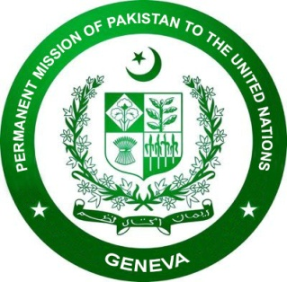

Statement on behalf of OIC by Ambassador Khalil Hashmi, Permanent Representative of Pakistan during Intersessional Panel Discussion on Challenges and Good Practices in the Prevention of Corruption, and Impact of Corruption on the Enjoyment of Human Rights in the context of the COVID-19 Pandemic

15 February 2022
Mr. Chairperson,

We thank all the panelists for their insights on various dimensions of corruption and how it deprives enjoyment of human rights including in the COVID context.

The OIC strongly supports a preventive approach to effectively counter the scourge of corruption in its varied forms. Such an approach must address drivers, actors, manifestations and impacts, especially from human rights lens.
The OIC expresses its grave concern over the growing scale of this menace and its devastating effects on individuals and societies.
According to Financial Accountability Transparency & Integrity (FACTI) Panel’s report of 2021, an estimated 7 trillion US dollars, often derived from various forms of corruption, are being funneled through haven countries. The corruption proceeds and non-repatriation of stolen public assets represent an economic cost to countries across the globe, especially developing countries. They deprive countries of resources that can otherwise be deployed to provide social safety net, and access to food, housing, health, education and employment.
The pandemic-induced economic downturn and reduced fiscal space have exacerbated inequalities and undermined recovery efforts. Preventing corruption has, therefore, become an urgent public policy and human rights imperative.
The Islamic faith prohibits corruption in all its forms. It provides ethical and legal guidance to prevent and curb this menace.

The OIC Independent Permanent Human Rights Commission, in collaboration with Pakistan, OHCHR, UNODC and UNDP, recently organized an international seminar in Islamabad to raise public awareness and galvanize support in countering the scourge of corruption.

Apart from awareness-raising and exchange of good practices, the pervasive nature of this plague necessitates stronger bilateral and multilateral cooperation. Greater financial transparency and integrity is equally essential as is the imperative of holding those abetting and benefitting from the corruption proceeds accountable.
I thank you.

