UN Questionnaire:

- To what extent has there been an increase of violence against women, especially domestic violence in the context of the COVID-19 pandemic lockdowns? Please provide all available data on the increase of violence against women, including domestic violence and femicides, registered during the COVID-19 crisis
In the past week (June 1-5), there have been protests in Nigeria following the rape and murder of 22 year old Uwaila Vera Omozuwa in a church in Benin City, closely followed by the rape and murder of 19 year old Bakarat Bello in Ibadan, Oyo State. In that same week, the arrest of 11 men who had raped a 12 year old girl at different times was reported in Jigawa State, the number of cases in the last week has re-energized activists and the call for the declaration of a State of Emergency on GBV in Nigeria.
It is important to note the ages of the victims and survivors. Most of the reported cases are adolescent girls and young women under the age of 24. In a report released by Mirabel Center, “79% of victims that sought the assistance of Mirabel SARC after a sexual assault were under the age of 18. Furthermore, 45% of this group were under the age of 11. Of those victims that were 18 years or older, 51% were between the ages of 18-22 (i.e. college age).” It was stated in the report that this provided clear evidence that adolescent girls and young women are most at risk of sexual violence. Additionally in a research study based on analysis of the 2013 Nigeria Demographic and Household Survey (NDHS), they noted that the frequency of IPV increased in younger women aged 15–24, peaked at 40.4% among women aged 25–34 years and declined to 9.7% among women aged 45–49 years.” According to NDHS (2018) the percentage of women who experienced physical violence has increased from 28% in 2008 and 2013 to 31% in 2018. Also, 36% of married women have experienced spousal physical, sexual, or emotional violence, and the prevalence was higher in 2018 than in 2008 (31%) and 2013 (25%). And when reviewing the breakdown by age, the percentage is alway higher among young women and adolescent girls in particular among young women ages 20 to 24.

According to the UN Women brief published on May 4, 2020. The “reported incidents of GBV cases in Nigeria based on preliminary information from 24 states shows that in March, the total number of GBV incidents reported were 346, while in the first part of April, incident reports spiked to 794, depicting a 56 per cent increase in just two weeks of lockdown.” More information has not been released since then. Additionally the Lagos State Domestic and Sexual Violence Response documented a 60% increase in reports during the lockdown. And for the protests held on Friday, June 5, 2020, a group of CSOs documented one hundred cases from media reports to show the scope of the problem in Nigeria. And image of the documented cases shown below shares the age of victims, dates and type of violence. On June 15, the Inspector General of Police reported that a total of 717 rape incidents. Age disaggregation were not available for the data shared during Covid19 but based on studies and reports, a few shared above and the media reports bit can be assumed that the majority of the cases were women in particular adolescent girls and young women.
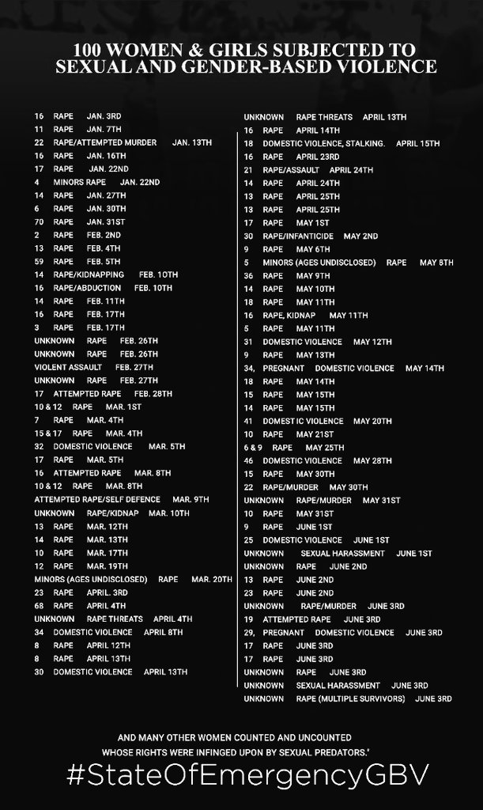
During the Covid19 lockdown which was focused on 3 states with the highest number of cases, Lagos, the Federal Capital Territory and Oyo State, SGBV services were not designated as essential. Service providers had to appeal either through UN agencies because they were supported through the UN Spotlight Initiative or through working relationship with local and state government agencies. Feminist organizations and platforms worked to raise and donate funds to gender units in Lagos to stay open for GBV crimes to be reported. The police had officially only received instructions to enforce the lockdown restrictions and measures. Abuja Municipal Council was one of the first local government areas to grant passes to service providers to support their ability to assist victims during the lockdown. Data collation was also difficult during this period, the only available data is from the UN Women Brief, the National Human Rights Commission reports, the Nigerian Police Force and Service Providers. The first Human Rights Commission Report from April 15 covering March 31st to April 13th documented 4 cases of SGBV, the 2nd report covering 13th of April to 4th of May documented 15 cases of SGBV. And it is important to note that these are just the cases reported to them. Nigeria was not exempt from the increased reports of domestic violence even though in some states, some women and girls were not able to access help because they were trapped with their abusers and could not access phones or transportation. Unfortunately the lack of a centralized data system made it difficult to make a strong argument for essential services designation during the lockdown. Beyond the provision of passes, there was limited government support to service providers. In the media, it was documented that the FCT administration provided palliatives to National Agency for the Prohibition of Trafficking in Persons, NAPTIP and the Lagos State provided palliatives to some shelters in Lagos state.
Additionally, Women’s Health and Equal Rights Initiative also documents instances of rights violation against LBQT women during the lockdown. According to them, they recorded an increase in cases of violations such as police harassment, blackmail and extortion, violence and hate speech. Also due to the lockdown, some LBQT women had to go back home to their families and hide their identities. And some were locked down with their abusers and need psychosocial support. They had 3 cases in March and by April, they had 14 cases. For the human right violations, state actors, police and military were able to hide their impunity under the enforcement of the lockdown, and they could get away with it because there were no witnesses. They recorded 4 human rights violations in March and 12 in April.

- Are helplines run by Government and/or civil society available? Has there been an increase in the number of calls in the context of the COVID-19 pandemic?
There are helplines and more were added in some states like Lagos state, due to increased reports of domestic violence. According to the Domestic and Sexual Violence Response Team, they saw a 50% increase in number of calls. And 60% were domestic violence cases. They had 390 cases in March. the National Agency for the Prohibition of Trafficking in Person, NAPTIP, the lead agency for the implementation of the Violence Against Persons Prohibition Act, VAPP also reported an increase in reporting though they did not provide figures. They also released hotlines during that period in a video of the Director General. The National Human Rights Commission as well CSOs like Education as Vaccine,FIDA, WRAPA, WARDC, WHER, TIERS, Dory Njemanze Foundation and more also shared their helplines through social media platforms and radio jingles.

- Can women victims of domestic violence be exempted from restrictive measures to stay at home in isolation if they face domestic violence?
Based on the press briefings and releases shared, victims of domestic violence were not exempted. SGBV services were not designated essential even if according to UN agencies, they were deemed essential. It was never published in the media or documented with the other exemptions. So the potential for domestic violence victims and service providers to be harassed during the lockdown was high, they mentioned this in the brief that survivors were scared to leave and get help before of fear of being harassed or victimized. Most service providers as mentioned in the previous articles shared had to rely on telephone calls for mediation and the use of online platforms. Domestic violence victims could not access services that were not available online. They were being asked to find a family member or friend to help or manage their relationships with their abusers until the lockdown was over. There was however no special exemption. Service providers with passes provided support as best as they could.
- Are shelters open and available? Are there any alternatives to shelters available if they are closed or without sufficient capacity?
Some shelters were available but most were closed to new clients due to fear of Covid19 transmission. The UN women brief shared that “Service providers’ fear of COVID-19 infection and the lack of appropriate personal protective equipment has contributed to the closing of several GBV service points. Even if staff can work in the shelters, survivors’ access continues to be constrained, with many survivors deterred by checkpoints and fear of exposure to COVID-19.” And that was the case across the country. Many service providers were unwilling to take in new clients unless they were tested.

- Are protection orders available and accessible in the context of the COVID-19 pandemic? The courts were closed except for cases of capital crimes and election cases during the lockdown. And the police and other security agencies focused on enforcement of the lockdown. This is also documented in the UN Women brief.
- What are the impacts on women's access to justice? Are courts open and providing protection and decisions in cases of domestic violence? See above. Courts were closed and cases were backlogged even prison services were unavailable for convictions that had been finalized in states that were not on lockdown but had certain restrictions. This wasn’t officially documented but that was the situation many service providers faced.
- What are the impacts of the current restrictive measures and lockdowns on women's access to health services? Please specify whether services are closed or suspended, particularly those focusing on reproductive health.
It had a serious impact. The Ministry of Health released guidelines on safe management of pregnancy and nursing mothers however there was lot of fear. According to the Director of the Family Health Unit during a talk at the Center for Global Development, she mentioned that health workers were scared to work because of lack of PPEs, family planning commodities were scarce. And the lockdown led to transportation and mobility issues even though health services were still considered essential. But transportation was not available and supplies were low and many believed those services were not available. According to the Director, the continuity of essential health services which includes SRHR are being prioritized. The easing of the lockdown is also helping with this. During the lockdown period, people could not access services, civil society organizations were filling the gap using mobile and delivery services where possible. There aren’t figures, even though a drop in antenatal services was noted but the lack of data makes it difficult to quantify the impact in Nigeria.

- Please provide examples of obstacles encountered to prevent and combat domestic violence during the COVID-19 lockdowns.
- SGBV services were not deemed essential in writing therefore are mentioned above service providers had to rely on mobile technology to provide services
- Many service providers had to close shop or scale down services due to lockdown because they did not have passes, relied on public transportation or fear Covid19 transmission due to lack of PPEs.
- The police and other security agencies prioritized the enforcement of the lockdown over the security of women and girls due to the order from the government.
- Victims had to rely on counseling and deescalation over the phone due to the lockdown or could not get immediate response when facing harm. During the day and due to passes some service providers were able to move but only in certain situations.
- Courts were closed so access to justice or protection orders were not available during the lockdown. Although in cases where service providers had passes, agencies like NAPTIP were able to help in some cases.
- Lack of a centralized data collection system at the state and national level to be able to successfully advocate for SGBV services to deemed essential and support granted to service providers and security agencies to address domestic violence.
- Providing funds to police to handle cases.
  - Please provide examples of good practices to prevent and combat violence against women and domestic violence and to combat other gendered impacts of the COVID-19 pandemic by Governments.

- Please provide examples of good practices to prevent and combat violence against women and domestic violence and to combat other gendered impacts of the COVID-19 pandemic by NGOs and NHRIs or equality bodies.
Lagos state announced free maternal services during the lockdown
Use of hotlines and social media platforms from government agencies especially DSVRT Lagos - @DSVRT on twitter, the National Human Rights Commission created a gender handle on twitter to respond cases.
Coordination among NGOs, some support government agencies to develop jingles, form state level situation rooms to respond to violence against women
Advocacy especially protests and social media activism and this led to action by the national government to create an inter ministerial committee on SGBV, resolutions adopted but the House of Representatives, operational guidelines developed and shared by the Nigerian Police Force and a declaration of a State of Emergency on GBV by Nigerian Governors.
- Please send any additional information on the impacts of the COVID-19 crisis on domestic violence against women not covered by the questions above.
The lack of age disaggregation among other factors makes it difficult to demonstrate the impact this crisis is having on adolescent girls and young women. Many of whom are out of school and trapped with their abusers. Most of the available data from Covid19 are not disaggregated, all we can do until the data is disaggregated and consolidations of which efforts are underway is note existing patterns before Covid19. Most women and girls do not report, according to NDHS2018, 55% of women and adolescent girls do not report. And according to the UNICEF violence against children survey, 1 in 4 girls will experience sexual violence before the age of 18. Covid19 has led to increased incidences, this means the number of girls and women experiencing all forms of violence increased and unfortunately depending on their status, displaced, disability, literacy, sexual orientation, location, economic status etc, their ability to report and access help was limited especially during the lockdowns and restricted movements.

https://edition.cnn.com/2020/06/05/africa/nigeria-student-rape-family-account-as-equals-intl/index.html
https://nigeria.un.org/sites/default/files/2020-05/Gender%20Based%20Violence%20in%20Nigeria%20During%20COVID%2019%20Crisis_The%20Shadow%20Pandemic.pdf
https://www.vanguardngr.com/2020/06/as-nigerians-grapple-with-covid-19-lockdown-lagos-witnesses-increase-in-sexual-gender-violence/
https://twitter.com/DSVRT/status/1244633216977379329?s=20
https://www.nigeriarights.gov.ng/nhrc-media/press-release/100-national-human-rights-commission-press-release-on-covid-19-enforcement-so-far-report-on-incidents-of-violation-of-human-rights.html
https://www.nigeriarights.gov.ng/nhrc-media/press-release/104-report-of-alleged-human-rights-violations-recorded-between-13th-april-to-4th-may-2020-following-the-extension-of-the-lockdown-period.html
https://www.vanguardngr.com/2020/06/as-nigerians-grapple-with-covid-19-lockdown-lagos-witnesses-increase-in-sexual-gender-violence/
https://guardian.ng/news/nigeria/there-is-increase-in-sexual-domestic-violence-reports-despite-lockdown-says-dsvrt/
http://saharareporters.com/2020/04/20/covid-19-lockdown-domesticsexual-violence-cases-rise-lagos-government-warns-perpetrators
https://guardian.ng/features/focus/sexual-and-gender-based-violence-hidden-social-pandemic-under-radar-of-covid-19-lockdown/
https://thenationonlineng.net/lockdown-domestic-violence-on-the-increase-says-naptip/
https://reliefweb.int/sites/reliefweb.int/files/resources/guidelinesforpregnantwomen.pdf
https://www.channelstv.com/2020/04/04/lockdown-lagos-govt-announces-free-medical-services-for-pregnant-women-people-with-health-emergencies/

