REPORT ON THE RISE OF DOMESTIC VIOLENCE AND OTHER RELATED VIOLENCE AGAINST WOMEN IN THE CONTEXT OF LOCKDOWN OCCASIONED BY THE CODIV-19 PANDEMIC IN NIGERIA
By
Centre for Information Technology and Development (CITAD),
Kano, Nigeria
1.INTRODUCTION
Technology, especially communication and information technology (ICT) is only a tool for personal development but also an everyday tool for personal empowerment. It helps to activate individual and collective agency, just as it can be used to suppress such collective and individual agency. In the context of patriarchal setting, it can be used by women and girls to both subvert and demystify patriarchal of control of women life. But it is also used as tool to silence women, widened economic and political and marginalization. Technology is not just a neutral tool. It is application of a patriarchal thinking and their insertion in society is informed by these experiences and thinking that have gone into their making. In this sense, as a product of patriarchal system, it is inserted in the ways in which patriarchy has thought to control and dominate the life of women.
Within the content of Nigeria, CITAD has documented various dimensions of an insidious gender related digital divide in which women and girls in general do not have the same opportunities to access and use ICTs as their male counterparts. This gender digital dimension is not just about access but also in the very ways in which technology itself is used or misused. In this content, we have found that gender-based violence and online harassment have been deployed to intimidate women and squeeze them out of the cyber space, while it can be used to report instances of gender violence by women, it has been used to maintain such oppressive use that dehumanizes women.
At the individual level, most women do not have access to the technology so that when they are subjected to domestic violence or other forms of gender related abuse, they cannot access the technology to report, government it itself has not taken measures to ensure women have access to and use to technology so that they can protect themselves against both offline and online harassments.
As countries across the globe struggle to manage the COVID-19 pandemic, concerns are being raised about the effect of the pandemic on Domestic and Gender Based Violence (GBV) and this intersects with technology both as facilitator and tool to counter such violence in all countries affected by the COVID-19 pandemic.
Countries across the globe have made various efforts to suppress transmission of COVID-19 and to mitigate its socio-economic impacts. This unprecedented crisis unfolds in the context of many pre-existing challenges, one of which is the gendered dimensions of access to basic necessities in a world rife with gender inequality. These challenges are now exacerbated by the pandemic and have a disproportionate impact on women’s enjoyment of human rights including economic, social and cultural rights.
Lockdowns have been one of the globally supported measures to prevent the spread of COVID-19 and mitigate its impact on public health. What this means for many women and girls, however, is that they are trapped at home with abusive spouses, partners and family members with limited access to support services. In the context of COVID-19, Technology advances have allowed intimate partner to take violence in a new form, as the victim is stalk to her abuser. The abuser has more access to the victims’ private information, control over online accounts and use of electronic devices to track victim’s whereabouts.

Gender-Based violence (GBV) increases during every type of emergency whether economic crises, conflict or disease outbreaks. Pre-existing toxic social norms and gender inequalities, economic and social stress caused by the COVID-19 pandemic, coupled with restricted movement and social isolation measures, have led to an exponential increase in Gender Based Violence. Many women are in lockdown at home with their abusers while being cut off from normal support services.

Nigeria has long been facing a gender-based violence crisis, with women and girls having experienced sexual abuse. Lack of coordination amongst key stakeholders and poor implementation of legal frameworks, combined with entrenched gender discriminatory norms has hampered government and civil society efforts to address Gender Based Violence. These efforts have been further compromised by the COVID-19 pandemic.
The pandemic has seen the diversion of priorities and resources and resulted in a surge of reports of gender-based violence. For Survivors of domestic and sexual violence, the internet can quickly become a scary place to interact. Concerns about privacy invasion, stalking, harassment, impersonation, non-consensual intimate image sharing and other threats can leave people like they have no choice but to avoid online entirely. In such case, it is vital to protect online activities and understand the ways in which technology may compromise your safety.
The lockdown has also compromised access to life-saving services and justice at a time when these are needed most. Many one-stop centres and domestic abuse shelters have been forced to close or provide limited services. Strict movement restrictions have meant that survivors are unable to access centres and shelters, having to rely on hotlines to receive any kind of support. With the inadequate internet facilities and lack of data in rural areas in Nigeria, that has led to rural women and girls suffering more during the pandemic because their voices cannot be heard on the social media. Such cases, seeking for help will be difficult for them as they are stalked with their abuser. Although some Nigerians, who have access to internet used the advantage of social platforms to make their voices heard and to seek justice. Hashtags were created and relevant authorities were tagged,

Within the context of COVID 19, several factors are lending themselves to a heightened risk of violence for women and girls in Nigeria and technology facilitated abuse has been given little attention in government initiative aimed at tackling domestic violence. This prompted CITAD to carry this research to find out how Lockdown has impacted Domestic and Gender Based Violence in Nigeria in the content of unequal access to and use of technology and a use both facilitates and gratifies the use of violence and violence-against women sanctioning message. CITAD conducted Focus Group Discussions with Journalists, CSOs, Students and women in General. Also Conducted Key Informant Interview, organized Web Seminar, twitter chat and a desktop research. The submission was however derived from the findings.

Therefore, CITAD posits that government both federal and states need to review the laws related to Gender Based Violence and also ensure to recent events and implementable as well as consider the articulation and implementation of a national gender digital inclusion agenda that will facilitate the bridging the gender digital divide and make easy for women to appropriate technology and use it as part of the tools in the fight against gender violence and the silencing of women in the society. .

2.CONTENT AND CONTEXT
Gender Based Violence is violence directed against a person because of their gender; although GBV cuts across the male and female gender, history has shown that it is most prevalent against women and girls and it is rooted in power inequalities between men and women. In some communities in Nigeria, it is a welcome behaviour for men to beat up women and they have no say when it comes to sex. In both work and home settings, there has been violence against women, girls and children. The ineffective implementation of Nigerian laws has led to increase in GBV because the Nigerian constitution does not discriminate against anyone but these days the rights of women and people living with disabilities (PWDs) are not considered. Also, the failure of some states to domesticate laws such as the Child Rights Acts has been an impediment in prosecuting cases of violence against children; so far, 21 states have domesticated the Child Right Act in Nigeria. In those states some progress has been made in prosecution of abusers and further policies are put in place to further aid the prosecution of cases such as the case in Ekiti State where an accused abuser is not released on bail until the case is prosecuted fully by the court of law. However, in those states with no Child Rights Act passed, prosecuting of such cases has been greatly inhibited. The same can be said of the Violence Against People Prohibition Act (VAPP) which was enacted in 2015 to tackle the increase of GBV by prohibiting and criminalising GBV. The VAPP has been domesticated only in four states in Nigeria. The belief of families of victims of GBV to settle cases of GBV out of court so as not to soil the family name has overtime fueled the culture of silence by victims as perpetrators of these acts go free while scouting for their next victims.
The COVID 19 was declared a global pandemic in December 2019 and various regulations were put in place so as to curb its spread. In Nigeria, lockdown in some states were put in place from March 2020 till date.
On 27th February, 2020, the first case, the national index was reported in Lagos of an Italian who was working in a company in the country. A few days later a number of cases were reported in Abuja which included two high profile patients who have contacts with the highly place government officials. this made government to step up contact tracking and when further tests were conducted three governors, among other government officials tested positive, by this time the numbers in Lagos and Ogun state were relatively large and government had to close these two states along with the Federal capital territory, these measures were not effective and the virus continued to spread in those state as well as in other states of the federal. Following this, on Sunday, 29th March, 2020, the President of federal government directed residents of Lagos and Ogun States as well as the Federal Capital Territory to stay at home for an initial period of fourteen days starting from Monday, 30th March 2020/ this was the beginning of the lockdown, although at this stage it was limited to these areas. A legal instrument, the Quarantine Order was signed by the President on 30th March
Basically, this order (Quarantine Act, COVID-19 Regulation No 1) required all people excluding those on essential services to remain at home 24 hours and
- All businesses were closed down
- Not intercity or interest travels
- All borders were closed
- All public service, including the courts were closed
This order was originally meant to last for a period of two weeks. However, by 13th April, 2020 when the president made his second Address, “Many State Governments also introduced similar restrictions” and the president through Quarantine Act, COVID-19 Regulation No 2 announced on April 13 extended the original order by another 14 days with effect from Tuesday, April 14.
a. Selected businesses and offices can open from 9 a.m. to 6 p.m.;
b. There will be an overnight curfew from 8 pm to 6 a.m. This means all movements are will be prohibited during this period except essential services;
c. There will be a ban on non-essential inter-state passenger travels until further notice;
d. There will be partial and controlled interstate movement of goods and services will be allowed to allow for the movement of goods and services from producers to consumers, and
e. We will strictly ensure the mandatory use of face masks or coverings in public in addition to maintaining physical distancing and personal hygiene. Furthermore, the restrictions on social and religious gathers shall remain in place. State Governments, corporate organisations, and philanthropists are encouraged to support the production of cloth masks for citizens.
Just as there has been a rise in global cases of GBV which have affected mostly the female gender, Nigeria has not been an exception as there has also been a spike in GBV cases. This has been aggravated because victims are locked in with their victims and they do not have access to places where they can report this violence. This is further made worse by the fact that women, generally do not have access to information technology that could allow them to report these instances of abuse easily. Access to Internet is constrained for women by among other factor, poverty, poor educational accomplishment, and social inhibitions such as men not wanting women to use social media and fear of the internet by women in part due to prevalence of online gender harassment.
It is true that cases of GBV have increased worldwide for the past couple of months and Nigeria has not been an exception. According to the President of FIDA, 72 cases of GBV were recorded in the first two weeks of lockdown and these cases have been on the increase. To collaborate this statistics, a brief prepared by UN Women on behalf of UN system in Nigeria on 4th of May 2020 reports that the number of reported cases in the 6 geopolitical zones of Nigeria have increased between the month of March and April 2020 with the South West leading with an increase from 91 cases to 296 cases, 67 cases to 156 cases in the North Central, 50 cases to 115 cases in the North East, 36 cases to 92 cases in the South East, 52 cases to 87 cases in the North West and 18 cases to 35 cases in the South South.
However, it should be noted that the brief released by the UN system in Nigeria clearly stated that the published data are reported cases, one is left to ponder on the number of cases which were/are not reported. This was glaringly portrayed in the trends on social media in the months of May and June 2020 when women broke the culture of silence and spoke on how they have been sexually abused in the past and called for both the government and individuals to set measures in place to curb violence against women of all ages. These calls for justice for those who are victims of GBV were pushed majorly by the youths on various social media platforms such as Twitter, Face book and Instagram and pockets of peaceful demonstration in some states across the country.
The government has not done enough in setting in place measures which cases can be reported and prosecuted even before the COVID 19 crisis and this shortcoming has become more glaring as GBV has become a shadow epidemic within the COVID 19 epidemic. Some steps had been put in place such as the emergence of the gender desks at police stations however; there is still need for rigorous training in how these cases should be handled from the point of reporting as this directly influences the success or failure of reported cases. There is still a strong culture of silence as victims are blamed for simply being victims and questioned on clothes worn and being in the “wrong” place at the wrong time. This culture of blaming and stigmatising the victim, whilst taking emphasis and the blame off the abuser has shown that much more needs to be done so as to change already established perceptions; and turn tides around. The situation has looked grim for a long time, but right now; hope flickers are at the horizon as more people are speaking out against rape and calling for justice for GBV victims. On social media platforms, the hash tags #WeAreTired #SayNoToRape #NoToGBV #JusticeForUwa #JusticeForTina #JusticeForBarakat #No2Rape #RealMenDontRape. These hash tags were used all by individuals to call the attention of both government and the society to the GBV in the country during the lockdown, Also the media has been active in reporting cases of GBV. Media houses like Premium Times mention published news on rape cases and its ongoing police investigations such as the case of 11 suspects who allegedly raped 12-year-old in Jigawa State. Channels TV; another reckoned media house in Nigeria also reported rape cases across the country. The government taking steps to put in policies in place which will checkmate GBV and the victims daring to speak out even when threatened GBV,
3. METHODOLOGY
The study used a multiple approach of a six-tool art design to generate information and insights on the on the impacts of lockdown on sexual and gender-based violence. As a result of the pandemic, the research was carried out virtually and none of the research activity involved any physical contacts. WhatsApp, Zoom, Twitter and mobile phone calls were used as the platforms for communication throughout the research. The tools included desktop review, online questionnaire administration, focus group discussions, Key Informant Interview (KII), Web Seminar and Twitter Chat. All relevant responses generated from any of the above mechanism were adequately used and, in some cases, integrated into other similar responses.
4. LIMITATIONS
A side from the context of the report which made it difficult to engagement stakeholders more intimately, the report suffers some limitations, including:
- There are no known robust observatories for report of data and incidences of gender-based violence in the country. While there are many organizations working and responding to distress calls from victims, these organizations do not keep data over a long period. For example, WRAPA, one of the most consistent and focused organization in the sector, it has only data of reported cases during the lockdown and not logged data for pre-lockdown period. In this way, there is no pre -COVID period to make an empirical judgement and therefore conclusions are drawn mainly from responses and experiences of several organizations working on the issue as well as personal testimony of respondents. As this research has shown technology can be used to gather accurate data about domestic violence and gender harassment given that much of the data obtained here was through the use of technology. This is even more so in the context of COVID-19 which restricts movement and therefore reporting has to be via technology. But this lack of data could also be an indication of the extent to which women have limited access to technology as a consequence of the digital gender divide.
- Our FGDs did not cover the whole country. We sampled only three out of the six geo-political zones of the country.
- The limited time we had did not allow us to wait and get more responses from the online questionnaire and also do more KIIs.
- Also, for the same reason, we could not interview the many organizations working on this issue to interrogate the data they have in their custody. For example, the Inspector General of the Nigeran Police Force, in a report to the President, in May asserted that there was a high rice in rape cases across the country under the lockdown. It will have been useful to have a look at the data the police have.
5.FINDINGS
5.1 COVID-19 and the Increase in Domestic and Sexual Violence
Since the outbreak of the COVID-19 pandemic in December 2019, there has been a spike of domestic and gender-based violence worldwide. Countries with higher GDPs such as Sweden or lower GDPs as Sudan, are not spared the raging havoc left in the wake of COVID-19 across states, cities, towns, and rural areas. Countries with lockdowns, partial or full, are recording spikes in domestic and gender-based violence. In response to this, the United Nations has raised alarm regarding the increase of reported cases directly attributed to forced proximity occasioned by lockdowns.
As many media reports have indicated, there has been a rapid increase in domestic and sexual violence against women and girls in Nigeria. This is publicly acknowledged as 92% of our survey respondents said they are aware of the increase in gender violence against women and girls, and 69.1% said they believed the increase as a result of the restrictive measures imposed to curtail COVID-19. In addition to that, all FGD respondents to this study said they have noticed a drastic increase in different forms of violence against women and girls which they heard either by proximity, from traditional media and or social media. The findings also from the Twitter chat, desktop review and web seminar have proven the same. A number of Information released by National Human Right Commission on Twitter on sexual and domestic violence is also disturbing and alarming.
Although there are no available statistics accurately covering all incidents of SGBV in Nigeria, however statistics from different state governments, CSOs organisations have proven the surge.
For instance, Lagos state alone has recorded rising cases of domestic violence during the last Coronavirus lockdown, with figures jumping to 697 cases in less than two months compare to 791 cases recorded in 10 months before the lockdown was imposed; May 2019 and February 2020.
In the Web seminar conducted for the purpose of this submission, Rhoda Tyden the National President of Women Lawyers Federation of Nigeria commonly known as FIDA lamented that the increase is very high as indicated from the reports she received daily from their 33 branches across the country. According to her, after the first two weeks of the lockdown, 70 cases of GBV were recorded and this number has continued to be on the increase. FIDA receives new cases on daily basis where women are violated sexually, psychologically, including economic deprivation. “One of the things that have aggravated the GBV is the regulation which was put in place to curb the spread of COVID 19 because victims are locked in with their abusers daily” the president said, describing the increase as impacts of the pandemics. WRAPA also recorded 40 cases over the period from February to May with February being outside the lockdown period. The figure below give show the data from WRAPA mapped over the period. As can be seen the data show case of increasing cases of domestic violence over the lockdown period.

Since the lockdown in March 2020 as a result of the COVID-19 pandemic, ActionAid Nigeria and her partners have documented a total of 253 cases of Gender-Based Violence in Bauchi, Cross River, Enugu, Kebbi and Kwara States," Ms Ene Obi said, adding "we have never been more alarmed about the cases of Gender-Based Violence in Nigeria than in recent times. Girls, Women, young and old now live in fear as they are no longer safe even in their own homes.
Immediately after the Uwa case occurred and got so much public attention, many more sordid cases had been reported. There had been the case of 18-year-old Barakat Bello in Ibadan who was also raped to death, the 12-year-old girl in Jigawa raped by 12 men including a 67-year old man, the 13-year-old Elizabeth Ochanya Ogbanje who was a victim of her guardian’s criminal tendency. The Daily Trust edition of June 6, 2020 stated that 65 cases of rape had been reported between January and the first week of June 2020.
In our Twitter chat, Niri Goyit the Project Coordinator of North Women's Voice and Leadership Project, ActionAid Nigeria, explained that the FCT branch of FIDA use to have about 40 cases of domestic cases per month, but this has risen to 60 incidences per month during the lockdown.
ASH Foundation with partners in Bauchi state use to manage about 10 cases per month but handled 37 cases of rape and domestic violence in the month of May alone while the In Nigeria, Domestic Violence Referral Centre in Lagos reported about a 35% increase.”
One KII respondent lamented that there is surge increase of SGBV where perpetrators are family members or acquittance. People now had no values for their immediate family. Before now, family members would go to all length to protect their families against perpetrators. Today there are scenarios of father raping his own daughter, brothers raping sisters, old men raping babies of months. this is something that society needs to critically look at the contemporary rape scenarios and why it is becoming so prevalent these days. In line with this opinion thus, our survey respondents think that 70.1% of sexual and domestic violence are husband, brothers, family members, fathers, and neighbours are mostly the perpetrators of violence against women and girls.
In the web seminar, Lauratu Abdulsalam of ACT/British Council lamented that women and men are passing through this difficult time and GBV increases during the time of an emergency situation. She reported that between March and April 2020, GBV cases has increased from 60 to 228. The cases have drastically increased because of the total lockdown, and the cases in states with strict lockdown have more increment as compared to states with lesser lockdown.
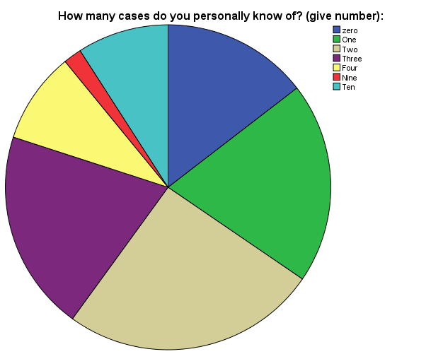
Dr. Abiola Akiode-Afolabi highlighted that in Lagos, Ogun, and the Federal Capital Territory Abuja, since the lockdown, the most common gender-based violence reports recorded include spousal violence, landlord-tenant violence, neighbor-to-neighbor violence, parent-children abuse, homeowner-house help violence, boyfriend-girlfriend violence, violence on widows, police-sex worker violence, police-citizen violence, visitor-caught-in-lock-down child rape.
At least 85.1% of our survey respondents said they personally knew from one to ten cases that they knew had occurred during lockdown.
5.2 Impacts of Technology on the Victims during Lockdown
In its response to this study, WRAPA has reported a significant level of increase in the incidence of reported and unreported GBV in the context of COVID-19 pandemic lockdowns. At its headquarters in FCT, WRAPA receives an average of seven (7) direct calls from victims on the organizations three dedicated helplines. Eight to ten (8-10) daily incidence reports are also registered on the WhatsApp platforms. At neighborhood, family or acquaintance levels, WRAPA staff do receive on their personal telephone numbers GBV incidence reporting calls. What this means is that if women and girls have better access to technology, especially the internet and mobile connectivity, they the reports would be lager than is being recorded. This is because often, victims are denied access to means of communication by the perpetrators of acts of violent against the women, including seizure of telephone handsets for those who have but often many of the poor women do not own handsets and do not even have the skills to use them. Women are routinely threatened that if they use the social media to report acts, they would suffer more.
Using technology such as online platforms was adopted by many GBV response teams to enable victims have access to reporting violation of their rights; many reports received were done either via phone calls and through social media as victims who have access and digital skills reached these teams. The NHRC, NAPTIP, Ministry of Justice as well use social media platforms to inform new developments, make awareness raising and advocacies. In particular, the official handle of the commission @NHRCTweets and especially the gender handle @NHRCGender has exposed so many cases of SGBV against women and girls that occurred under the lockdown period on Twitter. Correspondingly, lots of online advocacies, conferences, awareness raising, cries by private organizations, individuals, women and youth groups as well as concerned citizens etc were organized and taken up to social media with several handles calling the attention of key stakeholders to take action against the spike in gender violence. In addition, The Lagos team, set up to carry out physical interventions, has moved online, using phones, social media, 24/7 web chat to reach people in abusive situations who need help, and exceptional cases, the team goes out to rescue children who may have been abused, and women who need assistance in abusive relationships.
This has proven that the use of technology such as online platforms has been properly deployed by some government agencies and nongovernmental response team and have greatly helped in providing response to victims. Promoting greater access to technology and skills for women and girls to use technology will greatly improve reporting, which his essential for addressing the problem.
However, access and connectivity have also hindered a lot of victims to make such reports. Many women in the urban and semi urban areas do not have the smartphones and other device to enable them make a report, while the unavailability of connectivity, affordability as well as lack of digital skills has contributed greatly in preventing victims to report cases especially in the rural areas. Many women and girls from the rural communities would not be found on especially Twitter where most of the campaigns and advocacies are taken place. In essence, the existing gender digital gap has been reinforced by the pandemic as well as the lockdown measures.
Reports also from our findings have indicated how abusers kept monitoring and spying the devices of their victims as well as seizure of mobile phones to deny them access to reporting. This has further posed another form of online gender violence and deprivation of digital access. In essence, the lockdown has both increased both physical and online gender-based violence.
5.3 Factors Contributing to the Spike in Sexual, Domestic and Online GBV under Lockdown
In Delta State, during an interview with the Chairperson of FIDA, Barr. Stella Mejulu, she explained that in the last week of March, four weeks into the lockdown, she went to court over a case of homicide where a woman was murdered. She also noted that rape and molestation of minors involving high profile older men and patricide were also on the rise.
Using technology such as online platforms was adopted by many GBV response teams to enable victims have access to reporting violation of their rights; many reports received were done either via phone calls and through social media as victims who have access and digital skills reached these teams. The NHRC, NAPTIP, Ministry of Justice as well use social media platforms to inform new developments, make awareness raising and advocacies. In particular, the official handle of the commission @NHRCTweets and especially the gender handle @NHRCGender has exposed so many cases of SGBV against women and girls that occurred under the lockdown period on Twitter. Correspondingly, lots of online advocacies, conferences, awareness raising, cries by private organisations, individuals, women and youth groups as well as concerned citizens etc were organised and taken up to social media with several handles calling the attention of key stakeholders to take action against the spike in gender violence. In addition, The Lagos team, set up to carry out physical interventions, has moved online, using phones, social media, 24/7 web chat to reach people in abusive situations who need help, and exceptional cases, the team goes out to rescue children who may have been abused, and women who need assistance in abusive relationships.
5.4 Factors Contributing to the Spike in Sexual and Domestic and Online GBV under Lockdown
As suggested by many media reports as well as responses gathered from this study, domestic violence against women has increased to a great extent because the lockdown makes it impossible for them to seek help or alternative safe space which keeps the perpetrators and victims under the same roof for many days. These abuses are not only physical but it comes as emotional, digital, socio-economical and psychological trauma due to verbal abuses among others.
Respondents opiniated that financial factor has affected the increment in domestic violence, because the lockdown has affected the financial lives of millions of people in Nigeria. Sources of incomes for many family heads who rely mostly on menial jobs or daily earnings have been blocked by the restrictions. Thus, husbands relieve their frustrations on their wives and children whom they live with. Anger and hunger have therefore played critical role in the spike as abusive partners, husbands, brothers etc. become aggressive and violent at the slightest provocation. In essence, poverty has played a key role in the increase of GBV during the lockdown and as well financial dependency of women on men to provide them with food and other basic needs have become a provocation and trigger of violence against the women and even their children.
The government in another way has aided the spike in GBV as the promised palliatives could not reach the needy who could have been relieved from hunger. In fact, to so many people, the palliatives are either a mere statement or could be benefited by only those close to the government or politicians. Of course, distribution of palliatives by both state and federal government had taken place even though accountability to the money spent could not be established. However, millions of people in need have not benefitted.
The FIDA National President, Dr. Rhoda was of the view that GBV in its entirety is rooted in power inequality between men and women. In some communities, it is a welcome behaviour for men to beat up women and in some communities, the women have no say when it comes to sex. Violence against women is from prehistoric time and even in work settings or home settings, there has been violence against women, girls and children. According to Dr. Rhoda, ineffective implementation of our laws has led to increase in GBV because the Nigerian constitution does not discriminate against anyone.
In a similar view, the National Coordinator of West African Network of Peace Builders (WANEP), Bridget Osakwe during our seminar charted her discussion from the perspective of COVID 19 as violence itself; it produces fear, death, lockdown and hunger. It all means it increases societal vulnerability. Domestic violence is a reflection of deeper disregard we have in our society. It is important to examine the cultures or habit that is haunting us. Pre-existing tension has been in homes and has exasperated the violence and managing communication in family will produce a better society.
In addition, lack of proper implementation of laws and or polices that ensure proper implementation has provided the perpetrators with impunity and which encourages them to repeat their criminal acts or even encourage new perpetrators to carry out their act since they knew the punishment is either light or would not even exist.
Online GBV is also in the increase, this is because the digital space has become more and more congested as many people return to the internet to either source for information, carry out their official works and meetings, as well as for entertainment purposes. It is highlighted thus that many people spend a lot of time online and thus online bully and harassment against women has increased.
One important point made by an FGD respondent is that there are certain unrevealing factors that are not put in consideration. In Nigeria, mental health or psychological state of couples are almost not considered in marriage although it has affected a lot of people and has resulted in many sad stories over time even before the pandemic. And thus, Mental health has been greatly impacted by the pandemic and caused a hype in the number of male spouses that resort to violence on their wives and children whom they live with, which in many cases, result into emotional harm for the victims.
Drawing from the existing benefits internet offers in terms of counselling and guidance however, there are evidences on how internet and social media have become important avenues to seek advice, support etc for people especially women. There are several social media platforms especially on Instagram, Facebook and WhatsApp platforms where certain discussions, seeking helps, counselling or advices from experts and other participants in groups take place. These include seeking advices on marital/relationships problems, parenting as well as dealing with emotional crisis. “Northern Hibiscus” for instance is an example of an Instagram platform “Relationships and Marriage Tips,” “Relationships Advice” both on Facebook, Tafarkin Tsira on WhatsApp are instances of social media platforms that offer advises to women in various aspect of their lives. Similar efforts should be made by government and other private or nongovernmental groups where women can log in and seek emotional support and advice.
5.5 Access to Helplines and Shelters
A number of government agencies including NAPTIP, NHRC, security agencies as well as many NGOs including WRAPA, FHI 360 FIDA, LACVAW, FMWA, Ash Foundation, and other NGO and Development Partner have Helplines available and NLC Women Wing and Police Force have gender desks. This study has also found out that all the lines have and are still registering significant increase in the number of GBV related assistance calls from or for trapped victims.
Shelters are also available and being operated by government and NGOs. However, and compared to the service demand levels in the numbers and capacity of shelters are grossly inadequate.
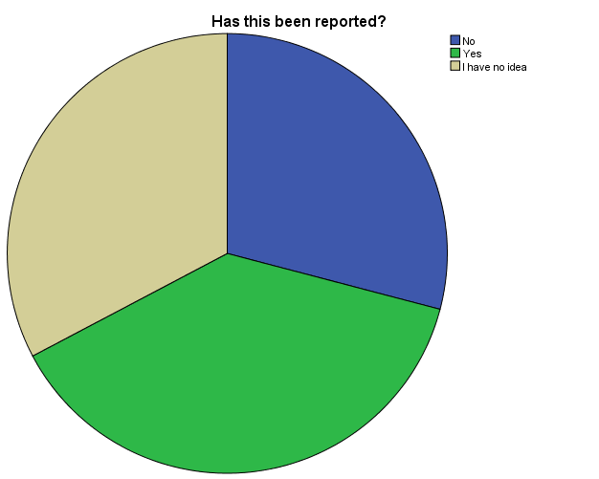
However, due to lack of structural social service systems in place in Nigeria, access to hotlines, shelters, civil society groups, and non-government organizations specialized in providing support and legal expertise is far and in between, or non-existent. Reports on gender-based violence have more than doubled (2) and all the increase in GBV we witness now may not reflect the actual image of the spike as more than 50% of GBV are not been reported (4). Some victims either do not or are denied access to relevant authorities or simply refused to report it to cover up the matter for fear of stereotype and culture of stigmatisation of survivals of violence issues. Reluctance to report GBV by the victims or their families could also be related to threats by abusers who threaten to kill or hurt those who speak up. Only 32.7% of our survey respondents said they are sure the cases they knew were reported.
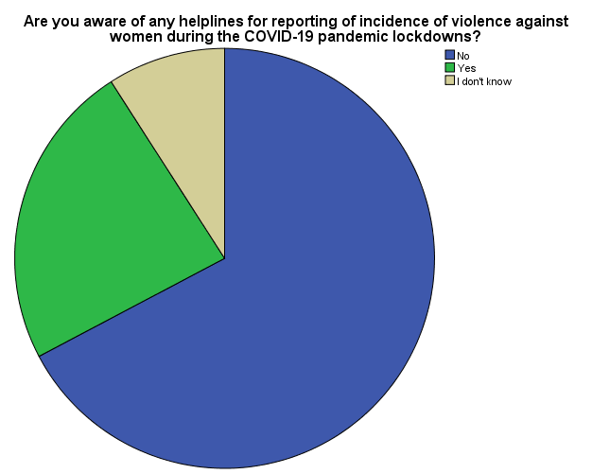
Only 23.6% of our survey respondents said they are aware there are helplines by either government or CSOs, while 83.6% said they don’t know the contacts of the helplines. A great number of the responses from our FGD respondents also explained that helplines by government are not functional and they’re no shelters available.
“The GBV hotlines are public, other numbers aren't, I can't personally attest to the availability of other important hotlines” expressed a respondent. “I have not seen any of the helplines actually, so I can't say.” It was established from the findings that the helplines are not publicly known especially to the group of people who are vulnerable of being victimized of GBV.
As many women are not aware of the helplines, there many others who don’t have access because some women don't have phones or any other means to make the call. Thus, affordability is playing a critical role in denying women access to these helplines. “Women in my area don't have phone to call even their family and relatives. They prepare to go police station or vigilante office rather than to call help line” mentioned a KII respondent.
Lack of GBV helplines to get help is a big challenge. And when women get access to intervention phone lines, they find it difficult to speak on the phone because their abuser is only an earshot away, leaving many women to suffer in silence. Although Whatsapp is one of the cheapest communication tools to reach out for help, high cost of data (Nigeria affordability index according to the World Web Foundation report of 2019 was 61.13% and ranked 19 out 28 countries), and internet access make it difficult for abused women to seek help in communities where these are absent. Theoretically as mobile technology has achieved full covered of the country, it can be said that potential everyone has access to the internet, but accessibility is limited by many factors including in ability to for major players to make landing in rural communities. on the other hand actually use is constrained by low educational accomplishment, especially among women and poverty which in the country is often said to have a feminine face.
Report from the survey has also shown that victims are ostracized by both family members and community members. However, despite the fact that many victims in both rural and semi-urban communities do not have internet access, the internet and social media in particular has provided lot of solidarity and support for victims. The helplines were publicly circulating on various online platforms as well as several advocacies and awareness raising on the need to contact response team when victimized of SGBV. This has yielded a better result of increase reporting of cases. This has therefore proven that there is great potential on contribution technology can offer in addressing SGBV in both Covid-19 and post Covid-19 context.
5.6 Restrictive Measures and Movement of GBV Victims
Can women victims of domestic violence be exempted from restrictive measures to stay at home in isolation if they face domestic violence?
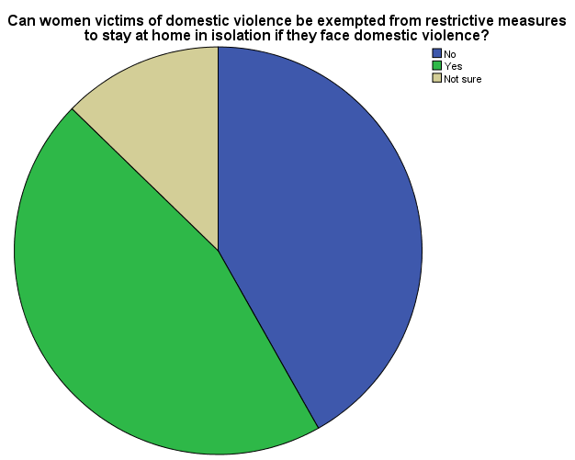
41.8% of the survey responses is yes 45.5% of the total responses was no, while 12.7% said they have no idea. This study has also gathered from most of the FGDs and KII respondents that it was never part of lockdown directives by both state and federal governments to put into consideration the emergency of sexual and domestic violence, neither were there any statement by government officials issued to address the needs of women facing domestic violence under lockdowns. Similarly, government did not list SGBV respondents as one of providers of essential services. This affected their ability to provide adequate services to survivors.
Security operatives are also not cooperative, most of them don't understand or make room for GBV emergency cases. The lack of movement has forced victims to stay in their abused environments, which increased their abuse as the perpetrators also knew that they had nowhere to run to.
According to WRAPA, under these circumstances, it is more practical and beneficial to declare GBV response rendering activities as essential services by recognised government and nongovernmental organizations. This will mean granting exemptions for the staff of these organizations.
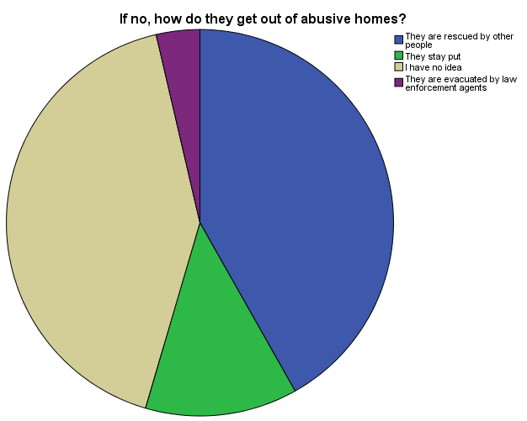
In many cases, victims stay and continue to experience more abuse of their right. Sometimes they are either rescued by other people, evacuated by law enforcement agents according to 59.2% of our survey respondents.

5.7 Access to Justice
“If there are mobile courts for Covid-19 directives offenders, why can’t we also have mobile courts for GBV perpetrators? These would have hastened prosecution of many GBV perpetrators nationwide” decried a respondent.
“But how could women under lockdown have access to such courts because the mobile court are only for does that violate the lockdown directives?” cried another?
The lockdown has made it difficult for women to easily and quickly reach the police. The walking distance to the police station and delayed response from the police is a big challenge. Without money to pay the police and without proper legal and literacy support, reporting a case and filing paperwork at the police station is also a cumbersome affair for the average woman. A woman’s state of mind at that point and a possible battling feeling of self-worth makes her even more vulnerable at the police station.
Women's access to justice has been the challenge during the lockdown as Courts have been closed. Police have also been working with CSOs to respond to cases of GBV but the absence of the Court has limited their operations. However, 40% of the survey respondents said victims have access to court during lockdown.
Niri Goyit explained that as a result, there is a backlog of cases waiting to be actioned by the courts and this has delayed justice for victims.
Responding to this, WRAPA explained that in the first and second phases, of the lockdown in the FCT, Lagos and Ogun State, the courts were not in session. NGOs were limited to documentation and evidence gathering in preparation for when the courts open or alternative means are adopted. On Monday 20, 2020, the Attorney General of the Federation (AGF) and Minister of Justice, Abubakar Malami, announced in a statement that while ordering the suspension of all court sittings except in matters that are argents, he announced that the courts would be sitting virtually, developing technology to allow for continued access to justice during the lockdown. In the same statement, he added however that certain changes would need to be backed up by the National Assembly and effected by the National Judicial Council (NJC), thus “empowering the institutions of the ACJA, 2015 to commence functioning immediately”. While a bill proposing an amendment to the Constitution to allow for digital trial, this process has not been completed till now as the bill as to in addition to being passed by the two houses of the National Assembly, has to be debated passed by the 36 state houses of Assembly. Unfortunately, these legislative changes have not been done, the result of which is that the statement remained as mere wish. However, Ogun State Judiciary piloted the first virtual court trial on May 7, 2020. It should be added that a similar move in July 2019 to make virtual court session constitutional failed. In principle this would make enhance access to justice, first as people can access the court processes from home and therefore removed the constraints that lockdown has created. The reality however is that unless women and girls have access to and the skills to use technology, its impact on domestic violence will be minimal.
For many women/girls’ victims, from making a phone call, to reporting to the police and to accessing justice from court is something they typically have no idea even prior to this pandemic, nor do they have the financial capacity to process that. And when the pandemic arrived it complicated everything putting them in a position further from justice.
In many cases, government officials contribute to depriving women the justice they deserve especially if the perpetrator is a member, family or friend of the government where they pressurize security agencies to release the perpetrators. Security agencies especially the police have been reported to release or grant bail perpetrators who are member, family or friend of government. A typical example here is the case of Kogi state governor and top officials are piling pressure on the Nigeria Police Force to release Mr Abdulmumini Danga, commissioner for Water Resources in the state who assaulted and raped a lady over a Facebook Post.
However, social media has played a critical role in publicizing GBV cases and advocating and demanding for justice. For instance, since the Uwa case occurred and got so much public attention, many more sordid cases had been reported and many CSOs, women and youths’ organizations had kept demanding for justices for victims through online and offline advocacies and demonstrations. The traditional media as well have been contributing a lot to publicizing and setting agendas for discussion on issues of GBV under the lockdown as expressed by Lauratu Abdulsalam who said media has contributed greatly so far in bringing the issue of GBV to the fore front of policy makers in addressing the issue. Interestingly, Lauratu also pointed out that people are genuinely committed to ensure putting an end to this menace and government is also open to discussion with CSOs on how to resolve this problem; this is a good turning point for us. People are calling for behavioural change need to be instituted; the government and leaders need to put their heads together to put an end to GBV; and the VAPP bill needs to be domesticated.
5.8 Government Agencies Responses to SGBV
There is no doubt that justice delayed is justice denied – thus delays in investigative and forensic processes, along with judicial delays do indirectly encourage criminals – and damage the innocent. There are many instances of the haphazard handling of investigation, prosecution and final resolution of crimes.
These calls and demands from citizens, and several organisations has made all 36 states government to declare SGBV a state of emergency. Several CSOs and NGOs have been putting pressure also for the adoption of the Violence Against Persons (Prohibition) Bill and Child Right Acts by all state governments.
In responses for the public cry and demand, the Attorney General of the Federation (AGF) and Minister of Justice, Abubakar Malami (SAN), expressed their plan to set up a committee which will to process speedy trial of cases involving rape and girl child molestation. He added that as a people-oriented government that listens to the yearnings and aspirations of its citizen, the Ministry of Justice has identified with call for national response against rape and sexual assault in the country.
The NHRC has also been making a lot of effort to ensure that justice have been served to people whose rights have been violated. The commission has been making a lot of commitment to scale up action on awareness on SGBV and rape on its quest to tackle the menace and entrench the culture of respect for human rights in the country. This include among other efforts embarking on a nationwide five-day activism to protest the scourge as announced by Tony Ojukwu, the Executive Secretary of NHRC. The Commission has also created a gender handle on Twitter responsible for advocating against sexual and gender-based violence.
NAPTIP has been making similar efforts including calls for ensuring effective adoption of the VAPP and called for the harmonisation of all laws against rape and violence to ensure that sentence against rape was life imprisonment as prescribed by the VAPP Act 2015.
5.9 Impacts on Women’s Access to Health
At the beginning of the outbreak of the pandemic in Nigeria, most health facilities focused their attention on Covid-19, neglecting other important health issues including women reproductive health. 84% of our survey respondents said health services were either closed or suspended.
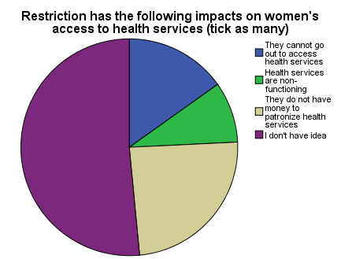
According to WRAPA, women’s access to health services and facilities has been severely impacted on by the restrictive measures. In fear of being infected in health facilities, pregnant women stayed away from the few operating health facilities. Routine health services were reported suspended in most facilities. Antenatal and immunization operated on a low key in secondary facilities.
Niri Goyit explained that women have been a bit reluctant to visit the hospital because of the whole COVID-19 fear - some feel going to the hospital increases their risk of contracting the virus. In the FCT, there were no reports of hospitals stopping women's access to reproductive health services. However, some women have reported being delayed at checkpoints in cases of emergencies, while some deliberately refuse to go to hospitals. However, many women from different states including Kano state has reported closure of some health centres. In Kano state alone, 50% of private clinics and hospitals have been closed in fear of Covid-19. This has made the public facilities to be overwhelmed. Even so, there were no adequate health workers in the public hospitals ho refused to work due to lack of Protection Equipment (PPEs). Thus, the failure of government to provide and support the Frontline workers has contributed to the deficiency in health service provision especially for women.

Another important dimension is that most women are daily income earners, their income have been affected by the lockdown. As a result, many women cannot afford to pay for their sexual and reproductive health needs.
Again, the lockdown which restricted movements of vehicles also inhibited women from accessing health services. Many women needed commercial vehicle to convey them to health facilities which are not available.
In essence, a lot of women gave birth at home with lot of complications; plenty died with pregnancy while some lost their babies. Children health has also been affected by the closure of the anti-natal, maternity and post-natal services. Children could not be immunized as well. One respondent explained that “A cousin of mine had to deliver at home despite having history of Eclampsia.”

“A woman I knew gave birth last week, she needs blood, no one in her family was compatible and blood bank is closed. She lost blood plenty and is now on home supplement to regain the blood she lost” explained another.

One respondent KII respondent who is a women health advocate explained that she personally visited some midwives who refused to work and asked them their reasons for that action, they mentioned that they are living in fair and wouldn’t and to exposed themselves to Covid-19 since they are not aware of the health status of the women coming to their facilities.

There is very limited infrastructure for telemedicine services in Nigeria, much of it at pilot levels. The states that have some pilot telemedicine service include Lagos, Cross River and Kano. While in both Lagos and Cross River States, the telemedicine initiatives are government owned. In the case of Kano, it is a civil led initiative, mainly responding to the challenges of COVID-19 which has on the one had made many healthcare service providers to suspend their operations due to lack of insufficient protective materials, which had led to COVID-19 infection among healthcare workers and one the other hand, fear by citizens that they could contract COVID-19 in hospital environments that are testing for COVID-19. The pilot in Kano was put up by the Kano Against COVID-19, a coalition of academics, industry captions, entrepreneurs and professionals with secretariat at CITAD. Overall, these pilots have no impact in responding to the challenges of victims of domestic violence getting medical attention under lockdown.
5.10 Challenges Faced by GBV Response Team
There are a number of challenges faced by GBV response team and even individuals. In some situation it even led to arrest of advocates or defendant of victims like the situation of the Human Right Lawyer, Obono Martins who was held at the Zone 7 Zonal Police Station in Wuse Zone 3, Abuja for defending 3 young women who were raped by a single perpetrator on different occasions. For publicly speaking out against him, the perpetrator collided with the police officials and the detained the three women in a single cell with other male detainees.
Other general challenges include:
- Restrictions of vehicular movement to reach victims.
- Passes could not be obtained by staff (and are mostly paid for)
- Access to homes of some victim is difficult as some victims were not allowed to interface with ‘strangers’
- Law enforcement responses were slow due to overstretch of their service in enforcing the lockdown.
- Neighbours shying away from being involved in domestic violence settings invoking right to privacy.
- Poor collaboration of family members who mostly prefer to cover the incident in fear of stereotype and stimatisation.
6.RECOMMENDATIONS

6.1. Technology in the Lives of Women and Girls
Works by CITAD has shown the unequal nature of access to and use of technology by women and girls in compared to men in the country. Specifically, although women constitute a majority of population of the country, they are minority users of technology. Their voice as users and actors has minoritized. Technology as tool for personal empowerment can used be to tackled domestic violence where it occurs. For this reason, we recommend that we respect to technology:

- That government should articulate and implement a national gender digital inclusion agenda
- Improve access to technology and skills in schools for females
- Address in a holistic manner, the prevalence of gender-based harmful content on the internet
- Ensure the protection of the privacy and rights of women and girls as part of a large agenda for the protection of privacy of users
- Mainstream women voices in policy making around technology issues as their experiences is important in shaping non-discriminatory policies
- Ensure that all have free and unhindered access to the internet so that all can use and benefit from it
- Mainstream feminist internet principles in national internet policies so that structure and built biases that go into design of platforms, tools and even algorithms and which serve to reinforce the digital marginalization of women can would be limited
6.2 Government and CSOs
- The laws at state and federal levels must be domesticated where necessary and enforceable.
- Government both Federal and State should provide essential services and facilities in the form of short-term shelter, hotlines across the country, legal, and trauma counselling services nationwide should be provided as a mandatory social system structure
- Government should increase the turnaround time of testing during lockdown to save more women in abusive homes.
- Hotlines should be free and manned 24/7.
- More shelters need to be built as pointers for victims to escape from their abusers and restart a new life. There is also a need to have more referral systems
- Civil Society Organisations should organize more town hall meetings with religious, traditional, and community leaders as a support system and champions to end GBV.
- The government needs to recognize women and girls and stop treating them as second-class citizens as many have not been included in policymaking and stimulus packages regarding how this can be most effectively put to use.
- The government should designate and strengthen gender desks and family support units within police departments and other departments of government
- The government needs to understand the legitimacy of supporting NGOs, CSOs, and other human rights organizations to have a special task force managing GBV.
- The VAPP Law need to be domesticated in all states
- The Sexual Offenders Register need to be implemented in all states
- There is need for fund raising to procure and distribute food and essential needs to augment families. Thereby reducing the tension that could worsen relationships and increase risk of Gender Based Violence
- Government and CSOs should Network and Collaborate in rendering Gender Based Violence services within the lockdown services
- The government should put in place Multisectoral coordination system of Sexual and Gender Based Violence in all State, thereby to combat and respond to SGBV
- Women Groups should find alternative accommodation to remove their members from an abusive home
- All states should adopt the Domestic and Sexual Violence Response Team of Lagos state for speedy response, management and resolving of GBV
- Helplines should be provided and interconnected to social media platforms to scale up the reach
- There is need to strengthen the response mechanism to gender-based violence issues.
- There should be continuous review of existing policies and laws on GBV in order to accommodate best practices
6.3 Parents/Family
- We must promote the culture of equal respect for all. Parents need to train the boy child and girl child to understand that violence is not and never an option despite the situation.
- There is need to facilitate modules for sex education for our children from school. Boys and girls must know how to respect and protect themselves.
- Parents should not entrust their female children to the care of supposed friends, relations and neighbours.
- Managing Communication in family may bring an end to domestic violence
- There is need to have Neighborhood/ Community surveillance watch teams working to identify and upscale domestic violence cases

6.4 Security Agencies
- The police force must stop trivializing gender based and domestic violence, molestation, rape, etc.
- Police need to employ more paralegals units in its force and also put an end to police brutality towards all. Jail terms for police offenders would serve as a deterrent.
6.5 Media
- Media organizations should produce programs to educate and guide gender Based violence victims on protective measures
- Nationwide sensitization should be held on all mass media to enlighten citizens about GBV
- Media should constantly report cases of Gender Based Violence
6.6 Religious and Traditional Leaders
- There is need for rural communities to be supported and create support systems for unemployed women; these may include access to traditional leaders, women groups, extended family groups, etc.
- Religious and traditional leaders must buy into the fact that there should be zero tolerance to GBV, domestic violence, and all forms of abuse and violence against all gender
- There is a need to review our cultures and religions to align with the laws of our country. The difference between the provisions of our laws and our customs/religions provides perpetrators of GBV opportunities to violate women and also escape being penalized
- There is need to reshape our social values and norms
- The misapplication in the cultural and religious text regarding women need to be revisited
6.7 Individuals
- People need to be educated about secondary trauma and how to effectively manage it.
- It is important for individuals to take more responsibility and see Gender Based Violence as an economic and social issue and we all need to address to be able to allow for a free non-violent environment.
- Women should break the culture of silence and speak out when violated so that perpetrators are prosecuted and penalized
- Behavioural Change need to be instituted in the case of GBV

- CONCLUSION
The effect of the COVID-19 pandemic is indeed multi-faceted and has shined light on the preparedness and under preparedness of various sectors of countries all over the world. A lot has been done by various nations to help curb the effects of the virus but there is a lot of gaps which need to be filled regarding GBV. It is now more than ever obvious that all hands need to be on deck and there is need for multi-level stakeholder collaboration. Government alone cannot solve the problems of GBV, in the same vein; the private sector alone cannot resolve the GBV pandemic; this is a truth, not only in Nigeria but all over the world. However, with calls for more observation of human rights all over the world, now more than ever, it is of utmost impetus for this window of opportunity to be seized, differences set aside in order to find a lasting solution to GBV. In Nigeria, there have been several calls for justice, laws, systems and structures to be set in place so as to fight the GBV pandemic; with the hope that generations yet to come will not fight the same fight but ride on the success of interventions and success stories achieved.

- Organizational Background
Centre for Information Technology and Development (CITAD) is a non-governmental and nonprofit organization that is committed to the use of information and communication technologies for development and promotion of good governance. CITAD sees technology as tool to promote sustainable development, good government and peaceful coexistence. It uses ICT to empower youth and women through access to informatin, skills and online mentoring opportunities. The vision of the organization is a knowledge-based democratic society free of hunger with a mission that commits to Using ICTs to empower citizens for a just and knowledge based society that is anchored on sustainable and balanced development
Our areas of work include:
1. Internet rights and gender digital equity
2. Applications of technology in governance and elections
3. Youth development and entrepreneurship
4. Peace building campaign, including Hate speech monitoring.

Ya’u, Y. Z and M. A. Aliyu (2017): Internet for Men?: The Digital Marginalization of Women, CITAD, Kano
CITAD, 2019: Women in a Poisoned Arena – Hate Speech, Online Gender Violence and Elections in Nigeria, CITAD, Kano
CITAD, 2019: A Policy Brief Towards an Inclusive Digital Society, CITAD, Kano
CITAD, 2018: Gender Based Hate Speech: A Policy Brief, CITAD, Kano
The Guardian/Features https://guardian.ng/features/focus/sexual-and-gender-based-violence-hiddem-social-pandemic-under-radar-of-covid-19-lockdown/
Prime News https://www.pmnewsnigeria.com/2020/06/03/lagos-records-697-domestic-violence-during-lockdown/
Premium Times https://allafrica.com/stories/202006030177.html
Sahara Reporters http://saharareporters.com/2020/06/02/breaking-kogi-commissioner-who-assaulted-raped-lady-over-facebook-post-being-interrogated
Prime News https://www.pmnewsnigeria.com/2020/06/03/lagos-records-697-domestic-violence-during-lockdown
https://www.thisdaylive.com/index.php/2020/06/12/sexual-gender-based-violence-rising-from-this-low-point/amp/?__twitter_impression=true
This Day https://www.thisdaylive.com/index.php/2020/06/12/sexual-gender-based-violence-rising-from-this-low-point/
Prime News https://www.pmnewsnigeria.com/2020/06/03/lagos-records-697-domestic-violence-during-lockdown/
Business Day, Jun 11, 2020 https://businessday.ng/news/article/committee-to-tackle-sexual-violence-child-abuse-on-the-way-agf/
Alliance for affordable Internet, 2019: Affordability Report 2019, World Web Foundation, Washington DC: Web Foundation
https://www.premiumtimesng.com/coronavirus/388959-coronavirus-nigerian-courts-to-hold-virtual-proceedings-malami.html
: https://www.youtube.com/watch?v=wfy0uRkqfow
Business Day, Jun 11, 2020 https://businessday.ng/news/article/committee-to-tackle-sexual-violence-child-abuse-on-the-way-agf/
Sahara Reporters http://saharareporters.com/2020/06/02/breaking-kogi-commissioner-who-assaulted-raped-lady-over-facebook-post-being-interrogated
This Day https://www.thisdaylive.com/index.php/2020/06/12/sexual-gender-based-violence-rising-from-this-low-point/
@NHRCTweets (Twitter)
https://kanoagainstcovid19.com/
For details on this see CITAD, 2018: Towards a Gender Digital Inclusion Agenda for Nigeria, CITAD, Kano, https://www.citad.org/download/towards-a-gender-digital-inclusion-agenda-for-nigeria/
For more details on this, see https://www.apc.org/en/news/intentional-infrastructures-feminist-principles-internet-and-community-networks-0

