Submission to the UN SRVAW thematic report COVID-19 and the increase of domestic violence against women in Lebanon

Legal Action Worldwide (LAW) is a unique non-profit organisation which provides innovative legal assistance and works towards equality of all before the law and to deliver access to justice to those who need it most – victims and survivors of human rights violations and abuses in conflict-affected and fragile environments. LAW uses creative legal strategies to improve access to justice and provide legal redress to the most vulnerable in conflict-affected and fragile regions. LAW’s areas of focus are gender equality and non-discrimination; sexual and gender-based violence; rule of law and accountability and transitional/transformative justice. LAW has developed its internal framework and guidelines for the provision of legal aid. All staff are trained in LAW’s approach to provide legal aid and strategic litigation; legal aid guidelines are adapted to local context in each country in which LAW works.
LAW works through four interlinked and mutually reinforcing pillars:
- Legal Empowerment and Legal Aid: LAW empowers individuals and communities to regain their agency by working with them closely to facilitate their meaningful access to justice through two main activity clusters. Legal empowerment and legal information; assistance and representation;
- Strategic Litigation: LAW utilizes domestic, transnational and international justice and human rights mechanisms to precipitate legal change;
- Technical Assistance: LAW works with justice institutions, law faculties and national partners to strengthen their ability to deliver survivor-centred and effective justice and uphold human rights;
- Strategic Advocacy: LAW conducts strategic advocacy with decision makers and supports national champions to promote human rights and the rule of law.
In Lebanon, LAW works through its sister partner, Legal Action, which is registered as a national NGO. Legal Action’s main office is in Beirut and there are four field offices in Lebanon: Burj Hammoud, Aley, Tripoli and Akkar. An experienced team of 20 Lebanese lawyers and paralegals provides legal information, assistance and representation to Syrian and Lebanese women and girls as well as migrant domestic workers. In less than one year, Legal Action registered over 1000 cases of civil documentation and protection orders (restraining orders against abusive family members) with a 90% success rate. Over 900 Syrian and Lebanese women have successfully registered their marriages and the birth of their children which has resulted in over 900 children now having access to basic services such as health care and education. Legal Action is working towards changes in both the Law 293 on domestic violence and the Labour Law to provide better protection for women.

Introduction: Lebanon
Standing at 145 out of a total of 153 countries according to the Global Gender Gap Report 2020, Lebanon has one of the highest overall gender gaps in the world, and amongst the lowest rates of women’s political participation (149 out of 153 countries) and labour market participation (139 out of 153 countries).
Despite recent legislation addressing gender-based violence in Lebanon there are still gaps – both in the legislation itself, and in the implementation of the law. Law No. 293/2014 on domestic violence has been criticized for being ineffective, and women’s rights organizations have presented amendments to the law and provided studies on its ineffectiveness.
A report by KAFA in 2016, shows that only one third of the total population claim they know about the law related to family violence in Lebanon.
Since 2011 Lebanon has been the host of a large number of Syrian refugees, and is the country in the world with the highest per capita refugee population, 1 of 4 according to UNHCR.
UN Agencies reported in 2019 that early and child marriage is used as a coping mechanism by refugees in Lebanon to alleviate economic burden or protect the girls against any possible abuses. 32% of Syrian women refugees in Lebanon, aged 20-49 years (41% among 20-24 years) were married before their 18th birthday compared to 4 of the Lebanese women aged 15-19 % years are currently married or in a union. Further, physical violence within the family or at home is one of the most reported types of violence, and an average of 1 in 2 persons reported that they personally know someone subjected to domestic violence.
The Government of Lebanon ordered strict measures and lockdown of the entire country, starting from 15 March. All private and public institutions were closed. Schools and universities were closed as well as banks, restaurants, bars, sport centres and other public places. Only grocery stores and pharmacies remained open with strict measures on hygiene and face masks. A strict 7 PM-5AM curfew was enforced by the Internal Security Forces. Cars were only allowed on alternate days, depending on the licence numbers. Only a few government agencies remained open with limited staff.
COVID-19 reached Lebanon at a time of historic and devastating economic crisis, rising unemployment and a weak social protection system. The potential short and longer-term consequences of this are exacerbated by issues of urban overcrowding, both within formal and informal refugee camps and settlements, and across the country more broadly. The pandemics has worsened existing inequalities. Quarantine and isolation policies, critical to flatten the growth curve of the pandemic, have exacerbated the conditions for those who already experience, or are vulnerable to, domestic violence, as victims and survivors have been in isolation with their abusers. Isolation paired with increased economic pressure also aggravate household stress, and in turn increased domestic violence and child protection issues. The economic crisis in Lebanon is expected to take many years to resolve, and women and girls will remain at risk of negative coping mechanisms such as gender-based violence, child marriage and survival sex.
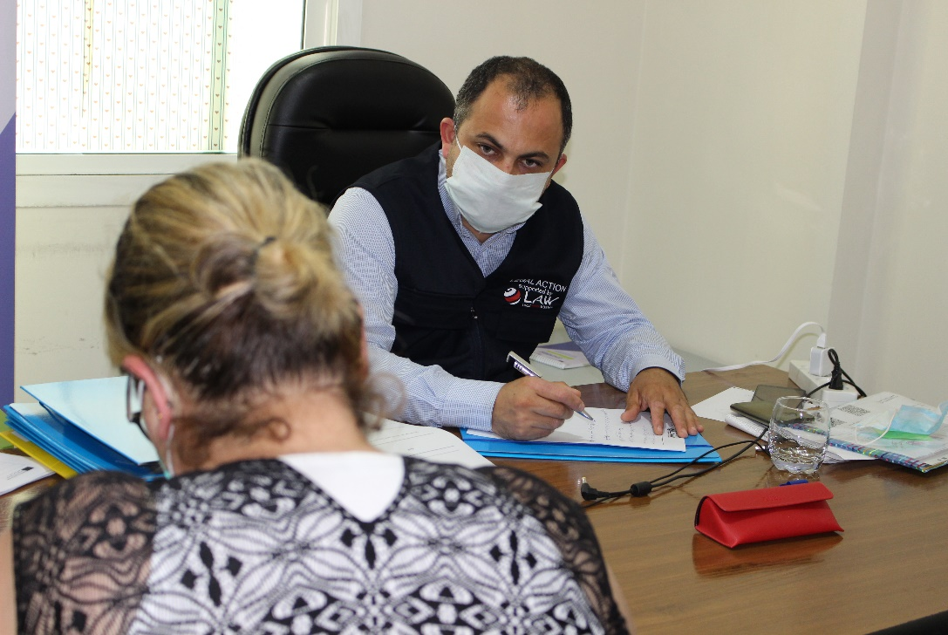
Legal Action's Lawyer is filing a domestic violence case in Mount Lebanon field center - June 3, 2020

Increase of violence against women, especially domestic violence in the context of the COVID-19 pandemic lockdowns
While there is some available data on the rise of domestic violence in Lebanon during the COVID-19 lockdown, the number varies greatly. However, they all show a clear and significant increase in domestic violence and the reporting of domestic violence and SGBV.
The Lebanon Inter Agency task force on SGBV reported that Lebanon indicated a 4% increase of intimate partner violence compared to the same time period in 2019 and an 8% decrease in reporting in March 2020 compared to January 2020. According to the same study, 54% of the interviewed reported increased harassment, abuse or violence of women and girls in their communities.
Lebanon’s Internal Security Forces (ISF) announced an increase of over 100 per cent in reported cases of domestic violence in Lebanon in March 2020, when a strict lockdown was enforced, compared to the same period last year.
Another study found that domestic violence against women has been on the rise in Lebanon since the lockdown. 10% of people surveyed observed an increase in harassment, violence and abuse against women and girls since the pandemic outbreak. Additionally, 37% of women and girls surveyed reported feeling less safe since the lockdown started.

Legal Action Worldwide has experienced a 117 % increase in intake and registration of SGBV cases. Legal Action Worldwide has received at least two clients calling having received death-threats from family members after showing flu-like symptoms.

Lebanese and regional news have reported continuous cases of domestic violence during the pandemic, including a girl and a woman being severely injured having jumped from the second floor in their home in Beirut to escape abuse and a six-year-old Syrian girl died after being beaten by her father.
Although with conflicting statistics it is difficult to measure the increase in exact numbers, the trends are very clear; Lebanon has experienced a significant increase of domestic violence during the lockdown. In the case of Lebanon, it is likely to continue to rise as there are no signs of the economic crisis improving.

Are helplines run by Government and/or civil society available? Has there been an increase in the number of calls in the context of the COVID-19 pandemic?

Lebanon’s Internal Security Forces (ISF) has launched a hotline (1745) for reporting domestic abuse cases in Lebanon. The ISF hotline experienced a 100% increase at the beginning of the lockdown, from 44 in March 2019 to 88 in March 2020. The Internal Security Forces distributed a pandemic awareness poster to all Lebanese territories to reduce the spread of the corona epidemic and halt domestic violence.
In addition, several women’s rights organisations and legal organisations have their own hotlines:
Legal Action Worldwide provides immediate legal assistance and representation in case of domestic violence and other legal issues on its hotline; telephone number 81315001 and on its social media platforms. LAW used to receive an average of five calls per month before the outbreak. However, following increased announcements of the hotline on social media and through whatsapp campaigns, LAW’s hotline exceeded 175% in May 2020. 15% of the calls were GBV representation cases. The majority of the clients who were subjected to domestic violence were abused by their husbands (91%), fathers (3%) and other family members (brother, uncle 3%) and the remaining (3%) were outside the immediate family.
ABAAD’s 24/7 helpline was mostly used to schedule appointments for face-to-face consultations and services, in addition to emergency calls from women in life-threatening situations due to violence.
KAFA (Enough) Violence and Exploitation and the Lebanese National Commission for Women, the Directorate General of the Internal Security Forces jointly operated the hotline 1745 to receive complaints of domestic violence.
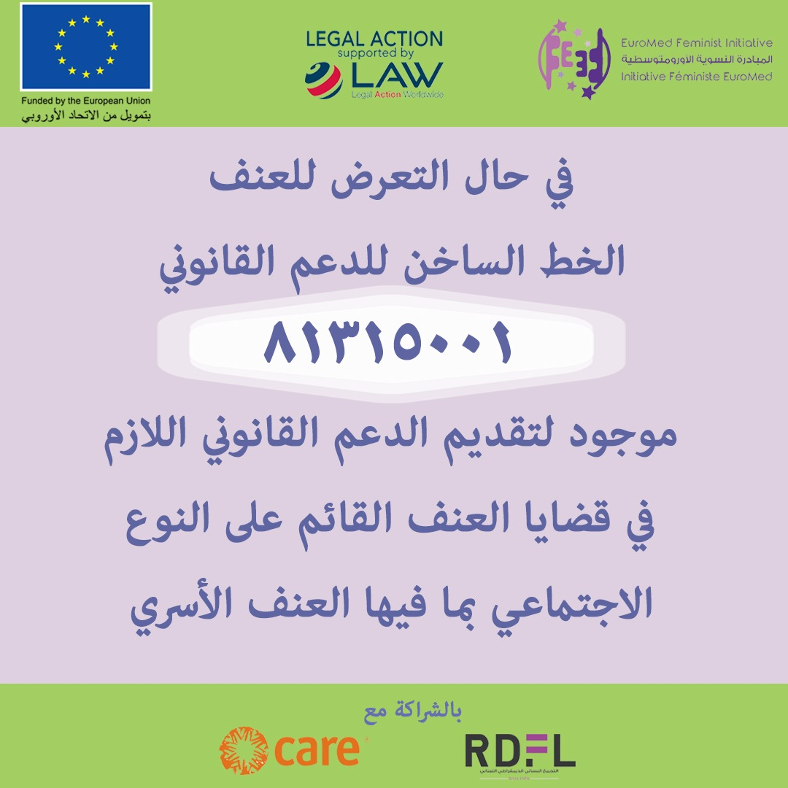
Poster by LAW on social media platform proposing Legal Assistance and representation in case of Domestic Violence

Can women victims of domestic violence be exempted from restrictive measures to stay at home in isolation if they face domestic violence?

There have been no such measures in place in Lebanon. However, the Directorate of the ISF issued an early decision to receive victims of violence in all its stations despite the lockdown. It also made a decision to take allow victims’ statements through online platforms if the victims were unable to go to the police station due to the state of general mobilization and the increasing phenomenon of domestic violence in Lebanon.

Are shelters open and available? Are there any alternatives to shelters available if they are closed or without sufficient capacity?
Lebanon does not have any government-run shelters for women. Instead, women’s rights organisations are providing emergency shelters for women fleeing from abusive husbands and family members. ABAAD runs three shelters in Lebanon for victims and survivors of SGBV. Caritas has one shelter for SGBV survivors and migrant domestic workers detained due to illegal status in the country.
However, due to the threat of coronavirus spreading quickly due to overcrowding, shelters and safe houses have reduced new admissions to the minimum, and NGOs have been struggling to find alternative accommodation.

Most safe houses have adapted new guideline for accommodating women including only high-risk cases such as rape cases, sexual abuse, death threats and clients that completely lack any other options than the shelter. ABAAD has also applied PCR tests for the new cases and adopted new ways of isolation inside the shelters.

Are protection orders available and accessible in the context of the COVID-19 pandemic?
In 2014, the Lebanese Parliament introduced a law that protects women and family members from domestic violence and physical abuse. According to the LAW 293 on domestic violence, women can receive protection orders from court. However, the law only protects against violence from family members. Lebanon has an estimated 250,000-300,000 migrant domestic workers, mainly from Ethiopia, Bangladesh, Sri Lanka and the Philippines. Migrant domestic workers are subject to high levels of physical, psychological and sexual abuse, that enjoy no protection by the law as employers are not considered family members and despite the fact that the workers often are locked in the house of their employer.

What are the impacts on women's access to justice? Are courts open and providing protection and decisions in cases of domestic violence?
All courts except the Court of Urgent Matters were closed during the lockdown. Legal Action Worldwide also experienced that some of the judges who were supposed to attend the Court for Urgent Matters refused to attend hearings out of fear of being exposed to the virus, making it increasingly difficult for women to obtain protection orders.

Legal Action Worldwide has found it particularly difficult to obtain protection orders from the courts during the beginning of the lockdown. However, responding to the crisis as well as to the need to protect abused women, the Government of Lebanon, with the High Judicial Council, issued several decisions facilitating access to protection orders. Women can now apply for a protection order by email, and obtain it later at court once granted.
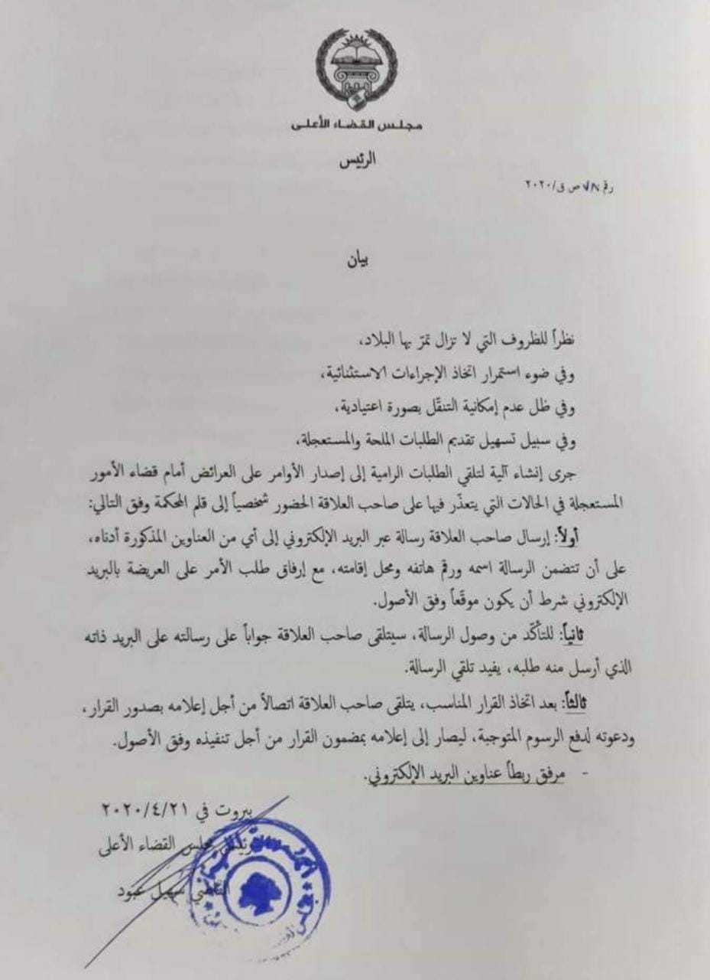
A statement by The High Judicial Council about facilitating urgent decisions including protection orders by emails
In order to mitigate the risks and to facilitate the process for obtaining protection orders the Directorate of the ISF issued an early decision to receive victims of violence in all its stations despite the lockdown. It also made a decision to allow victims’ statements through online platforms if the victims were unable to go to the police station due to the state of general mobilization and the movement restrictions in Lebanon.

The High Judicial Council issued a decision enabling abused women to apply for protection orders by email and requested government agencies to:
- Impose stricter punishment for violation of protection orders;
- Undertake awareness campaigns to inform about the measures to protect women and girls;
- Develop means of communication between the departments, the police and the courts to facilitate the contact from victims and survivors.

The circular instructed the public prosecutors specialized in domestic violence to take all possible measures to protect women victims and their children. The circular included the following procedures:
- Requesting the judicial police to open immediate records of all cases of domestic violence, even the cases of non-witnessed crimes;
- Allow for the prosecutors to listen to victims personally or through the judicial officer in charge of the investigation, via video call, or by any means he finds appropriate.
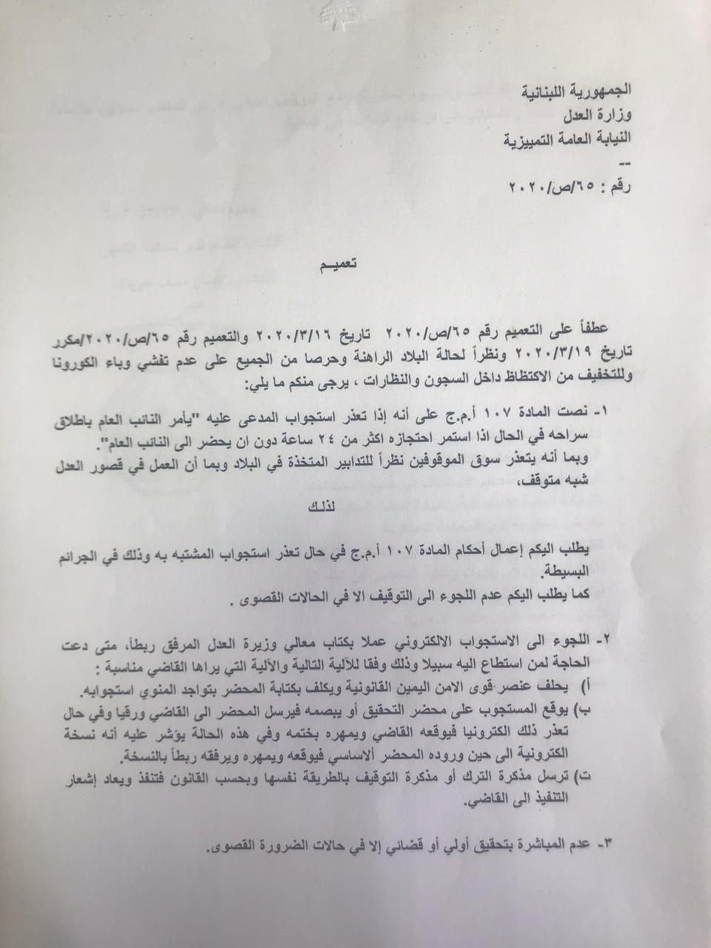
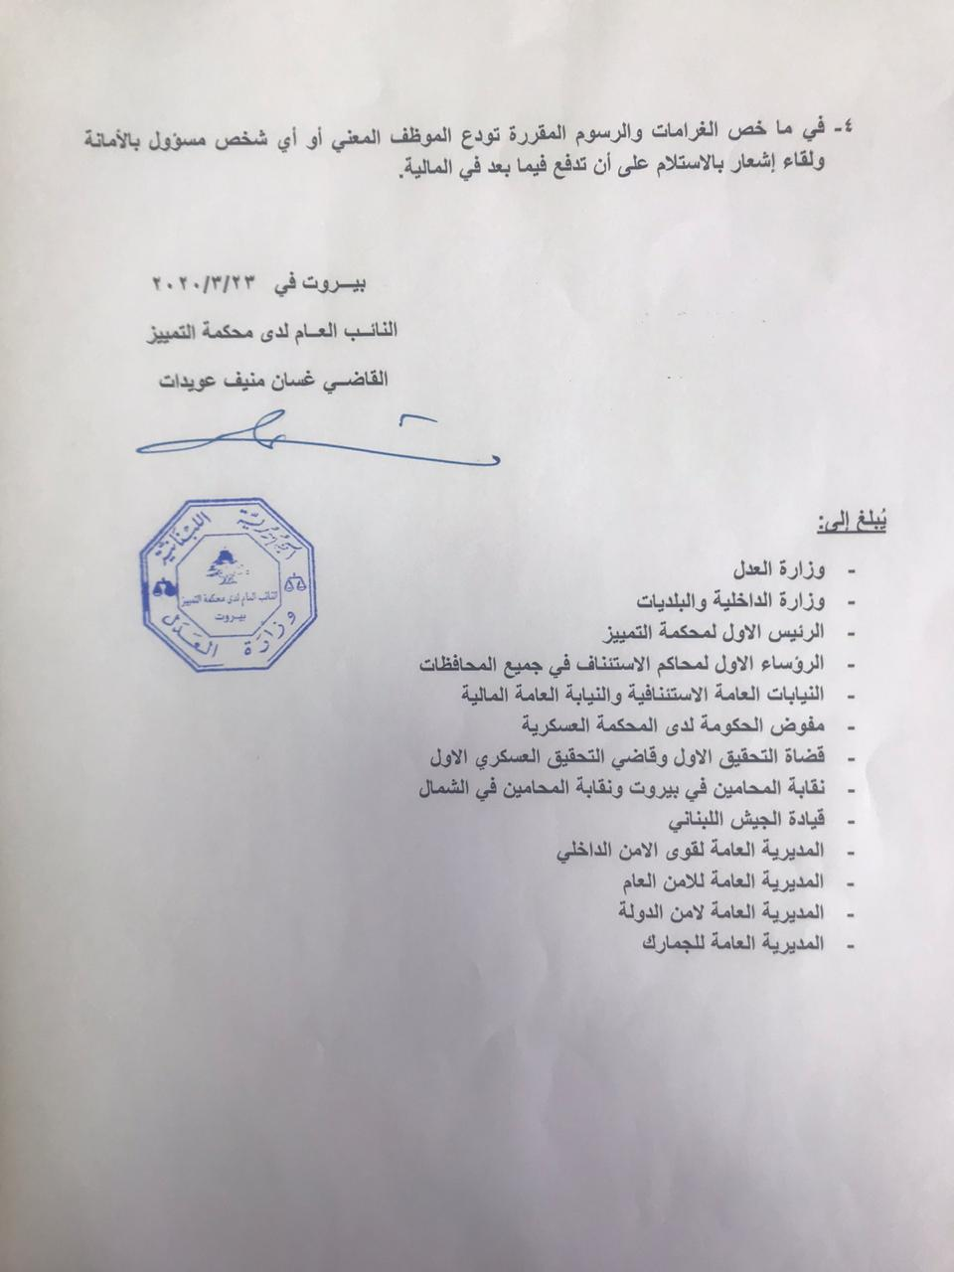
A circular by The Ministry of Justice about facilitating listening and investigating with victims and perpetrators electronically

What are the impacts of the current restrictive measures and lockdowns on women's access to health services? Please specify whether services are closed or suspended, particularly those focusing on reproductive health.

Legal Action Worldwide communicated directly with doctors and hospitals on where clients could address any medical needs following domestic violence, making sure that lawyers and paralegals were aware and could inform clients about health services as needed.
However, the movement restrictions severely hindered access to health care for Syrian and Palestinian refugees in the camps. Lebanese municipalities have put in place their own discriminatory restrictions of movements in and out of camps and informal settlements, preventing NGOs and humanitarian response from providing health care to those in the camps. Clinics that normally provide services for Syrians noticed a 30% reduction of visitors in the first few months of the pandemic.
The Norwegian Refugee Council (NRC) reports that the majority of health facilities are requesting Syrian and Palestinian refugees to present UNHCR certificates, UNRWA cards and/or identification documents (identity card, passport, civil extract or family booklet) for adults and a birth notification or a birth certificate for children. Given that maximum 30% of Lebanon-born Syrian children have birth certificate, and only 12% Syrian adults have legal residency in Lebanon, the requirements for ID or passports is excluding hundreds of thousands of refugees from accessing health services in Lebanon.
Human Rights Watch reports that the needs of disabled persons have been overlooked completely by the Lebanese government and health services throughout the mobilisation during COVID-19.
According to the report of the Inter Agency SGBV Task Force, 85% of women and girls are aware of where to go and how to seek help if they need health assistance. 30% of the interviewees had accessed non-GBV services since the outbreak of the pandemic. It is too early to confirm impacts of sexual and reproductive health care during COVID-19. UNFPA will conduct an impact assessment in 2020.

Please provide examples of obstacles encountered to prevent and combat domestic violence during the COVID-19 lockdowns.
Some of the main obstacles experienced were the restrictions in movements; Lebanon had a very strict curfew during general mobilization - curfew started 7pm until 5am the following morning. Cars were only allowed on alternate days, depending on the licence numbers. All government and private institutions were locked down, or reduced in capacity. Many NGOs who usually provide humanitarian support were restricted in movements and outreach to vulnerable communities. The lockdown affected operations in the field including Focus Group Discussions, legal information sessions and any direct contact with beneficiaries was suspended entirely (except for emergency GBV cases), and work was continued remotely by staff working from home.
Although the Court of Urgent Matters remained open and operational, it was with reduced capacity. Despite Lebanon’s provision of protection orders and legislation on domestic violence, the law is rarely enforced as it is connected to stigma. The general view in Lebanon is still that domestic violence should be solved within the family, and police and prosecutors are reluctant to register cases.

Please provide examples of good practices to prevent and combat violence against women and domestic violence and to combat other gendered impacts of the COVID-19 pandemic by Governments.

The Government of Lebanon decided to facilitate the process of interviewing victims and survivors through online platforms, reducing the needs for victims and survivors to appear in person and the early decision to receive victims of violence in all its stations despite the lockdown. In addition, the government requested several government authorities to undertake awareness campaign on what to do if experiencing domestic violence.

Please provide examples of good practices to prevent and combat violence against women and domestic violence and to combat other gendered impacts of the COVID-19 pandemic by NGOs and NHRIs or equality bodies.

Legal Action Worldwide introduced new and innovative routines and ways to reach out to its clients during lockdown, both existing ones and reaching out to new groups. The team communicated with various hospitals, the Red Cross and individual physicians in order to find the available means for victims and survivors of domestic violence to access medical treatment.

LAW also has a hotline available 24/7 to enable survivors and to communicate with the legal team and receive legal information and assistance.

LAW made a particular effort of reaching out to clients via social media, and undertook an advocacy campaign to ensure larger coverage and targeted campaigns to women and girls in certain areas and of certain ages.

In addition, LAW and the Norwegian Church Aid (NCA) developed key operational guidelines for how to assist legal aid providers in with practical guidelines in how to reach out to clients, how to ensure confidentiality and consent, and how to provide efficient remote legal aid. These are being rolled out across 19 fragile and conflict affected countries and can be made available.

Please send any additional information on the impacts of the COVID-19 crisis on domestic violence against women not covered by the questions above.
Human Rights Watch reports that LGBTQI individuals have been marginalised during the lockdown in Lebanon. Given the family structure in Lebanon is so important, and many LGBTQI persons are rejected by their families, they do not enjoy the social protection of the family. In addition, LGBTQI individuals are more vulnerable to sexual and gender-based violence and have to submit to negative coping mechanisms that put them even more at risk.
Another large group that has been negatively affected by the COVID-19 and the economic crisis is Lebanon’s’ migrant domestic workers. The kafala system excludes migrant domestic workers from the protection of the Lebanese labour law, rendering migrant residency status’ contingent on the employment relationship. If the worker wishes to leave their employers house, they need the consent of their employer or they are at risk of losing their residency status and risk detention and deportation. This leads to a dangerous inequality of power which has led to a commonality of reports of physical and psychological abuse, sexual violence, deprivation of liberty, confiscation of passports and refusals to pay salaries.
Many migrant domestic workers are subject to physical, verbal, psychological, and sexual abuse by the sponsor or a household member. Since 2008, there has been a 100% increase of deaths of domestic workers; from one per week in 2008, up to two per week in 2019 according to numbers from the General Security Organisation (GSO), though human rights organisations estimate the real numbers to be higher. The deaths are rarely investigated by the police or authorities, and it is unclear whether the most common cause of death is suicide, abuse/murder or accidents while trying to escape. “Suicides” are almost never investigated and the Lebanese justice system is failing these women.
Migrant domestic workers are extremely vulnerable in every aspect. They lack support systems, and they are not allowed to organise themselves. MDW are often kept isolated from others, completely dependent on their employer. The deepening economic crisis following strict COVID-19 lockdown in Lebanon has also worsened the conditions for MDW. Just like victims of domestic violence, MDW are now forced to live in isolation with their abusers. The only difference is, that the law on domestic violence only covers abuse by family members, again failing to protect MDW. Many families have lost income and are no longer able to pay their workers. In the beginning of July dozens, if not hundreds of MDW gathered outside the Ethiopian Consulate in Beirut. They have simply been deposited there by their employers or have been evicted and made their own way there. As airports and borders are closed, they have no way of returning to their home countries. Most of them have no personal belongings, passports or money other than what they are wearing.

For more details and information, please contact Jenny Bjerlestam, Head of Middle East, Legal Action Worldwide: bjerlestam@legalactionworldwide.org +961 79 300087

World Economic Forum 2017 http://www3.weforum.org/docs/WEF_GGGR_2020.pdf
https://www.kafa.org.lb/sites/default/files/2019-01/PRpdf-102-636510265940280395.pdf
https://www.kafa.org.lb/sites/default/files/2018-12/PRpdf-94-635951276749134776_0.pdf
The annual UNHCR Vulnerability Assessment of Syrian Refugees (VaSyR 2019)
file:///C:/Users/pc/AppData/Local/Microsoft/Windows/INetCache/Content.Outlook/JA0XC032/Infographic%20-%20Impact%20Assessment.pdf
COVID-19 MENA, a consumer sentiment tracker by IPSOS
https://www.aljazeera.com/news/2020/04/domestic-abuse-cases-soar-lebanon-coronavirus-lockdown-200416233054044.html
https://www.ilo.org/wcmsp5/groups/public/---arabstates/---ro-beirut/documents/publication/wcms_524149.pdf
https://www.thenewhumanitarian.org/feature/2020/04/21/Lebanon-coronavirus-refugee-healthcare
file:///C:/Users/pc/AppData/Local/Microsoft/Windows/INetCache/Content.Outlook/JA0XC032/ICLA_Briefing%20note_Documentation%20and%20access%20to%20healthcare_May2020.pdf
https://reliefweb.int/report/lebanon/lebanon-people-disabilities-overlooked-covid-19-enar
file:///C:/Users/pc/AppData/Local/Microsoft/Windows/INetCache/Content.Outlook/JA0XC032/Narrative%20report%20SGBV%20May%202020.pdf
Human Rights Watch report a minimum of 20% of MDW being subject to physical violence, although they expect this number to be lower than the actual number. 7-11 % of MDW are subject to sexual abuse according to the same report. https://www.hrw.org/report/2010/09/16/without-protection/how-lebanese-justice-system-fails-migrant-domestic-workers

