Exploring NGO’s Initiative to Tackle Gender Based Violence during COVID-19 in Bangladesh

Tasnia Ahmed
Program Officer
SERAC-Bangladesh
Email: tasnia.ahmed.dia@gmail.com

Ananda Kumar Biswas
Program Development Officer
SERAC-Bangladesh
Email: ananda.ku.mds18@gmail.com

Corresponding Author:
Ananda Kumar Biswas
Email: ananda.ku.mds18@gmail.com

Domestic violence against women is getting higher in Bangladesh amid the COVID-19 lockdown, whereas lack of social activities and financial pressures are increasing rifts within families. According to Bangladesh Mohila Parishad, 4,622 women became victims of abuse in 2019. Bangladesh Bureau of Statistics reported 54.2% of married women facing lifetime physical and sexual intimate partner violence. From January-February 2020, 29 women were murdered by their husbands, according to the Ain o Salish Kendra (ASK). Under the shadow of “sticky” social norms, these cases remain mostly unreported. 1 in 2 women in Bangladesh have experienced sexual, emotional and physical violence in this lockdown crisis according to UNFPA statistical data.
On April 15-2020, Obaidul Haque Tutul, a Bangladeshi citizen,belongs to Feni (one of the districts/provinces of the country), live streamed the murder of his wife on Facebook after a domestic feud. The confrontation stunned the country, especially those who witnessed it. For a split second, they couldn't even react to it, as they couldn't believe the phenomenon which was out of imagination. Even in that particular ambiance, the COVID19 infected rate is lower than domestic or mediated technical violence, whereas the COVID19 infected rate is 12.27% following the month of June, but according to Bangladesh Bureau of Statistics, 54.2 percent of married women face physical and sexual intimate partner violence, which is almost five times higher than the COVID19 infected rate. Bangladesh enacted the Suppression of Violence against Women and Children Act in 2000 targeting rape, trafficking, and kidnapping and the Domestic Violence (Prevention and Protection) Act in 2010 criminalizing domestic violence. Despite having legislation in place the implementation of the laws largely remains complex.
Shakila Zaman, a woman from one of the coastal areas of Bangladesh, mentioned that she faced domestic violence for the first time due to this lockdown ambiance and she also added that her husband is becoming increasingly frustrated at home due to a lack of social interaction and doing injustice behaviors and normative attitude randomly.
The nuisance of the COVID-19 pandemic has inadvertently increased the threat of domestic violence worldwide. Most of the supportive organization and mental and emotional counseling centers have expressed their negative reactions and fears of the possible ascend of violence at home due to lockdown ambiance. Enlarged violence is becoming a common phenomenon during any emergency period including political conflicts, economic disaster or infection outbreaks.
According to women human rights defenders and activists, violent tendencies among abusers are encountered by isolation and trauma. The anxiety caused by the epidemic is to be expected to root out more aggravation and antagonism as the women like Shakila stated above accordingly.
Offensive partners are likely to validate their atrocity using segregation from any social interaction to escalate their belligerence.
According to the report of Brac Institute of Governance and Development (BIGD), In China, a magnificent domestic feud has been conducted and reported accordingly which is the continuation of other countries including Bangladesh. Even In the United States, the national domestic violence hotline received increasing volumes of complaints against abusers, who have been misconstruing the COVID-19 crisis to maneuver and control victims.
Considering the situation, a simple question arises about the Next Steps of the sort out of this violence. The county has legal tools to combat domestic violence. The demand for having a separate bill for domestic violence emerged in the 1990s and women’s rights organizations formed a coalition named Citizen’s Initiative against Domestic Violence (CiDV) in 2007 to initiate the drafting process. After successful advocacy and lobbying, the government adopted the Domestic Violence (Prevention and Protection) Act in 2010. The national helpline centre has a 24 hour toll-free hotline number – 109. However, the law’s implementation remains difficult with various kinds of resistances arising when translating into action. The government is already playing a vital role to combat any normative situation, where GO-NGO partnership is needed as well as NGO initiatives must be focused in a broader sense. Because there are almost 3000+ (According to NGO Bureau statistical data) non government organization are working against gender based violence but in this lockdown situation, the things are vice-versa, whereas almost all organizations are like sitting with the lockdown restrictions and continue their activities through online platform by assembling social media talk-show, webinar advocacy and interrelation meetings, hashtag campaigns, photo and story sharing and media buzz activities.
The aim of this study is to bring out the NGO initiatives and the consequences, impact and implementation criteria of violence tackling. This study is based on the content analysis of NGO initiatives and activities concerning the target group of local level to national level.
Methodology: Simple Random Sampling method is seized for this study to deem NGO, INGO and initiative or movement’s the impact in this lockdown position. This study took analysis the fifteen different NGOs, Youth Led Organization and women and Youth led Initiative. To analysis their social media and web content to find-out their activating during COVID-19 period. To follow some thematic areas for analyzing the contents which are related with GBV.
Result & Discussion:
Gendered impacts of lockdown situation and #COVID19 by NGOs and NHRIs or equality bodies, some renowned organizations, legal aid, youth led initiatives and women platform are working for violence trafficking and hinder issues including domestic, physical, sexual and emotional violence through online platform including advocacy meetings, webinar, close ended or interrelation meetings, virtual workshops and online judicial platform with legal actions. But field level activities are decreasing very rapidly and the consequences are facing violence in a trigger way mostly in the marginalized area who are out of internet access and don’t get any technological support including filing complaints or accessing hotline numbers to raise concern.
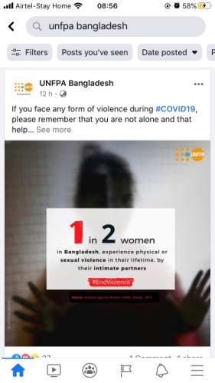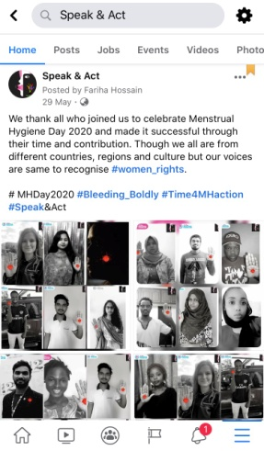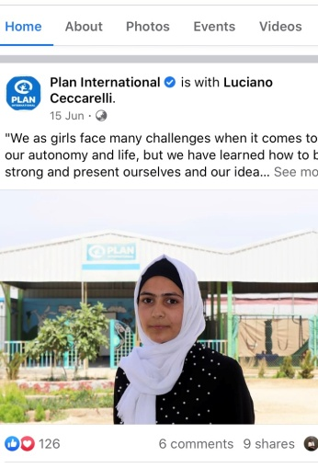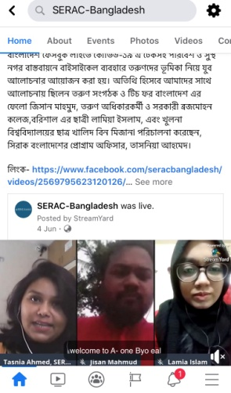
As following some illustrations, 5 non-governmental organizations (NGOs) including Manusher Jonno Foundation (MJF), Bandhu Social Welfare Society, SERAC-Bangladesh, Naripokkho and BLAST are chosen randomly, are come up with social media campaigns, talk-shows and webinars connecting to advocacy and communication, whereas Bandhu Social Welfare Society and BLAST brought out reports and position papers following to the gender based violence on women, transgender and other communities in this lockdown crisis. They all are trying to reach to the local authorities through online news and message sharing. Again BLAST a legal aid is conducting their activities by engaging virtual judges, government officials and other relevant stakeholders to turn on the switch of the issue; The Citizen’s Initiative against Domestic Violence (CIDV) has urged the government with a petition to provide legal support to the victims; again the SDG Fund-Bangladesh is operationally closed. But their site is alive for knowledge and dissemination purposes. SERAC-Bangladesh is targeting the adolescent and youth group to make awareness about where to seek support in line with child marriage and violence.
In addition to this, 5 International non-government organizations are selected with similar method to figure out their crisis moment’s activities. Plan International Bangladesh, UNICEF, Care International, BRAC and UNFPA Bangladesh are trying to create awareness through social media campaigns and doing advocacy with the government officials for violence trafficking through online webinar with the experts on the effective solutions with an infrastructure juridical stability situation. Through the policy briefs, potion papers or research papers, actual violence situations are fetching out to the globally with the data based information.
Moreover women led platform and initiatives are also taken with parallel method including Speak & Act, Women Chapter, YFC, Think Women as Women and Writu are running their activities through arranging webinar sessions, social media campaigns and talk-shows, including grassroot level to national level experts who can give concrete suggestions to against violence trafficking. Interestingly these organizations are targeting the grassroot level field workers who are experiencing these incidents through meadow jobs or by themselves.
Following the content analysis of NGO activities, government as well as private and NGO platforms are doing activities focusing in violence trafficking more in online platform less than manual or offline activities. Though the initiatives of NGOs quite similar, where they could make collaboration to strengthen the platform. As an example, a social media hashtag campaign will be more viral and make a buzz while making any positive transformation with a huge group rather than a single initiative. So collaboration among the NGOs must be considered to thrive the actual renovation. Even these online based activities are covering the internet users, but the grassroot level people are deprived of get any information of seeking assistance while facing such kind of incidents.
The COVID-19 crisis has exposed Bangladesh to the risk of gigantic financially viable arguments. Redundancy is spiking overnight and the country lacks necessary health care facilities which turn into domestic violence due to the depression. With frustrations and anxiety building at the household level, it is now decisive to evaluate our country’s inclination to study from the global domestic violence crisis. Procedure calls for it to be implemented to ensure that complaints can be made safely and confidentially, followed up with rapid and effective response from the authority. Cooperation between legal and development agencies, research institutes and the government is desired to effectively counter narrative to this disaster. Hotlines require to be supplementary approachable; service providers more amicable. If such dealings are not immediately implemented, the county will fall short to counter the budding deluge of violence and abuse in the family.

Recommendations:
Governmental organizations & Non-Governmental Organizations are working in tackling GBV but their problem is to
- To need collaboration among Govt., NGOs, Initiative and Youth-Led organization for tackling GBV.
- Need more specific program modality.
- Engaging men and community people in tackling GBV field for getting better result.

Reference:
https://bigd.bracu.ac.bd/quarantine-in-home-or-prison-domestic-violence-in-the-time-of-covid-19-and-what-it-holds-for-bangladesh/
https://www.unwomen.org/media/headquarters/attachments/sections/library/publications/2020/issue-brief-covid-19-and-ending-violence-against-women-and-girls-infographic-en.pdf?la=en&vs=5155

