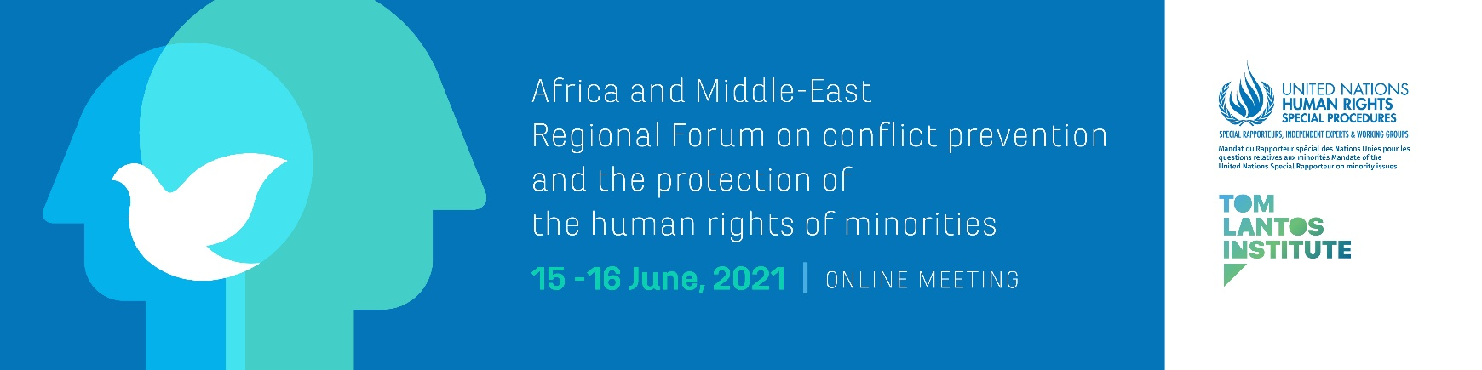

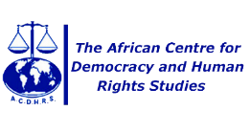
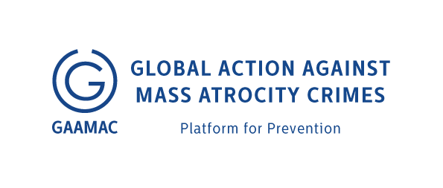
Hosted by The Gambia in cooperation with:
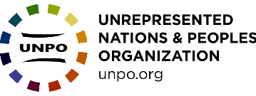
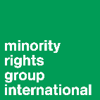
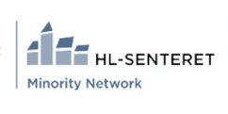

Programme of Work

Day 1 – Tuesday 15th June 2021
10:00-11:00 (Geneva, UTC +2) Opening Session

Welcoming remarks (5 minutes)
Anna-Mária Bíró, Director of the Tom Lantos Institute

Opening Remarks (45 minutes)

Dawda A. Jallow, Attorney General and Minister of Justice of the Republic of the Gambia

Alice Wairimu Nderitu, Special Adviser of the Secretary-General on the Prevention of Genocide

Solomon Ayele Dersso, Chair of the African Commission on Human and Peoples' Rights

Ambassador Nassima Baghli, Permanent Delegation of the Organization of Islamic Cooperation to UN and other international organizations in Geneva

Roueida El Hage, OHCHR Regional Representative for the Middle East and North Africa

Fernand de Varennes, UN Special Rapporteur on minority issues

Rules and Guide to Proceedings (5 minutes)

Anna-Mária Bíró, Director of the Tom Lantos Institute, will set-out the process and explain the rules of proceedings for the forthcoming sessions.

11:00 – 11:15 (Geneva, UTC +2) Technical Break

11:15-12:15 (Geneva, UTC +2) High-Level State Panel

Moderator: Hannah Forster, African Centre for Democracy and Human Rights Studies
Panel: Bafou Jeng, Senior State Counsel and Coordinator of the Human and Child Rights Units of the Ministry of Justice, Republic of the Gambia

H.E. Dr. Turki Abdulla Al-Mahmoud, Acting Head of Human Rights Department, MOFA, Qatar

12:15-12:30 (Geneva, UTC +2) Technical Break

12:30-14:00 (Geneva, UTC +2)
Thematic Session 1: Substantive root causes of contemporary conflicts involving minorities

Moderator: Naji Moulay Lahsen, Executive Director, CIDH
Experts: Seenaa Jimjimo, Executive Director, Oromo Legacy Leadership & Advocacy Association (OLLAA)
Hedi Sarkar, Program Manager, Alliance of Iraqi Minorities Network
Laura Anyola Tufon, Coordinator, Justice and Peace Commission

Interactive dialogue

14:00-15:00 (Geneva, UTC +2) Break

15:00-16:30 (Geneva, UTC +2)
Thematic Session 2: Normative framework: the human rights of minorities and conflict prevention

Moderator:
Experts: Aoife Hegarty, Focal point on minority issues, OHCHR Regional Office for the Middle East and North Africa
Solomon Ayele Dersso, Chair of the African Commission on Human and Peoples' Rights

Judge Jamila Mohamed, Chairperson, Kenya National Committee on the Prevention of Genocide
Beza Dessalegn Assistant Professor, Hawassa University, Ethiopia
Interactive dialogue

Day 2 – Wednesday 16th June 2021

10:00-11:45 (Geneva, UTC +2)
Thematic Session 3: Obstacles to implementing the rights of minorities and early effective conflict prevention

Moderator: Fateh Azzam, Executive Committee member, Boston Consortium for Arab Region Studies, Boston and Member, Palestinian Independent Commission for Human Rights (NHRI), Ramallah
Experts: Geofrey Sabiiti, Africa Conflict Prevention and Peace Building Coordinator, Minority Rights Group International
Kwadwo Appiagyei-Atua, Senior Lecturer, Faculty of Law, University of Ghana
Amina Amharech, Council Representative & EMENA Steering Committee Member, International Land Coalition
Interactive dialogue

11:45-12:45 (Geneva, UTC +2) Break
Thematic Session 4: Ways forward towards addressing gaps in human rights mechanisms to protect minorities and prevent conflicts
12:45-14:15 (Geneva, UTC +2)

Moderator: Frank Okyere Head, Peace Support Operations Program at Kofi Annan International Peacekeeping Training Centre
Experts: Hon. Rémy Ngoy Lumbu, Vice Chairperson, African Commission on Human and Peoples' Rights
Wale Adeboye, Director, West Africa Responsibility to Protect Coalition
Aya Manaa, former OHCHR Minority Fellow
Interactive dialogue

14:15-16:00 (Geneva, UTC +2) Lunch Break

16:00-17:00 (Geneva, UTC +2) Presentation of Recommendations

In this session, the proposed recommendations developed during the four thematic sessions will be made available to participants to consider.
The session will be introduced by Fernand de Varennes, UN Special Rapporteur on minority issues, following which Marcus Oda, Programme Manager at the Tom Lantos Institute, will present the list of recommendations.
Participants can make any final comments on specific recommendations using the Zoom chat function.
Chair: Anna-Mária Bíró, Director of the Tom Lantos Institute

17:00-17:30 (Geneva, UTC +2) Concluding remarks

Fernand de Varennes, UN Special Rapporteur on Minority Issues

Simultaneous interpretation will be provided in Arabic, English, French and Portuguese.

