IN PUT FOR 2022 REPORTS

As your purpose view it:
To inform the Special Rapporteur’s reports:
the human rights to safe drinking water and sanitation of indigenous peoples: state of affairs and lessons from ancestral cultures to be presented at the 51st session of the Human Rights Council in September 2022;
and the human rights to safe drinking water and sanitation of people living in impoverished rural areas to the 77th session of the United Nations General Assembly in October 2022. I am Gervais NDIHOKUBWAYO a Mutwa, indigenous people of Burundi. Burundi is one of the East African countries in which contain the Batwa or Abasangwabutaka community I think that you know this. That is to say the pygmies or indigenous peoples. This country is limited to the North by Rwanda, to the East and to the South by Tanzania, to the West by the Democratic Republic of Congo. It contains a group of Batwa including me who have just finished the state university in the department of English in Institute for Applied Pedagogy and I am also member of an organization Unite for the Promotion of the Batwa (UNIPROBA in acronym)
This is why I present to you my community which is in all under the feet of poverty and in the hands of it. The Batwa community is a community that lived off the pottery in the past years, the Batwa did not think that this activity will be out of fashion and lack enough to feed their families.
They do not now have land and have not educated the children. This community is really in a difficult situation because they have no cultivable land, they have not educated their children, the activity of making the pots is made archaic, and one can think of what then live now the Batwa of Burundi? It is really difficult to answer. They are in the dilemma
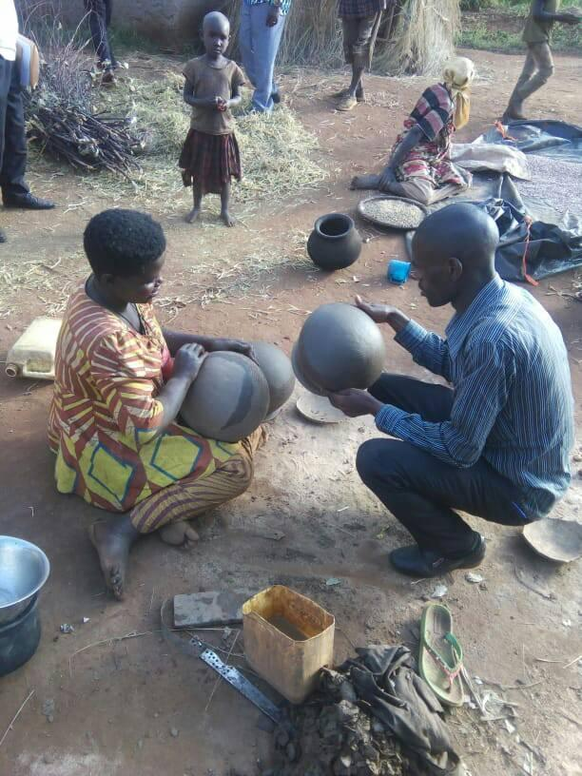
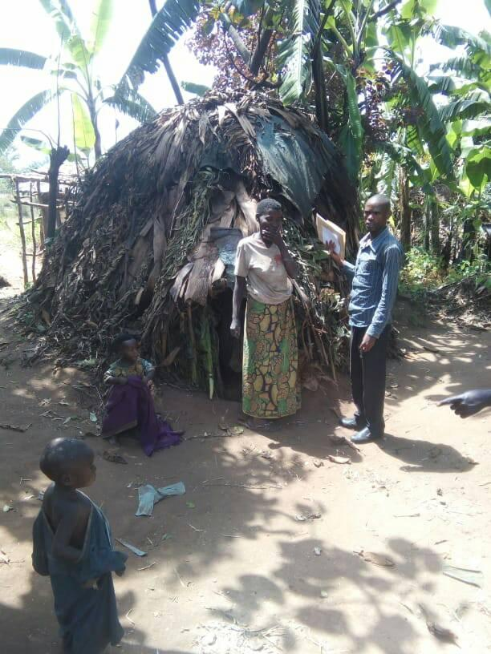

As you spoke about the objective of drinking clean water, it is really difficult to be able to build taps when you are a Mutwa due to lack of means.
Our community uses hall water in their daily business.
As you see in this photo.
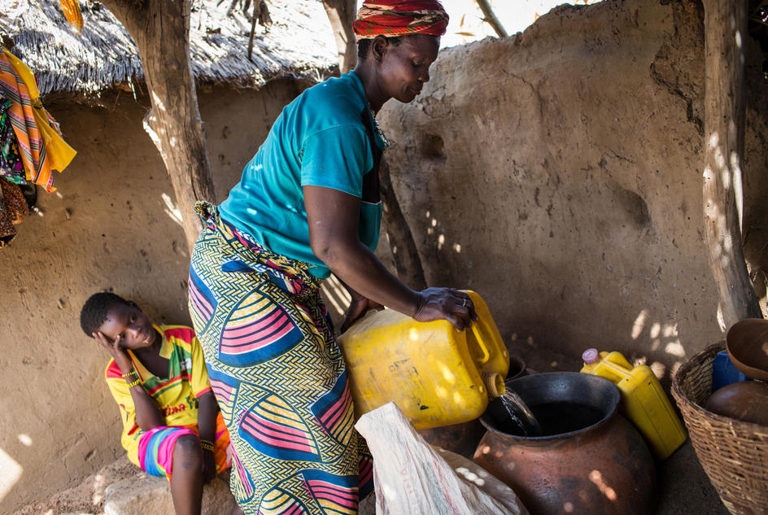
I therefore ask you to give it your hand of assistance in order to clear up certain diseases resulting from this use of improper water.

Cordially Gervais NDIHOKUBWAYO
Member of UNIPROBA
Twitter:@NDIHOKUBWAYOG14

