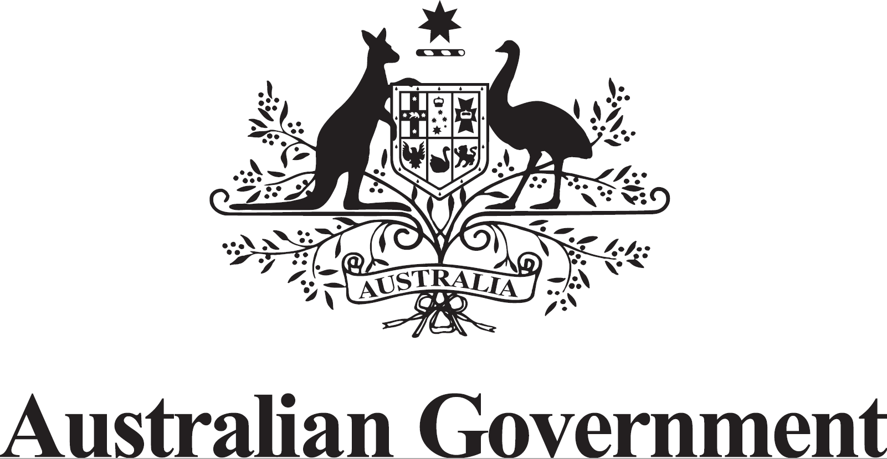

Australian Submission

UN Special Rapporteur on the Human Rights to Safe Drinking Water and Sanitation
“Study on the human rights to safe drinking water and sanitation of indigenous peoples: state of affairs and lessons from ancestral cultures”

Contents
Introduction 1
National legal and regulatory framework for water 2
Access to safe drinking water, sanitation and hygiene 3
Accountability framework 3
Meaningful participation relating to decisions, policies, and projects affecting human rights to safe drinking water 4
Rural areas 5
Attachment A: Additional Information from Australian Government Websites 5

Introduction
The Australian Constitution of 1901 established a federal system of government, based on the British (Westminster) tradition of government. Differing powers and responsibilities sit with Australia’s national government (the Commonwealth) and its self-governed states (New South Wales, Queensland, South Australia, Tasmania, Victoria and Western Australia) and territories (the Australian Capital Territory and the Northern Territory).
Australia is a representative democracy where votes elect candidates to carry out the business of government on behalf of its citizens. Australian citizens over the age of 18 are required to vote in elections.
The Commonwealth is answerable to the Australian Parliament for its actions. The Prime Minister leads a Cabinet of responsible ministers.

National legal and regulatory framework for water
State, territory and local governments and their water utilities are responsible for the provision of water and sanitation services to all Australians including Indigenous and remote communities, based on service standards developed with their community and relevant regulators. Consequently, water utilities are subject to best practice governance and regulations arising from their respective state or territory legislation. This approach ensures water utilities have robust planning and delivery frameworks which ensure a minimum standard of water provision services, including minimum levels of water treatment.
As a shared Commonwealth, state and territory commitment, Australia’s National Water Initiative (NWI) came into effect in 2004 to increase the efficiency of Australia's water use. Statutory water plans provide the cornerstone of the NWI framework. The NWI requires statutory water plans be prepared for surface water and groundwater management units in which water entitlements are issued, and for water allocations and entitlements to be made consistent with these plans. The NWI states water plans should set down environmental and other public benefit outcomes for water systems and the means for achieving them; and provide for ‘resource security outcomes by determining the shares in the consumptive pool and the rules to allocate water during the life of the plan’. Water plans provide allocations to ‘environmental and other public benefit outcomes’ which have at least the same degree of security as allocations to the consumptive pool. ‘Environmental outcomes’ are defined for these purposes as maintaining ecosystem function, biodiversity, water quality, and river health, while ‘other public benefit outcomes’ are defined as including ‘Indigenous and cultural values’.
In addition to requiring water plans to identify and secure environmental and other public benefit outcomes, which include ‘Indigenous and cultural values’, the NWI (cl 52) obligates the Commonwealth, states and territories to:

provide for Indigenous access to water resources, in accordance with relevant Commonwealth, state and territory legislation, through planning processes that ensure:
(i) inclusion of Indigenous representation in water planning wherever possible; and
(ii) water plans will incorporate Indigenous social, spiritual and customary objectives and strategies for achieving these objectives wherever they can be developed.

The NWI also states ‘water planning processes will take account of the possible existence of native title rights to water in the catchment or aquifer area’ and notes that ‘plans may need to allocate water to native title holders following the recognition of native title rights in water’.
For example, the Water Act 2007 provides the legislative framework for ensuring Australia’s largest water resource, the Murray-Darling Basin is managed in the national interest. In doing so the Water Act 2007 recognises that states and territories in the Murray-Darling Basin continue to manage Basin water resources within their jurisdictions and must have regard to “social, cultural, Indigenous and other public benefit”.

The Commonwealth is currently working with states and territories to renew the NWI, with a focus on water for cities and towns, water for Indigenous Australians, climate change impacts on water availability and new water infrastructure. As part of the renewal, the Committee on Aboriginal Water Interests (CAWI) was established to advise on Indigenous water priorities. CAWI consists of eleven Aboriginal and Torres Strait Islander water experts in locations across Australia.

Access to safe drinking water, sanitation and hygiene
While there are logistical challenges faced with installing and maintaining infrastructure in the most remote communities arising from vast distances and seasonal climatic conditions, we aim for all Australians have universal access to potable water and sanitation services.
Access to safe drinking water, sanitation and hygiene for people living in remote areas is the responsibility of states and territories, which have implemented a range of programs and policies to ensure the provision of water and wastewater services.
In the state of New South Wales the state is delivering the ‘Aboriginal Communities Water & Sewerage Program’. Investing over $200 million to improve water supply and sewerage services, the program aims to raise the standard of service by engaging local utility providers to operate and manage water and sewerage infrastructure.
In the state of Queensland, the state is delivering the ‘Indigenous Councils Critical Infrastructure Program’. Providing $120 million for infrastructure works relating to critical water and wastewater assets, the program is specifically dedicated to 16 Aboriginal and Torres Strait Island councils.
The Commonwealth has provided support for the National Cultural Flows Project, a research project that has added significantly to the body of knowledge related to Indigenous interests in water (particularly in the Murray-Darling Basin) and how they can be more effectively reflected and accounted for in water planning and management.
A key output of the project was the development of a national framework for cultural flows. This framework for reforming existing water policy and law in Australia focuses on three interconnected approaches:
- providing sustainable Indigenous water rights enabling ownership, use and access to water;
- strengthening Indigenous influence over water landscapes by improving the laws related to water and water rights; and
- transforming existing foundations of water governance and partnership to ensure effective Indigenous representation and consideration in decision-making processes.

Accountability framework and Information
Water utilities maintain social and web-based media platforms which provides their customers with a wide range of up-to-date information on water and wastewater services, including service standards, water supplies and water quality, as well as providing feedback and complaint mechanisms. Customers are able to refer the matter to state-based ombudsmen or similar to undertake further enquiries if the utility does not provide a response to the customer’s satisfaction. The occurrence of complaints is an indicator recorded under the Urban Water National Performance Report (NPR) and puts the onus on utilities to provide a consistently high quality of service.
In addition, the NPR supports commitments made by states and territories under the NWI to report publicly and independently on the performance of urban water utilities with more than 10,000 connections. Now in its fifteenth year, its annual performance reports provide independent analysis and benchmarking of over 80 water utilities and covers water resources, financial operations, pricing, regulatory compliance, assets, customers and customer service, and environmental performance. This report is complimented by the annual Water Account published by the Australian Bureau of Statistics, that presents information on the physical and monetary supply and use of water.
National Indigenous Australians Agency – Evaluations and Evidence:
https://www.niaa.gov.au/indigenous-affairs/evaluations-and-evidence
“The work of the National Indigenous Australians Agency (NIAA) is underpinned by effective data and evidence. The NIAA provides advice and information to the Minister for Indigenous Australians, the Commonwealth Government, State and Territory governments, organisations, providers and communities to inform policy development, programs and monitoring of the effectiveness of programs for Aboriginal and Torres Strait Islander peoples.
The NIAA provides statistical analysis of data, evidence and research to inform policy and programs through:
- The Aboriginal and Torres Strait Islander Health Performance Framework report
- Input into a range of government reviews and reports that monitor progress and the effectiveness of programs for Aboriginal and Torres Strait Islander people (e.g. the Commonwealth Closing the Gap annual report)
- Monitoring trends in outcomes for Aboriginal and Torres Strait Islander people.”
National Agreement on Closing the Gap:
https://www.closingthegap.gov.au/national-agreement
The objective of the National Agreement on Closing the Gap (the National Agreement) is to enable Aboriginal and Torres Strait Islander people and governments to work together to overcome the inequality experienced by Aboriginal and Torres Strait Islander people, and achieve life outcomes equal to all Australians. The National Agreement includes four Priority Reforms, to change the way that governments work with Aboriginal and Torres Strait Islander people, and 17 socio-economic targets.

The Joint Council on Closing the Gap (Joint Council) has recommended a new target on Community Infrastructure to First Ministers, which will commit all governments to maintaining a minimum standard of services, including water, in remote areas and discrete Indigenous communities.

The Joint Council is also undertaking work to add an inland water target to the National Agreement on Closing the gap. Joint Council will consider the finalised statistical baselining exercise at its next meeting to improve understanding of existing levels of Indigenous corporations’ water ownership.

Meaningful participation relating to decisions, policies, and projects affecting human rights to safe drinking water
The NWI provides for the inclusion of Indigenous social, spiritual and customary objectives into water planning. State and territory water agencies engage with Indigenous peoples on water issues through their water planning processes with individual agencies having their own strategy and/or guideline for engagement. Indigenous representation in water planning can take many forms, such as:
- advisory committee arrangements to promote participation in decision making forums for water planning and management processes;
- employing Indigenous water planners and/or Indigenous staff to enable meaningful consultation and provide a conduit for Indigenous views (including those for water-dependent cultural values) to be represented in the water planning process;
- working with Indigenous community groups and organisations to define culturally appropriate ways to be engaged in water planning and decision making;
- developing principle-based partnerships and co-management arrangements; and
- investing in capacity building exercises for Indigenous peoples to develop their skills in water planning and management practices, and reciprocal knowledge transfer from Indigenous peoples to water planners.
In 2017, the Commonwealth and states and territories developed a ‘module’ to the NWI Policy Guidelines for Water Planning and Management named Engaging Indigenous peoples in water planning and management.
This module builds upon existing engagement processes to ensure inclusive approaches to water planning which support genuine consideration of Indigenous social, spiritual and customary objectives. It provides best practice guidance on the nature of Indigenous interests in water resources and how they can be reflected in planning processes and outcomes.
The guidance involves three elements:
- recognising Indigenous values and needs in water resource planning and management;
- native title and other Indigenous land rights – implications for water planning and management; and
- options for improving Indigenous water access in plans.

The CAWI, an advisory body to the NWRC, has approximately 50:50 membership ratio of Indigenous men to women, including a male and a female Co-Chair.

Rural areas
All Australians have universal access to potable water and sanitation services. There is no delineation between geographic or demographic groups for the provision of water services. State, territory and local governments are responsible for the provision of water and sanitation services. Within each jurisdiction, water utilities operating on a state-wide or local level adhere to regulations which ensure the provision of water and sanitation services to their customers. Technical and regulatory authorities in each state or territory maintain oversight of the provision of water and sanitation services through utilities.
For example:
- The Office of the Tasmanian Economic Regulator provides for the safe, environmentally responsible, efficient and sustainable provision of water and sewerage services to the Tasmanian community by developing and issuing licences, codes and guidelines.
- The Essential Services Commission of South Australia is responsible for the economic regulation of water and sewerage services through industry licensing, consumer protection and retail pricing.

Attachment A: Additional Information from Australian Government Websites

Attachment A: Australian Bureau of Statistics (ABS) – “Estimates of Aboriginal and Torres Strait Islander Australians”
Australian Bureau of Statistics: The Centre of Aboriginal and Torres Strait Islander Statistics
https://www.abs.gov.au/about/aboriginal-and-torres-strait-islander-peoples/aboriginal-and-torres-strait-islander-engagement
The Australian Bureau of Statistics is Australia’s national statistical agency and an official source of independent, reliable information. The ABS Centre of Aboriginal and Torres Strait Islander Statistics (CoATSIS) has a leadership and coordination role for national statistical activity about Aboriginal and Torres Strait Islander peoples. CoATSIS is dedicated to early and ongoing conversations with Aboriginal and Torres Strait Islander peoples to increase participation in, and the relevance of, ABS statistical collections. They engage with communities across a range of statistical activities and outputs from Indigenous specific surveys such as the Aboriginal and Torres Strait Islander health and social surveys, the five yearly Census, administrative data, and data integration projects.”

Comment: The following images on pages 20 - 21 are screen shots from sections of the ABS website that report on population estimates for Aboriginal and Torres Strait Islanders. More information is available at this link: https://www.abs.gov.au/statistics/people/aboriginal-and-torres-strait-islander-peoples/estimates-aboriginal-and-torres-strait-islander-australians/latest-release

