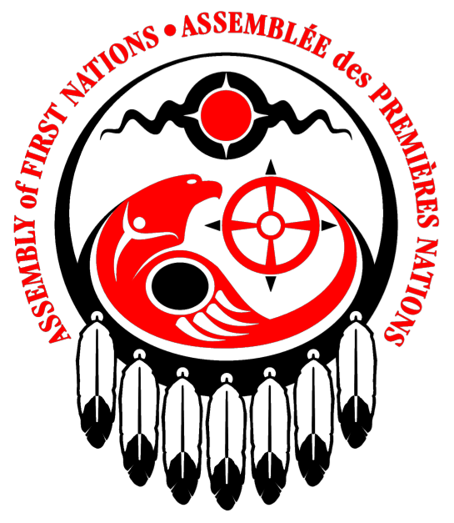

Assembly of First Nations

Submission to the United Nations Special Rapporteur on the Human Rights to Safe Drinking Water and Sanitation’s Call for Input: Indigenous peoples and people living in rural areas

December 31, 2021

Page | 1

Response to Questionnaire (Specifically - Section 9)

Please provide information on the Indigenous peoples living in rural areas that your organization is aware of or represents or works with, particularly on their access to water and sanitation:
9.1. how indigenous peoples access water (for drinking, for domestic and personal usage), and sanitation (toilet, pit latrines, sewerage, shower facilities, handwashing, menstrual hygiene);
9.2. what agencies are responsible for the provision of water and sanitation services to indigenous peoples, and what service providers – public or private; at community, municipal, or supra-municipal level – manage those services;
9.3. the value, spirituality, beliefs and practices involving water and sanitation.
9.4. the role of indigenous peoples and their communities relating to water management and the resources (human, technical, financial) they have; and
9.5. the different gender roles that indigenous women and girls have in the provision of water for their families and community.

Response from the Assembly of First Nations

The Assembly of First Nations (AFN) is the national, political organization of First Nations governments and their citizens, including those living on and off reserve. Every Chief in Canada is entitled to be a member of the Assembly, and the National Chief is elected by the Chiefs in Canada, who in turn are elected by their citizens. The AFN has 634 member nations within its Assembly. The role and function of the AFN is to serve as a nationally delegated forum for determining and harmonizing effective, collective, and co-operative measures on any subject matter that the First Nations delegate for review, study, response, or action, and to advance the aspirations of First Nations.

The AFN advocates on various issues related to drinking water and sanitation, with a direct focus on advocating to support the creation of First Nations-led policies and solutions related to access to clean and reliable drinking water, adequate sanitation, and safe and quality infrastructure. Water-related issues are viewed through a multi-dimensional jurisdictional lens which includes elements of infrastructure, fisheries, environment, fulfillment of human rights, as well as consideration of the critical roles of First Nations women with respect to water.

The AFN appreciates the opportunity to provide a submission to the UN Special Rapporteur on the Human Rights to Safe Drinking Water and Sanitation’s Call for Input from non-state actors. The response below contains 1982 words, in keeping with the UN’s Call for Input that requested responses 2000 words or less.

Context
Water is a fundamental human right for First Nations, and this right is uniquely situated within a framework of inherent rights that are constitutionally protected under section 35 of the Canadian Constitution Act of 1982, and supported by international mechanisms and instruments, including the United Nations Declaration on the Rights of Indigenous Peoples. First Nations in Canada also have Inherent and Treaty rights regarding the protection of water within their lands and territories. Relinquishing water rights was never part of Treaty negotiations, and First Nations water rights must be acknowledged and affirmed in any discussions pertaining to the management and protection of freshwater.

Waters within First Nations lands and territories have become polluted and decreased in quality and quantity due, in part, to industrial practices that have taken place without the free, prior and informed consent of First Nations. The contamination of water within the traditional territories of First Nations has led to significant negative health outcomes.

Many First Nations are facing daily challenges to access safe, clean drinking water. The Canadian government has violated its international human rights obligations toward First Nations by failing to remedy the severe water crisis. Currently, more than 100 communities are without clean drinking water with active advisories in place. This number includes First Nations with compromised water wells lacking a distribution and sanitary collections system. Many have faced these conditions for years and even decades.

As defined by the human right to water, First Nations face greater barriers in accessing water, with respect to quantity, quality and accessibility. First Nations face disproportionately higher numbers of drinking water advisories and are subjected to these advisories for longer periods of time than non-Indigenous communities. Simply speaking, there are current and persistent examples of First Nations without adequate access to sufficient, safe and acceptable water. From a water quality perspective, the number of waterborne diseases in First Nations communities is 26 times higher than the national Canadian average, and people living on reserve are 90 times more likely to have no access to running water compared to other Canadians. ,

At any given moment over the past three decades, as based on available information, there have been at least 100 advisories (both long- and short-term) in place at any given time, in First Nations communities across Canada. Evidence of inadequate access to safe water for First Nations abounds. For example, in 2005, five years after the Walkerton crisis, Kashechewan, a Northern Ontario First Nation had been on a boil water advisory for two years when the residents were ordered to leave by the province due to high levels of E.coli in their drinking water. This was after the Justice O’Connor, in the Report of the Walkerton Inquiry, noted that First Nations had the poorest-quality water in the province of Ontario. In Grassy Narrows (Asubpeeschoseewagong) First Nation residents have been exposed to high levels of toxic mercury for over half a century, with over 90 percent of the community exhibiting symptoms of mercury poisoning., Attawapiskat First Nation has been on and off long-term advisories for over two decades, including several states of emergency and evacuations that have received notable media attention. In Shoal Lake 40, near the Ontario and Manitoba border, residents have been on an advisory since 1997. The advisory was put in place shortly after the 1995 construction of a pumphouse which was intended to help service the manmade island. The community residents were forced onto this land following the expropriation of land to better service water to neighbouring Winnipeg. This First Nation’s advisory was just lifted in September 2021. In the case of Pikangikum First Nation, the 2001 National Assessment of Water and Wastewater Systems found that 387 homes did not have water services, with many accessing drinking water directly from the nearby lake. The community requested funding in 2001 for both the water treatment system and its distribution system, but the request was denied.

Responsibilities
First Nations across Canada are disproportionately impacted by water pollution, water scarcity and flooding. As a result, their human right to safe, clean water is impacted, as are their recognized rights, affirmed in the United Nations Declaration on the Rights of Indigenous Peoples. The Federal Government has a fiduciary responsibility to First Nations, through the Indian Act, and more recently through the Federal Government’s commitment to implement the Declaration.

Some specific examples include:
  - Currently, First Nations Drinking Water is not regulated. There is, however, the Safe Drinking Water for First Nations Act that allows for the creation of enforceable regulations. However, issues with this legislation have been identified by First Nations communities and organizations therefore, work on the regulatory end has stopped, and First Nations are seeking repeal and replacement of the Act.
  - As a common standard, First Nations communities work to the levels of the Guidelines for Canadian Drinking Water Quality.
Canada does not explicitly recognize the right to a safe, clean, healthy, and sustainable environment in constitutional instruments. However, the provinces of Quebec and Ontario have recognised the right to a healthy environment through the Charter of Human Rights and Freedoms and Environmental Bill of Rights, respectively. The territories of Yukon and Northwest Territories each have similar legislation as well. A constitutional challenge is currently underway to determine if Section 7 of the Canadian Charter of Rights and Freedoms extends “life, liberty, and security of the person” to include a safe environment.

As of October 25, 2021, there are 43 long-term drinking water advisories in effect in 31 First Nations. To date, Indigenous Services Canada (ISC) confirms that 119 long-term advisories have been lifted since November 2015. However, this report number includes only ISC-funded assets, and systems with 5 connections or more; they do not include the many First Nations on individual wells or cisterns. These numbers also do not include many advisories in British Columbia, and those within the Saskatoon Tribal Council.

It is of the utmost importance for the federal government to live up to their commitment of ending all long-term drinking water advisories and upholding the United Nations affirmed human right to safe drinking water. The AFN continues to seek additional information from the federal government on their proposed Action Plan, including a transparent reporting and monitoring process.

While the AFN interacts with numerous federal agencies, including Indigenous Services Canada (ISC)/First Nations and Inuit Health Branch (FNIHB), Environment and Climate Change Canada (ECCC), the Canada Water Agency (CWA), the Department of Fisheries and Oceans (DFO), Ministry of Infrastructure and Communities, and Transport Canada, there remain challenges to ensuring the full and meaningful participation of First Nations in decision-making processes related to water. In particular, engaging with ECCC on the development of the CWA has been a challenge.

The Prime Minister's commitment to reconciliation, as demonstrated by his commitment to a 'nation-to-nation' relationship based on the recognition of rights, respect, cooperation and partnership, offers an important opportunity for guidance on the appropriate consideration and participation of First Nations in the context of water.

Canada's obligations and responsibilities to First Nations, reaffirmed under the United Nations Declaration on the Rights of Indigenous Peoples (UN Declaration) must be seen as the framework for the contextualization and operationalization of reconciliation, especially as it relates to First Nations’ relationships with water. AFN Resolution 01/2019, First Nations Treaty and Inherent Rights to Water, mandates the AFN to call on Canada to immediately work in full partnership with First Nations to advance the work needed to achieve reconciliation and the standards as set out in the UN Declaration, including Articles 25 and 32 for the full and meaningful implementation of Indigenous water rights in their territories, including via Canada’s legislative commitment to the UN Declaration in the United Nations Declaration on the Rights of Indigenous Peoples Act (former Bill C-15).

Cultural Significance of Water
Water is fundamental for life. For First Nations, the significance of water deepens through our eternal connection to water. Many First Nations consider water to be a relative, rather than a resource that can be bought or sold in which there exists a reciprocal relationship that must be continuously nurtured and respected. We operate under the basic principle that if you take care of the water, it will take care of you. We understand that a healthy ecosystem is necessary in order to exercise our Indigenous rights and laws, which enable us to fish, hunt, gather and practice our traditional customs and ceremonies. While some of these concepts likely resonate with non-Indigenous peoples as well, the reality is that Western ways of knowing have largely precluded such characterizations and have, thereby, led to the pollution and desecration of Mother Earth.

For First Nations women, this connection to water deepens through their roles as child bearers. Just as water from Mother Earth carries life to us, women carry life and water in their wombs during pregnancy. It is in this way that we recognize that all aspects of creation are interrelated. When settlers arrived on Turtle Island (i.e., North America), Indigenous natural law was largely replaced by colonial law, changing the ways that water was respected. Colonialism has had negative ramifications for Indigenous Knowledge relating to water, and the intergenerational transfer of this knowledge has thereby been diminished. Our traditional ways of being were not passed on from grandmothers to mothers who, in turn, have been unable to teach our youth. As a result, First Nations have suffered a loss of traditional roles, responsibilities, practices, and stewardship. It has been difficult to reclaim these roles since, to this day, the vast majority of policies in Canada that involve water fail to embody the critical roles of First Nations women with respect to water.

Conclusion
There are many water-related issues encountered within First Nations territories that require further attention and research. Industrial development and climate change are both negatively impacting our health and way of life. Industrial practices often contravene our water-related rights, including the contamination of water from tailing ponds, unsustainable agricultural irrigation practices, oil and chemical spills, the diversion of waterways (e.g., dams), gray water from pulp and paper mills, the addition of foreign substances in aquaculture (e.g., antibiotics), and plastic water pollution to name only a few. In addition to industrial threats, climate change exacerbates many of these challenges with extreme weather events, which cause increased occurrences of both flooding and droughts. Amongst both freshwater and marine environments, rising water temperatures escalate the likelihood of harmful algal blooms and eutrophication, acidification, melting sea ice and sea level rise. Finally, the rapid melting of glaciers threatens the sustainability of many of our freshwater river systems.

While the AFN is not a rights holder, it is a duly delegated body to support First Nations’ rights and advocacy. Thank you in advance for your consideration of this brief. The AFN is committed to ensuring that the United Nations affirmed Human Right to Safe Drinking Water is upheld and that safe, clean and reliable drinking water and sanitation is accessible to all First Nations across the country.

Appendix 1 – Relevant Resolutions

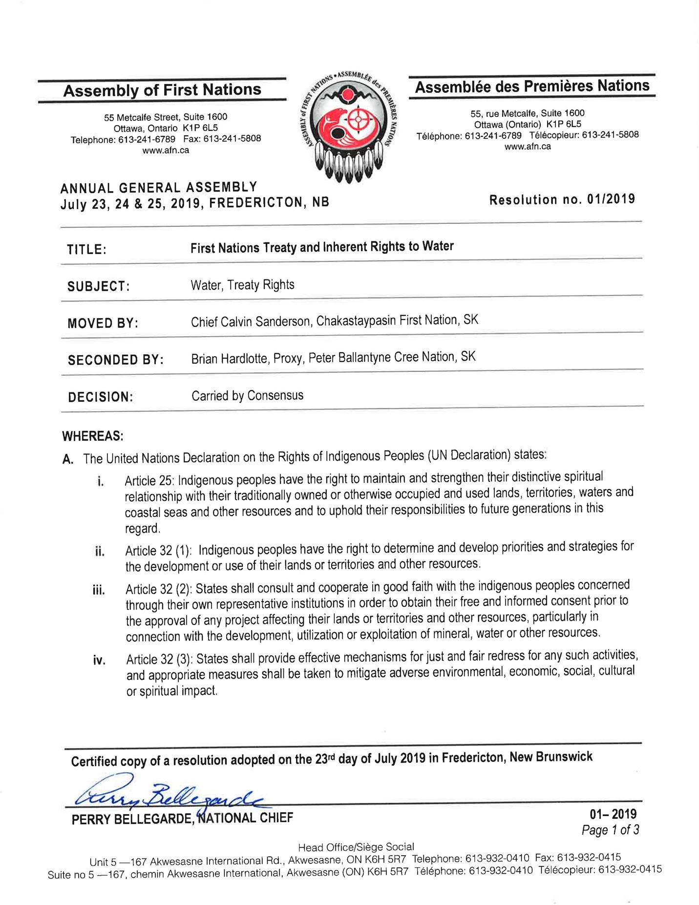
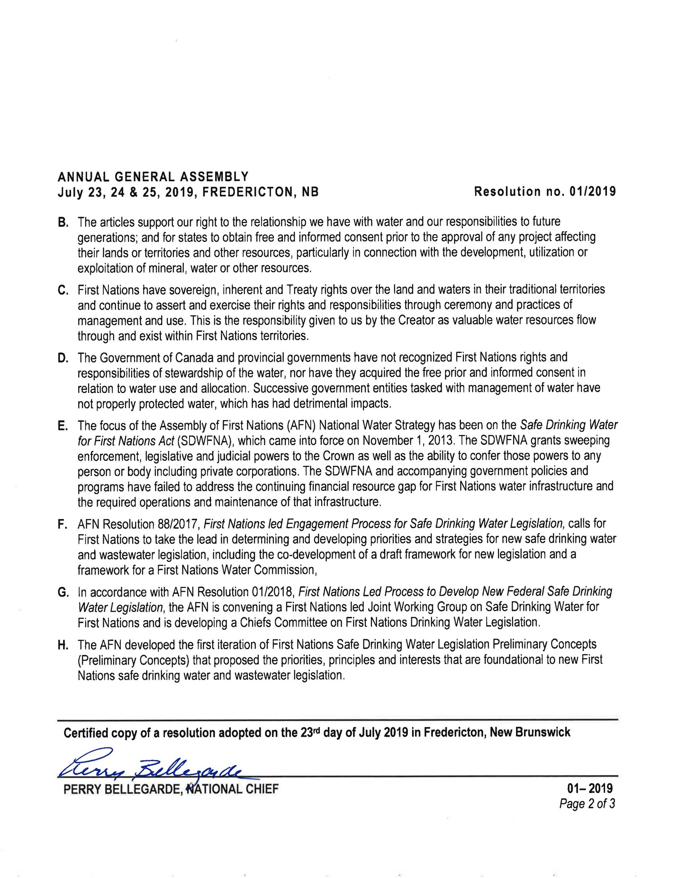
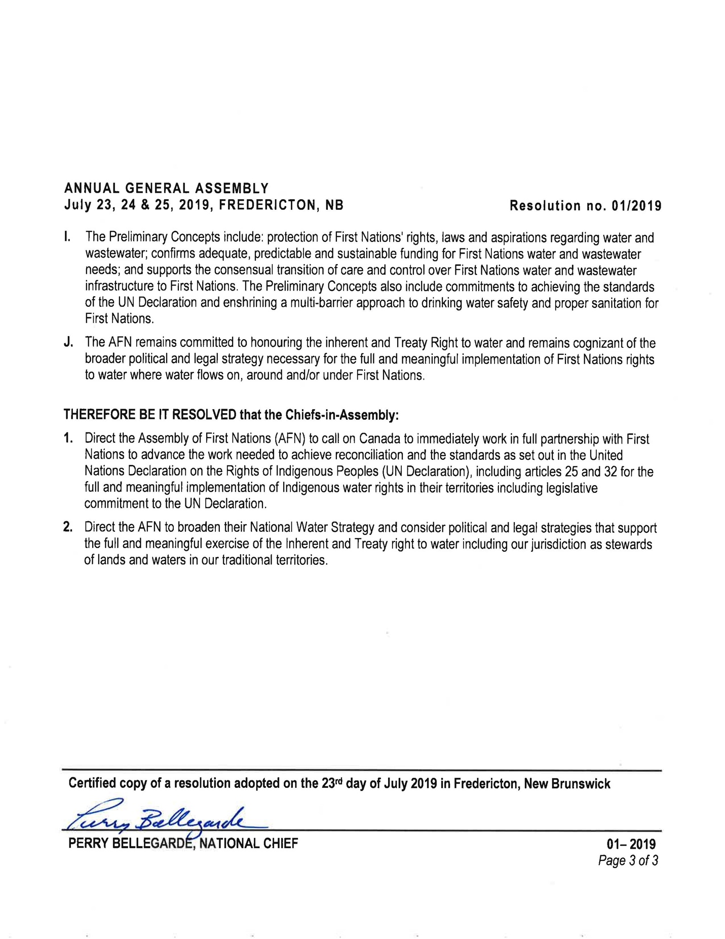

Basdeo, M.; Bharadwaj, L. (2013). Beyond physical: Social dimensions of the water crisis on Canada’s First Nations and considerations for governance. Indig. Policy J. 2013, 23, p.1
Boyd, D. R. 2011. No taps, no toilets: First Nations and the Constitutional right to water in Canada. McGill Law Journal 57: 81).
CBC, 2005, Toxic Water: the Kashechewan Story. CBC News in Review, December,m 2005
O’Connor, D. (2002) The Report of the Walkerton Inquiry: A Strategy for Safe Drinking Water; Ontario Ministry of the Attorney General: Toronto, ON, Canada, 2002.
Mosa, A., & Duffin, J. (2017). The interwoven history of mercury poisoning in Ontario and Japan. CMAJ, 189(5), E213-E215.
Wheatley, B., Paradis, S., Lassonde, M., Giguere, M. F., & Tanguay, S. (1997). Exposure patterns and long term sequelae on adults and children in two Canadian indigenous communities exposed to methylmercury. Water, Air, and Soil Pollution, 97(1-2), 63-73.
Indian and Northern Affairs Canada (INAC). Report of the Expert Panel on Safe Drinking Water for First Nations; Indian Affairs and Northern Development: Ottawa, ON, Canada, 2006; Volume 1.
Government of Canada (2021) Ending Long-Term Drinking Water Advisories. https://www.sac-isc.gc.ca/eng/1506514143353/1533317130660

