INVITED SPEAKERS

CHAIRPERSON
Ms. VICTORIA DONDA
Victoria Dona is the President of the National Institute against Discrimination, Xenophobia and Racism, Argentina She was born between July and August 1977 in the Escuela de Mecánica de la Armada (ESMA), in the city of Buenos Aires, while her parents were kidnapped by the Argentinean civil-military dictatorship (1976-1983); they are still disappeared today. She is a lawyer from the University of Buenos Aires, human rights activist and Argentinean politician. Between 2007 and 2019 she was a National Deputy and legislated especially on human rights, gender, youth, education and environmental issues. In 2010 she was president of the Commission on Human Rights and Guarantees of the National Chamber of Deputies. Currently, as of 10 December 2019, she chairs the National Institute against Discrimination, Xenophobia and Racism (INADI). And since November 4, 2020, She has chaired the IberoAmerican Network of Organisms and Organisations against Discrimination (RIOOD).

KEYNOTE SPEAKERS

H.E. MS. NAZHAT SHAMEEM KHAN

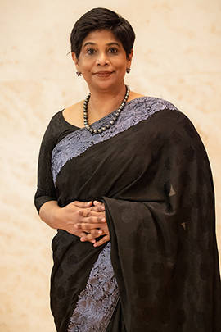
Ambassador Nazhat Shameem Khan was appointed to Fiji’s Permanent Mission to the United Nations and other International Organisations in Geneva, when it first opened in April 2014. Ms. Khan was appointed Fiji’s Director of Public Prosecutions in 1994, the first woman in Fiji to hold that post. In 1999, she was appointed Fiji`s first woman High Court judge, a position she held until 2009. While holding judicial office, she delivered a number of human rights decisions. As a private practitioner from 2009 to 2014, she conducted legal and corporate training for lawyers, judges, and the business community on human rights, corporate and good governance, and law and procedure. Since her appointment as Permanent Representative, Ms. Khan has supported the work of the Trust Fund for small island developing States (SIDS) and Least Developed Countries (LDCs) in working toward universal representation of all countries in the Human Rights Council.

Mr. FERNAND DE VARENNES

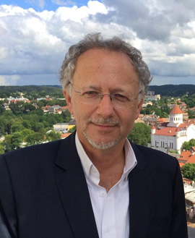

Fernand de Varennes is Extraordinary Professor at the Faculty of Law of the University of Pretoria (South Africa), Adjunct Professor at the National University of Ireland-Galway (Ireland), and Cheng Yu Tung Visiting Professor at the Faculty of Law of the University of Hong Kong (China).
Fernand de Varennes’ work and commitment focusses on the human rights of minorities, as well as the prevention of ethnic conflicts, the rights of migrants, the relationship between ethnicity, human rights and democracies, and the use of federalism and other forms of autonomy arrangements to balance competing cultural interests. His contributions on these topics in many parts of the world, including as a professor for almost 20 years at Murdoch University in Australia, and as a guest professor at the following institutions in Africa, Asia and Europe: Åbo Academy, Dato Bunka University, Ethiopian Civil Service University, Gakushuin University, Peking University, Seikei University, Universitas Pelita Harapan, Universitas Sam Ratulangi, Université de la Réunion, University of Hong Kong, University of Pretoria, and Vytautas Magnus University.
Fernand de Varennes holds degrees from the Université de Moncton (LLB, 1988), the London School of Economics and Political Science (LLM, 1992), and the Rijksuniversiteit Limburg (becoming in 1996 the University of Maastricht, Dr Juris, 1996).

Opening song in a minority language
Ms. NORA GHARYÉNI

Nora Gharyéni is a singer-songwriter and guitarist in Tunisian and Tamazight language. She sang and played the guitar sharing her passion among friends, in high school, at university, as part of cultural associations activities and in various national and international events (Morocco, Algeria, France). She has always been passionate about the indigenous culture of North Africa and has chosen to sing in its native language: Tamazight. She discovered a real sense of belonging after meeting people from all over North Africa who share the same history as her.
Currently, she works with North African artists to further develop music and create an interaction between the dialects and artistic specify of each region. Also, she seeks to work with artists from all over the world to exchange experiences and compose songs that show the beauty of linguistic diversity and the richness of several musical styles. Her main goal is to highlight the similarities, as well as the differences, in cultures and therefore contribute to the promotion of Amazigh art and its advancement at the international level.
Besides music, she holds a bachelor's degree in Psychology and is currently pursuing a master's degree in Occupational Psychology and Ergonomics at the Higher Institute of Human Sciences of Tunis. She is also a civil society activist and an editor/translator of a site scientific web.

High-Level segment

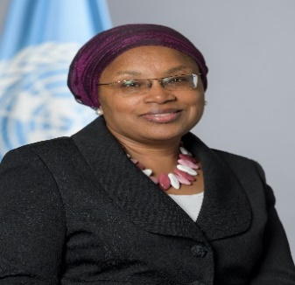

Ms. ALICE NDERITU
Alice Wairimu Nderitu of Kenya is the Special Adviser on the Prevention of Genocide. Ms. Nderitu is a recognized voice in the field of peacebuilding and violence prevention, having led as mediator and senior adviser in reconciliation processes among communities in Kenya, as well as in other African settings. She served as Commissioner of the National Cohesion and Integration Commission in Kenya, as well as Founding Member and co-Chair of the Uwiano Platform for Peace, a prevention agency linking early warning to early response. She is also the founder of Community Voices for Peace and Pluralism, a network of African women professionals preventing, transforming and solving violent, ethnic, racial and religious conflicts worldwide.
Ms. Nderitu’s national experience includes her tenure as Director of the Education for Social Justice programme at Fahamu, and as Head of the Human Rights Education and Capacity-Building Programme for the Kenya National Commission on Human Rights and its predecessor, the Standing Committee on Human Rights. Previously, she was Researcher and Administrator of the Kenya Prisons Service within the Ministry of Home Affairs. She is a member of the Kenya National Committee on the Prevention and Punishment of the Crime of Genocide, War Crimes, Crimes Against Humanity and All Forms of Discrimination, as well as the African Union Network of African Women in Conflict Prevention and Mediation (Fem-Wise), and the Women Waging Peace Network.

H.E. NASSIMA BAGHLI
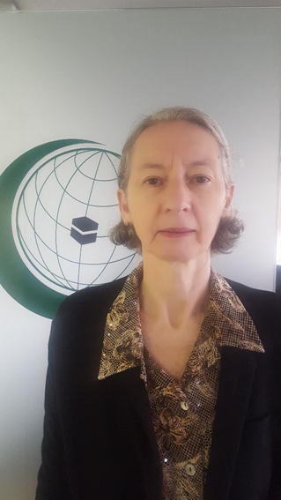
Ambassador Nassima Baghli is a senior Algerian diplomat. During her career at the Ministry of Foreign affairs of Algeria she successively dealt with Communication, African affairs, Multilateral issues notably disarmament.

ln 2009, she was appointed Ambassador of Algeria to the Kingdom of The Netherlands. Since 2017, she is the Permanent Observer of the Organization of Islamic Cooperation (OIC) to the United Nations Office in Geneva.
In this capacity, she participates in many forums where she presents the contribution of the OIC to the international efforts aimed at addressing the many challenges the world is facing notably in the field of peace and security, socio-economic development, the fight against discriminations and hate speech, the importance of dialogue among civilizations and cultures, as well as other issues of interest for the OIC.
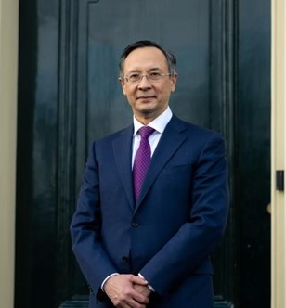
H.E. KAIRAT ABDRAKHMANOV
Ambassador Kairat Abdrakhmanov of Kazakhstan took up the mandate of OSCE High Commissioner on National Minorities on 4 December 2020. Before taking up the position of High Commissioner, Abdrakhmanov was Ambassador of Kazakhstan to Sweden and Denmark.

Amb. Abdrakhmanov joined the Kazakhstan Ministry of Foreign Affairs in 1993 and held a number of key positions. He was Foreign Minister from 2016 to 2018, and twice held the position of Deputy Foreign Minister. From 2013 to 2016, he was Kazakhstan’s Permanent Representative to the UN, when he led Kazakhstan’s bid to become the first Central Asian State elected as a non-permanent member of the UN Security Council. He then represented his country as the Foreign Minister on the UN Security Council between 2017 and 2018.

Amb. Abdrakhmanov served as Kazakhstan’s Permanent Representative to the OSCE from 2007 to 2013 and Chaired the OSCE Permanent Council in 2010 when Kazakhstan became the first post-Soviet country to hold the Chairmanship. He was instrumental in organizing the first OSCE Summit in 11 years in December 2010, during which the Astana Commemorative Declaration: Towards a Security Community was adopted.

He also served as the Ambassador of Kazakhstan to Austria from 2007 to 2008 and 2011 to 2013; and to the State of Israel from 2003 to 2006. He was Deputy Chief of Mission at the Embassy of Kazakhstan to the United Kingdom from 2001 to 2003.

ITEM 2: Root causes of contemporary conflicts involving minorities

Mr. JOHN PACKER
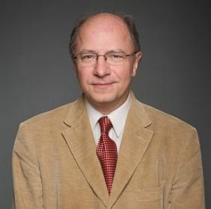

John Packer is Neuberger-Jesin Professor of International Conflict Resolution in the Faculty of Law and Director of the Human Rights Research and Education Centre at the University of Ottawa. He previously taught at the Fletcher School (Tufts University, USA) and the University of Essex (UK), held Fellowships at Cambridge and Harvard Universities, and has lectured at academic and professional institutions around the world. Over his 30-year career, he was an inter-governmental official for 20 years (UNHCR, ILO, OHCHR, UNDPA, OSCE) and has advised numerous governments, communities and other actors in over fifty countries. As a UN staff member in the early 1990s, he investigated serious violations of human rights in Iraq, Afghanistan and Burma/Myanmar. From 1995 to 2004, he was Senior Legal Adviser then the first Director of the Office of the High Commissioner on National Minorities of the Organisation for Security and Cooperation in Europe (OSCE). In 2012-2014, he was the Constitutions and Process Design Expert on the UN’s Standby Team of Mediation Experts and continues to advise UNDPPA in a number of situations. The focus of his research and practice is at the inter-section of human rights (including minority rights) and security, notably conflict prevention and quiet diplomacy, international mediation, transitional arrangements, and institutional developments at domestic and multilateral levels.

Ms. RITA MANCHANDA

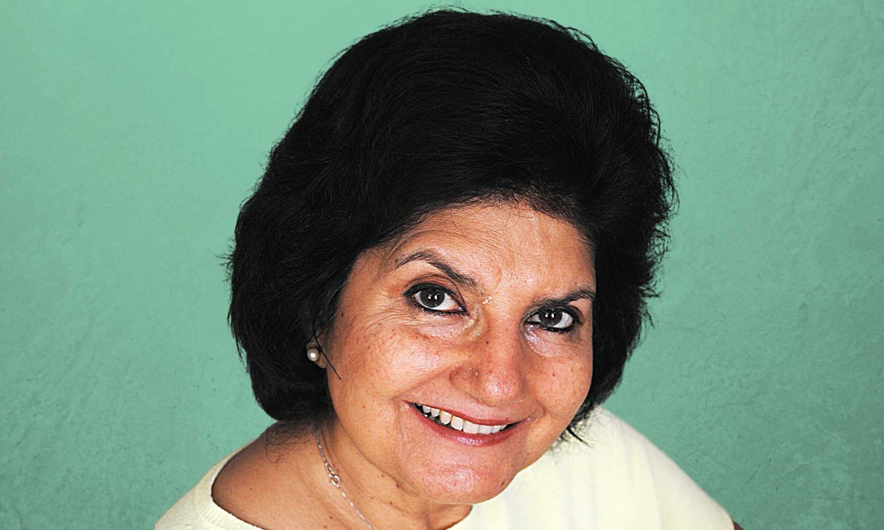

Rita Manchanda is a scholar, and human rights and peace advocate working in South Asia with particular attention to defending the rights of vulnerable and marginalised groups: women, religious and ethnic minorities and forcibly displaced persons. Attention to the multifaceted deficits of power is reflected in Sage Series in Human Rights Audits of Peace Processes which I edited and co-authored; and publications such as ‘No Nonsense Guide to Minority Rights in South Asia’, ‘Sates in Conflict with their Minorities’, ‘Media & Mediated Public Discourse on “Terrorism” and “Defending Religious Freedoms in India” (forthcoming).

Ms. CONCHÚR Ó MUADAIGH
Conchúr Ó Muadaigh is an Irish speaker living in Belfast, Ireland who studied Childhood Studies and Criminology at Ulster and Queen's University. He is involved in the Irish language revival movement and works full time as the Advocacy Manager for Conradh na Gaeilge based in their offices in Belfast. The organisation works on behalf of the Irish language across the island. Conradh na Gaeilge have been appointed by Foras na Gaeilge, the all island body responsible for the promotion of the Irish language, as one of the six lead organisations funded to develop the Irish language across the island.

Primarily, the role of Conradh na Gaeilge is to protect the language, to act as its representatives and to raise awareness of the language. Conchúr is also the Chairperson of the Irish language community and youth organisation Glór na Móna, board member for human rights NGO 'Participation and Practice of Rights and a member of An Dream Dearg, the Irish language rights grassroots campaigning network which has spearheaded the campaign for language rights in the north.

ITEM 3: Legal and institutional framework: the human rights of minorities and conflict prevention

Mr. MOHAMMAD SHAHABUDDIN
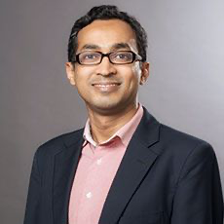

Mohammad Shahabuddin is Professor of International Law & Human Rights at Birmingham Law School, University of Birmingham. He specialises in history and theory of international law and human rights, and also in ethnicity and nationalism, self-determination, minority rights, and ethnic conflicts from international law perspectives. His research is informed by critical, postcolonial, and TWAIL (Third World Approaches to International Law) scholarship. He is the author of Ethnicity and International Law: Histories, Politics and Practices (Cambridge University Press, 2016) and Minorities and the Making of Postcolonial States in International Law (Cambridge University Press, 2021). He is a recipient of the prestigious Leverhulme Trust Research Fellowship (2018-2020).

Ms. AMINA AMHARECH
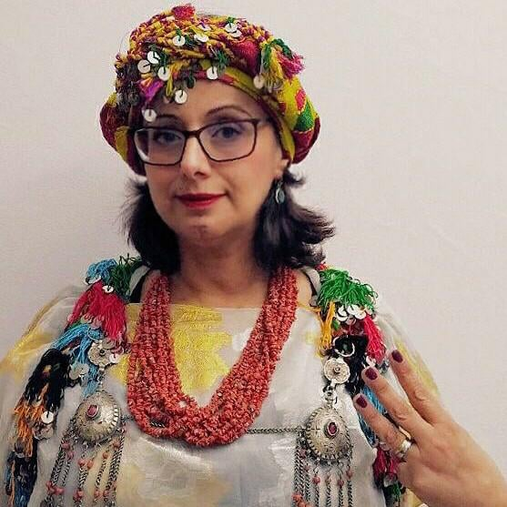
Amina Amharech, indigenous Amazigh woman from Morocco. President of the association Acal El Hajeb, founding member of the Amazigh community network AZUL in 2013. Member of the Global Council of the International Land Coalition (ILC) for the EMENA region since 2018. Founding member of the Feminist Land Platform ( FLP ) 2019. Recipient of the OHCHR Indigenous Fellowship Programme, 2018. Teacher trainer of French and communication for 27 years. Currently studying Law at the University of Tangier
Poetess, painter Advocate for the rights of the Amazigh people under the terms of the United Nations Declaration on the Rights of Indigenous Peoples.

Mr. ARNO KOMPASTCHER
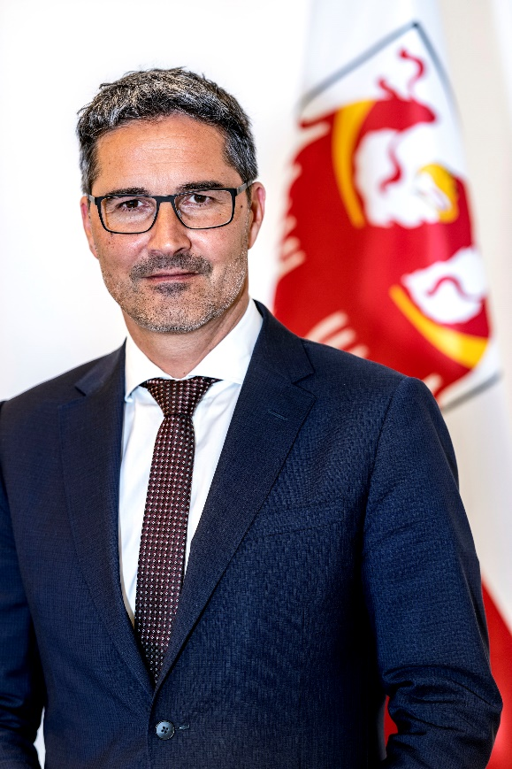
Arno Kompatscher is the governor of the Bolzano-South Tyrol province, Italy and was reappointed to the Parliament of the Autonomous Province of Bolzano/Bozen in 2018. He has served as the president of the European Region Tyrol-South Tyrol-Trentino and the president of the Autonomous Region of Trentino – Alto Adige/South Tyrol, Italy. From 2011 to 2013, Kompatscher served as a President of the South Tyrolean Municipalities Association and as a mayor of the municipality of Völs am Schlern/Fiè allo Sciliar from 2005 to2013.
He has also worked as President and Director of the Administrative Board of the Company Seis - Seiser Alm Umlaufbahn AG.

ITEM 4: Focusing on the rights of minorities and effective early prevention of conflicts
Ms. AYA MANAA
Aya Manaa, is a 35 years old Palestinian activist and human rights defender; for her community; the Palestinian minority in Israel. Aya holds M.A in Human rights and conflict management from Scuola Superiore Sant'Anna, Pisa, Italy.(2011)
Aya has gained significant experience as a human rights advocate through Civil Society Organizations. To this end, she has been involved for over 10 years in the promotion and protection of human rights in Israel and the occupied Palestinian territories, where she has worked for several human rights organizations.
She is the manager of the community center in her village for the last three years, where she has made a significant change both in the quality and quantity of projects for the community. Women and youth are her main target groups besides people with disabilities.
Mr. KWADWO APPIAGYEI ATUA
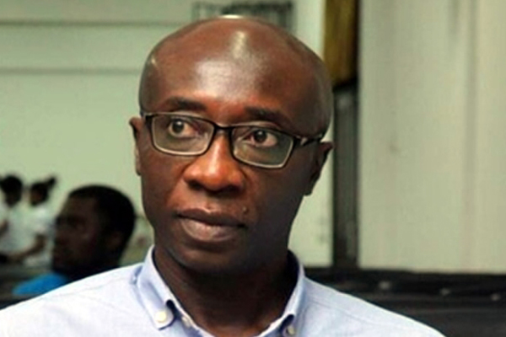
Prof. Appiagyei-Atua is Associate Professor at the School of Law, University of Ghana, where he teaches Public International Law, International Human Rights Law and Law of Diplomacy. He was a Marie Curie International Incoming Fellow at the Centre for Educational Research and Development, Lincoln University, UK and a Global Ethics Fellow of the Carnegie Council for Ethics in International Affairs, New York, USA. Kwadwo is a member of the Ghana Bar.
He completed his LLB at University of Ghana, Legon; LLM at Dalhousie University and DCL at McGill University, all in Canada. Kwadwo has been a consultant for different inter-governmental and non-governmental organisations in the broad areas of public international law and international human rights law.

Ms. MARIA EUGENIA CARBONE
Eugenia Carbone joined the Auschwitz Institute in 2013. A lawyer, Ms. Carbone specialized in International Public Law at the Universidad de Buenos Aires and also completed a Master’s in Human Rights at the Universidad de La Plata. She was the Coordinator of International Affairs at the Human Rights Secretariat of the Ministry of Justice in Argentina. Previously, she worked in the Ministry of Foreign Affairs/White Helmet Commission, collaborating on the design and implementation of international humanitarian assistance projects.
She is an instructor for the Raphael Lemkin Seminar for the Prevention of Genocide as well as various other national and regional-level seminars organized by the Auschwitz Institute. Ms. Carbone also teaches as a Professor of International Relations at the Universidad Nacional de La Matanza. Additionally, since joining AIPG, she has served as the Technical Secretary of the Latin American Network for Genocide and Mass Atrocity Prevention.

ITEM 5: Towards a lasting peace: positive initiatives to better protect the rights of minorities to prevent conflicts
Ms. FARAH MIHLAR
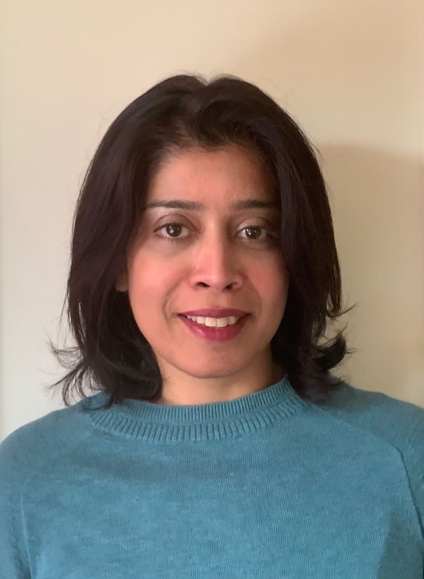
Farah Mihlar grew up in Sri Lanka during the height of the country’s armed conflict. On becoming a journalist, and reporting from the war-torn areas of Sri Lanka and she realised the full imact of armed conflict on civilians. She has always been drawn to and affected by the vast and intense suffering caused by war, especially on how it affects women, and I am passionate about justice.
Farah started her career as a journalist in Sri Lanka and worked for a number of national and international media organisations, such as Reuters, the BBC World Service, The Times of India and in Sri Lanka; the Sunday Times, Daily Mirror, ETV and Capital Radio.She moved to England to do a MSc in Social Policy at the London School of Economics (LSE) and subsequently went on to do her PhD in the Study of Religion at the School of Oriental and African Studies.
Amidst her academic work she built a career in conflict prevention and international human rights. She has worked for a number of international organisations, including the UN, International Crisis Group and Minority Rights Group International. Her work involved research and publications; human rights training; project management and conducting international advocacy with the UN Human Rights Council.

Ms. IlZE BRANDS KEHRIS
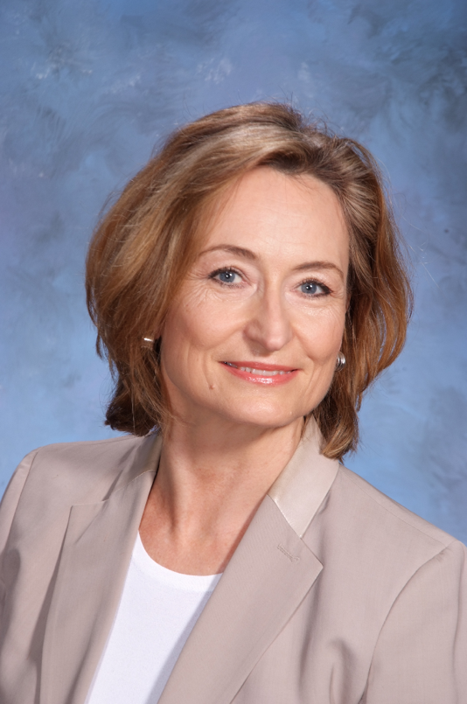

Ilze Brands Kehris assumed her functions as Assistant Secretary-General for Human Rights on 14 January 2020, heading the UN Human Rights Office in New York. Ms. Brands Kehris combines extensive expertise in political science, conflict prevention and human rights, with a specialisation in minority rights, and long-standing experience in intergovernmental fora and with civil society organisations.
From 2017 to 2019, Ms. Brands Kehris served as independent Expert Member of the United Nations Human Rights Committee, the treaty body monitoring the implementation of the International Covenant on Civil and Political Rights. Between 2016 and 2019, she served as a senior research fellow at the Raoul Wallenberg Institute for Human Rights and Humanitarian Law, Lund University, in Sweden.
She has previously held several leadership positions in national and regional level human rights organisations, including as Member and Chairperson of the Management Board of the European Union Fundamental Rights Agency. Ms. Brands Kehris also held the positions as Director of the Office of the OSCE High Commissioner on National Minorities, first Vice-President and Member of the Advisory Committee on the Council of Europe Framework Convention for the Protection of National Minorities, and Member of the Management Board and Vice-Chairperson of the Executive Board of the European Union Monitoring Centre on Racism and Xenophobia. She also served as Director of the Latvian Centre for Human Rights.

Ms. MIREILLE KAMITATU

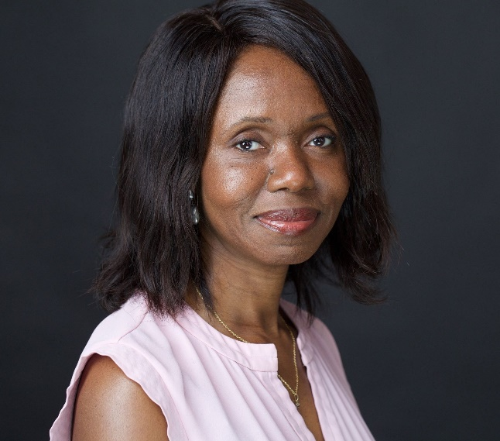

Mireille Kamitatu is the Peace and Development Advisor in the UN Resident Coordinator’s Office (RCO) in Cameroon. In this capacity, she advises the RC and the UN country team on peacebuilding and human rights efforts, including issues of minority rights. Before joining the RCO, She worked with the UN and international NGOs on political analysis, policy, and programme development in Central Africa, Mali, Kosovo, Albania, Haiti, and Headquarters. Under these capacities, she particularly focused on minority rights such as Roma in Albania or Batwa in Burundi. A DRC Native, Ms. Kamitatu holds a master’s degree in African Studies from University Paris-Panthéon (Paris-1).

