Private Bag X931, Pretoria, 0001, 36 Hamilton Street, Arcadia, Pretoria
Tel.: 012 359 0071/2, Fax: 012 323 5954

DWYPD COMMENTS:
ACCESS TO DECENT WORK AND EMPLOYMENT OPPORTUNITIES FOR PERSONS WITH DISABILITIES, DECEMBER 2021

Access to Decent Work and Employment Opportunities
The White Paper on the Rights of Persons with Disabilities (WPRPD) policy directives promote equal employment and access to economic opportunities for persons with disabilities in private and public sector. These measures afforded employees with disabilities who were at risk of contracting the virus due to their disability, comorbidities and health conditions to apply for working at home during the lockdown period.
The DoLE also released the Annual Employment Equity report with disability employment statistics for both private and public sector through the Commission for Employment Equity (CEE). The disability employment statistics for the year under review are as follows:
Workforce Profile, Workforce Movement and Skills Development at the Top Management Level by population group, gender and disability
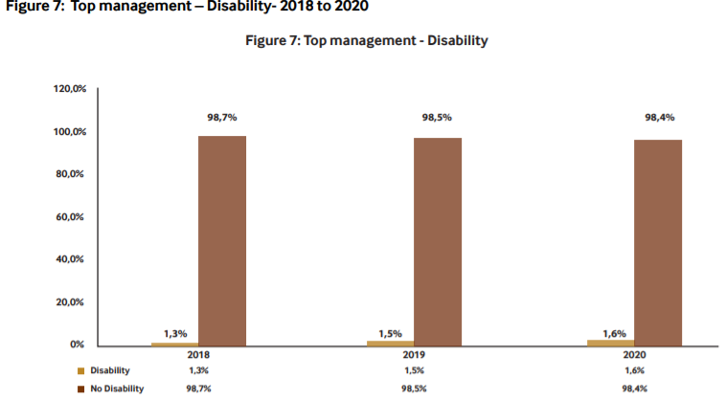
Figure 7 shows a steady increase in the representation of persons with disabilities at this occupational level from 1.3% in 2018 to 1.6% in 2020. (Source 21st CEE 2020/21)
Workforce Profile, Workforce Movement and Skills Development at the Senior Management Level by population group, gender and disability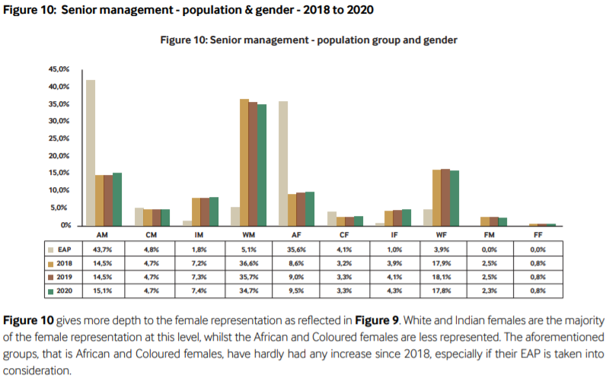
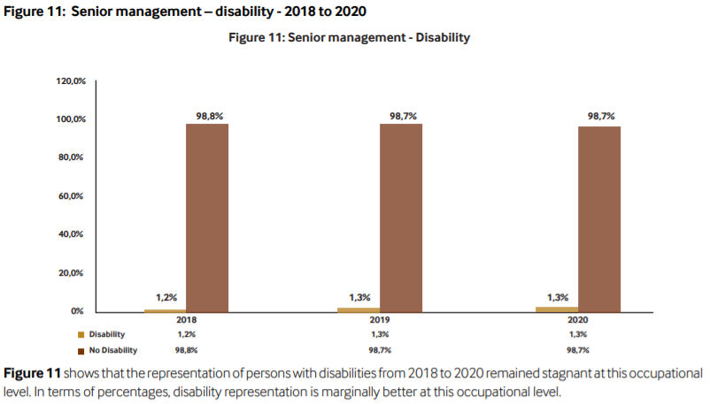
(Source 21st CEE 2020/21)

Workforce Profile, Workforce Movement and Skills Development at the Professionally Qualified Level by population group, gender and disability
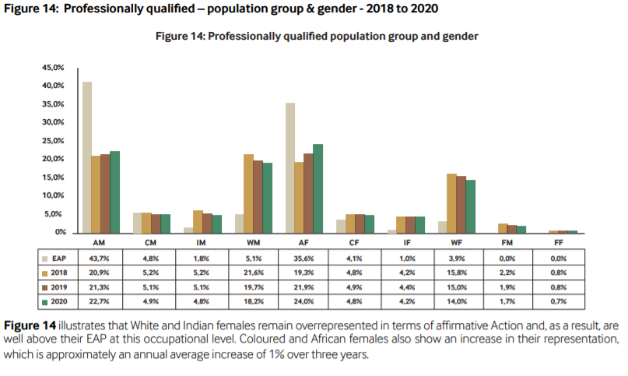
(Source 21st CEE 2020/21)
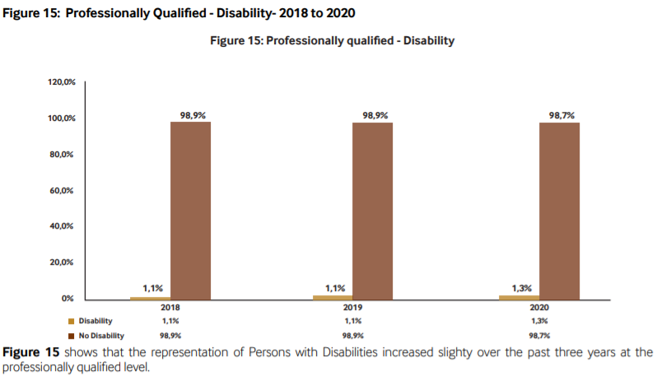
(Source 21st CEE 2020/21)

Workforce Profile, Workforce Movement and Skills Development at the Skilled Level by population group, gender and disability
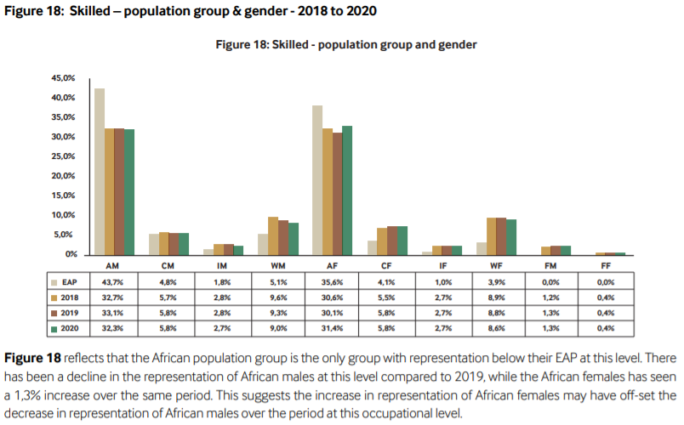
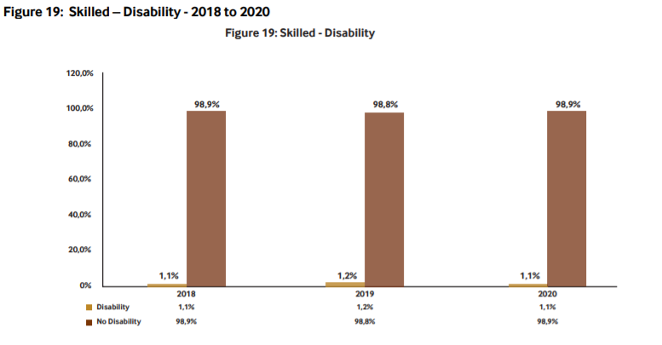
Figure 19 shows that the representation of persons with disabilities remained slightly above 1% over the past three years at this occupational level (Source 21st CEE 2020/21).
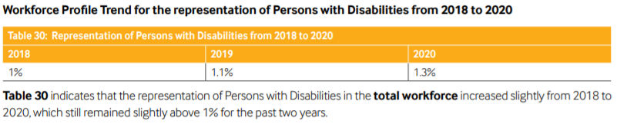
(Source 21st CEE 2020/21)
The DoLE has also finalised the review of the Technical Assistance Guidelines on the Employment of Persons with Disabilities (Disability TAGs) to streamline the implementation of EEA with regards to persons with disabilities in the year 2020.
The public sector, as a major employer and as custodian of policies promoting the empowerment of persons with disabilities, is under particular obligation to ensure that employment of persons with disabilities is achieved. The main focus is the 2% representation of persons with disabilities across all levels and the 50% representation of women at SMS. Departments that have achieved both the 50% and 2% targets are highlighted in order for other departments that are struggling to meet the targets to be able to contact them and share best practices.
All national and provincial government departments are mandated to report annually to DPSA on progress made with implementation of the JobAccess Strategic Framework for the Recruitment, Appointment, and Retention of persons with disabilities. During the compilation of this annual compliance report, employment equity report for 2020/2021 financial year for public service was still under draft format hence the 2019/2020 employment equity report was considered for this purpose. The status for employment representation of persons with disabilities in the public service as from March 2020 was as follows:
Representation of persons with disabilities by gender and disability status.
As at 31 March 2020 there were 1 215 057 employees in the Public Service of which 12 560 (1.03%) were employees with disabilities. Women were 6 607 (52.60%) and men were 5 953 (47.40%). The representation of persons with disabilities increased by 398 between March 2019 and March 2020. An additional 11 741 employees with disabilities need to be employed in order for the entire Public Service to achieve the 2% representation target.
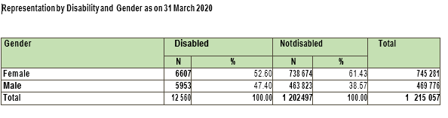
Representation of persons with disabilities by age.
The table below shows the representation of persons with disabilities by age. The number of youth with disabilities in the Public Service is continuing to decrease, from 1 290 to 1 197 between March 2019 and March 2020. Most of the employees with disabilities are between the ages 35 to 59 amounting to 10 629 which represent 84.62%. Effective strategies need to be employed in order to recruit more youth with disabilities in the Public Service.
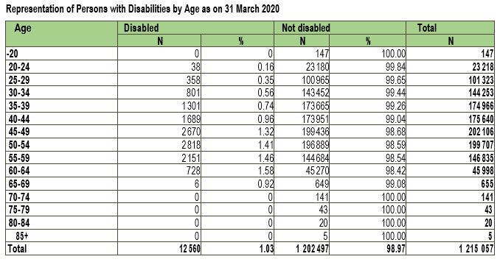
Representation of persons with disabilities by salary levels.
This paragraph depicts the representation of persons with disabilities according salary levels. The largest number of persons with disabilities are still employed between salary levels 05 and 08 with a total number of 8 091 which translates to 64.41%. There are 1 759 (14%) employees with disabilities between levels 09 and 10, 605 (4.81%) between levels 11 and 12 and 153 (1.22%) between levels 13 and 15. There is still no representation of persons with disabilities in level 16.
Compliance with meeting the 2% equity target for public servants with disabilities

Between the end March 2019 and the end March 2020 the number of departments that surpassed the 2% representation of persons with disabilities increased from 52 to 55. National departments maintained their number at 15, Gauteng province had a significant increase from 07 to 10 departments, the North West increased from 07 to 08 departments and the Northern Cape increased from 02 to 03 departments. KwaZulu Natal decreased from 03 to 02 departments and the Western Cape decreased from 06 to 05 departments.

The other provinces maintained their numbers, namely, the Eastern Cape 03, the Free State 01, Limpopo 03 and Mpumalanga 05, respectively.
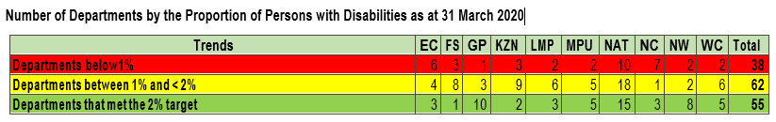

Departments that achieved 2% representation of persons with disabilities
Provincial departments had an increase of three departments which achieved the 2% representation of persons with disabilities from thirty seven to forty, whilst national departments maintained their number at fifteen during this reporting period. Fifteen National Departments that have achieved or surpassed the 2% representation of persons with disabilities are; Department of Arts and Culture, Department of Economic Development, Department of Environmental Affairs, Government Communication and Information System, Department of Labour, National School of Government, Department of Public Service and Administration, Department of Science and Technology, Department of Small Business Development, The Presidency, Department of Trade and Industry, Department of Tourism, Department of Traditional Affairs, Independent Police Investigative Directorate and Department of Women now known as Department of Women, Youth and Persons with Disabilities.

Gauteng is still the province with highest number of departments that have achieved the 2% representation of persons with disabilities with 10, followed by North West province with 08 departments, Mpumalanga and the Western Cape provinces with 05 departments each, the Northern Cape, Limpopo and the Eastern Cape provinces with 03 departments each and KwaZulu Natal province with 02 departments. The Free State is still the only province with one department that has met the 2% target.
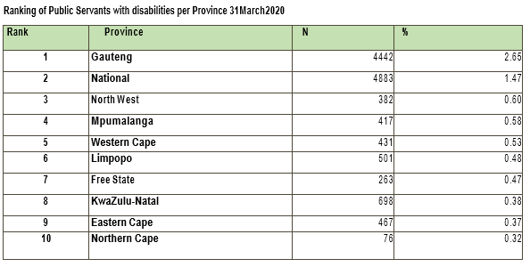
The above rankings depicts the representation of persons with disabilities per province. Gauteng is the only province that have exceeded the 2% representation of persons with disabilities and the province with the highest number of persons with disabilities (4 442) representing 2.65% of the workforce in that province. National departments have 4 883 (1.47%) employees with disabilities which is an increase of 171 employees as compared to the previous financial year at second position.

The North West province maintained their third position with 382 (0.60%) and Mpumalanga at fourth position with 417 (0.58%), followed by Western Cape 431 (0.53%), Limpopo 501 (0.48%), Free State 263 (0.47%) and KwaZulu Natal improved to the eighth position with 698 (0.38%), whilst the Eastern Cape succumbed to the ninth position with 467 (0.37%). The Northern Cape remained at the bottom of the ranking for the fifth consecutive year 76 (0.32%). The Eastern Cape Province experienced the highest decline of the representative of persons with disabilities by 24 from 491 to 467, followed by Western Cape by 12 from 443 to 431, Northern Cape by 05 from 81 to 76 and lastly Mpumalanga by 01 from 418 to 417.
The DPSA has issued specific regulations, guidelines and directions to designated employers on measures to combat the spread of the Covid-19 virus at employment environments in order to ensure protection and safety of employees including persons with disabilities.
Subsequent to the President of the Republic of South Africa declaring the national lockdown with effect from 27 March 2020 due to the prevalence of the COVID-19 pandemic, the Department of Public Service and Administration issued a number of circulars to give guidance and ensure continuity of service delivery.

Circular 15 issued 25/03/2020
The circular gave directions in respect of service delivery and business continuity for the Public Service during COVID-19. The objectives of circular 15 is:
- 1.3 To provide for arrangements of remote work for employees following the outbreak of the coronavirus (COVID-19) in South Africa for which the President of the Republic of South Africa has declared a national state of disaster;
- To provide for arrangements of remote working for the duration of the declared national state of disaster declared by Government Notice R 313 of 15 March 2020. The remote work arrangements should be based on a management philosophy of trust and mutual benefit;
- 6.4 A head of department must implement plans for business and service delivery continuity.

Circular 07 of 2020
It gave guidelines for the containment of the coronavirus (COVID-19) in the Public Service.
- Regulation 5.3 provides that HoD shall establish and maintain a safe and healthy working environment for employees of the department. It must also be linked to:
- Occupational Health and Safety Act;
- Risk assessment;
- Health and safety provisions;
- Steering committees including organised labour; and
- Guidelines, action plans and protocols.

Circular 18 issued 01/05/2020
Gave guidance to Public Service return to work guidelines after the easing of the national lockdown. The objectives of Circular 18 are to:
- Preparation of the workplace in response to the easing of the lockdown;
- Staggered return to work;
- Remote work arrangements; and
- Employees return to work.
All departments are required to report annually to the Department of Public Service and Administration (DPSA) on progress made with implementation of the JobACCESS Strategic Framework for the Recruitment, Appointment and Retention of Persons with Disabilities Implementation Plan.

