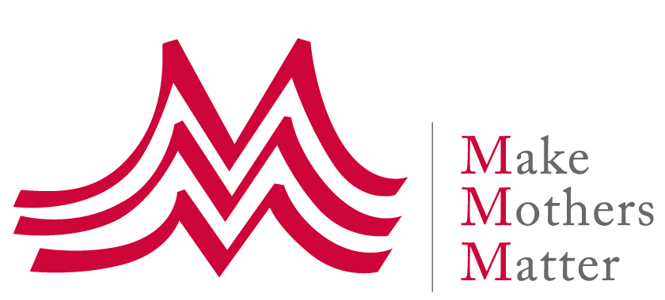
HRC Intersessional Session
The right to social security in the changing world of work
Panel 4: The right to social security at the heart of the new social contract
Oral Statement

We at Make Mothers Matter would like to stress the critical importance, relevance, and legitimacy of the Right to Social Security for unpaid caregivers, especially mothers.

The Covid crisis has exposed how the inequitable distribution of care responsibilities is a source of economic injustice for women, and the challenges that most mothers and other unpaid caregivers face in trying to juggle care with paid work.

Investing in Care and supporting women, parents and other caregivers doing the essential yet unpaid and mostly invisible work must at the heart of a new social contract.

As part of such a new social contract, unpaid care work must be recognized as work, essential work, which sustains the economy and benefits society as a whole. It must therefore be recognized as being our collective responsibility.

This means that every unpaid caregiver should have access to social security just like any other worker. In particular, every mother should have access to income security, healthcare, pension rights and full maternity protection.

Social protection must also be considered as an investment, not as an expense that should be minimized. Supporting caregivers, parents especially, through adequate public services AND social protection is investing in people and families. Ultimately it is also about investing in children it brings high returns, especially for vulnerable families.

To summarize, the pandemic provides a unique opportunity for systemic changes and a new social contract, and this begins by changing narratives:
- Unpaid family care work IS work, essential work
- Supporting this unpaid care work through social protection is both our collective responsibility and an investment
- The right to social security must therefore be part of a new social contract – where care and education are central

