[Check against delivery]

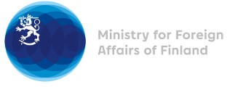

Human Rights Council intersessional full-day panel discussion on the right to social security in the changing world of work

(Human Rights Council resolution 42/13)

1 November 2021

Chairperson/Honorable Moderator,

Let me thank the panelists for their valuable interventions and for this opportunity to share experiences. Finland is committed to the realization of the right to social security. It is indispensable for ensuring a life in dignity. Our Constitution guarantees everyone social security benefits in the event of unemployment, illness, disability, during old age and at the birth of a child or the loss of a provider.

The Finnish social security system is tailored bearing in mind that different individuals face different situations in life.

Everyone with resident status in Finland is entitled to basic social security coverage if his or her life situation requires. This has enabled the social security system to react flexible to new forms of the world of work and to the challenges caused by the COVID-19 pandemic.

However, achieving and maintaining equality is an ongoing process and our system needs updates. The Government’s social security system reform aims for a clearer and more efficient system. One of the main objectives is to accommodate together employment and social security in changing life situations. The human rights obligations, including observations by international monitoring bodies, are thoroughly examined and taken into account in these reforms.

Thank you.

