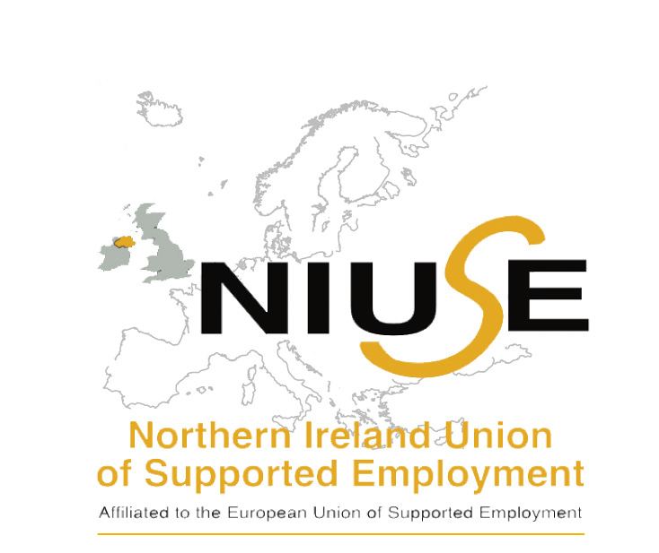
Northern Ireland Union of Supported Employment’s (NIUSE) response to Draft General Comment on the Rights of Persons with Disabilities in relation to the discussion on Article 27 to the UNCRPD.

Introduction
The Northern Ireland Union of Supported Employment is (NIUSE) is an umbrella organisation representing disability employment organisations promoting employment opportunities for disabled people and people from disadvantaged situation through the use of Supported Employment model. NIUSE is a NGO.
NIUSE represents over 15 disability employment organisations covering all areas of disability (physical, mental health, learning, sensory, hidden and neurodiversity disability). NIUSE is a member of the European Union of Supported Employment (EUSE).
Supported Employment model assist disabled people to find, stay and progress in paid employment in the open labour market by providing one to one personalised support.
The definition of Supported Employment is to “provide support to people with disabilities or other disadvantaged groups to secure and maintain paid employment in the open labour market”
Key elements of the Supported Employment model are:-
- Paid employment
- Open labour market
- Personalised and on going support
The Supported Employment model is based on the following fundamental Principle and Values:-
- Zero Rejection (Everyone can work)
- Competitive Employment
- Individualised
- Control (self-determination & empowerment)
- Wage and Benefits
- Focus on Capacity and Capabilities
- Importance of Relationships
- Power of Support
- Importance of community
The Supported Employment model is internationally recognised and aligns fully with the UNCRPD, Article 27 Right to Work and Employment.

NIUSE fully supports UNCRDP Article 27 Right to Work and Employment however recognises that disabled people are still significantly underrepresented in the open labour market, do not receive the same employment rights and conditions, have no legal protection and are not working in inclusive workplaces. For example in In 2020 the employment rate was 38% for people with disabilities in NI and 80% for those without, indicating a disability employment rate gap of 42 percentage points (Norhern Ireland Statistics and Research Agency (NISRA, 2021). The disability employment gap between Northern Ireland (42%) and the whole of the UK (28%) in 2020 remains high, and has been continually higher since 2014 (NISRA, 2021).
Furthermore, COVID-19 has had a disproportionate impact on the health and wellbeing of disabled workers and jobseekers.
NIUSE welcomes and strongly supports the rationale and recommendations in the Draft General Comment on Article 27 on the Rights of person with disabilities to work and employment. State Parties need to take action now to ensure that disabled are given the same opportunities to access paid employment in the open labour market (not segregated) as well as acknowledging that some disabled people may require personalised support to achieve this.
In response to the Draft General Comment on Article 27 NIUSE would highlight the following areas for consideration:-
- People with complex disabilities are at the most at risk of unemployment, discrimination, exploitation and segregation. State parties must ensure that people with complex disabilities should be treated on an equal basis as all disabled people and specific consideration must be given regarding legislation, policy and practice. For example in Northern Ireland people with a learning disability or mental health condition are especially likely to be disadvantaged in terms of employment rate, type of work and level of unemployment (Equality Commission for NI, 2018). One size does not fit everyone and those with complex disabilities are often left behind.
- Supported Employment model is internationally recognised and aligns fully within Article 27 and state parties should consider the model as a pathway to inclusive open employment.
- State parties should ensure that there is high quality in delivery of programmes (i.e. vocational training, internships, apprenticeships etc) for disable people. High quality programmes and services will drive increase employment outcomes. An example of quality standards model is the EUSE’s Supported Employment Quality Framework (SEQF). For further information on SEQF click here.

For further information contact:-
Northern Ireland Union of Supported Employment (NIUSE)
E: info@niuse.org.uk or edythdunlop@niuse.org.uk

