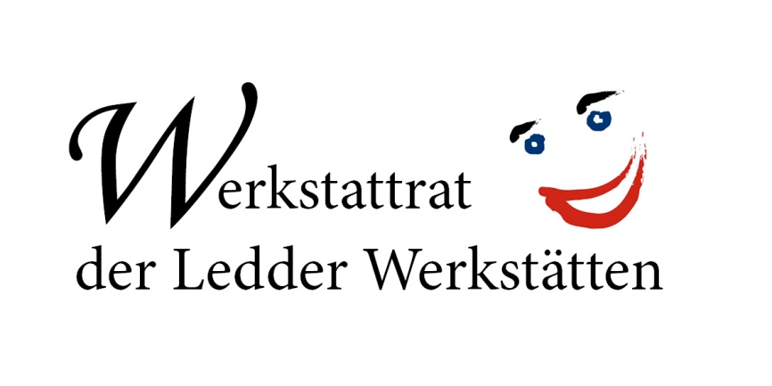

Submission of the workshop council of the Ledder Werkstätten gGmbH to the Draft General Comment on Art. 27 UNCRPD
The Committee on the Rights of Persons with Disabilities recommends in their Draft General Comment on article 27 on the right of persons with disabilities to work and employment in paragraph 97 (g) to “phase out” sheltered workshops “expeditiously”. As a workshop council, we would like to take a stand on this recommendation and present our opinion as those directly affected by this requirement.
“Nothing about us without us“

As a workshop council, which consists of workshop users and represents the interests of people with disabilities in the Ledder Werkstätten, we expressly oppose the abolition of sheltered workshops!
It is often claimed that sheltered workshops prevent the inclusion of people with disabilities. As the workshop council of the Ledder Werkstätten, we contradict this statement because we see it differently! For people with severe disabilities the sheltered workshop often is the only way to participate in work and social life – which means to be included. As workshop users, we see ourselves as part of an inclusive labour market. In the workshop we have the possibility to work in different areas based on individual skill levels. These tasks include working on orders from manufacturing companies, in workshop-owned cafes, grocery stores and in many other fields of work.
We, the workshop council of the Ledder Werkstätten, feel comfortable in the sheltered workshop and do not want to work anywhere else. Many of our colleagues see it the same way, even if there are colleagues who want to enter the general labour market. If someone wants to work on the general labour market, he or she gets support from the workshop to achieve that goal.
There are also colleagues who worked on the general job market and got mentally ill there due to great pressure and stress. They don't want to go back there.
Furthermore, the sheltered workshop is also very important for our colleagues with severe and multiple disabilities. Here in North Rhine-Westphalia, the workspace for people with severe and multiple disabilities is part of the workshop. This is the only way for these people to participate in working life.
We want that to be accepted by politics and we demand that we and our work in the sheltered workshop are respected! We don't always want to justify ourselves for working in a sheltered workshop!
We advocate that there are many different job offers and opportunities for people with disabilities that the person can choose from. So every person can participate in working life in the way that suits them best: They decide whether they can and want to work in a sheltered workshop, on the general labour market, in an inclusive company or, for example, in an outsourced workplace. In our opinion, this diversity is what characterizes an inclusive labour market. But that only works if the person has different options. With the elimination of sheltered workshops, one of these options that would be lost is the right one for many people with disabilities.
It is often presented as if the only job of sheltered workshops is to place people with disabilities in the general labour market. But that is not true! The sheltered workshops in Germany do not only have the task of promoting the transition to the general labour market. They have many other important roles to play. These are also stated in the German law (§219 SGB IX). Sheltered workshops give people with disabilities who cannot access the general labour market a suitable job. Furthermore, the sheltered workshop offers educational opportunities, for example in the field of vocational training. You can learn many new jobs in the workshop. Besides there are also offers for personal development, such as health offers, trainings for reading and writing, driver's license, etc.
The sheltered workshops have enhanced in recent years and they will develop further in the future. Today, complex and multifarious work and community-based activities are carried out there by people with disabilities.
The subject of remuneration is also raised repeatedly. Of course, we as the workshop council, also want to improve the pay situation of workshop users. But even here, the representation is often incorrect or imprecise. The subject is very complicated and not easy to understand. We support the proposal of “Werkstatträte Deutschland” (German federation of workshop councils) for “Basisgeld” (basic money).
We demand that politicians finally become more involved in this issue! Politicians have a responsibility here, because only through political changes the pay situation for people with disabilities in sheltered workshops can be improved.
And we demand that the political decision-makers ask us as workshop users for our opinion on sheltered workshops according to the motto of the UNCRPD: “Nothing about us without us”.

The workshop council of the Ledder Werkstätten

