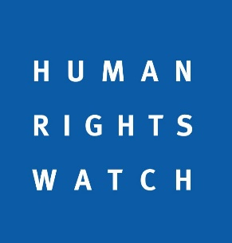

Human Rights Council full-day intersessional seminar on good practices,
key challenges and new developments relevant to access to medicines and vaccines
December 12th, 2021
Human Rights Watch Statement
We welcome this opportunity to exchange on opportunities for global cooperation and measures to improve universal access to medicines and vaccines, and assess particular challenges posed by the Covid-19 pandemic and vaccine inequity.
Achieving universal access to testing, treatments, and vaccines to prevent and respond to Covid-19 through sharing of intellectual property, technology, and knowledge is the appropriate rights-based approach to ensure all governments, especially low-and-middle-income, can fulfil their obligations and continue to progressively realize the highest standard of health. In this context, we’d like to re-iterate our support for the proposal put forward by 64 governments from low- and middle-income countries at the World Trade Organization to waive some intellectual property rules under the TRIPS agreement until everyone everywhere can get access to Covid-19 vaccines.
Intellectual property rules should not act as a barrier to governments fulfilling their human rights obligations to cooperate internationally to share the benefits of scientific research to protect the rights to life, health, and an adequate standard of living, among others. Other discretionary, voluntary and charitable models of vaccine provision can help temporarily relieve scarcity but do not provide sustainable pathways for protecting rights.
We urge a swift adoption of the TRIPS waiver by WTO member states by the end of this year. A Ministerial Conference is not necessary to reach a meaningful outcome on the TRIPS proposal. The WTO can, and must, prioritize engagement on the TRIPS Waiver proposal to enable agreement as soon as possible. We echo calls made by the UN High Commissioner and a number of UN special procedures for states to ensure universal and equitable access to vaccines, and encourage them to keep the Human Rights Council regularly informed of further steps needed to advance this goal.

