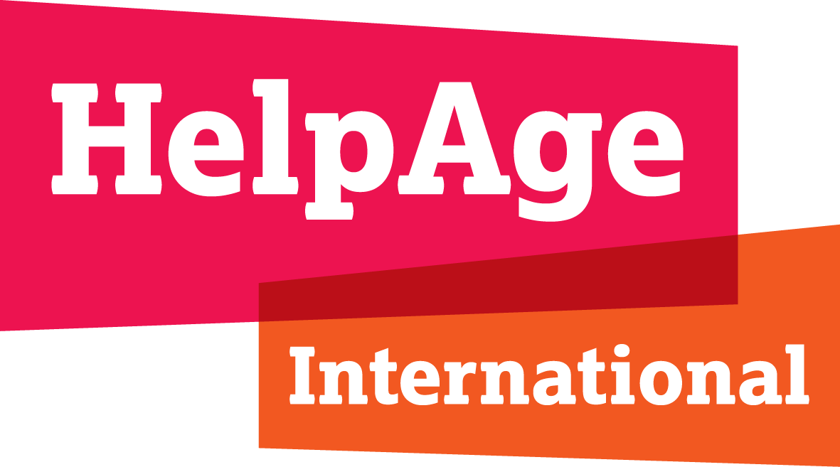

Submission by HelpAge International on the normative standards and obligations under international law in relation to the human rights of older persons

- Introduction

This submission is primarily based on the outcomes of previous consultations with older persons regarding key areas of human rights. The recommendations on the normative elements are informed by older people’s own lived experience as reported in the consultations. The normative gaps discussed below are not exhaustive.
- Ageism and age discrimination
There remains a significant normative gap at the international level when it comes to the prohibition of age discrimination and ageism. Although the right to equality and non-discrimination is one of the pillars of international human rights law, age is not explicitly listed as a prohibited discrimination ground in the core human rights treaties. It is only implied when provisions require States to respect, protect and fulfil the right to equality and prohibition of discrimination on the basis of “other status”.
This renders ageism and age discrimination invisible, unchallenged and unsanctioned. Today older persons depend on a broad and evolutive interpretation of non-discrimination clauses to enjoy their right to equality. However, case law on age discrimination remains very limited and rarely focuses on age discrimination outside the scope of employment and mandatory retirement. In those cases, States parties are granted considerable leeway in the use of age differentiations. Several regional equality provisions do include an explicit reference to age, but these are of course limited in territorial scope. The persistence of ageism and age discrimination against older persons calls for a more explicit prohibition of age discrimination at the international level and clarification of States’ obligations in this regard.
Recommendations
An international comprehensive prohibition of age discrimination should cover every aspect of life. The right should contain a range of general obligations on states to ensure both formal and substantive equality in older age, including a duty to consider the differential impact of all their decisions on older people. Positive action to tackle ageism and age discrimination should explicitly be allowed. All forms of discrimination should be prohibited, including direct, indirect, by association, by perception or imputation, harassment, multiple and intersectional discrimination. The prohibition of age discrimination should not be subject to a wider range of exceptions to the principle of equal treatment than is permitted for any other prohibited ground. Any exceptions, including age proxies, require specific justification. Both discrimination against an individual and harmful ageist social norms and practices should be prohibited and States should have an obligation to take steps to eliminate harmful ageist social norms and practices. States should also assist older people in making claims and accessing justice.
- Elder abuse and violence against older persons
There is currently no international right to protection from all forms of violence, abuse and neglect in older age that applies specifically to older persons. There is some protection against violence and abuse under UN human rights treaties, such as the right to life, the prohibition of torture and inhuman and degrading treatment, and the right to liberty and security of the person. The Committee on the Elimination of Discrimination Against Women’s General Recommendation No. 27 on older women includes violence, abuse and neglect but does not apply to older men. Similarly, the obligations under the Convention of the Rights of Persons with Disabilities (CRPD) on the prohibition of torture and prevention all forms of violence and abuse only apply to older persons with disabilities. In principle, general human rights norms could be interpreted in a way as to reflect older persons’ particular needs. However, there is no clarity about the scope of States’ obligations in this regard, in addition to a serious lack of awareness and data regarding the issue of elder abuse, its prevalence, its different forms and effects on older persons.
Recommendations
There is a need for an explicit right to freedom from violence, abuse and neglect in older age at the international level. This right should include all forms of violence, abuse and neglect against older people. It should apply to both public and private spheres, to acts perpetrated by both private and public actors. States should have an obligation to actively prevent violence, abuse and neglect in older age. The right should explicitly provide for access to a wide range of support services for survivors as well as the right to an effective remedy and access to redress mechanisms. Finally, the right should explicitly include an obligation for States to collect, disaggregate, analyse, utilise and make public at regular intervals appropriate information and statistical data on all forms of violence, abuse and neglect.
- Autonomy, independence and legal capacity
Older persons are not always able to make their own decisions due to people interfering with their autonomy and a lack of adequate support. Yet there are no explicit standards on autonomy and independence in older age in international human rights law.
The CRPD introduced respect for individual autonomy, including the freedom to make one's own choices, and independence of persons as general principles of the Convention. It also includes a specific right to legal capacity and listed several positive obligations for States in this regard, such as taking all appropriate and effective measures to ensure the equal right of persons with disabilities to own or inherit property, to control their own financial affairs and to have equal access to bank loans, mortgages and other forms of financial credit. Article 19 CRPD recognizes the right to independent living for persons with disabilities. To that end, States parties must ensure that they can choose their place of residence, and have access to a range of in-home, residential and other support services. This clarification of Member States’ positive obligations is necessary to guarantee the full enjoyment of these rights in practice.
As important as these provisions are for persons with disabilities, they also demonstrate the normative gap that exists in this regard for older persons. The rights to autonomy, independence and legal capacity in older age are not clearly articulated in international human rights law. Some regional human rights standards recognise the right to autonomy and independence in older age. However, these vary, are limited in territorial scope and are inconsistent across regions.
Recommendations
The right to autonomy and independence should apply to choice and control in all aspects of older people’s lives. This should include the right to have those decisions respected. The right should include full, effective and meaningful participation in family, social, cultural, economic, public and political life, and educational and training activities. Older people should have the right to live independently in the community on an equal basis with others. The right should provide for access to support services, including to make decisions and exercise legal capacity, and services to support independent living and inclusion in the community. Older people should have the right to designate trusted persons to support them with making decisions and the right participate in, and challenge, any decisions that interfere with the exercise of their legal capacity. Appropriate and effective safeguards should be in place to prevent abuse in the exercise of older people’s legal capacity, while respecting their will and preferences in accordance with international human rights law. Older persons should have effective access to justice and redress and States should have the obligation to ensure trusted persons, support and other service providers receive appropriate training in this area.
- Social protection and social security
Older persons face particular barriers realizing their right to social protection and social security. These include inadequate levels of entitlements; discriminatory age limits on social security and social protection measures; pension penalties for those who wish to continue working after retirement age; inadequate income and support services for persons with disabilities as they age and for those who acquire a disability in older age; disparities in life expectancy between different populations; and the exclusion of measures for care and support for independent living from social security and social protection floor schemes.
These unique barriers older persons face are not adequately covered under international human rights law. The right to social security is protected by the ICESCR and clarified with regard to specific groups, such as women, migrant workers and persons with disabilities, but not older persons. Older people without a pension or with an inadequate pension are not only denied their right to social security and social protection but also their rights to health, an adequate standard of living, participation in society, work, autonomy and independence, and education and lifelong learning.

Recommendations
The right to social protection and social security needs to be explicitly applied to the unique context of older age. All older persons should have the right to social protection and social security measures, whether in cash or in kind, to ensure adequate income security, access to healthcare, medication and assistive devices, and access to care and support services for independent living in older age.
The core normative elements of the right to social security include availability; adequacy; accessibility; and non-discrimination and equality. For older persons, accessibility entails a right to access social protection and social security schemes and measures without discrimination, as well as access to information and support with applying for them without delay. Delivery mechanisms should also be adapted to ensure their accessibility and affordability. In the context of older age, availability means social protection and social security measures should be in place that are relevant to the risks and contingencies older persons face, including in relation to care and support. Adequacy requires social security measures that are high enough in value and quality, and for a long enough duration of time for an adequate standard of living and to enable them to live dignified, autonomous, independent lives and fully participate in society.
In addition, older persons should have a right to measures that are appropriate and acceptable for their needs and preferences, and the right to mechanisms, including supported-decision-making processes, to exercise their right to autonomy and independence in relation to the use of income from social protection and social security schemes. Older persons also have a right to access accountability mechanisms and for remedies and redress in case of violation of their right to social protection and social security.
Long-term care and support and palliative care
When asked about their lived experiences, many older people say there are no long-term care and support services available in their community other than the support provided by family members. Often, they also lack access to palliative care to help them die free from pain and unnecessary suffering. Within international human rights law, however, there exists no explicit and comprehensive normative basis for the provision of long-term care and support for older persons, nor for palliative care.
Article 19 CRPD establishes the right to independent living for persons with disabilities, which applies to older persons with disabilities, and which includes provision of support services to enable such independent living. Some regional human rights standards recognise care and support for independent living in older age and the right to palliative care as well. These vary and are inconsistent across regions but can help contribute to a better understanding of the role and responsibilities of the state in this regard. Central to these standards is that care and support services should enable older people to live independent and autonomous lives. Framing older people’s right to care and support services in the context of independent living will ensure those services enable older people to lead autonomous and independent lives in any setting they choose to live.
Recommendations
There is a need for a clear articulation in international human rights law of the right to long-term care and support for older persons, as well as their right to palliative care. Older persons’ right to care and support for independent living should apply to all settings, public and private. It should provide access to a range of care and support services that are easily available and affordable and should ensure older people can enjoy their right to choose where they live and with whom on an equal basis with others. The right should be unrelated to their income or that of family members. Care and support services should be adapted to older people’s individual needs and preferences and older people’s autonomy should be guaranteed in all aspects of long-term care and support, including by ensuring access to supported decision-making.
Older people should also have the right to holistic palliative care without discrimination of any kind, that applies in all settings and is not limited to pain relief or any particular treatment. Palliative care services, including medicines, should be affordable, available and accessible for older people. Older people should have the right and opportunity to make free and informed decisions and have access to palliative care in settings that meet their needs, will and preferences, including at home and in residential facilities. Older persons’ autonomy should also be guaranteed in all aspects of palliative care, including by providing for supported decision-making processes where necessary, while making sure older people retain legal capacity. States should ensure adequate and appropriate training of health personnel in palliative care and ensure regulation of all palliative care providers and monitoring of their compliance with professional obligations and standards.
- Concluding remarks
An analysis of the international human rights framework shows a significant gap in the promotion and protection of the rights of older persons. Although the list of rights discussed here is by no means exhaustive, it demonstrates that existing rights provisions fail to clarify the scope of States’ obligations in the context of old age. Especially when comparing the normative content of existing norms of a general nature with those adopted at the regional level focusing on older persons specifically, it is clear that it would take a great deal of awareness and proactiveness of judges to interpret those general provisions in a way that effectively protects older persons’ rights and adequately takes into account their particular needs. This lack of an older persons’ perspective in international human rights law supports claims for a new global binding instrument to fill these gaps.

For further information, contact Marijke De Pauw, Global Rights Policy Adviser, HelpAge International: marijke.depauw@helpage.org

With the exception of Article 7 of the Convention on the Rights of Migrant Workers.
E.g. Articles 2(1) and 26 International Covenant on Civil and Political Rights (ICCPR); Article 2 (2) International Covenant on Economic, Social and Cultural Rights (CESCR); Article 5 Convention on the Rights of Persons with Disabilities (CRPD).
At the international level, see, for example, Human Rights Committee (Views), Rubén Santiago Hinostroza Solís v. Peru, 27 March 2006, Communication No. 1016/2001; Human Rights Committee (Views), Néstor Julio Canessa Albareda and others v. Uruguay, 24 October 2011, Communication Nos. 1637/2007, 1757/2008 and 1765/2008.
Article 21 (non-discrimination) of the EU Charter of Fundamental Rights; Article 1(1) of the Inter-American Convention on the Elimination of All Forms of Discrimination and Intolerance; Article 5 of the Inter-American Convention on Protecting the Human Rights of Older Persons; Article 3 of the Protocol on the Human Rights of Older Persons in Africa.
HelpAge International, Entitled to the same rights: What older women say about their rights to non-discrimination and equality, and to freedom from violence, abuse and neglect, London, HelpAge International, 2017.
Article 6 ICCPR.
Article 7 ICCPR and the Convention against Torture and Other Cruel, Inhuman or Degrading Treatment or Punishment.
Article 9 ICCPR. Article 10 ICCPR further requires certain standards to be met in cases of deprivation of liberty.
See Articles 15-17 CRPD. HelpAge International, Entitled to the same rights: What older women say about their rights to non-discrimination and equality, and to freedom from violence, abuse and neglect, London, HelpAge International, 2017.
HelpAge International, Entitled to the same rights: What older women say about their rights to non-discrimination and equality, and to freedom from violence, abuse and neglect, London, HelpAge International, 2017.
HelpAge International, Freedom to decide for ourselves: What older people say about their rights to autonomy and independence, long-term care and palliative care, London, HelpAge International, 2018.
Article 3 CRPD.
Article 12 CRPD.
Article 7 and 11 of the Inter-American Convention on Protecting the Human Rights of Older Persons; Article 5 of the Protocol to the African Charter on Human and Peoples’ Rights on the Rights of Older Persons in Africa; Article 25 of the European Union Charter of Fundamental Rights; and Article 23 of the Revised European Social Charter.
HelpAge International, Freedom to decide for ourselves: What older people say about their rights to autonomy and independence, long-term care and palliative care, London, HelpAge International, 2018.
Ibid.
HelpAge International, Living, not just surviving: What older people say about their rights to social protection and social security, and to education, training, lifelong learning and capacity building, London, HelpAge International, 2019.
Article 9 ICESCR.
Article 11 (e) CEDAW.
Article 27 ICMW.
Article 28 CRPD. Article 24 (1)(b) of the 1951 Convention relating to the Status of Refugees requires States to accord to refugees lawfully staying in their territory the same treatment as to nationals as regards social security, including for the contingency of old age.
HelpAge International, Living, not just surviving: What older people say about their rights to social protection and social security, and to education, training, lifelong learning and capacity building, London, HelpAge International, 2019.
Committee on Economic, Social and Cultural Rights, General Comment No.19, The right to social security, 2008.
HelpAge International, Freedom to decide for ourselves: What older people say about their rights to autonomy and independence, long-term care and palliative care, London, HelpAge International, 2018.
Ibid.
Article 12 Inter-American Convention on Protecting the Human Rights of Older Persons; Articles 10 and 11 Protocol to the African Charter on Human and Peoples’ Rights on the Rights of Older Persons in Africa; Article 25 European Union Charter of Fundamental Rights; Article 23 Revised European Social Charter.
Article 6, 11, 12 and 19 Inter-American Convention on Protecting the Human Rights of Older Persons; Article 11 Protocol to the African Charter on Human and Peoples’ Rights on the Rights of Older Persons in Africa.
HelpAge International, Freedom to decide for ourselves: What older people say about their rights to autonomy and independence, long-term care and palliative care, London, HelpAge International, 2018.
Ibid.
Ibid.

